BiNoM REFERENCE CARD

BiNoM I/O

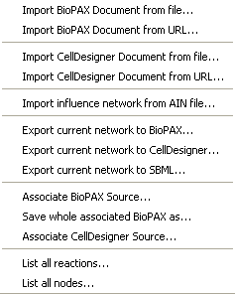

Import BioPAX Document from file: imports a BioPAX file (with .owl extension) from a local folder and creates three BioPAX interfaces (Reaction Network (RN), Pathway Structure (PS) and Protein-Protein interactions (PP)).

Import BioPAX Document from URL: imports BioPAX interfaces from a web address.

Import CellDesigner Document from file: imports a CellDesigner file (with .xml extension) from a local folder.

Import CellDesigner Document from URL: imports a CellDesigner file from a web address.

Import influence network from AIN file: imports an AIN file (Annotated Influence Network), transforms a text-based annotated file into an influence network, accessible in BioPAX format.

Export current network to BioPAX: saves the network (interface) into a BioPAX format (with .owl extension) provided that it is associated to an existing BioPAX file. Only the visible part of information is exported.

Export current network to CellDesigner: saves the network into a CellDesigner format (with .owl extension) provided that it is associated to an existing CellDesigner file. Only the visible part of information is exported.

Export current network to SBML: saves the Reaction Network interface into an SBML format.

Associate BioPAX Source: associates the Cytoscape network with an existing BioPAX object (or file).

Save whole associated BioPAX as: saves the whole BioPAX object associated with the current interface.

Associate CellDesigner Source: associates the current network an existing CellDesigner document.

BiNoM Analysis

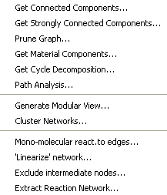

Get Connected Components: isolates from the rest of the network all the connected components

Get Strongly Connected Components: isolates a sub-network with the property that there exists an undirected path from one node to another.

Prune graph: separates the graph into three sub-networks: incoming flux (what comes in), outgoing flux (what goes out) and the cyclic part (containing strongly connected components).

Get Material Components: separates the network into sub-networks describing the life cycle of each entity (protein, small molecule, etc.).

Get Cycle Decomposition: decomposes the network into minimal cycles.

Path Analysis: highlights shortest, sub-optimal or all paths from a species to another. Select some nodes first.

Generate Modular View: creates a graph in which the nodes are sub-networks (or modules) of an initial network. The modules are linked together according to the number of common interactions, or nodes.

Cluster networks: lumps together sub-networks or modules that share a certain proportion of nodes, given a specified percentage of overlap.

Mono-molecular reactions to edges: transforms a BioPAX network into an influence graph

‘Linearize’ network: replaces explicit reactions of complex formation by direct influences (for AIN imported files).

Exclude intermediate nodes: replaces intermediate nodes by direct influences (an intermediate node has only one incoming and one outgoing arrow).

Extract reaction network: cleans up the diagram from all extra edges and nodes such as publications, entities, etc. and only keeps the reaction network.

BiNoM BioPAX Utils

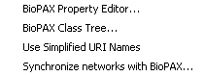

BioPAX Property Editor: reviews all the available information about a protein, a gene, a pathway, etc. contained in BioPAX.

BioPAX Class Tree: shows all instances of BioPAX classes (proteins, complexes, conversions, catalyses, etc.) with the possibility to call the editor and create new instances.

Using Name Service Names / Using URI Names: changes the way species are named: from names generated by BiNoM Naming Service to URIs (Uniform Resource Identifier) and vice versa.
Synchronize networks with BioPAX: updates all interfaces according to changes made in their common BioPAX object.

BiNoM BioPAX Query

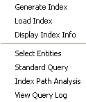

Generate Index: generates a full attributed graph representation of BioPAX (index) creating a file with an .xgmml format from an .owl file (maps BioPAX onto a labelled graph).

Load Index: loads the full attributed graph representation of BioPAX.

Display Index Info: lists the names of the index and of the index file, the accession number table file (when available), number of all types of objects in the index.

Select entities from the index: finds entities specified by names or accession numbers in the BioPAX index loaded

Standard Query: given a BioPAX interface, extends it from the BioPAX index loaded (adds complexes, chemical species, reactions, or publications).

Index Path Analysis: finds the directed or non-directed, shortest, optimal or suboptimal, non intersecting paths with a pre-defined number of intermediaries in an index file. Select species on the graph before this query.

View query log: recapitulates all the queries done during the session.

BiNoM Utilities

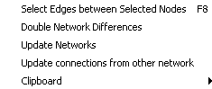

Select Edges between selected nodes: selects all the edges that connect selected nodes.

Double Network Differences: compares two networks A and B by computing first A-A∩B and then B-A∩B.

Update Networks: updates specified Cytoscape networks related to some base network according to the modifications made in that network (for example, used to propagate changes on sub-networks).

Clipboard

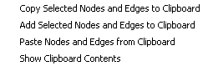

Clipboard: computes several clipboard operations such as: copying and pasting selected nodes and edges, adding selected nodes and edges to clipboard and showing the content of the clipboard.

April 2008, © BiNoM
http://bioinfo.curie.fr/projects/binom

