Installation
Batchfermentation is developed in python to help researchers to make their computation easier.
To install this package unpack beda,zip and double click batchfermentation.exe
Or open the command prompt and go to the path where the file is unzipped and type batchfermentation.exe.
Eg: C:/beda/batchfermentation.exe
Creating Input file
The first row of the file should be header
The time is expected to be given as Hours and concentration in grams/L
The output will be generated as grams/L
The input should be in CSV format (Example file Book1.csv given as screenshot)
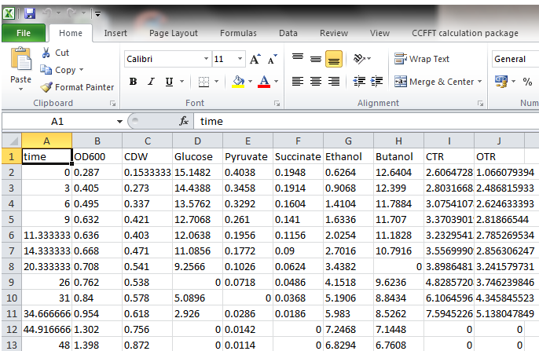
15 Steps for analysis
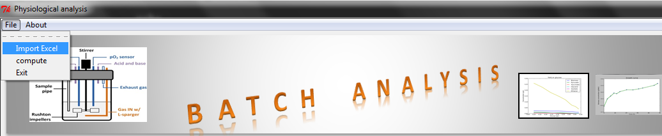
- Go to File import CSV file of Batch fermentation data

The file will be loaded in the input area
- Select substrate in the Header columns listbox click Add substrate button
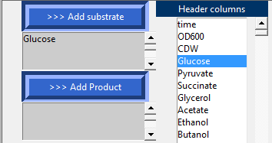
In the example Glucose is added as substrate
- Enter Molecular weight and number of carbons for substrate and click submit
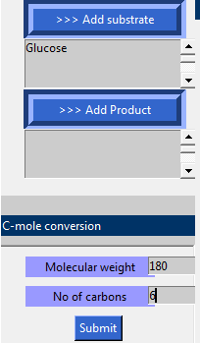
- Select Product in the Header columns listbox click Add Product button
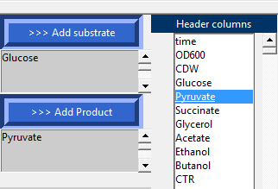
In the example pyruvate is added as a product
- Enter Molecular weight and number of carbons for product and click submit
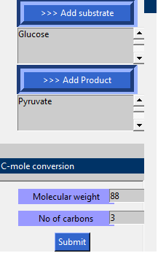
- Select Biomass and time column
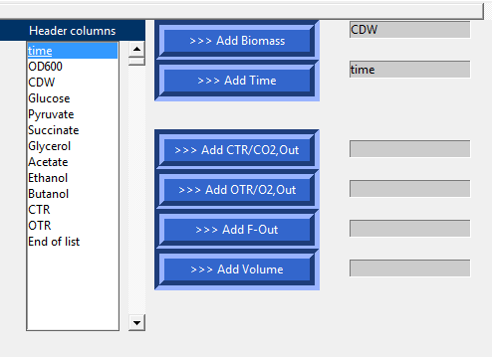
- If CTR is present then select CTR and click Add CTR/Co2
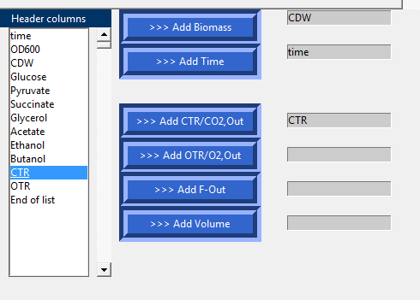
- Similarly If OTR is present then select OTR and click Add OTR/O2
- If CTR is not present select columns F-out, Volume, Co2,out, O2,out and click their respective buttons

- Enter parameters Pressure, temperature, O2,in, Co2,in, Gas Flow-in click calculate for CTR and OTR calculation and finally RQ average
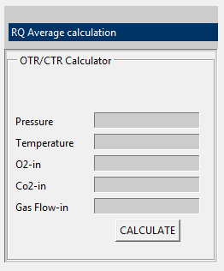
- Enter elemental composition or select organism to get the composition automatically
- Click Compute
- Growth curve will be generated select two points specifying starting and ending point of exponential phase
- Yield, Rates and RQ average will be calculated
- The output images and the outfile with their results will be stored in Output folder

Background on computation
Cell Growth rate
In Batch, the cells are dividing at a constant rate resulting in an exponential increase in the number of cells present.
dx/dt=μX
where dx/dt is Exponential growth rate is First Order with respect to X, X is the cell concentration, μ is the cell growth rate

ln(x/x0)=μt
where x and x0 are cell concentration at time t and t=0.

Doubling time td(time required to double microbial mass or number) when x=2x0
td = ln2/μ
Yield Coefficients
Biomass formed per substrate consumed Ysx = μ/rs =Δx/Δs , where rs is substrate rate
Product formed per substrate consumed Ysp = rp/rs =Δp/Δs, where rp is product rate
YO2x = X/(OUR/μ)
where OUR is specific oxygen uptake rate
YCO2x = X/(CUR/μ)
where CUR is specific carbon uptake rate
RQ average
Respiratory coefficient RQ=CTR/OTR
where OTR and CTR stand for oxygen and carbon dioxide transfer rate
CTR = P/RT(Fgas,out*yco2,out/Vw)
OTR = P/RT(Fgas,in*yo2,in-Fgas,out*yo2,out/Vw)
Where P is pressure, T is Temperature

