**Exercise 1: Toy model 1**

1. Create a constraint-based model of the simple biochemical system directly in COBRA using the *createModel* command. Create a new COBRA model with the following reactions:

|  |  |  |
| --- | --- | --- |
| **Reaction Name** | **Reaction formula** | **Gene Name** |
| *v1* | → A | G0 |
| *v2* | A → B | G1 |
| *v3* | B → C | G2 |
| *v4* | A → D | G3 |
| *v5* | C → D | G4 |
| *v6* | D → | G5 |

1. Fix *v*1 = 2 and optimize for *v*2, *v*3, and *v*6*:* What results do you get? Why?
2. Perform a robustness analysis for *v*2 as changing variable, with *v*3 and *v*5 as objective function. What is the difference? Why?
3. First perform a flux variability analysis for *v*1 = 2 and objective function *v3, v4* and *v*6. Then, perform a flux variability analysis for *v*1 = *v*4 = 2 and objective function *v*6. Discuss the differences.
4. Perform a sampling of the allowed flux distributions for *v*1 = 2 around the optimal objective value. Discuss the result.

**model = changeRxnBounds(model,'v6',0.9*FBAsolution.f,'l');**

1. Perform a single gene deletion study with the objective function *v*6. Discuss the result.
2. Perform a double gene deletion study. What is the only non-lethal double deletion?

**Exercise 2: Toy model 2**

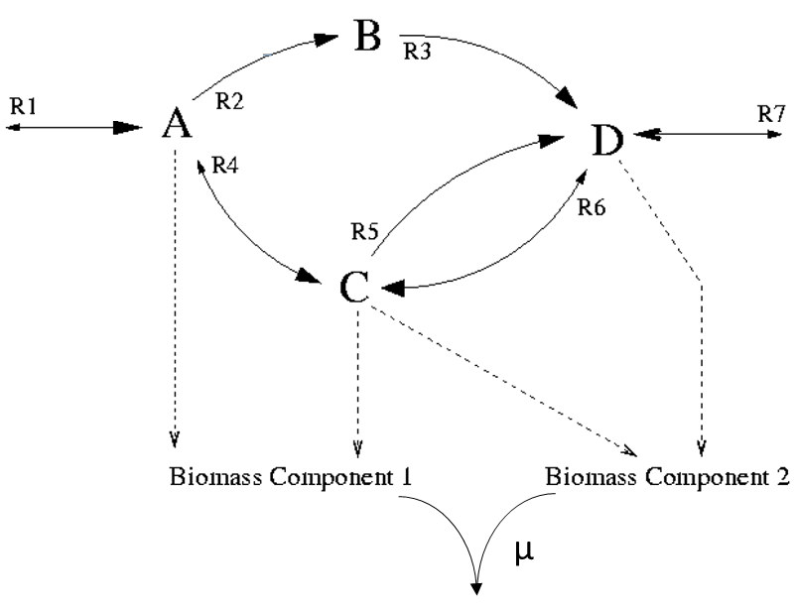

1. Create the constraint-based model of the biochemical system above, using the following reactions: **(Hint:** ↔ **= <=>)**

|  |  |  |
| --- | --- | --- |
| **Reaction Name** | **Reaction formula** | **Gene Name** |
| mu | 0.5 BC1 + 0.5 BC2 → | GeneMU |
| RBC1 | 2 A + C → BC1 | GeneBC1 |
| RBC2 | C + 3 D → BC2 | GeneBC2 |
| R1 | ↔ A | Gene0 |
| R2 | A → B | Gene1 |
| R3 | B → D | Gene2 |
| R4 | A ↔ C | Gene3 |
| R5 | C → D | Gene4 |
| R6 | D ↔ C | Gene5 |
| R7 | D ↔ | Gene6 |

1. What maximal growth rate *µ* can be obtained with *R*1 = 1 and *R7* ≥ 0?
2. Perform a Flux Variability Analysis and interpret the result. What happens if you fix *R*3 = 0? What happens if you fix *R*3 = *R*6 = 0? Discuss the difference.
3. Perform a sampling of the allowed flux distributions with *R*1 = 1 and *R7* ≥ 0 and identify correlated reaction sets. What happens if you fix *R*3 = 0? What happens if you fix *R*3 = *R*6 = 0? Discuss the differences.

Hints:

**sol = optimizeCbModel(model);**

**growthRate = sol.f;**

**model = changeRxnBounds(model,'mu',0.9*growthRate,'l');**

1. Represent on the same plot the results from the FBA, FVA and sampling using *R*1 = 1 and *R7* ≥ 0 for the followings reactions: GR, R1, R2, R4, R5. Perform FVA and the sampling around the optimal solution. Describe and discuss your observations.

**[minFlux,maxFlux] = fluxVariability(model,90);**

**rxns={'mu','R1','R2','R4','R5'};**

**figure;**

**for i = 1 : numel(rxns)**

**subplot(2,3,i)**

**pos=find(ismember(modelSampling.rxns,rxns(i)));**

**[counts,centers]=hist(samples(pos,:),15);**

**plot(centers,counts,'k','LineWidth',2)**

**hold on**

**pos=find(ismember(model.rxns,rxns(i)));**

**fig_axis=get(gca);**

**max_y=fig_axis.YLim(2);**

**plot([minFlux(pos) minFlux(pos)], [0 max_y],'r','LineWidth',2);**

**plot([maxFlux(pos) maxFlux(pos)], [0 max_y],'r','LineWidth',2);**

**plot([FBAsolution.x(pos) FBAsolution.x(pos)], [0 max_y],'y*','LineWidth',2);**

**title(model.rxns{pos});**

**xlabel('Flux')**

**ylabel('# samples')**

**hold off**

**end**

**legend('Sampling','MinFVA','MaxFVA','FBA')**

1. Perform a single gene deletion study with the objective function maximal growth rate by fixing *R*1 = 1 and *R7* ≥ 0. Discuss the result.
2. Perform a double gene deletion study. Which non-lethal double deletions did you find?