**Exercise 3: Chloroplast Carbon Metabolism**

1. Implement a Constraint Based Model of the following chloroplast network:

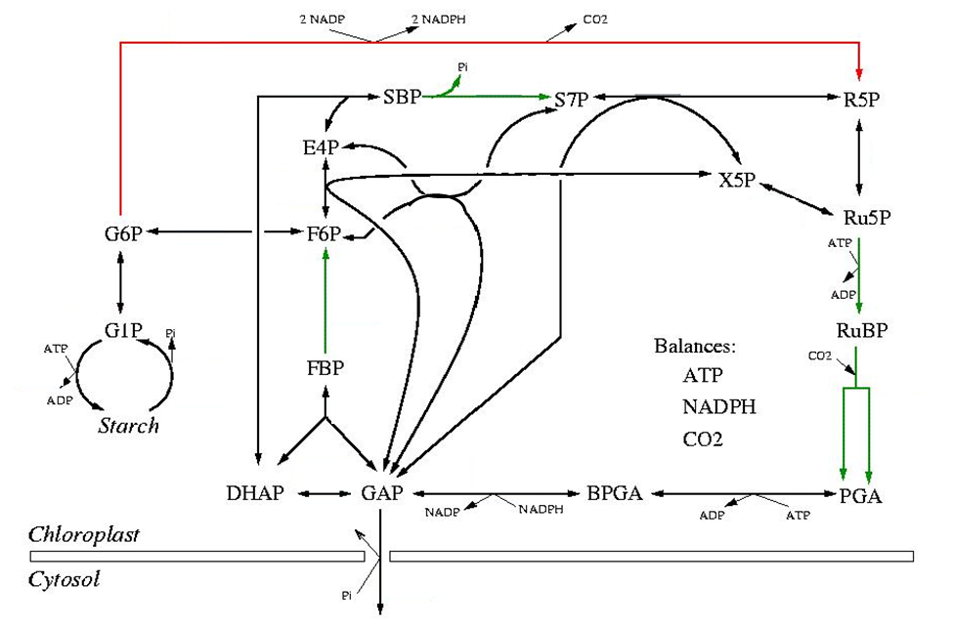

|  |  |  |
| --- | --- | --- |
| **Reaction Name** | **Reaction formula** | **Gene Name** |
| Rubisco | RuBP + CO2 → 2 PGA | Gene1 |
| PGK | PGA + ATP ↔ BPGA | Gene2 |
| G3Pdh | BPGA + NADPH ↔ GAP | Gene3 |
| FBPase | FBP → F6P | Gene4 |
| SBPase | SBP → S7P | Gene5 |
| Ru5PK | Ru5P + ATP → RuBP | Gene6 |
| StarchSynth | G1P + ATP → | Gene7 |
| ATP_Bal | ATP ↔ | Gene8 |
| TPI | GAP ↔ DHAP | Gene9 |
| Aldo | DHAP + GAP ↔ FBP | Gene10 |
| TKL1 | GAP + F6P ↔ E4P + X5P | Gene11 |
| Aldo2 | DHAP + E4P ↔ SBP | Gene12 |
| TKL2 | GAP + S7P ↔ R5P + X5P | Gene13 |
| R5Piso | R5P ↔ Ru5P | Gene14 |
| X5epi | X5P ↔ Ru5P | Gene15 |
| PGI | F6P ↔ G6P | Gene16 |
| PGM | G6P ↔ G1P | Gene17 |
| StarchDeg | → G1P | Gene18 |
| GAP_TP | GAP → | Gene19 |
| oxPPP | G6P → R5P + 2 NADPH + CO2 | Gene20 |
| NADPH_Bal | NADPH ↔ | Gene21 |
| CO2_Bal | CO2 ↔ | Gene22 |
| TAL | F6P + E4P ↔ GAP + S7P | Gene23 |

1. Investigate two different settings (day *vs* night) by setting the bounds for starch synthesis, starch degradation and RUBISCO appropriately and optimize for maximal GAP transport to the cytosol.

**Day**: RUBISCO=24, StarchSynth=2 and StarchDeg=0

**Night**: RUBISCO=0, StarchSynth=0 and StarchDeg=1

1. Which rate of *CO*2 production do you get during the night? Describe the pathway(s) from the starch to *CO*2.
2. Which rate of *CO*2 consumption do you get during the day?
3. Perform a single gene deletion study. What are the lethal genes? Why?
4. Perform a double gene deletion study. Are there any lethal combinations of genes, which are non-lethal as single mutations? If yes, give and explain an example.

**Exercise 4: *E. coli* core model**(a)

Load the model using **ecoli=load ('ecoli_core_model.mat');**

1. Calculate the maximal growth rate in the aerobic and anaerobic condition using glucose as substrate. Constraint the model accordingly: EX_glc(e) ≥ -18.5 mmol gDW-1 hr-1 (maximum uptake rate). Visualize the FBA results in the *E. coli* map and compare the differences in the pathway usage.

**addpath([pwd,'\Vizualization']);** % add path to use the visualization functions

**map = readCbMap('Ecoli_core_map.txt');** % load the map

**drawFlux(map,model,FBAsolution.x,[],'FileName','ecoli_aerobic.svg','ZeroFluxWidth',1,'lb',-15,'ub',15,'edgeWeight',20)**%Draw the E.coli map using the FBA solution. You can then use internet explorer to open the .svg file.

1. How much more glucose would have to be provided in the anaerobic condition in order to obtain the same growth rate as in the aerobic condition?
2. Calculate the maximal growth rate in the aerobic and anaerobic condition using alternate substrates. Set the maximum uptake rate of the respective substrate to 20 mmol gDW-1 hr-1. Calculate the maximal growth rate at least for 6 different substrates.

|  |  |  |
| --- | --- | --- |
|  | **Growth rate (hr-1)** | |
| **Substrate** | **Aerobic** | **Anaerobic** |
| ac |  |  |
| acald |  |  |
| akg |  |  |
| etoh |  |  |
| fru |  |  |
| fum |  |  |
| glc-D |  |  |
| gln-L |  |  |
| glu-L |  |  |
| lac-D |  |  |
| mal-L |  |  |
| pyr |  |  |
| succ |  |  |

1. Calculate the maximum ATP, NADH and NADPH yield from glucose under the aerobic and anaerobic condition. Set the EX_glc(e) =-1 mmol gDW-1 hr-1.

(Hints: To calculate the maximum ATP yield set ATPM ≥ 0 mmol gDW-1 hr-1.

To calculate the maximum NADH yield set ATPM=0 mmol gDW-1 hr-1 and add a NADH_drain reaction using the *addReaction* command.

E.g. **model=addReaction(model,’NADH_drain’,’nadh[c] -> nad[c] + h[c]’)** and optimize for NADH_drain. Do the same to calculate the maximum NADPH yield.)



1. Determine the growth rate using FBA and the core *E. coli* metabolic network with the given loss of function mutation of the gene(s) listed for each simulation. Then, compare the predictions to the experimental values listed below. Explain your observations. Select one condition where there is a major disagreement between predicted and experimental observations and discuss possible reasons why this occurred.

|  |  |  |  |  |  |
| --- | --- | --- | --- | --- | --- |
| **Main Carbon Substrate** | **Substrate Uptake Rate (mmol gDW-1 hr-1)** | **Aerobic Growth** | **Loss of Function Mutation** | **Growth rate (hr-1)** | **Predicted growth rate (hr-1)** |
| glc-D | 10 | yes | ackA (b2296) | 0.82 |  |
| lac-D | 20 | yes | ackA (b2296) | 0.72 |  |
| akg | 13 | yes | ackA (b2296) | 0.61 |  |
| glc-D | 10 | yes | pck (b3403) | 0.87 |  |
| akg | 13 | yes | pck (b3403) | 0.58 |  |
| glc-D | 10 | yes | tpi (b3919) | 0.52 |  |
| lac-D | 20 | yes | tpi (b3919) | 0.78 |  |
| glc-D | 10 | yes | atpABCDEFGHI (b3731-b3738) |  |  |
| lac-D | 20 | yes | atpABCDEFGHI (b3731-b3738) |  |  |

1. Perform a gene-deletion study for the core *E. coli* network glucose uptake rate =20 mmol gDW-1 hr-1) aerobically and anaerobically. Report the total number of genes and list the essential genes for each condition. Explain the difference between essential and conditionally essential genes and list them.
2. From the mentioned carbon sources in c), with a fixed uptake rate of 20 mmol gDW-1hr-1 and a minimum biomass production of 0.5 mmol gDW-1hr-1, determine which carbon source and which oxygenation condition yields the higher production rate of ethanol (etoh).

|  |  |  |
| --- | --- | --- |
|  | **Ethanol production rate (gDW-1 hr-1)** | |
| **Substrate** | **Aerobic** | **Anaerobic** |
| ac |  |  |
| acald |  |  |
| akg |  |  |
| fru |  |  |
| fum |  |  |
| glc-D |  |  |
| gln-L |  |  |
| glu-L |  |  |
| lac-D |  |  |
| mal-L |  |  |
| pyr |  |  |
| succ |  |  |