Notes
In rough set theory, a decision system can be formed as DS=< U, AT, d >, where U is a nonempty finite set of samples, AT is a nonempty finite set of conditional attributes and d is a decision attribute. ∀x∈U and ∀a∈AT, a(x) indicates the value of x over conditional attribute, and d(x) indicates the value of x over decision attribute.
1. Given a decision system DS;is a radius, the neighborhood relation over A⊆AT is defined as 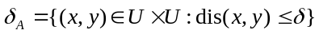, in which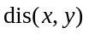implies the distance between x and y over A.
Given a decision system DS;is a radius, A⊆AT, U / IND(d) = {X₁, X₂,…, X_{q}}, based on neighborhood relation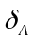, the neighborhood based lower approximation of A with respect to d is 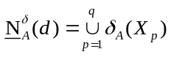.
The function of Cal_low is used to calculate the lower approximation.
3. The function of Cal_posreduct is the core of realizing the Fusing attribute reduction accelerator (Algorithm 2) in our manuscript. The specific steps of such algorithm are shown in the following.
(1) The potential reduct A is initialed to be an empty set.
(2) ∀a∈AT − A, evaluate the candidate attribute a by calculating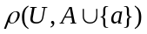.
(3) Select one qualified attribute b∈AT − A, and then add attribute b into A.
(4) If the intended constraint is satisfied, then reduct A is generated; otherwise, go to (5).
(5) Add the potential candidate attributes into T according to the granularity.
(6) Select one qualified attribute b∈T, and then add attribute b into A.
(7) Execute (5)-(6) repeatedly until the intended constraint is satisfied.

