SYSEN 5151 Foundations of Systems Engineering
EcoCommute (Team 6)
System Architecture Definition: Top-Level Functions
and System Requirements Definition
Report section combining the Chapter 4 and Chapter 5 assignments
Innoslate model: EcoCommute 10.7 (extends 10.5 c1-c4) | October 2026

Team Contribution
The table lists who contributed which part. Roles come from the team charter in the repository README; the contribution entries are a draft for the team to confirm before submission.
Team member | Role | Contribution (draft, to confirm)
Luyu Chen | Project Manager and Integration Lead | Integrated the report and the Innoslate model; Chapter 5 requirements document and traceability to the SRD.
Mingjie Fang | Quality, Risk and Documentation Lead | Major technical risks, requirements quality review (assessment criteria), report editing.
Karen Li | Product and Stakeholder Lead | Initial function list from the OpsCon; stakeholder trace and rationale for each system requirement.
Yinping Yin | Sustainability Data and Analysis Lead | Estimation, baseline and reference-case requirements; MOP, MOS and verification criteria.
Yiyang Zou | Technical Architecture Lead | Universe hierarchy, Metafunction, IDEF0-A0 and first-level IDEF0 diagrams in Innoslate.

1. Introduction

1.1 Purpose of System Requirements Definition
System Requirements Definition turns what stakeholders need into a verifiable statement of what the system must do and how well. It starts from the stakeholder requirements already approved for EcoCommute (SRD 2.x.x) and from the operational concept (OpsCon), identifies the functions the system of interest (SoI) must perform, and states each as a requirement that can be traced upward to a stakeholder requirement and downward to a function, an input/output or an interface. This report section covers the first step: the first-level functional architecture (Chapter 4) and the first draft of the system requirements derived from it (Chapter 5).

1.2 Description of this section
The SoI is C.0 EcoCommute, a responsive web application that estimates commute CO2e and suggests feasible greener options. Its external assets are X.1 Commuter, X.2 Pilot Administrator, X.3 Open-Meteo, X.4 Emission Factor Publisher and X.5 Hosting Provider. The nominal scenario (UC.1) is that a commuter logs a trip, EcoCommute retrieves a reviewed emission factor and a forecast, estimates CO2e, stores the trip, updates trends, compares the trip with an always-drive baseline, evaluates a feasible alternative and displays the result with an explanation. Institutional reporting (UC.2) is a separate scenario.
The section is organized as follows. Section 2 lists the system functions and presents the Universe hierarchy, the top-level (Metafunction) IDEF0, the IDEF0-A0 diagram and the first-level IDEF0 diagram. Section 3 states the system requirements: functional, input/output, external interface and system-wide (non-functional), with rationale, measures and verification criteria. Sections 4 and 5 cover verification and traceability. Section 6 lists the major technical risks. Appendix A checks the model against the assessment criteria.

1.3 Assumptions
- The stakeholder needs (SND 1.x.x) and stakeholder requirements (SRD 2.x.x) in the model are the approved baseline. System requirements are numbered 3.x.x and each traces to one or more SRD requirements.
- Function names are verb phrases, input/output names are nouns, and numbering follows the lab convention: F.1 to F.6 at the top level and F.2.0 to F.2.7 at the first level.
- Top-level input/outputs are deliberately broad ('bundles') so the diagram stays stable; first-level diagrams add the internal flows.
- Values taken from the SRD (30 s, 3 s, 99.5%, 500 accounts, $750,000, group size 5) are used unchanged. Two of them, the 3-second display time and the minimum group size of 5, are proposed values that the sponsor still has to confirm. No other numeric value has been invented.
- Requirement statements follow the pattern Innoslate's Generate Requirements script produces (The EcoCommute system shall ...). First-level functional requirements are shown as children of the single top-level functional requirement.

2. System Functions

2.1 Initial function list from the OpsCon
The functions were identified by working through the OpsCon narrative and the UC.1, UC.2 and OP.1-OP.5 actions in the model. Actions the user performs on the interface (open, enter, submit, review) are not system functions; they belong to the Commuter's function, F.1. Table 1 shows how each OpsCon action maps to a function. The first-level functions address both the OpsCon, because every action performed by the system appears in the list, and the SoI, because each function is something EcoCommute itself must do.
Table 1. Initial function list: OpsCon actions mapped to system functions.
OpsCon action (model reference) | Function
Accept the entry; check recorded consent (UC.1.5, OP.1) | F.2.1 Collect Commute Entries
Ingest reviewed emission factors (before UC.1); retrieve the applicable factor (UC.1.5) | F.2.2 Manage Reference Data
Request the forecast for the approved coarse location and trip time; receive it (UC.1.6, UC.1.7) | F.2.2 Manage Reference Data (with F.4 outside the SoI)
Estimate trip CO2e; compare with the always-drive baseline (UC.1.8, UC.1.9) | F.2.3 Estimate Commute Emissions
Store the trip; update weekly and monthly trends; restrict access; delete on request (UC.1.8, UC.1.9, OP.1) | F.2.4 Manage Commute Records
Evaluate transparent rules from distance, weather and the commuter's settings (UC.1.10) | F.2.5 Evaluate Feasible Alternatives
Display impact, trend, baseline difference, explanation and alternative (UC.1.11) | F.2.6 Present Commute Results
Provide the approved aggregate summary; evaluate pilot performance (UC.2, OP.3) | F.2.7 Summarize Pilot Results
Keep the service available; deploy releases; retire the service (OP.2, OP.4, OP.5) | F.2.0 Operate Service
Open entry, enter trip details, submit, review result (UC.1.1, UC.1.3, UC.1.4, UC.1.12) | Excluded: user interaction, part of F.1 Use EcoCommute Decision Support

2.2 Universe hierarchy and top-level (Metafunction) IDEF0
The Universe hierarchy (Figure 1) shows the SoI C.0 and the five external assets as children of the Universe, with the internal components C.1 to C.4 under C.0. Each box on the Metafunction IDEF0 has exactly one mechanism taken from this hierarchy.
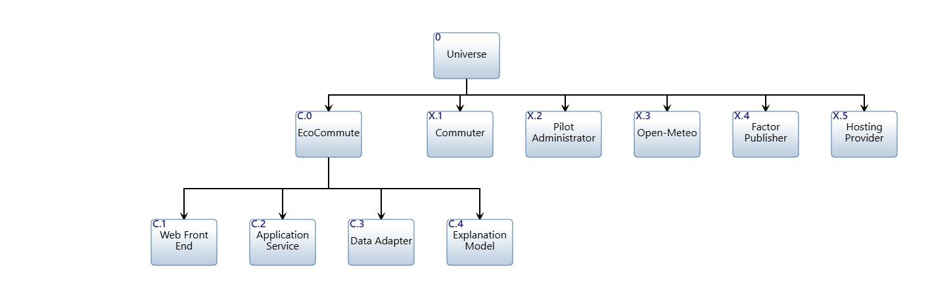
Figure 1. Universe hierarchy: SoI C.0 EcoCommute, external assets X.1 to X.5 and components C.1 to C.4.
The Metafunction (Figure 2) holds one top-level function for the SoI and one for each external asset. It has six functions, inside the five-to-nine guideline. Table 2 lists the functions with their mechanisms and ICOMs. Each function has exactly one mechanism. The SoI function F.2 Provide Commute Impact Decision Support is the highest-level action that gives the stakeholders their value, so it is the function carried into the IDEF0-A0 diagram.

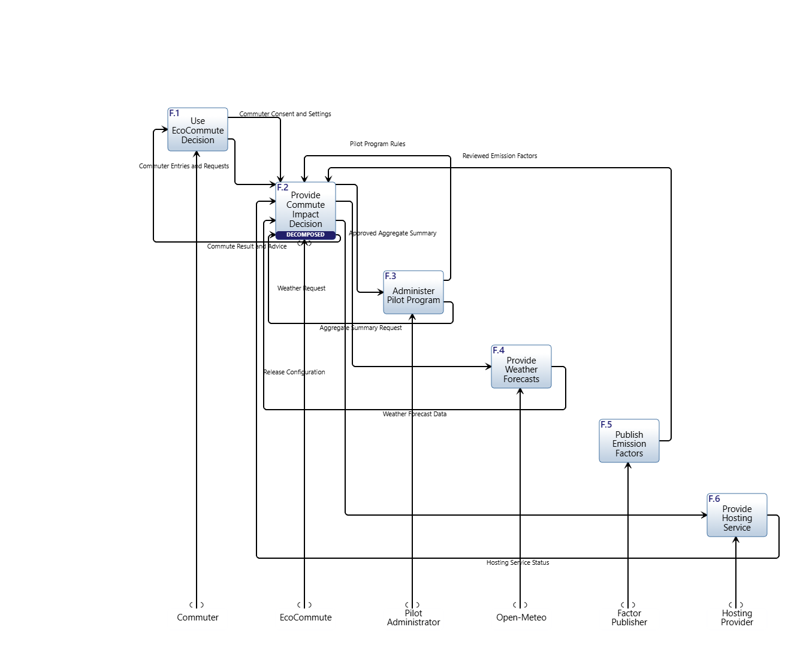
Figure 2. Metafunction IDEF0 for EcoCommute: top-level functions of the SoI (F.2) and the external assets (F.1, F.3 to F.6), with bundled input/outputs.

Table 2. Top-level functions, mechanisms and ICOMs (Metafunction IDEF0).
Function | Mechanism | Inputs | Controls | Outputs
F.1 Use EcoCommute Decision Support | X.1 Commuter | IO.3 Commute Result and Advice | implicit (outside design scope) | IO.1 Commuter Entries and Requests; IO.2 Commuter Consent and Settings
F.2 Provide Commute Impact Decision Support | C.0 EcoCommute | IO.1 Commuter Entries and Requests; IO.5 Weather Forecast Data; IO.7 Aggregate Summary Request; IO.11 Hosting Service Status | IO.2 Commuter Consent and Settings; IO.6 Reviewed Emission Factors; IO.9 Pilot Program Rules | IO.3 Commute Result and Advice; IO.4 Weather Request; IO.8 Approved Aggregate Summary; IO.10 Release Configuration
F.3 Administer Pilot Program | X.2 Pilot Administrator | IO.8 Approved Aggregate Summary | implicit (outside design scope) | IO.7 Aggregate Summary Request; IO.9 Pilot Program Rules
F.4 Provide Weather Forecasts | X.3 Open-Meteo | IO.4 Weather Request | implicit (outside design scope) | IO.5 Weather Forecast Data
F.5 Publish Emission Factors | X.4 Emission Factor Publisher | none | implicit (outside design scope) | IO.6 Reviewed Emission Factors
F.6 Provide Hosting Service | X.5 Hosting Provider | IO.10 Release Configuration | implicit (outside design scope) | IO.11 Hosting Service Status

Every input/output has a source and a destination function, so there are no tunnels. A control is an input/output that governs how the receiving function behaves rather than something it transforms: consent and settings (IO.2), reviewed emission factors (IO.6) and pilot program rules (IO.9). The environment functions F.1 and F.3 to F.6 are outside our design scope, so, following the lab convention, their own controls are treated as implicit. External interfaces are carried by eight conduits: Trip details, Result and advice, Weather query, Forecast, Reviewed factors, Summary request, Approved aggregates and Hosting service. Each conduit transfers the input/outputs listed against it in the model (for example Trip details transfers IO.1 and IO.2).

2.3 IDEF0-A0
The IDEF0-A0 diagram (Figure 3) is the black-box view of F.2 with its ICOMs and mechanism, as seen from the Metafunction. Table 3 explains each ICOM.

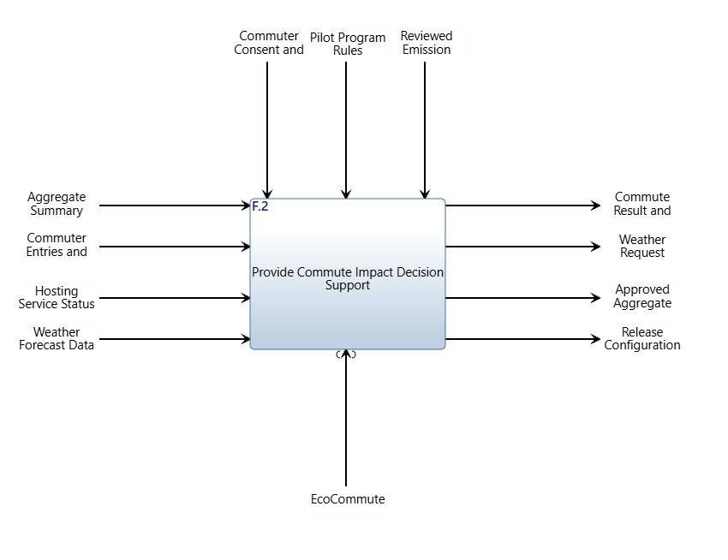
Figure 3. IDEF0-A0 (ICOM) diagram of F.2 Provide Commute Impact Decision Support with mechanism C.0 EcoCommute.

Table 3. ICOM description for F.2 Provide Commute Impact Decision Support (IDEF0-A0).
ICOM | Name | Flow | Description
Input | IO.1 Commuter Entries and Requests | F.1 to F.2 | Trip mode, distance, date, occupancy where applicable, coarse area and record deletion requests from the Commuter.
Input | IO.5 Weather Forecast Data | F.4 to F.2 | Forecast and forecast timestamp returned for the requested location and time.
Input | IO.7 Aggregate Summary Request | F.3 to F.2 | Authorized reporting period and group selection from the Pilot Administrator.
Input | IO.11 Hosting Service Status | F.6 to F.2 | Service status returned by the Hosting Provider.
Control | IO.2 Commuter Consent and Settings | F.1 to F.2 | Recorded consent and feasibility settings that govern whether trips are stored and which modes may be recommended.
Control | IO.6 Reviewed Emission Factors | F.5 to F.2 | Published factor values, units, geography, methodology and version that govern how emissions are estimated.
Control | IO.9 Pilot Program Rules | F.3 to F.2 | Reporting and retirement rules, including the minimum aggregate group size, set by the Pilot Administrator.
Output | IO.3 Commute Result and Advice | F.2 to F.1 | Estimated CO2e, trend, baseline difference, method disclosure, one feasible alternative and plain-language explanation.
Output | IO.4 Weather Request | F.2 to F.4 | Approved coarse location and trip time sent to the weather service.
Output | IO.8 Approved Aggregate Summary | F.2 to F.3 | Enrollment count, weekly active count and total CO2e with no individual identifiers; also the export at retirement.
Output | IO.10 Release Configuration | F.2 to F.6 | Deployment artifacts and operational service requests sent to the Hosting Provider.
Mechanism | C.0 EcoCommute | - | The SoI asset from the Universe hierarchy that performs F.2.

Reading the diagram: four inputs enter F.2 from the Commuter, Open-Meteo, the Pilot Administrator and the Hosting Provider; three controls constrain it (the Commuter's consent and settings, the reviewed emission factors and the pilot program rules); four outputs leave it (the result and advice for the Commuter, the weather request, the approved aggregate summary and the release configuration). All names are nouns, and every arrow has both a source and a destination function on the Metafunction. A0 uses the same input/output identifiers (IO.1 to IO.11) as the Metafunction, so the two diagrams are consistent.

2.4 First-level IDEF0
The first-level IDEF0 (Figure 4) decomposes F.2 into eight functions, within the five-to-nine guideline. The input/outputs of the Metafunction are carried down (black arrows) and allocated to the functions that use or produce them. New internal input/outputs (blue for inputs, orange for controls) show how the functions support one another. Operate Service is numbered F.2.0 so that it comes first: it feeds F.2.4 and F.2.7 and a function may not depend on one numbered after it. The eight functions are the actions the system must perform to deliver the OpsCon, grouped so that each has a clear purpose:
- F.2.0 Operate Service. Deploy releases to the hosting service, monitor availability and run retirement.
- F.2.1 Collect Commute Entries. Present the entry form, validate trip details, enforce recorded consent and route deletion requests.
- F.2.2 Manage Reference Data. Hold reviewed emission factors, select the applicable factor and obtain the forecast for the trip.
- F.2.3 Estimate Commute Emissions. Estimate trip CO2e from the factor and distance and compare it with the declared always-drive baseline.
- F.2.4 Manage Commute Records. Store trips, update weekly and monthly trends, restrict access, delete on request and at retirement.
- F.2.5 Evaluate Feasible Alternatives. Apply transparent distance, weather and feasibility-setting rules to select one alternative with a reason.
- F.2.6 Present Commute Results. Assemble and display impact, trend, baseline difference, method disclosure, alternative and plain-language explanation.
- F.2.7 Summarize Pilot Results. Aggregate usage and CO2e into approved summaries under reporting rules and small-group suppression.

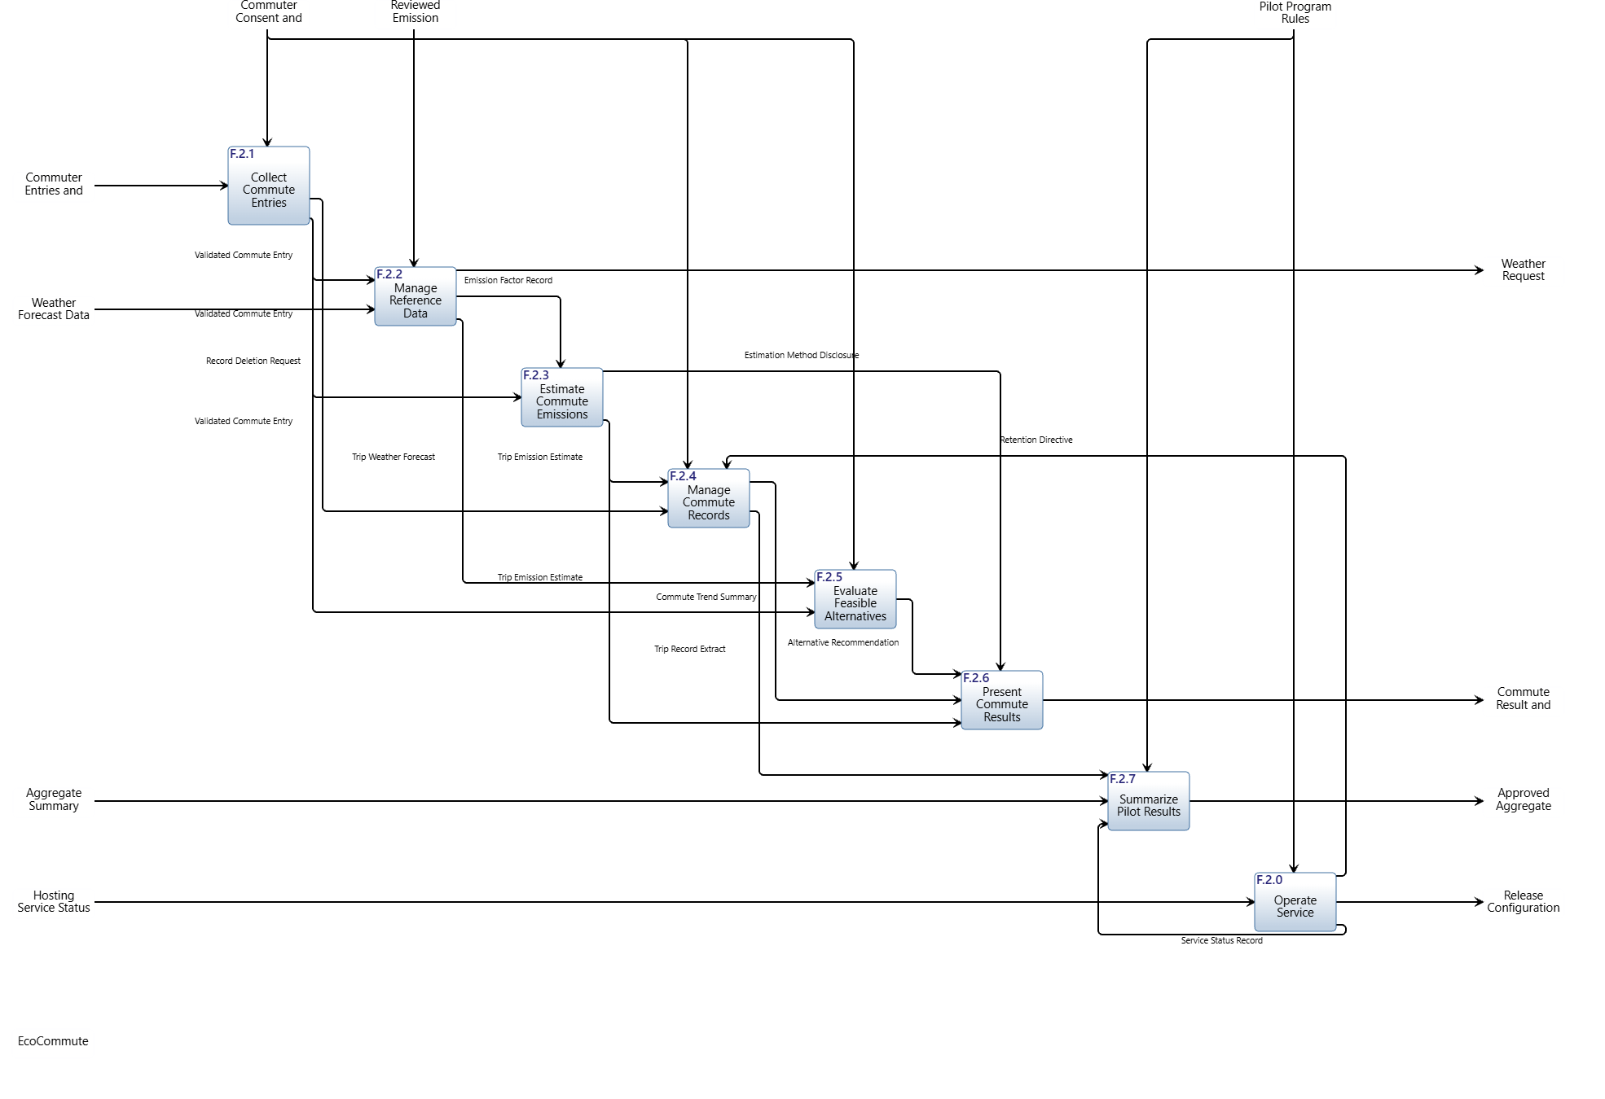
Figure 4. First-level IDEF0 for F.2: eight functions, carried-down input/outputs (black) and internal flows (blue inputs, orange controls). Control arrows are labeled (control).

Table 4. First-level functions and their ICOMs. Mechanisms for first-level functions are allocated in the next chapter.
Function | Inputs | Controls | Outputs | Use case / OP actions realized
F.2.0 Operate Service | IO.11 Hosting Service Status | IO.9 Pilot Program Rules | IO.21 Retention Directive; IO.22 Service Status Record; IO.10 Release Configuration | OP.2, OP.4, OP.5
F.2.1 Collect Commute Entries | IO.1 Commuter Entries and Requests | IO.2 Commuter Consent and Settings | IO.12 Validated Commute Entry; IO.13 Record Deletion Request | UC.1.2, UC.1.4, UC.1.5, OP.1
F.2.2 Manage Reference Data | IO.5 Weather Forecast Data; IO.12 Validated Commute Entry | IO.6 Reviewed Emission Factors | IO.14 Emission Factor Record; IO.15 Trip Weather Forecast; IO.4 Weather Request | UC.1.5, UC.1.6, UC.1.7
F.2.3 Estimate Commute Emissions | IO.12 Validated Commute Entry | IO.14 Emission Factor Record | IO.16 Trip Emission Estimate; IO.17 Estimation Method Disclosure | UC.1.8, UC.1.9
F.2.4 Manage Commute Records | IO.13 Record Deletion Request; IO.16 Trip Emission Estimate | IO.2 Commuter Consent and Settings; IO.21 Retention Directive | IO.18 Commute Trend Summary; IO.19 Trip Record Extract | UC.1.8, UC.1.9, OP.1, OP.4
F.2.5 Evaluate Feasible Alternatives | IO.12 Validated Commute Entry; IO.15 Trip Weather Forecast | IO.2 Commuter Consent and Settings | IO.20 Alternative Recommendation | UC.1.10
F.2.6 Present Commute Results | IO.16 Trip Emission Estimate; IO.18 Commute Trend Summary; IO.20 Alternative Recommendation | IO.17 Estimation Method Disclosure | IO.3 Commute Result and Advice | UC.1.11, UC.1.12
F.2.7 Summarize Pilot Results | IO.7 Aggregate Summary Request; IO.19 Trip Record Extract; IO.22 Service Status Record | IO.9 Pilot Program Rules | IO.8 Approved Aggregate Summary | UC.2, OP.3

Continuity for the use cases. The nominal scenario UC.1 can be followed through the diagram. The Commuter's entry and consent (IO.1, IO.2) enter F.2.1, which produces the Validated Commute Entry (IO.12). F.2.2 uses it with the forecast (IO.5) and the reviewed factors (IO.6) to issue the Weather Request (IO.4) and to produce the Emission Factor Record (IO.14) and the Trip Weather Forecast (IO.15). F.2.3 estimates emissions and the baseline difference (IO.16) and states the method (IO.17); F.2.4 stores the trip and produces the trend (IO.18); F.2.5 produces the Alternative Recommendation (IO.20); F.2.6 assembles IO.16, IO.17, IO.18 and IO.20 into the Commute Result and Advice (IO.3) returned to the Commuter. UC.2 follows IO.7 and IO.9 into F.2.7, which draws on the Trip Record Extract (IO.19) and the Service Status Record (IO.22) to produce the Approved Aggregate Summary (IO.8). The operational actions OP.1 (consent, access, deletion), OP.2 (operate), OP.4 (retire) and OP.5 (release) are carried by IO.2, IO.13, IO.21, IO.10 and IO.11.
Allocation preview. The Chapter 4 build step maps one module to one function. The repository has four components, C.1 to C.4, against eight first-level functions: F.2.1 and F.2.6 land on C.1, F.2.3 and F.2.5 on C.2, F.2.2 and F.2.4 on C.3, and C.4 supports F.2.6. F.2.7 and F.2.0 have no module yet. We have not connected first-level mechanisms in the model, as the lab instructs, and list this as risk TR.9.

3. System Requirements
The system requirements form a document of their own in the model. Section 3 of the model holds them under the root '3 System Requirements', with groups 3.1 Input/Output, 3.2 External Interface, 3.3 Functional and 3.4 System-wide. Every requirement has a name, a number and a description (the shall statement), belongs to the hierarchy through a decomposes relationship, is satisfied by the function, input/output or conduit it concerns, and is traced from the stakeholder requirement(s) shown. Rationale, the measure (MOP for functional, MOS for system-wide) and the verification criteria are stored in the requirement's Rationale attribute and repeated in the tables below.

3.1 Functional requirements
The internal input/outputs of the first-level IDEF0 (IO.12 to IO.22) are satisfied by the leaf-level functional requirement of the function that produces them, so that no input/output is left unsatisfied. There is one top-level functional requirement, 3.3.1, satisfied by the top-level function F.2. Its eight children, 3.3.1.1 to 3.3.1.8, are the leaf-level functional requirements, each satisfied by one first-level function. The measures are measures of performance (MOP).
Table 5. Functional requirements.
ID | Requirement | Satisfied by | Traced to SRD | Rationale | Measure | Verification criteria
3.3.1 | The EcoCommute system shall provide commute impact decision support. | F.2 Provide Commute Impact Decision Support | 2.1.2, 2.1.4, 2.2.1, 2.3.2, 2.4.1, 2.5.2 | Single top-level functional requirement. It is the highest-level action that delivers the stakeholder value: help commuters interpret impact and consider practical lower-carbon options, and give institutions approved engagement information. | Share of nominal-scenario trips (UC.1) that end with an estimate, baseline difference and, where eligible, one alternative displayed (target 100%). | Execute the UC.1 scenario for the reference cases and inspect each result. Method: Test.
3.3.1.1 | The EcoCommute system shall collect commute entries. | F.2.1 Collect Commute Entries | 2.1.1, 2.1.9, 2.5.2, 2.5.3 | Entry effort and consent are the first gate to every other function. | Median time to submit an entry (target 30 s or less for 80% of timed tasks). | Timed usability session with at least 20 participants. Method: Test.
3.3.1.2 | The EcoCommute system shall manage reference data. | F.2.2 Manage Reference Data | 2.4.1, 2.1.4, 2.5.1 | Estimates and advice are only as good as the factor and forecast behind them. | Share of estimates using a reviewed factor with provenance (target 100%). | Inspect factor records used by a sample of estimates. Method: Inspection.
3.3.1.3 | The EcoCommute system shall estimate commute emissions. | F.2.3 Estimate Commute Emissions | 2.1.2, 2.1.3, 2.4.2, 2.4.3, 2.4.4 | The estimate and always-drive baseline are the core of the product and of method credibility. | Difference between reproduced and agreed reference-case CO2e (target 0 g after rounding). | Run all agreed reference cases. Method: Test.
3.3.1.4 | The EcoCommute system shall manage commute records. | F.2.4 Manage Commute Records | 2.1.6, 2.1.7, 2.1.8, 2.3.2, 2.3.5, 2.3.6, 2.5.1, 2.5.2 | Records feed trends, evidence and pilot results while protecting privacy. | Trip records exposed to other roles (target 0); deletion requests leaving a record (target 0). | Role-based access matrix and deletion test. Method: Test.
3.3.1.5 | The EcoCommute system shall evaluate feasible alternatives. | F.2.5 Evaluate Feasible Alternatives | 2.1.4, 2.1.5 | Advice that ignores weather or the Commuter's limits will not be followed. | Recommendations containing a mode marked not feasible (target 0). | Rule test set over all combinations of excluded modes. Method: Test.
3.3.1.6 | The EcoCommute system shall present commute results. | F.2.6 Present Commute Results | 2.1.2, 2.1.3, 2.1.6, 2.1.9, 2.1.10, 2.4.4 | A result the Commuter cannot read or trust has no value. | Time from submission to display (target 3 s or less); explanations with unsupported facts (target 0). | Timing on three reference devices; inspect 50 explanations. Method: Test and Inspection.
3.3.1.7 | The EcoCommute system shall summarize pilot results. | F.2.7 Summarize Pilot Results | 2.2.1, 2.2.2, 2.2.3, 2.3.4, 2.3.7 | Sponsors need evidence without exposing individuals. | Groups reported with fewer than 5 Commuters (target 0); individual identifiers in summaries (target 0). | Aggregation test with seeded groups of 1 to 10. Method: Test.
3.3.1.8 | The EcoCommute system shall operate service. | F.2.0 Operate Service | 2.2.4, 2.3.3, 2.3.6, 2.3.7 | Reliable operation and clean retirement are conditions of the pilot. | Monthly availability (target 99.5% or more); identifiable records left at retirement (target 0). | Monitor availability; retirement rehearsal. Method: Analysis and Test.

3.2 Input/output requirements
There is one requirement per top-level input/output of F.2. Inputs and controls are 'accept' requirements (3.1.1.x) and outputs are 'provide' requirements (3.1.2.x). Each is satisfied by exactly one input/output and by F.2.
Table 6. Input and output requirements.
ID | Requirement | Satisfied by | Traced to SRD | Rationale | Measure | Verification criteria
3.1.1.1 | The EcoCommute system shall accept commuter entries and requests from the Commuter, including trip mode, distance, date, occupancy where applicable, coarse area and record deletion requests. | IO.1 Commuter Entries and Requests; F.2 Provide Commute Impact Decision Support | 2.1.1, 2.1.8 | A commute can only be logged, and data control exercised, if the system accepts these items from the Commuter (need 1.1.1, 1.1.6). | Share of valid, supported entries accepted (target 100%). | Submit a set of valid entries covering every supported mode and one deletion request; each is accepted. Method: Test.
3.1.1.2 | The EcoCommute system shall accept commuter consent and feasibility settings from the Commuter. | IO.2 Commuter Consent and Settings; F.2 Provide Commute Impact Decision Support | 2.5.2, 2.1.5 | Consent must be recorded before trips are stored and feasibility settings must reach the rules that choose alternatives. | Share of consent and settings submissions recorded and applied (target 100%). | Record consent for a test account, mark one mode not feasible, and confirm both are stored and applied. Method: Test.
3.1.1.3 | The EcoCommute system shall accept weather forecast data from Open-Meteo. | IO.5 Weather Forecast Data; F.2 Provide Commute Impact Decision Support | 2.1.4 | The alternative-mode rule depends on forecast weather for the trip. | Share of well-formed forecast responses accepted (target 100%). | Feed recorded well-formed and malformed responses through the interface; well-formed ones are accepted, malformed ones are rejected. Method: Test.
3.1.1.4 | The EcoCommute system shall accept reviewed emission factors, with source, units, geography and version, from the Emission Factor Publisher. | IO.6 Reviewed Emission Factors; F.2 Provide Commute Impact Decision Support | 2.4.1 | Only reviewed factors with recorded provenance may be used in estimates (need 1.4.1). | Share of factor records stored with source, units, geography and version (target 100%). | Ingest a reviewed factor file; inspect that every stored record carries all four fields. Method: Inspection.
3.1.1.5 | The EcoCommute system shall accept aggregate summary requests from the Pilot Administrator. | IO.7 Aggregate Summary Request; F.2 Provide Commute Impact Decision Support | 2.2.1 | The sponsor needs participation evidence on request for a selected period (need 1.2.1). | Share of authorized requests accepted (target 100%); unauthorized requests rejected (target 100%). | Submit authorized and unauthorized requests; only authorized ones are accepted. Method: Test.
3.1.1.6 | The EcoCommute system shall accept pilot program rules, including the minimum aggregate group size, from the Pilot Administrator. | IO.9 Pilot Program Rules; F.2 Provide Commute Impact Decision Support | 2.2.3, 2.2.2 | Reporting rules, such as small-group suppression, are set by the program owner and must govern every summary. | Share of rule changes in force for the next summary (target 100%). | Change the minimum group size and confirm the next summary applies it. Method: Demonstration.
3.1.1.7 | The EcoCommute system shall accept hosting service status from the Hosting Provider. | IO.11 Hosting Service Status; F.2 Provide Commute Impact Decision Support | 2.2.4 | Availability cannot be measured or managed without hosting status. | Share of status messages recorded (target 100%). | Replay status messages from a test provider; each is recorded. Method: Test.
3.1.2.1 | The EcoCommute system shall provide the commute result and advice to the Commuter. | IO.3 Commute Result and Advice; F.2 Provide Commute Impact Decision Support | 2.1.2, 2.1.3, 2.1.4, 2.1.6, 2.1.10, 2.4.4 | This is the main value delivered to the Commuter: impact, baseline difference, method, trends, one alternative and an explanation, labeled as estimates. | Share of accepted trips for which a result is displayed (target 100%). | Run the end-to-end commute scenario for each supported mode; a complete result appears each time. Method: Test.
3.1.2.2 | The EcoCommute system shall provide weather requests, containing only a coarse location and trip time, to Open-Meteo. | IO.4 Weather Request; F.2 Provide Commute Impact Decision Support | 2.1.4, 2.5.1 | Weather lookups must not disclose more location detail than the coarse-area rule allows. | Number of weather requests containing more than coarse location and time (target 0). | Capture outbound requests during a test run and inspect their fields. Method: Inspection.
3.1.2.3 | The EcoCommute system shall provide approved aggregate summaries to the Pilot Administrator. | IO.8 Approved Aggregate Summary; F.2 Provide Commute Impact Decision Support | 2.2.1, 2.2.2, 2.3.7 | Institutions receive program-level evidence only, also exported at retirement. | Share of authorized requests answered with the three required figures (target 100%). | Request a summary for a seeded cohort and compare figures with known totals. Method: Demonstration.
3.1.2.4 | The EcoCommute system shall provide release configuration to the Hosting Provider. | IO.10 Release Configuration; F.2 Provide Commute Impact Decision Support | 2.2.4 | The service can be deployed and operated only if the provider receives the release configuration. | Share of releases deployable from the supplied configuration without manual change (target 100%). | Deploy a release to a test environment using only the supplied configuration. Method: Demonstration.

3.3 External interface requirements
There is one requirement per conduit. Each is satisfied by its conduit, by the external asset it connects to C.0, by the top-level function of that asset (F.1, F.3 to F.6) and by F.2. This also gives every external function a requirement to satisfy.
Table 7. External interface requirements.
ID | Requirement | Satisfied by | Traced to SRD | Rationale | Measure | Verification criteria
3.2.1 | The EcoCommute system shall utilize a responsive web entry form over HTTPS to interface with the Commuter. | conduit Trip details; X.1; F.2 Provide Commute Impact Decision Support | 2.1.1, 2.1.9 | Conduit 'Trip details' is the only path for its information; fixing the medium early lets interface testing start. | Share of interface exchanges completed through the stated medium (target 100%). | Exercise the 'Trip details' conduit end to end with a stub of the external party. Method: Test.
3.2.2 | The EcoCommute system shall utilize a responsive web result view over HTTPS to interface with the Commuter. | conduit Result and advice; X.1; F.2 Provide Commute Impact Decision Support | 2.1.2, 2.1.9 | Conduit 'Result and advice' is the only path for its information; fixing the medium early lets interface testing start. | Share of interface exchanges completed through the stated medium (target 100%). | Exercise the 'Result and advice' conduit end to end with a stub of the external party. Method: Test.
3.2.3 | The EcoCommute system shall utilize an HTTPS API request to interface with Open-Meteo. | conduit Weather query; X.3; F.2 Provide Commute Impact Decision Support | 2.1.4, 2.5.1 | Conduit 'Weather query' is the only path for its information; fixing the medium early lets interface testing start. | Share of interface exchanges completed through the stated medium (target 100%). | Exercise the 'Weather query' conduit end to end with a stub of the external party. Method: Test.
3.2.4 | The EcoCommute system shall utilize a structured HTTPS API response to interface with Open-Meteo. | conduit Forecast; X.3; F.2 Provide Commute Impact Decision Support | 2.1.4 | Conduit 'Forecast' is the only path for its information; fixing the medium early lets interface testing start. | Share of interface exchanges completed through the stated medium (target 100%). | Exercise the 'Forecast' conduit end to end with a stub of the external party. Method: Test.
3.2.5 | The EcoCommute system shall utilize a reviewed file or source-document ingestion to interface with the Emission Factor Publisher. | conduit Reviewed factors; X.4; F.2 Provide Commute Impact Decision Support | 2.4.1 | Conduit 'Reviewed factors' is the only path for its information; fixing the medium early lets interface testing start. | Share of interface exchanges completed through the stated medium (target 100%). | Exercise the 'Reviewed factors' conduit end to end with a stub of the external party. Method: Test.
3.2.6 | The EcoCommute system shall utilize an authenticated dashboard to interface with the Pilot Administrator. | conduit Summary request; X.2; F.2 Provide Commute Impact Decision Support | 2.2.1 | Conduit 'Summary request' is the only path for its information; fixing the medium early lets interface testing start. | Share of interface exchanges completed through the stated medium (target 100%). | Exercise the 'Summary request' conduit end to end with a stub of the external party. Method: Test.
3.2.7 | The EcoCommute system shall utilize an authenticated dashboard and approved aggregate export to interface with the Pilot Administrator. | conduit Approved aggregates; X.2; F.2 Provide Commute Impact Decision Support | 2.2.1, 2.3.7 | Conduit 'Approved aggregates' is the only path for its information; fixing the medium early lets interface testing start. | Share of interface exchanges completed through the stated medium (target 100%). | Exercise the 'Approved aggregates' conduit end to end with a stub of the external party. Method: Test.
3.2.8 | The EcoCommute system shall utilize a provider deployment and status interface to interface with the Hosting Provider. | conduit Hosting service; X.5; F.2 Provide Commute Impact Decision Support | 2.2.4 | Conduit 'Hosting service' is the only path for its information; fixing the medium early lets interface testing start. | Share of interface exchanges completed through the stated medium (target 100%). | Exercise the 'Hosting service' conduit end to end with a stub of the external party. Method: Test.

3.4 Potential non-functional (system-wide) requirements
The system-wide requirements come from the cost, schedule, performance, availability, accessibility, privacy and estimation-quality stakeholder requirements. They are written in the form 'The EcoCommute system shall ...' with a threshold from the SRD, and each is satisfied by F.2. The measures are measures of suitability (MOS) and the last column is the validation criterion.
Table 8. System-wide (non-functional) requirements with measures of suitability (MOS) and validation criteria.
ID | Requirement | Traced to SRD | Rationale | MOS (threshold) | Validation criteria
3.4.1.1 | The EcoCommute system shall cost no more than $750,000 to develop and deploy. | 2.3.1 | The Company Sponsor approved a $750,000 baseline (need 1.3.1). | Total development and deployment cost in USD (threshold $750,000). | Cost report at pilot readiness against the baseline. Method: Analysis.
3.4.1.2 | The EcoCommute system shall provide the Company Sponsor with pilot results for each stakeholder measure of effectiveness before June 30, 2027. | 2.3.4 | The launch decision needs measured evidence by that date (need 1.3.2). | Date pilot results delivered (threshold June 30, 2027). | Compare delivery date with the deadline. Method: Inspection.
3.4.2.1 | The EcoCommute system shall display each trip result within 3 seconds of entry submission. | 2.1.2 | Immediate feedback is the core value proposition; 3 s is a proposed threshold to confirm with the sponsor. | Time from submission to result display in seconds (threshold 3 s). | Timing test on three reference devices. Method: Test.
3.4.2.2 | The EcoCommute system shall enable a Commuter to complete a commute entry in 30 seconds or less for at least 80 percent of timed entry tasks. | 2.1.1 | Entry effort is the main barrier to repeated use. | Percentage of timed entry tasks at or under 30 s (threshold 80%). | Pilot usability session, 20 participants, five trips each. Method: Test.
3.4.3.1 | The EcoCommute system shall maintain an availability of at least 99.5 percent during each month of the pilot. | 2.2.4 | Reliable access protects the logging habit and the sponsor's credibility. | Measured monthly availability (threshold 99.5%). | Monitor a successful service check every minute and report monthly. Method: Analysis.
3.4.3.2 | The EcoCommute system shall operate without functional failure with at least 500 enrolled Commuter accounts. | 2.3.3 | The pilot cohort is sized at 500 Commuters. | Functional failures observed at 500 accounts (threshold 0). | Load test with 500 seeded accounts. Method: Test.
3.4.4.1 | The EcoCommute system shall conform to WCAG 2.2 Level AA for the commute entry and result views. | 2.1.9, 2.5.3 | Inclusive access is a charter expectation and a pilot-entry condition. | Unresolved WCAG 2.2 AA failures (threshold 0). | Accessibility audit plus keyboard-only and screen-reader walkthroughs. Method: Inspection.
3.4.5.1 | The EcoCommute system shall restrict access to each Commuter's individual trip records to that Commuter. | 2.1.7 | Privacy control is a condition of voluntary participation. | Individual records exposed to any other role (threshold 0). | Role-based access test matrix. Method: Test.
3.4.5.2 | The EcoCommute system shall store trip location only at coarse-area granularity and shall not collect location traces from Commuter devices. | 2.5.1, 2.3.5 | Data minimisation limits the harm of a leaked record and the sponsor's privacy exposure. | Stored location fields finer than coarse area (threshold 0); device traces collected (threshold 0). | Inspect the data model and a sample of stored records. Method: Inspection.
3.4.5.3 | The EcoCommute system shall suppress any aggregate group that contains fewer than 5 Commuters. | 2.2.3 | Small groups can be re-identified; 5 is a proposed default for the sponsor to confirm. | Reported groups with fewer than 5 Commuters (threshold 0). | Aggregation test with seeded group sizes 1 to 10. Method: Test.
3.4.6.1 | The EcoCommute system shall reproduce each agreed reference-case CO2e result to the nearest gram. | 2.4.2 | Method reviewers must be able to defend every number. | Difference from agreed reference value in grams (threshold 0 g). | Run every agreed reference case. Method: Test.

3.5 Critical to quality (CTQ) considerations
The characteristics that most affect whether stakeholders accept the system are the following. Each is covered by a requirement above.
Table 9. Critical to quality considerations.
CTQ | How it is measured | Requirements
Trustworthy estimates | Reference-case results reproduced to the nearest gram; every estimate uses a reviewed factor with source, units, geography and version | 3.4.6.1, 3.3.1.3, 3.1.1.4
Fast, easy logging | 80% of timed entries in 30 s or less; result in 3 s | 3.4.2.2, 3.4.2.1
Advice that can be followed | No recommendation contains a mode marked not feasible; one alternative with a reason | 3.3.1.5
Privacy by design | No individual record exposed to another role; coarse location only; no group under 5 | 3.4.5.1, 3.4.5.2, 3.4.5.3
Inclusive access | Zero open WCAG 2.2 AA failures; keyboard and screen-reader completion | 3.4.4.1
Reliable pilot service | 99.5% monthly availability; 500 accounts without functional failure | 3.4.3.1, 3.4.3.2
Honest explanations | Zero explanations containing facts not in the calculated result | 3.3.1.6

3.6 System requirements considerations
- Quality of the statements. Each statement is a single 'shall' sentence about one thing, names the actor, avoids vague words and, for system-wide requirements, carries a threshold that can be tested. The input/output, interface and top-level functional statements deliberately stay general, as the lab expects of generated statements; their measurable targets are held in the measure and verification columns and will be refined when the document is edited in the next chapter.
- Proposed values. The 3-second display time (3.4.2.1) and the minimum group size of 5 (3.4.5.3, 3.1.1.6) are proposed values from the SRD that the sponsor must confirm. The percentage thresholds in the MOP column for the input/output and interface requirements are targets of 100% for correct handling, chosen by the team, not stakeholder values.
- Not yet covered. System requirements for the engineering and support and enabling provider stakeholders (SH.6, SH.7) are deferred to Architecture Definition, as recorded in the repository (item O-6). Off-nominal behavior, such as a weather outage or invalid input, is not yet modeled (item O-5).
- Stakeholder coverage. All 28 stakeholder requirements are traced to at least one system requirement, either through a group, a functional requirement or a system-wide requirement.

4. Requirements Verification

4.1 Potential MOP and TPM
Measures of performance (MOP) are attached to the functional, input/output and interface requirements; the technical performance measures (TPM) below are the few parameters the team will track through design because they are most likely to be at risk (see Section 6).
Table 10. Potential technical performance measures.
TPM | Requirement | Target | Related risk
Result display time | 3.4.2.1 | 3 s or less on three reference devices | TR.2, TR.7
Entry completion time | 3.4.2.2 | 30 s or less for 80% of tasks | TR.6
Reference-case error | 3.4.6.1 | 0 g after rounding | TR.1
Monthly availability | 3.4.3.1 | 99.5% or more | TR.7
Unsupported facts in explanations | 3.3.1.6 | 0 of 50 sampled | TR.4
Open WCAG 2.2 AA failures | 3.4.4.1 | 0 | TR.6
Aggregate groups below 5 Commuters | 3.4.5.3 | 0 | TR.5
Development and deployment cost | 3.4.1.1 | $750,000 or less | TR.8

4.2 Requirements verification and traceability matrix (RVTM)
The matrix lists, for every system requirement, the stakeholder requirement it traces to, the function or element that satisfies it, the verification method and the current status. All requirements are at Draft; none has been verified yet.
Table 11. Requirements verification and traceability matrix.
ID | Requirement | Stakeholder req. | Satisfied by | Method | Status
3.1.1.1 | accept commuter entries and requests | 2.1.1, 2.1.8 | IO.1 Commuter Entries and Requests; F.2 Provide Commute Impact Decision Support | Test | Draft, not yet verified
3.1.1.2 | accept commuter consent and settings | 2.5.2, 2.1.5 | IO.2 Commuter Consent and Settings; F.2 Provide Commute Impact Decision Support | Test | Draft, not yet verified
3.1.1.3 | accept weather forecast data | 2.1.4 | IO.5 Weather Forecast Data; F.2 Provide Commute Impact Decision Support | Test | Draft, not yet verified
3.1.1.4 | accept reviewed emission factors | 2.4.1 | IO.6 Reviewed Emission Factors; F.2 Provide Commute Impact Decision Support | Inspection | Draft, not yet verified
3.1.1.5 | accept aggregate summary requests | 2.2.1 | IO.7 Aggregate Summary Request; F.2 Provide Commute Impact Decision Support | Test | Draft, not yet verified
3.1.1.6 | accept pilot program rules | 2.2.3, 2.2.2 | IO.9 Pilot Program Rules; F.2 Provide Commute Impact Decision Support | Demonstration | Draft, not yet verified
3.1.1.7 | accept hosting service status | 2.2.4 | IO.11 Hosting Service Status; F.2 Provide Commute Impact Decision Support | Test | Draft, not yet verified
3.1.2.1 | provide commute result and advice to the Commuter | 2.1.2, 2.1.3, 2.1.4, 2.1.6, 2.1.10, 2.4.4 | IO.3 Commute Result and Advice; F.2 Provide Commute Impact Decision Support | Test | Draft, not yet verified
3.1.2.2 | provide weather requests to Open-Meteo | 2.1.4, 2.5.1 | IO.4 Weather Request; F.2 Provide Commute Impact Decision Support | Inspection | Draft, not yet verified
3.1.2.3 | provide approved aggregate summaries to the Pilot Administrator | 2.2.1, 2.2.2, 2.3.7 | IO.8 Approved Aggregate Summary; F.2 Provide Commute Impact Decision Support | Demonstration | Draft, not yet verified
3.1.2.4 | provide release configuration to the Hosting Provider | 2.2.4 | IO.10 Release Configuration; F.2 Provide Commute Impact Decision Support | Demonstration | Draft, not yet verified
3.2.1 | utilize responsive web entry form over HTTPS to interface with the Commuter | 2.1.1, 2.1.9 | conduit Trip details; X.1; F.2 Provide Commute Impact Decision Support | Test | Draft, not yet verified
3.2.2 | utilize responsive web result view over HTTPS to interface with the Commuter | 2.1.2, 2.1.9 | conduit Result and advice; X.1; F.2 Provide Commute Impact Decision Support | Test | Draft, not yet verified
3.2.3 | utilize HTTPS API request to interface with Open-Meteo | 2.1.4, 2.5.1 | conduit Weather query; X.3; F.2 Provide Commute Impact Decision Support | Test | Draft, not yet verified
3.2.4 | utilize structured HTTPS API response to interface with Open-Meteo | 2.1.4 | conduit Forecast; X.3; F.2 Provide Commute Impact Decision Support | Test | Draft, not yet verified
3.2.5 | utilize reviewed file or source-document ingestion to interface with the Emission Factor Publisher | 2.4.1 | conduit Reviewed factors; X.4; F.2 Provide Commute Impact Decision Support | Test | Draft, not yet verified
3.2.6 | utilize authenticated dashboard to interface with the Pilot Administrator | 2.2.1 | conduit Summary request; X.2; F.2 Provide Commute Impact Decision Support | Test | Draft, not yet verified
3.2.7 | utilize authenticated dashboard and approved aggregate export to interface with the Pilot Administrator | 2.2.1, 2.3.7 | conduit Approved aggregates; X.2; F.2 Provide Commute Impact Decision Support | Test | Draft, not yet verified
3.2.8 | utilize provider deployment and status interface to interface with the Hosting Provider | 2.2.4 | conduit Hosting service; X.5; F.2 Provide Commute Impact Decision Support | Test | Draft, not yet verified
3.3.1 | provide commute impact decision support | 2.1.2, 2.1.4, 2.2.1, 2.3.2, 2.4.1, 2.5.2 | F.2 Provide Commute Impact Decision Support | Test | Draft, not yet verified
3.3.1.1 | collect commute entries | 2.1.1, 2.1.9, 2.5.2, 2.5.3 | F.2.1 Collect Commute Entries | Test | Draft, not yet verified
3.3.1.2 | manage reference data | 2.4.1, 2.1.4, 2.5.1 | F.2.2 Manage Reference Data | Inspection | Draft, not yet verified
3.3.1.3 | estimate commute emissions | 2.1.2, 2.1.3, 2.4.2, 2.4.3, 2.4.4 | F.2.3 Estimate Commute Emissions | Test | Draft, not yet verified
3.3.1.4 | manage commute records | 2.1.6, 2.1.7, 2.1.8, 2.3.2, 2.3.5, 2.3.6, 2.5.1, 2.5.2 | F.2.4 Manage Commute Records | Test | Draft, not yet verified
3.3.1.5 | evaluate feasible alternatives | 2.1.4, 2.1.5 | F.2.5 Evaluate Feasible Alternatives | Test | Draft, not yet verified
3.3.1.6 | present commute results | 2.1.2, 2.1.3, 2.1.6, 2.1.9, 2.1.10, 2.4.4 | F.2.6 Present Commute Results | Test and Inspection | Draft, not yet verified
3.3.1.7 | summarize pilot results | 2.2.1, 2.2.2, 2.2.3, 2.3.4, 2.3.7 | F.2.7 Summarize Pilot Results | Test | Draft, not yet verified
3.3.1.8 | operate service | 2.2.4, 2.3.3, 2.3.6, 2.3.7 | F.2.0 Operate Service | Analysis and Test | Draft, not yet verified
3.4.1.1 | cost no more than $750,000 to develop and deploy | 2.3.1 | F.2 Provide Commute Impact Decision Support | Analysis | Draft, not yet verified
3.4.1.2 | report pilot results before June 30, 2027 | 2.3.4 | F.2 Provide Commute Impact Decision Support | Inspection | Draft, not yet verified
3.4.2.1 | display each trip result within 3 seconds | 2.1.2 | F.2 Provide Commute Impact Decision Support | Test | Draft, not yet verified
3.4.2.2 | complete commute entry in 30 seconds or less | 2.1.1 | F.2 Provide Commute Impact Decision Support | Test | Draft, not yet verified
3.4.3.1 | maintain availability of at least 99.5 percent | 2.2.4 | F.2 Provide Commute Impact Decision Support | Analysis | Draft, not yet verified
3.4.3.2 | operate with at least 500 enrolled accounts | 2.3.3 | F.2 Provide Commute Impact Decision Support | Test | Draft, not yet verified
3.4.4.1 | conform to WCAG 2.2 Level AA | 2.1.9, 2.5.3 | F.2 Provide Commute Impact Decision Support | Inspection | Draft, not yet verified
3.4.5.1 | restrict access to individual trip records | 2.1.7 | F.2 Provide Commute Impact Decision Support | Test | Draft, not yet verified
3.4.5.2 | store only coarse location and collect no device traces | 2.5.1, 2.3.5 | F.2 Provide Commute Impact Decision Support | Inspection | Draft, not yet verified
3.4.5.3 | suppress aggregate groups below 5 Commuters | 2.2.3 | F.2 Provide Commute Impact Decision Support | Test | Draft, not yet verified
3.4.6.1 | reproduce reference-case results to the nearest gram | 2.4.2 | F.2 Provide Commute Impact Decision Support | Test | Draft, not yet verified

5. System Requirements Management

5.1 Requirements document in Innoslate
The system requirements are held in the Innoslate model as one hierarchy rooted at '3 System Requirements' and sourced from its own artifact, the EcoCommute System Requirements Document (SysRD), which is separate from the Stakeholder Requirements Document. The hierarchy is shown in Figure 5. Counts: 52 requirement entities, of which 39 are system requirements (7 input, 4 output, 8 external interface, 9 functional, 11 system-wide) and 13 are organizing groups. The generated structure follows Innoslate's pattern of Input/Output, External Interface, Functional and System-wide groups. The wording follows the structure of the statements that Innoslate's Generate Requirements script produces, and the top-level statements are not edited further in this chapter, in keeping with the lab instruction. The system-wide requirements are added manually from the stakeholder requirements, as the lab describes, because the script does not generate them.
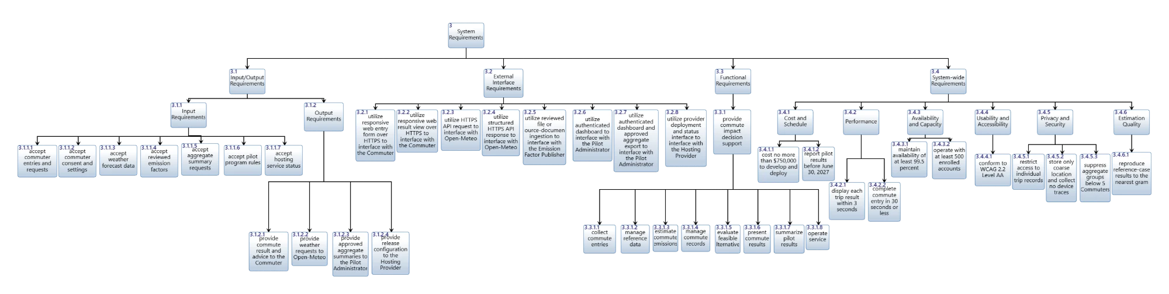
Figure 5. System requirements hierarchy (decomposes relationships) for requirement group 3.

5.2 Requirements traceability diagrams
Figure 6 is the requirements traceability matrix from Innoslate. Its rows are the top-level functional requirement 3.3.1 and its eight children 3.3.1.1 to 3.3.1.8, and its columns are the stakeholder requirements of the SRD (2.x.x). A cross marks a traced-from relationship, so each row shows the stakeholder requirements that drive that system requirement. For example, 3.3.1.1 collect commute entries is traced from 2.1.1 enable fast trip entry, 2.1.9 conform to accessibility standard, 2.5.2 record consent before storing trips and 2.5.3 pass assistive-technology walkthrough; 3.3.1.5 evaluate feasible alternatives is traced from 2.1.4 and 2.1.5; and 3.3.1.7 summarize pilot results is traced from the sponsor requirements 2.2.1, 2.2.2, 2.2.3, 2.3.4 and 2.3.7. Several stakeholder requirements, such as 2.1.2 and 2.5.1, reach more than one row because the result depends on several functions. Every row has at least two crosses, so no functional requirement is without a stakeholder source, and the top-level requirement 3.3.1 is traced from the six stakeholder requirements spanning the commuter, sponsor, method and assurance stakeholders. The satisfying function of each requirement (F.2 for 3.3.1 and F.2.0 to F.2.7 for the children) is shown in the requirements diagram that follows.
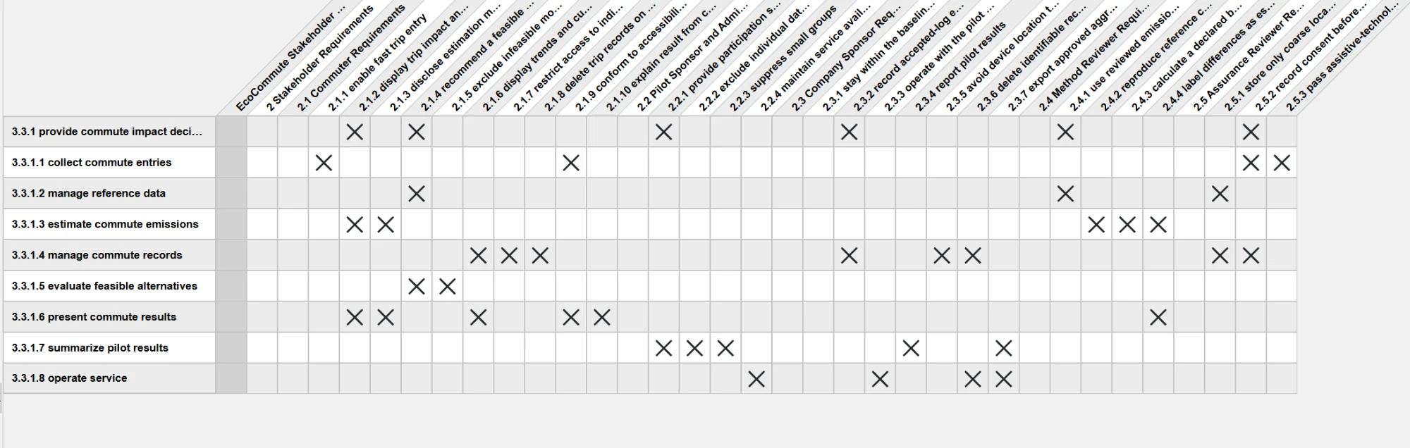
Figure 6. Requirements traceability matrix from Innoslate: functional requirements (rows) traced from stakeholder requirements (columns).
Figures 7 to 10 show the requirements diagram exported from Innoslate, one figure per group so that each can be read: 3.1 Input/Output Requirements, 3.2 External Interface Requirements, 3.3 Functional Requirements and 3.4 System-wide Requirements. In each figure the group is at the top and its requirements are below it. Each requirement is drawn with its text, and the model elements that satisfy it (the input/output, the conduit, the external asset and the function F.2 or the first-level function) and the stakeholder requirements it is traced from are shown at the bottom. Together they show that every system requirement is part of the hierarchy and is satisfied by a model element.
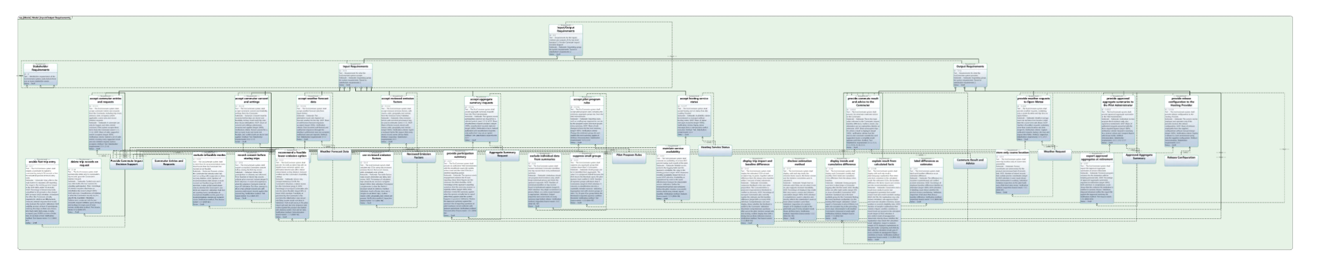
Figure 7. Requirements diagram from Innoslate: group 3.1 Input/Output Requirements.
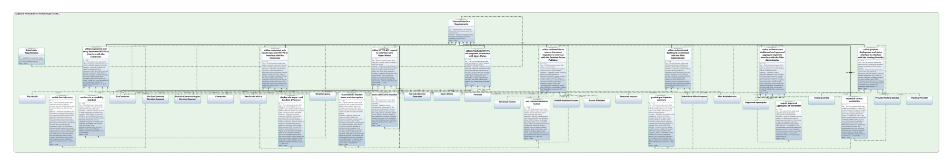
Figure 8. Requirements diagram from Innoslate: group 3.2 External Interface Requirements.
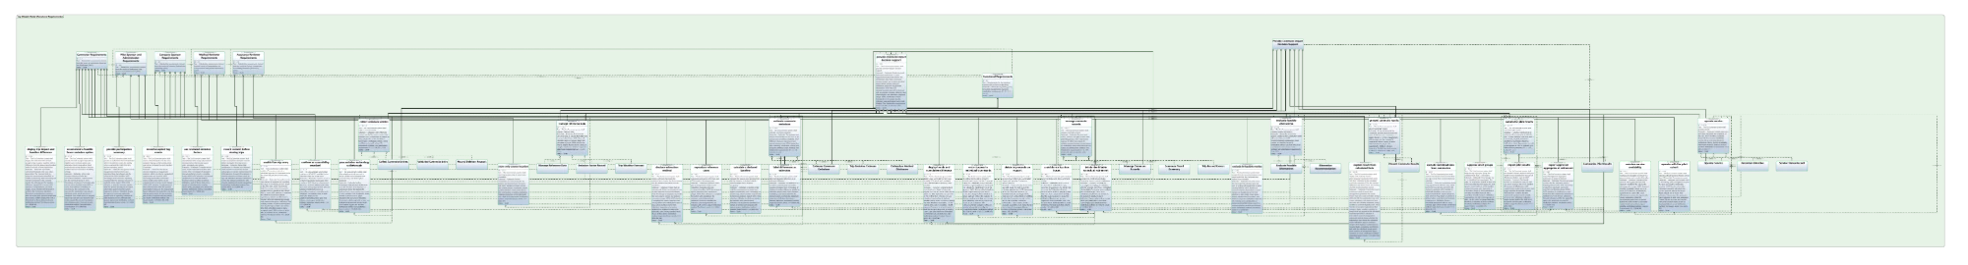
Figure 9. Requirements diagram from Innoslate: group 3.3 Functional Requirements.
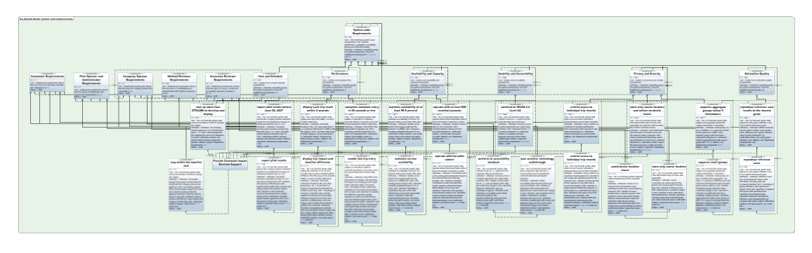
Figure 10. Requirements diagram from Innoslate: group 3.4 System-wide Requirements.

5.3 System requirements spider diagrams
The spider diagram in Figure 11 is centered on the top-level functional requirement 3.3.1. It shows that 3.3.1 is satisfied by the top-level function F.2, decomposes into the eight leaf-level functional requirements, sits in group 3.3, and is traced from six stakeholder requirements spanning the commuter, sponsor, method and assurance stakeholders. The diagram in Figure 12 is centered on F.2 and relates form to function to requirement: the mechanism C.0 performs F.2, F.2 decomposes the Metafunction and is decomposed by F.2.0 to F.2.7, and F.2 satisfies 31 system requirements (a sample is shown).
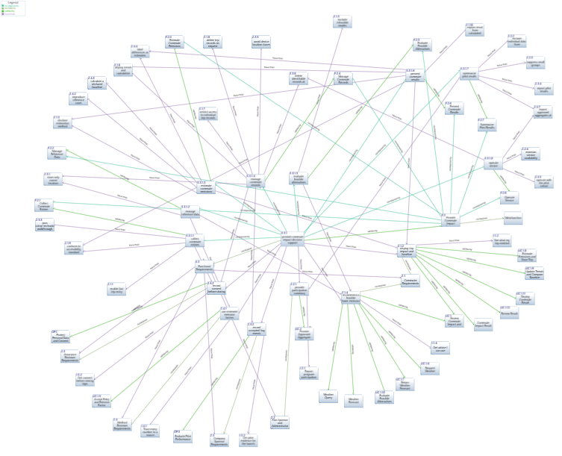
Figure 11. Spider diagram of the top-level functional requirement 3.3.1.
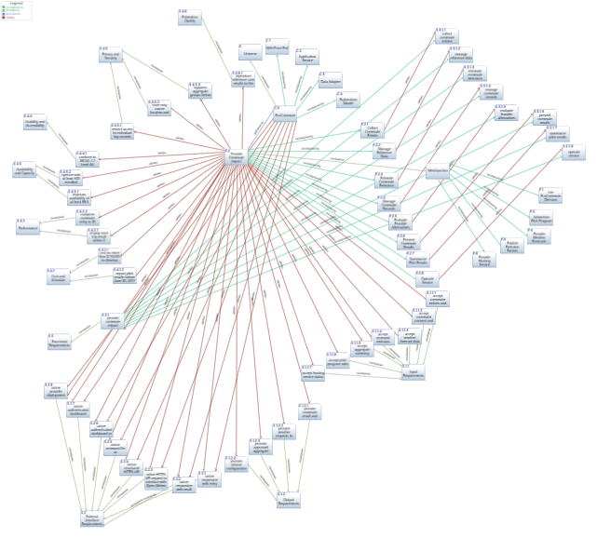
Figure 12. Spider diagram of the top-level function F.2 showing mechanism, decomposition and satisfied requirements.

6. Major Risks

6.1 Potential technical risks
The risks below are technical risks to meeting the first set of system requirements. Likelihood (L) and consequence (C) are team estimates on a 0 to 1 scale for ranking only; they are stored in the model as the Probability and Consequence of each Risk entity.
Table 12. Potential technical risks, ranked by likelihood times consequence.
ID | Risk | Description | L / C | Mitigation | Related requirements
TR.1 | Emission factors unreviewed or placeholder | Factors in the walking skeleton are placeholders (version stub-0); estimates cannot be defended without reviewed factors. | 0.5 / 0.8 | Method Reviewer supplies the reviewed factor table before pilot readiness; version is shown with every result. | 3.1.1.4, 3.4.6.1, 3.3.1.2
TR.3 | Recommendation rule not validated | The under-3-km and no-rain threshold is unvalidated and occupancy is not handled, so advice may be infeasible or unfair. | 0.5 / 0.5 | Product Lead and Method Reviewers validate thresholds in the pilot; rule changes are version-controlled. | 3.3.1.5, 3.3.1.3
TR.6 | Accessibility conformance unproven | There is no web UI yet; WCAG 2.2 AA and keyboard and screen-reader completion are not demonstrated. | 0.4 / 0.6 | Build to WCAG from the first UI increment and audit before pilot readiness. | 3.4.4.1, 3.3.1.1
TR.4 | Explanation states unsupported facts | A language-model explanation could state figures, conditions or modes not in the calculated result and overclaim savings. | 0.3 / 0.7 | C.4 receives only calculated facts and uses a constrained template; inspect 50 explanations before release. | 3.3.1.6, 3.1.2.1
TR.7 | Availability and capacity depend on hosting | 99.5% monthly availability and 500 accounts depend on an external Hosting Provider and are unproven. | 0.3 / 0.7 | Select hosting with a matching service level, monitor each minute and load test at 500 accounts. | 3.4.3.1, 3.4.3.2, 3.3.1.8
TR.2 | Forecast service outage or latency | Open-Meteo is external. An outage or slow reply can break the 3-second display requirement or the weather-dependent advice. | 0.4 / 0.5 | Set a forecast timeout and show the result without the weather-dependent alternative, saying so (off-nominal path to be modeled, repo item O-5). | 3.1.1.3, 3.4.2.1, 3.3.1.5
TR.5 | Re-identification through aggregates | Small groups or coarse location combined with other data could reveal an individual. | 0.2 / 0.9 | Suppress groups under 5, exclude identifiers, review privacy risk with Assurance Reviewers. | 3.4.5.3, 3.4.5.2, 3.3.1.7
TR.8 | Cost exceeds the $750,000 baseline | Hosting, language-model use and accessibility work may exceed the approved baseline. | 0.3 / 0.6 | Track cost monthly against the baseline and hold scope to manual logging and coarse location. | 3.4.1.1
TR.9 | First-level functions do not map one to one to components | Eight first-level functions map to four components C.1-C.4, which can blur ownership at Architecture Definition. | 0.4 / 0.4 | Allocate functions to mechanisms explicitly in the next chapter and add modules where a function needs one. | 3.3.1

7. Summary
We defined 14 functions: six top-level functions on the Metafunction (one for the SoI and five for the external assets) and eight first-level functions that decompose the SoI function F.2. They cover every system-performed action in the OpsCon. We drew the IDEF0-A0 diagram of F.2 and the first-level IDEF0 with 22 input/outputs, none of which is a tunnel. From the first-level architecture we drafted 39 system requirements: one top-level functional requirement with eight children, eleven input/output requirements, eight external interface requirements and eleven system-wide requirements. Each has a rationale, a measure, verification or validation criteria and a trace to the stakeholder requirements, and each is satisfied by a function, input/output or conduit in the model. Nine technical risks are recorded with mitigations.
Next steps: (1) allocate first-level functions to mechanisms and resolve risk TR.9; (2) edit the generated requirement statements and set quantitative MOP values in the next chapter; (3) confirm the 3-second and group-size-5 values with the sponsor; (4) model off-nominal paths; (5) write requirement-driven tests for the product build.

Appendix A. Model Assessment Check
Self-assessment against the IDEF Model Assessment Criteria and the System Requirements Definition Innoslate Model Assessment Criteria.
Criterion | Status and evidence
IDEF0-A0 includes all ICOM entities with naming conventions | Met. F.2 has 4 inputs, 3 controls, 4 outputs and mechanism C.0 (Table 3).
All functions have verb-oriented names | Met. For example Provide Commute Impact Decision Support, Collect Commute Entries.
Functions are numbered with a clear convention | Met. F.1 to F.6; F.2.0 to F.2.7.
All input/outputs have noun-oriented names | Met. For example Weather Request, Trip Emission Estimate.
Every input/output has a source and destination function | Met in the model: each IO is generated by one function and received by one or more.
Each function has appropriate input/outputs | Met (Tables 2 and 4).
Internal interactions give continuity for the use cases | Met. UC.1, UC.2 and OP actions are traced through Section 2.4.
Each Metafunction function box has exactly one mechanism from the Universe hierarchy | Met. X.1, C.0, X.2, X.3, X.4 and X.5, one each.
Diagram content is legible | Figures use landscape pages.
Each requirement has a name, number and description | Met for all 52 requirement entities.
Each requirement is in the hierarchy by decomposes | Met. Root 3 decomposed by groups, groups by requirements.
Input/output requirements are satisfied by one input/output and the top-level function | Met (3.1.1.x, 3.1.2.x).
External interface requirements are satisfied by the top-level function | Met (3.2.x); also by their conduit and assets.
Top-level functional requirement is satisfied by the top-level function | Met. 3.3.1 satisfied by F.2.
System-wide requirements are satisfied by the top-level function | Met (3.4.x).
Requirements are organized in a Document | Met. Requirement group 3 and its descendants.
Requirement statements are properly written | Written as single 'shall' sentences with testable thresholds; to be confirmed in the team review.
System requirement diagrams created | Met. Figures 5 to 12.
Top-level system requirements traced to top-level stakeholder requirements | Met. Group 3 traced from 2; groups 3.3 and 3.4 from 2.1 to 2.5.
System requirements RVTM created | Met. Table 11.
Innoslate Intelligence analysis | Run on the imported model: overall pass rate 81%, no errors, warnings only (Figure 13). Remaining warnings are expected at this stage, for example first-level functions not yet allocated to mechanisms, which the lab defers.

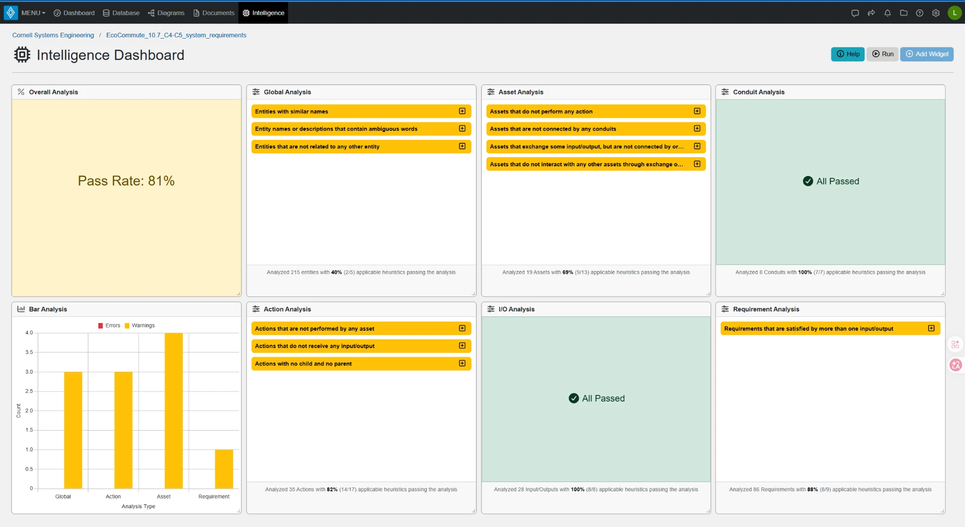
Figure 13. Innoslate Intelligence dashboard for the model: overall pass rate 81%, no errors.

