**Contents**

1. Device Configuration 2

1.1. Windows 10 IoT Core Dashboard 2

1.1.1. Installing Windows 10 IoT Core dashboard 2

1.1.2. Set up a new device 3

1.2. Raspberry PI Configuration 7

1.2.1. My devices 7

1.2.2. Login to Device portal 10

1.3. Clone the code 13

1.4. Creating the Edison.Devices.Onboarding package 15

1.5. Installing the Edison.Devices.Onboarding package in Device Portal 20

1.5.1. Check the WIFI Network 24

1.5.2. Generate QR Code 24

1.6. Admin Mobile Application 25

# Device Configuration

Need IoT Core Dashboard to upload a new firmware.

## Windows 10 IoT Core Dashboard

Windows 10 IoT Core Dashboard is the best way to download, set up and connect your Windows 10 IoT Core devices.

Download IoT Core Dashboard from the below link.

<go.microsoft.com/fwlink/?LinkID=708576>

### Installing Windows 10 IoT Core dashboard

Double click on the downloaded **setup.exe** icon to install the windows 10 IoT Core dashboard.

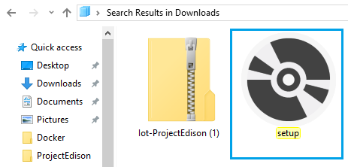

Then click **Install** to continue to install Windows 10 IoT Core Dashboard.

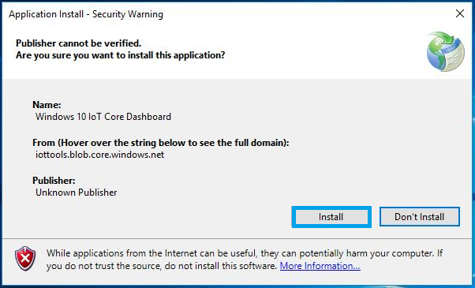

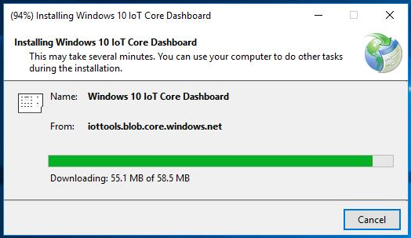

### Set up a new device

The IoT Dashboard makes it easy to set up a new device.

**Note:** Please insert the SD card into your computer to download and install the Software.

Click **Set up a new device.**

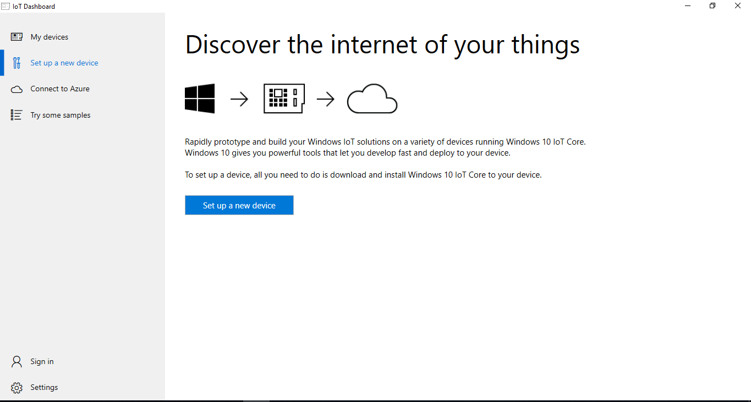

Click **Sign in with Microsoft.**

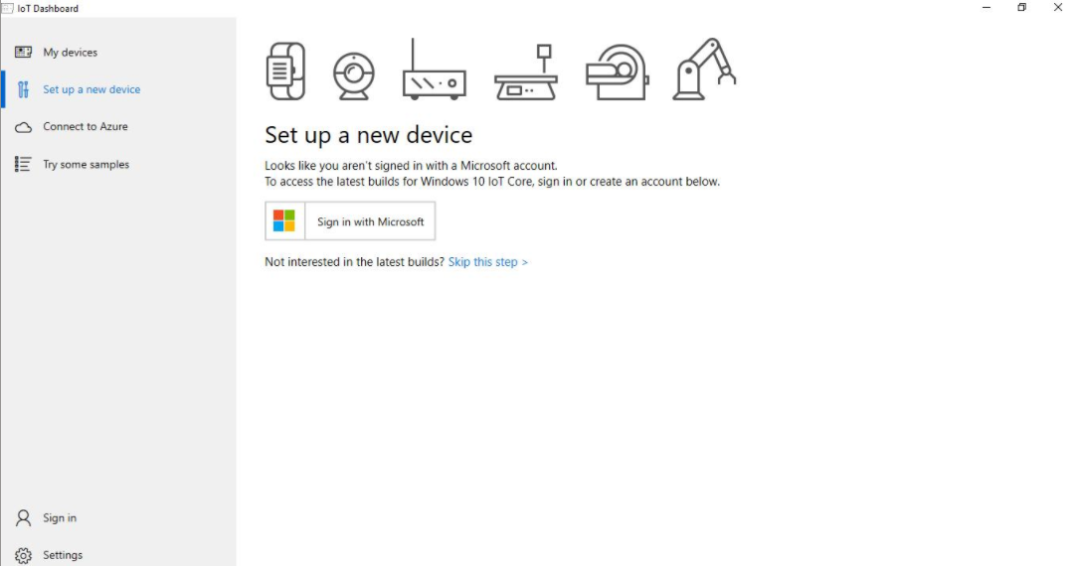

Enter your Microsoft account credentials to login.

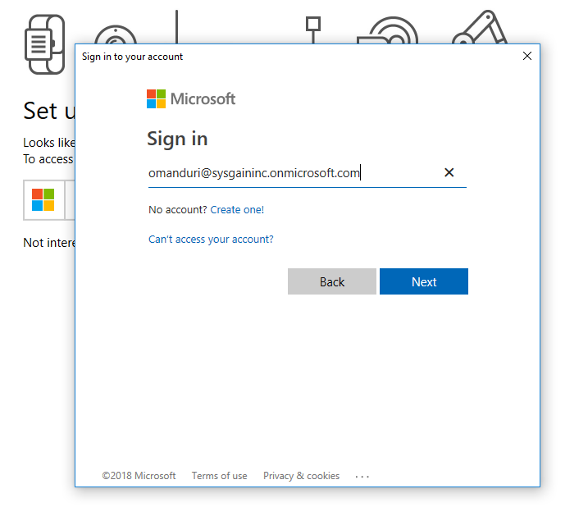

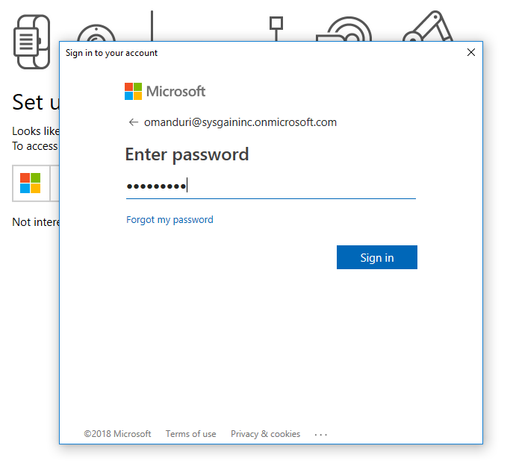

Enter the below required fields to download and install the software.

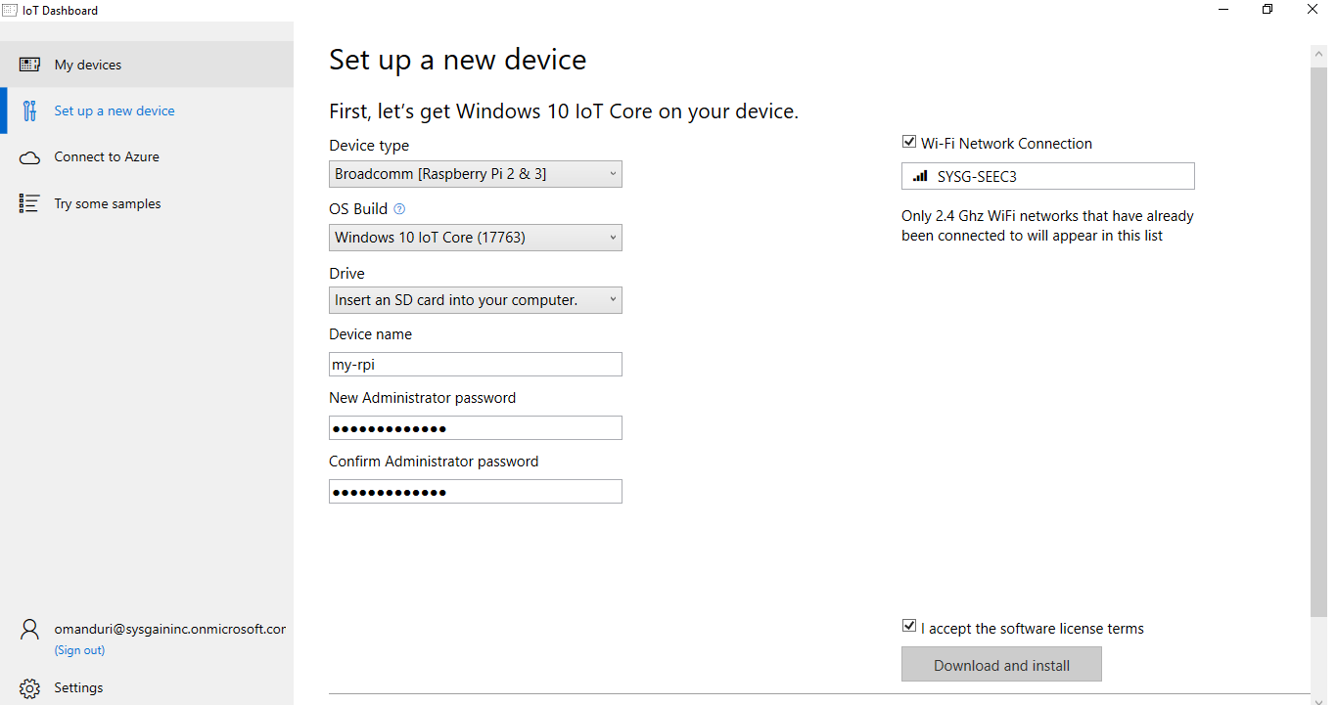

After Successful installation of the software, Remove the SD Card from your Computer and place it in the Rasp berry PI.

## Raspberry PI Configuration

To configure Raspberry PI we require **Mouse**, **Key board**, **Monitor** and **power cable**. Which need to be connected in their respective ports of Raspberry PI.

Setup the WIFI network while configuring the Raspberry PI.

**Note:** Connect to the same WIFI Network used to Configure Raspberry PI for accessing the device which was added to Raspberry PI from Windows 10 IoT Core Dash board.

### My devices

Once the Setup is done navigate to **My devices** in Windows 10 IoT Core Dashboard to check for the connected device.

After your device is connected to the internet, the IoT Dashboard will automatically detect your device.

You can see the connected device in below screen.

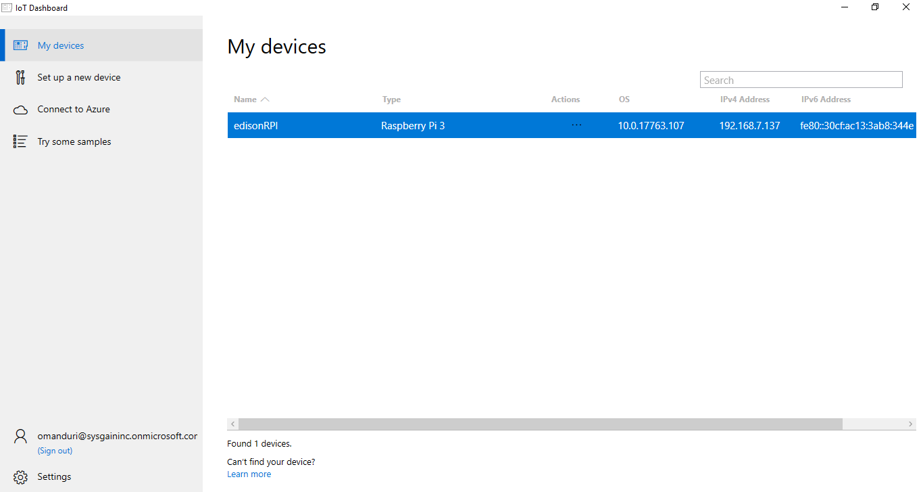

**Note:** If your device is not listed, try rebooting the device. Make sure that if there are more than one devices on the network, they each have a unique name.

Also make sure that your **windows10iotcoredashboard.exe** is allowed to communicate through Windows Firewall by following the steps below:

1. Open **Network and Sharing Center** and then find the type of network (Domain/Private/Public) your PC is connected to.
2. Open **Control Panel** and click **System and Security**.

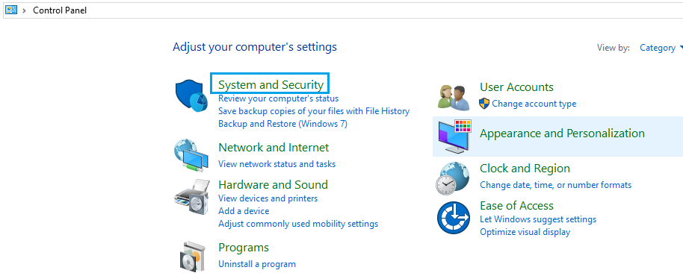

1. Click **Allow an app through Windows Firewall** under **Windows Firewall**.

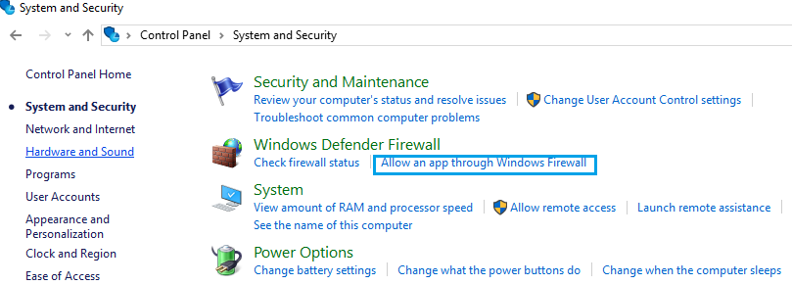

1. Click **Change settings**.

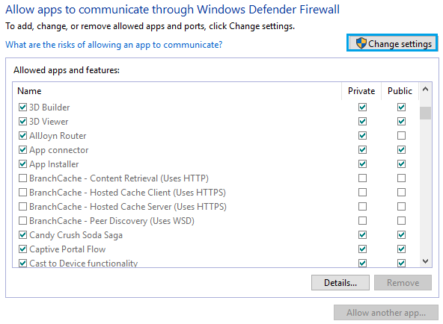

1. Find **windows10iotcoredashboard.exe** in **Allowed apps and features** and then enable the appropriate network check box (i.e. the network type you found in step 1).

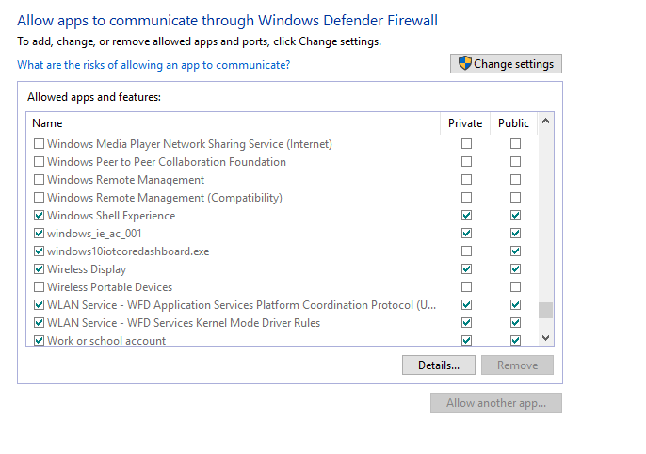

### Login to Device portal

Right click and select **Open in Device Portal**. This will launch the [Windows Device Portal](https://docs.microsoft.com/en-us/windows/iot-core/manage-your-device/deviceportal) page and is the best way to interact and manage your device.

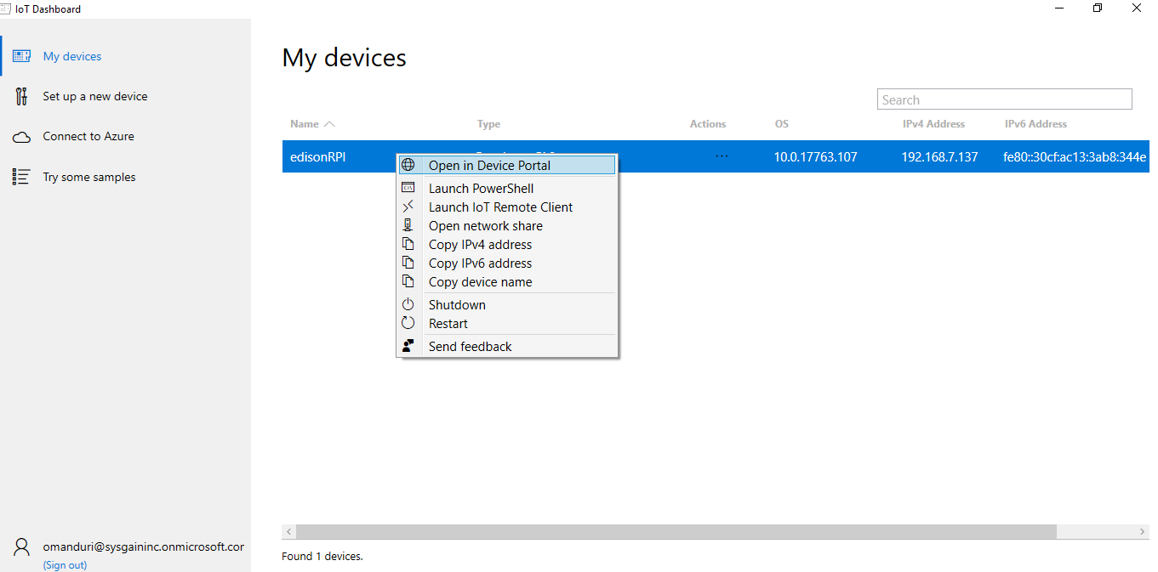

Enter the credentials to login to the windows device portal.

**Username**: Administrator

**Password:** Password@1234

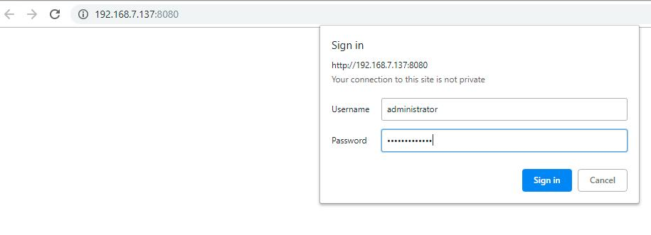

After successful login you are redirected the Windows device portal page.

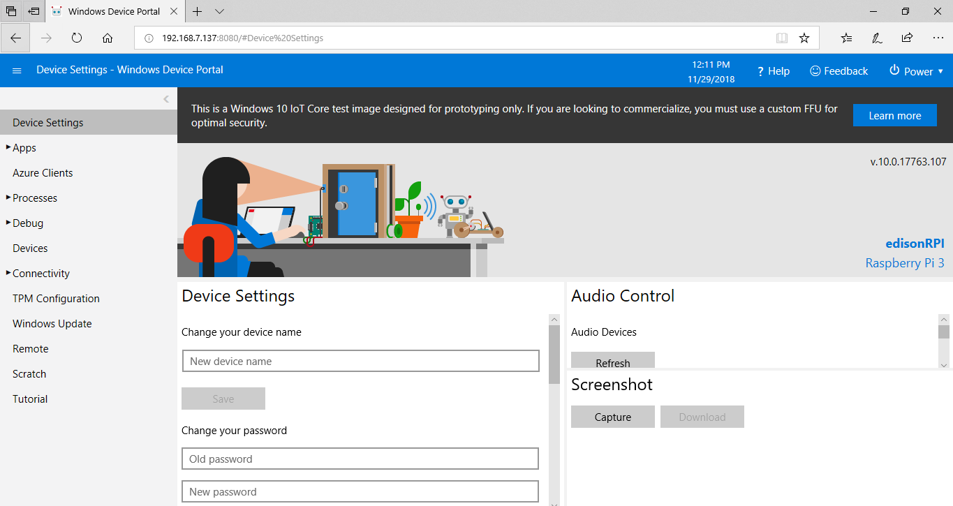

You can change the device password after Login to Windows Device Portal.

Click on **Device Settings** -> enter your old and new Passwords under change your password Section then click **Save.**

Then it will ask you Re-Login to the Windows device portal for confirmation.

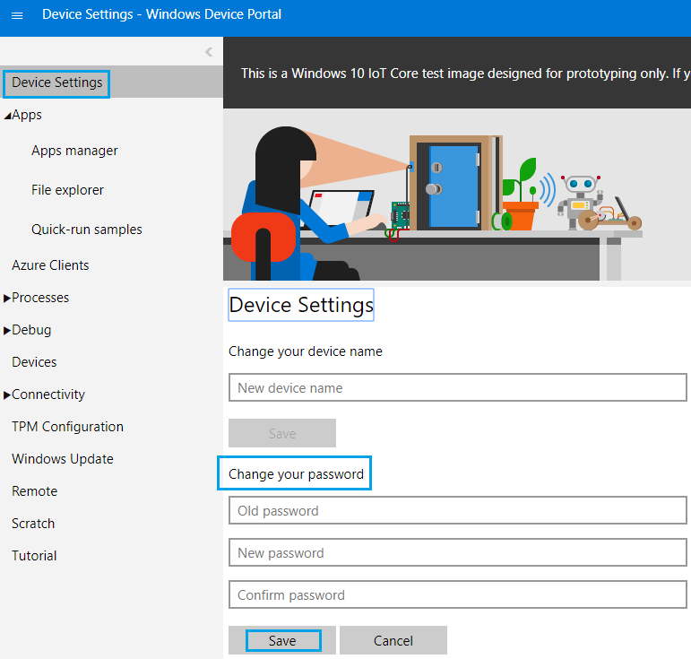

## Clone the code

Open the git bash and clone the repository using below command

Git clone <**url of the repo**>

Take the URL from git hub as like below screen.

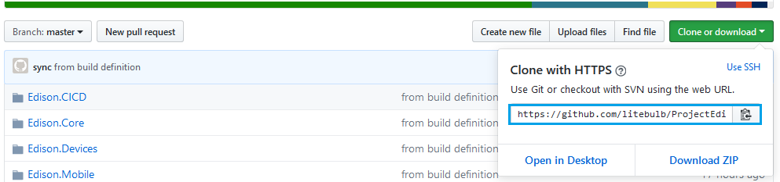

**Ex: git clone** [**https://github.com/litebulb/ProjectEdison.git**](https://github.com/litebulb/ProjectEdison.git)

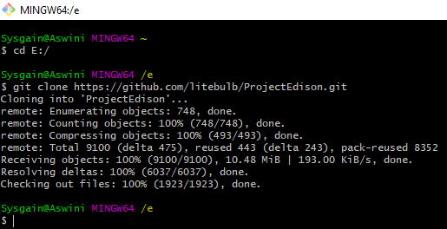

Now open the cloned file and select **Edison.Devices.sln** and open with Visual studio 2017.

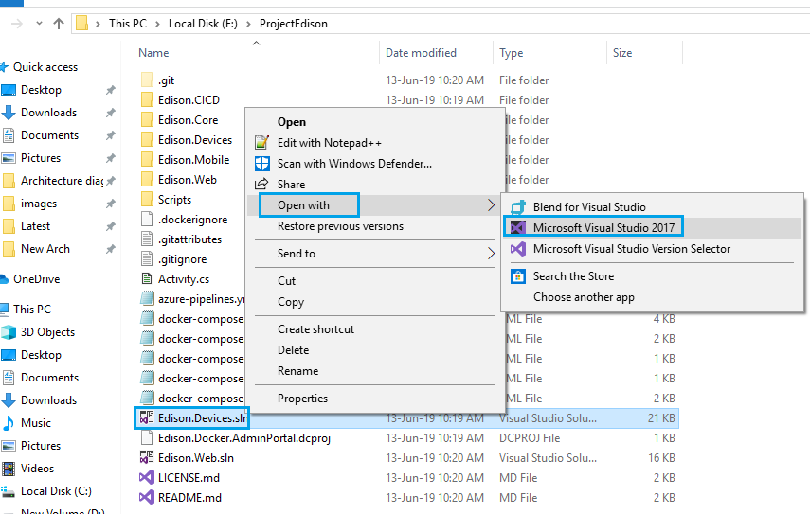

## Creating the Edison.Devices.Onboarding package

Before Creating **Edison.Devices.Onboarding package**, Build the Entire Solution to load the project dependencies.

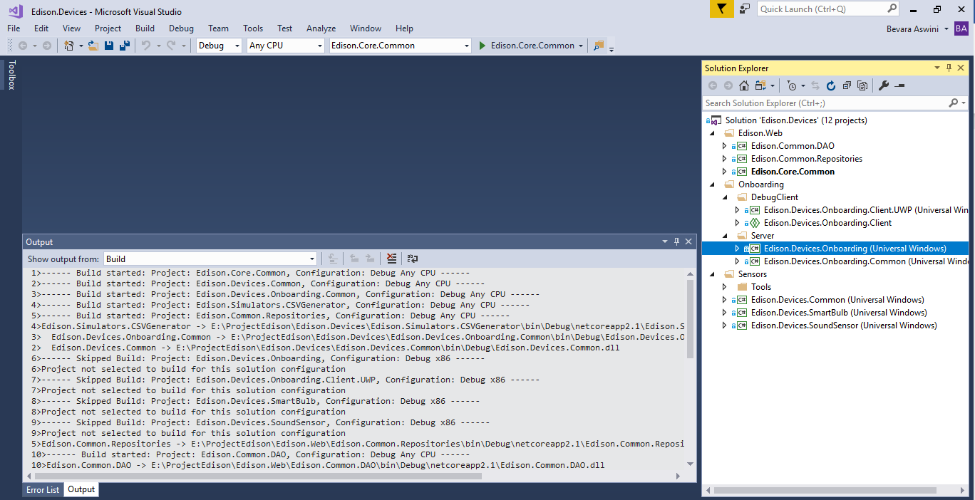

From the Top menu Select Debug, ARM and **Edison.Devices.Onboarding (Universal Windows)** from the drop down list as shown like below screen.

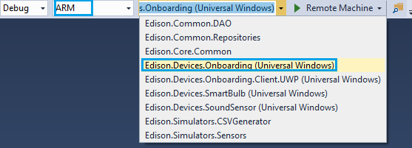

Now select the Edison.Devices.Onboarding (Universal Windows) project to create Onboarding package.

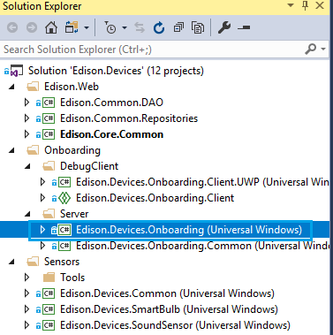

Select Edison.Devices.Onboarding (Universal Windows) project -> Right click –> Store -> Create App Packages.

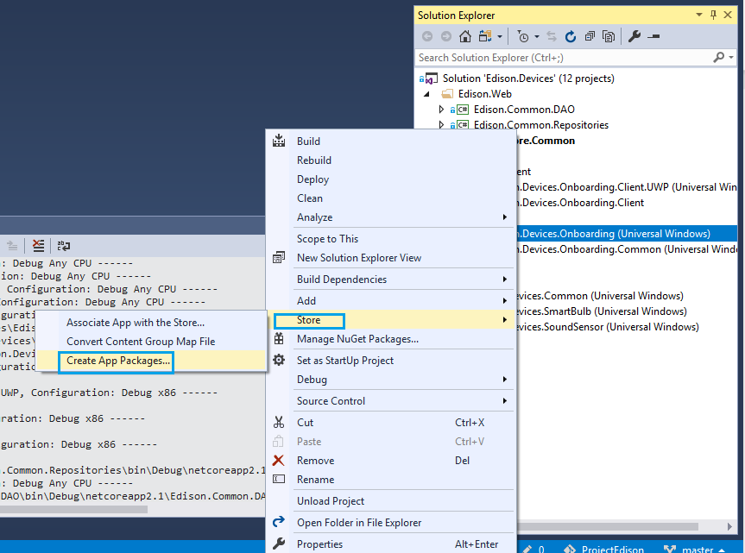

Now choose the **second option (I want to create packages for sideloading)** as shown like below screen then click **Next**.

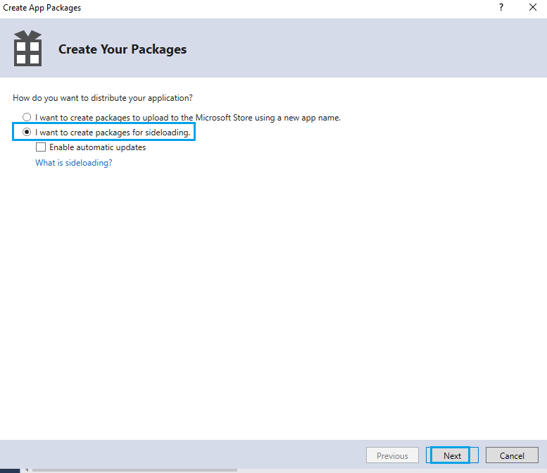

Now browse the **Output location** in which you want to download the package then click **Create**.

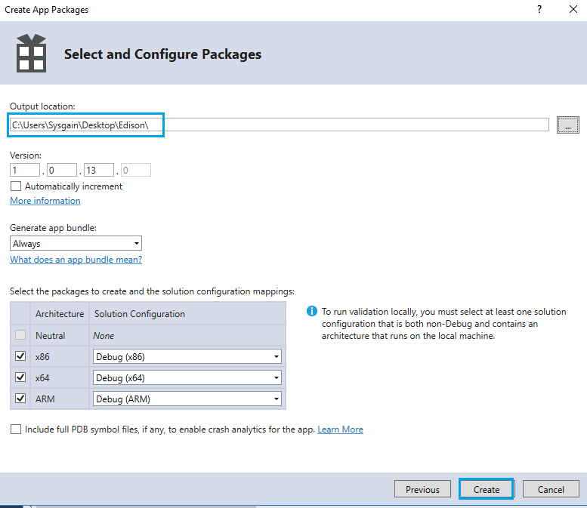

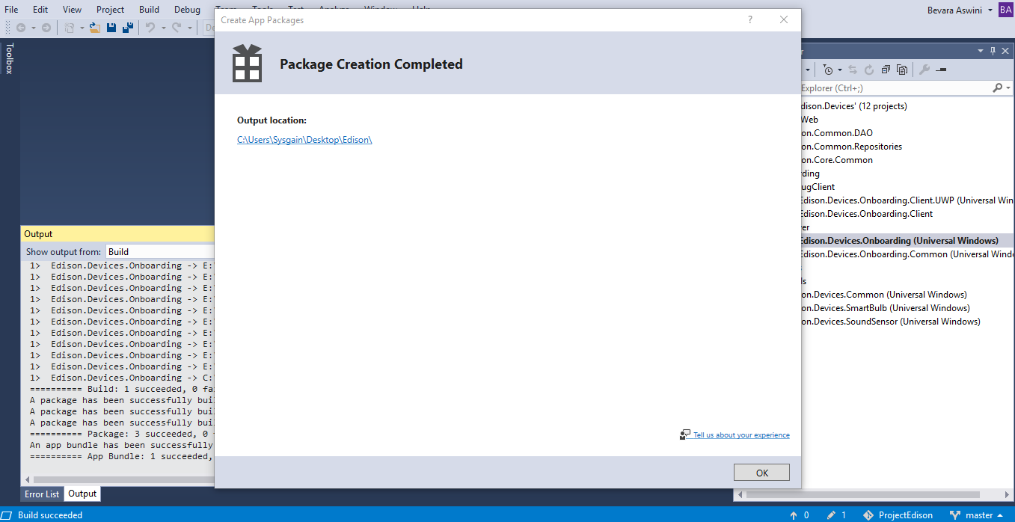

Now go back to Device Portal to upload the Edison.Devices.Onboarding package.

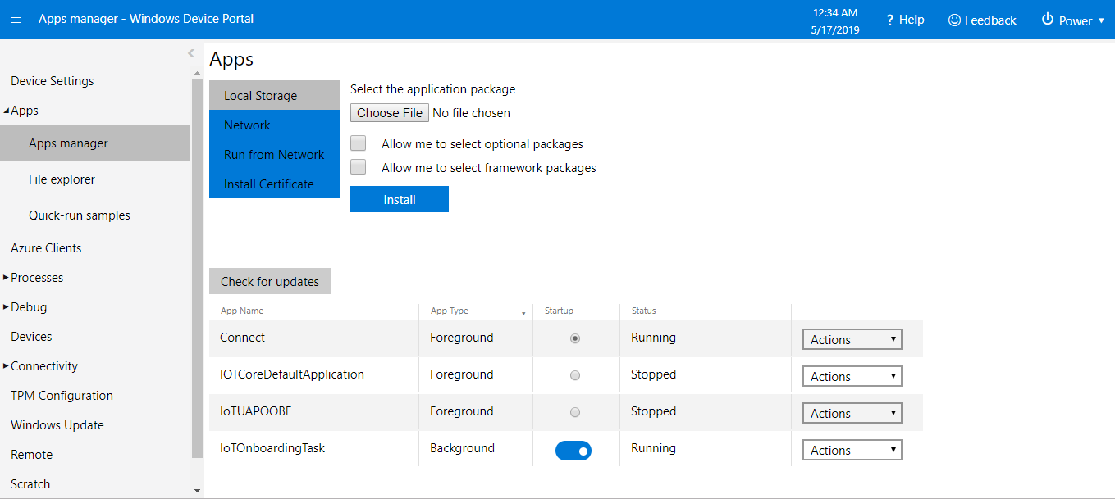

## Installing the Edison.Devices.Onboarding package in Device Portal

Go to **Device Portal** -> **Apps**-> **App manager** -> click **Choose file**

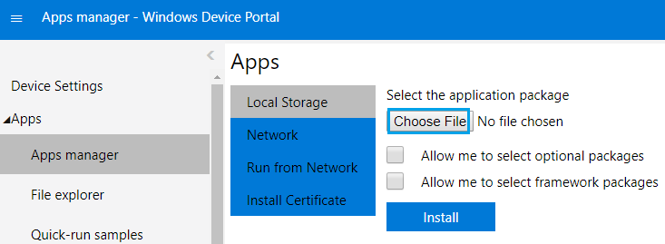

Browse the location where you have downloaded the packages and select **Edison.Devices.Onboarding** file and then click open.

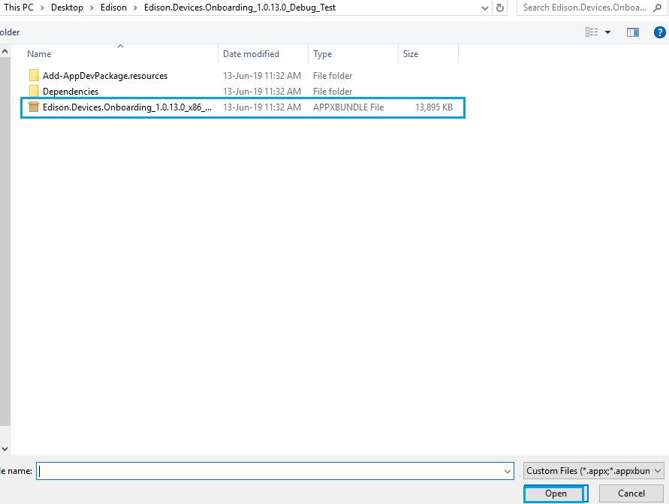

Click **Next**.

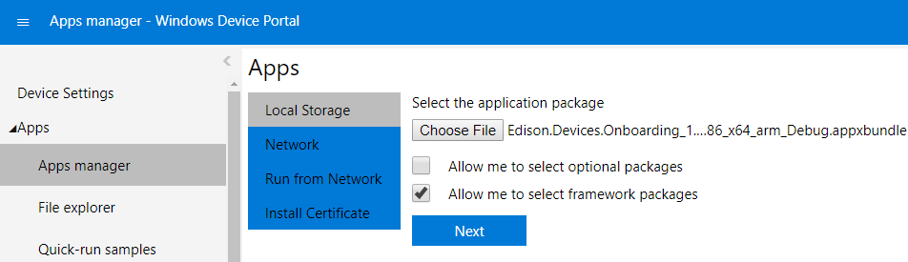

Now click **choose file**.

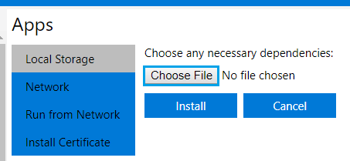

Browse the **Dependencies** -> **arm** -> select below shown files one after one.

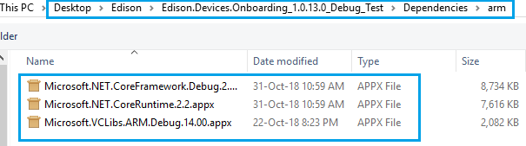

Now click **Install** to install the package.

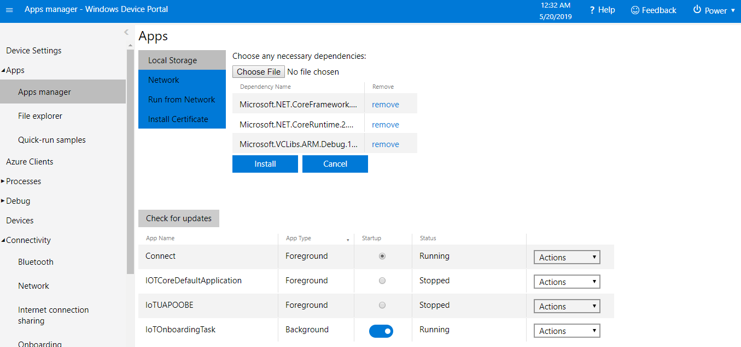

Now you can observe the installed package in Device Portal as shown in below screen.

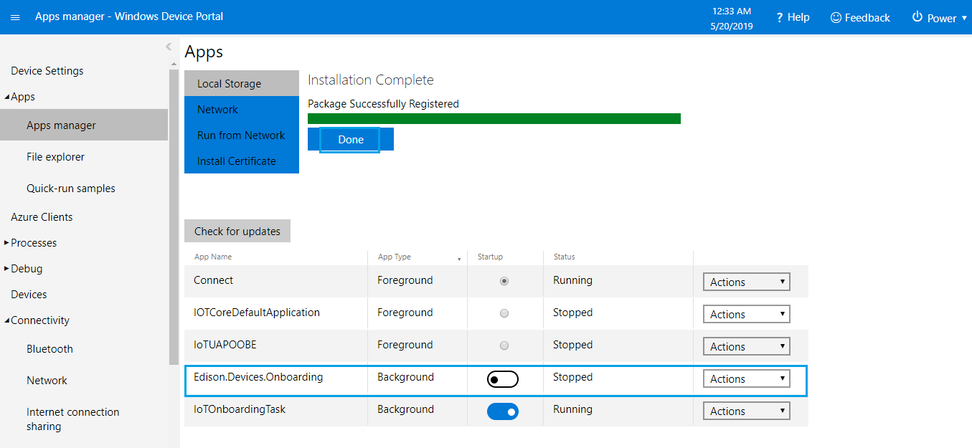

Now **Toggle** the **Stopped** button to **Running** to run the Edison.Devices.Onboarding.

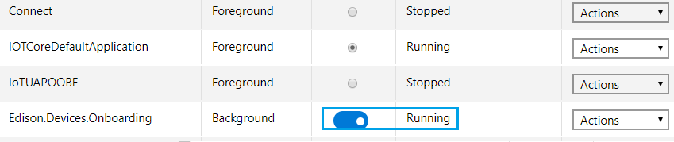

### Check the WIFI Network

Now you can observe the WIFI prefixed with **EDISON_<unique string>** under WIFI Networks.

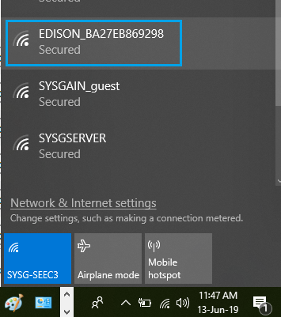

### Generate QR Code

Generate the **QR Code** for the SSID of created WIFI (**EDISON_BA27EB869298**).

Click on below link to open online QR Code Generator.

<https://www.the-qrcode-generator.com/>

Now enter the SSID as shown like below screen and then click **save**.

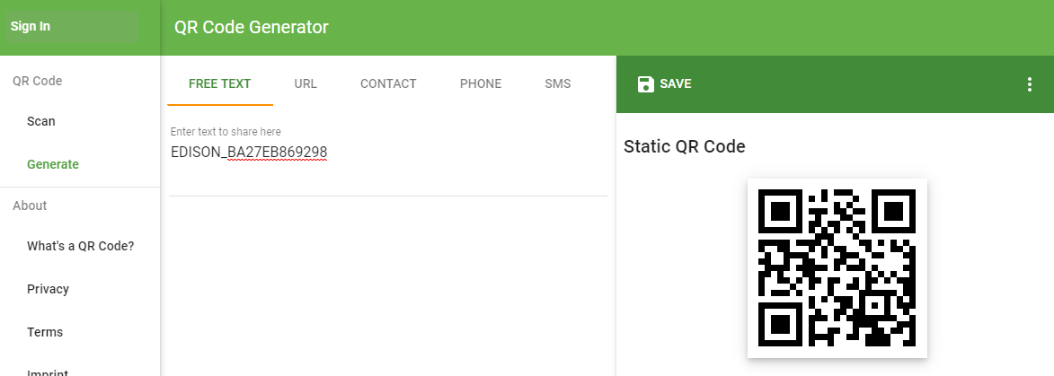

## Admin Mobile Application

Connect to **EDISON_BA27EB869298 WIFI** Network on your Mobile.

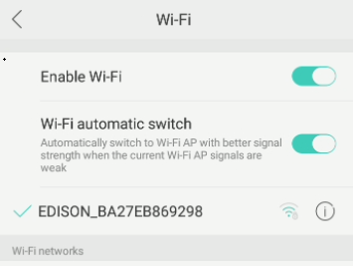

Now Open the Admin Mobile Application installed on your mobile.

**Note:** Refer User Guide documentation for configuring & Installing Admin Mobile application.

Click on **Set Up New Device**.

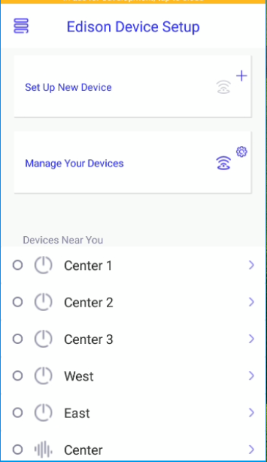

Select the Device type as **Button/Sound Sensor/ Light** then click **Next**.

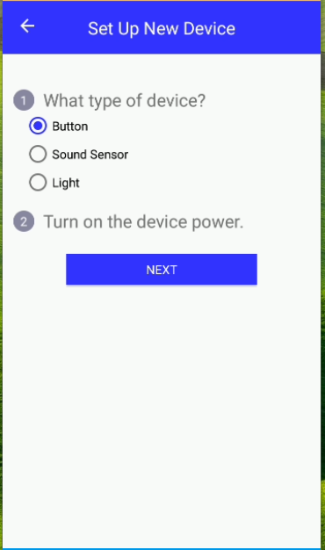

Scan the generated QR code using Admin Mobile application.

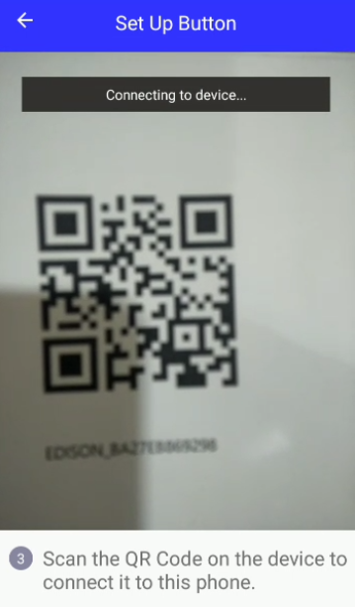

Now Connect back to any WIFI in your Network

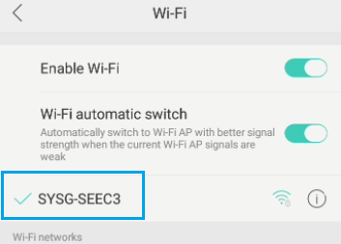

After scanning getting the below error.

