1. Enter your mail to login or create an account to Login.

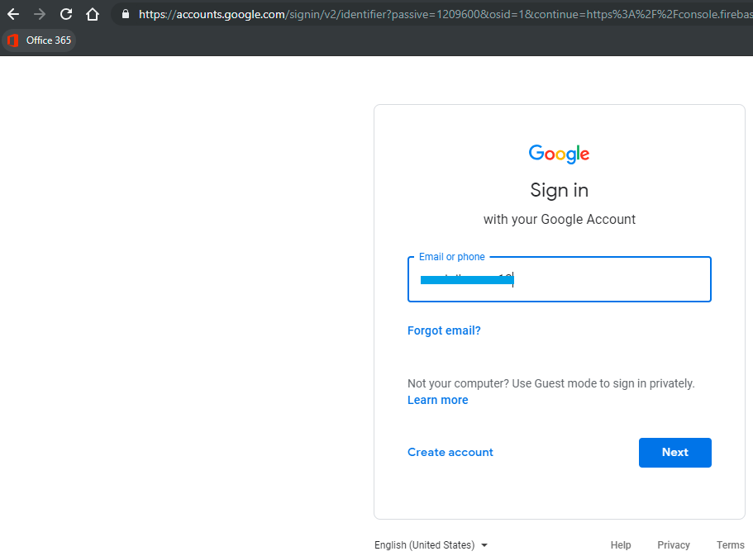

1. Enter your mail password and click Next.

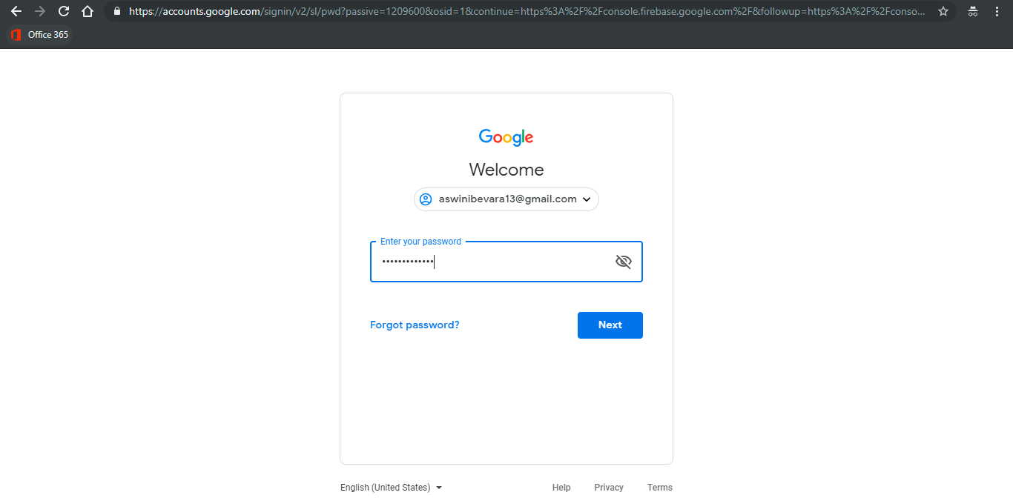

1. Create a new Firebase project if you don't have one. Click **Add project**.

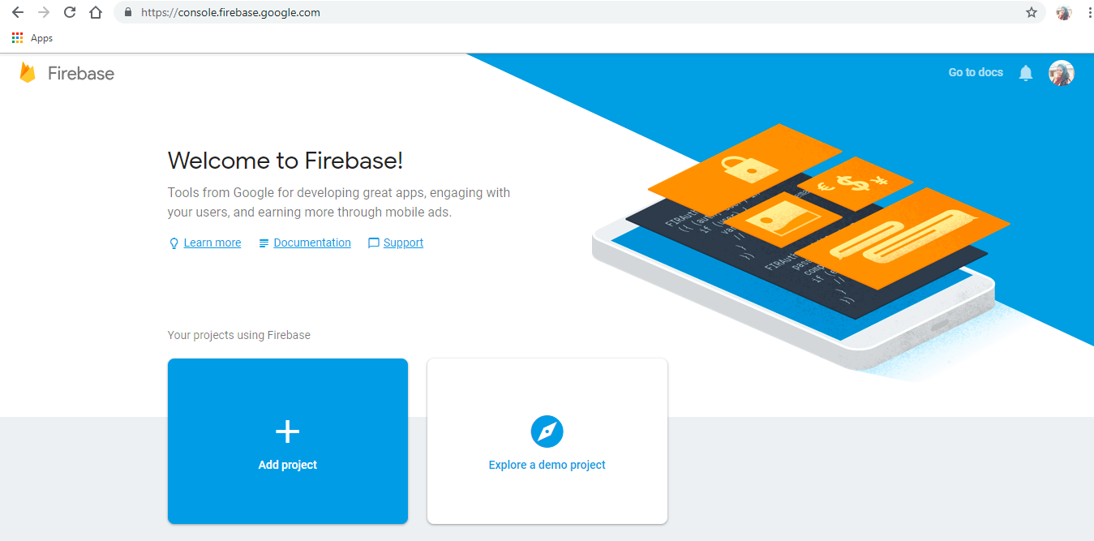

1. Enter **Project name** and check the terms & conditions agreement and click on **Create project**.

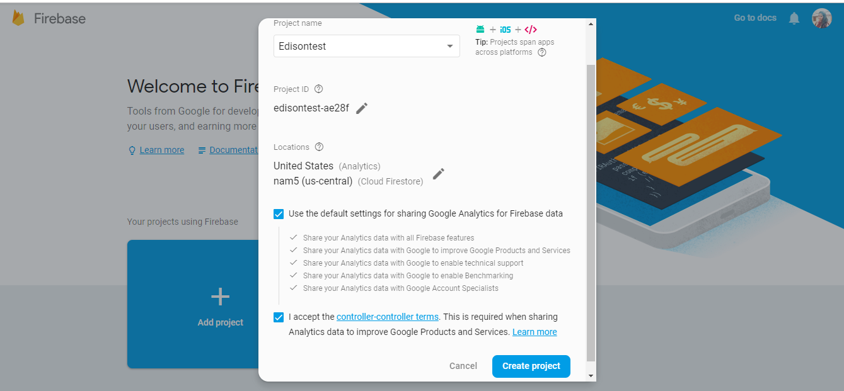

1. Click Continue.

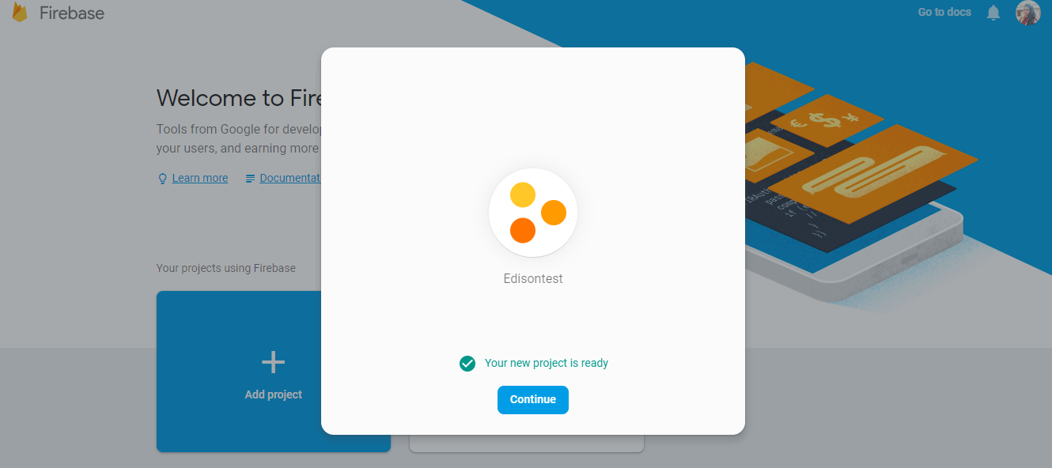

1. After you create your project, select **Add Firebase to your Android app**.

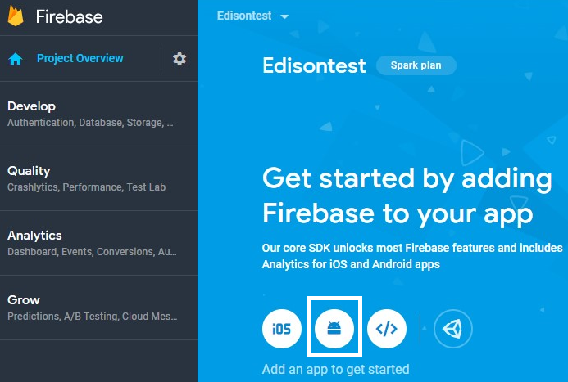

1. Enter android package name and click Register app.

Ex: com.<company name>.<app name>

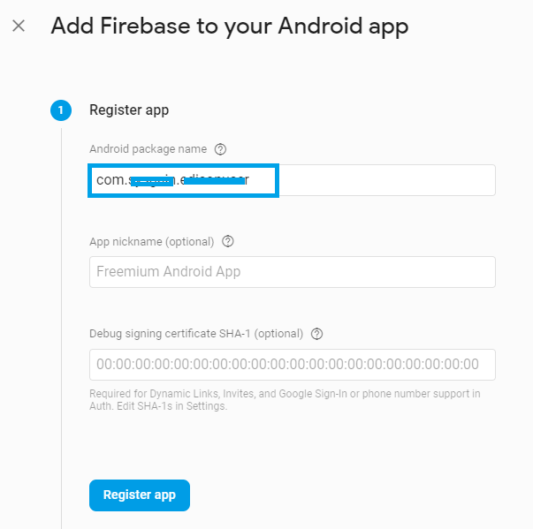

1. Click **Download googl-service.json** and save it in your local machine.

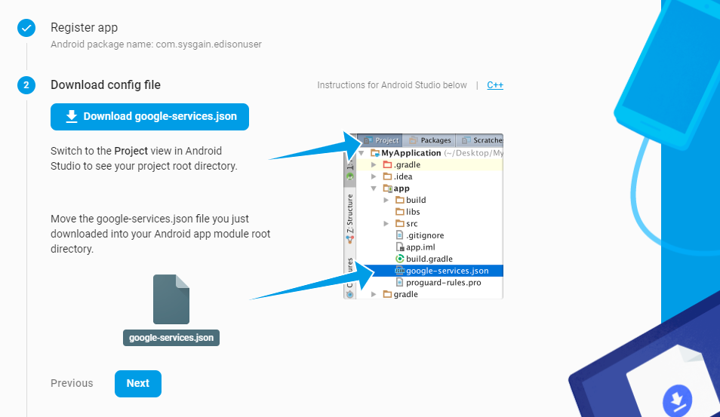

1. Click Next.

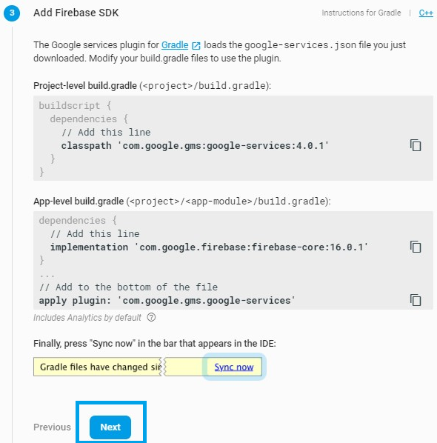

1. Select **Skip this step** on the page.

