1. Open Git Bash and run the below command to clone the Repo into your Remote Machine.

**git clone <git hub repo URL>**

**Ex: git clone** [**https://github.com/<xxxx>/<xxxxxx.git**](https://github.com/%3cxxxx%3e/%3cxxxxxx.git)**>**

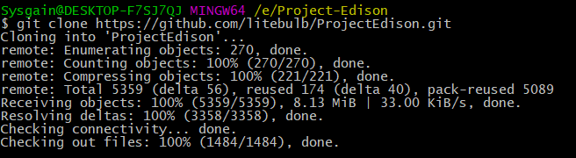

1. Find the solution called **Edison.Devices.sln**

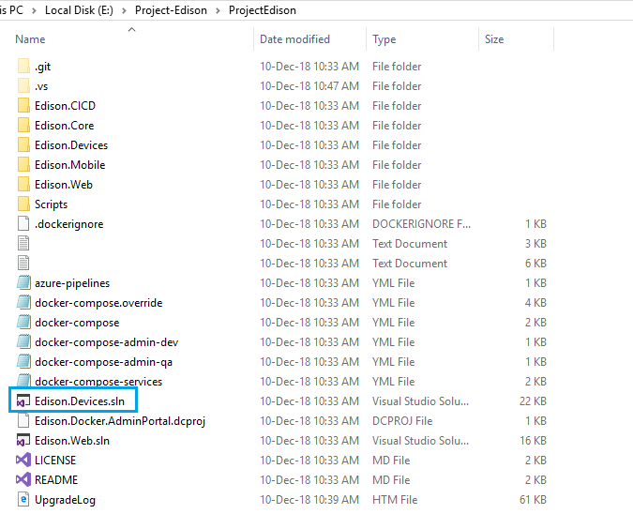

1. **Right** **click** and Open with **Visual studio 2017.**

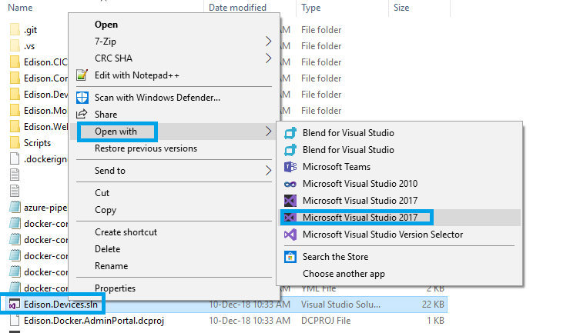

**Note:** Make sure that the **Microsoft.NETCore.App (2.1) SDK** was installed in your Visual Studio 2017.

1. Open appsettings.json from **Edison.Simulators.Sensors** Project**.**

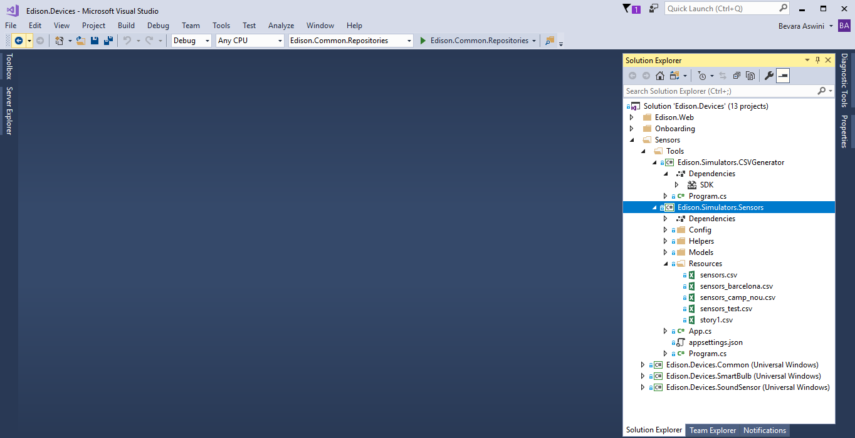

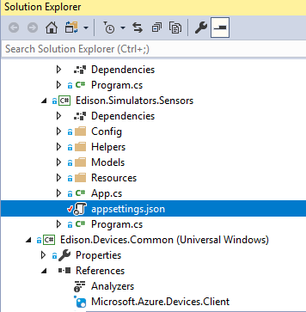

1. Fill in the values of all the necessary keys such as Cosmos DB, Service Bus, Tenant, IoT Hub, Bot details and save it.

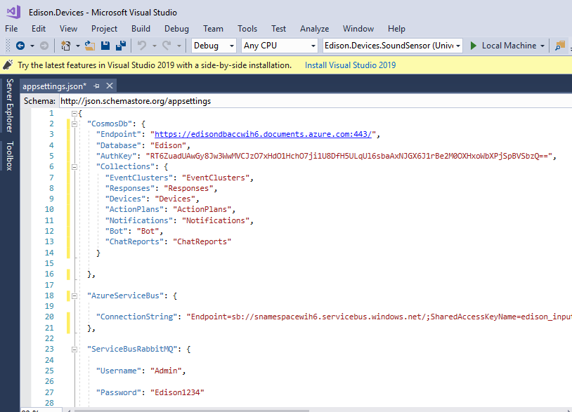

1. Select **Edison.Simulators.Sensor** from dropdown list to run the Simulator as shown in below screen.

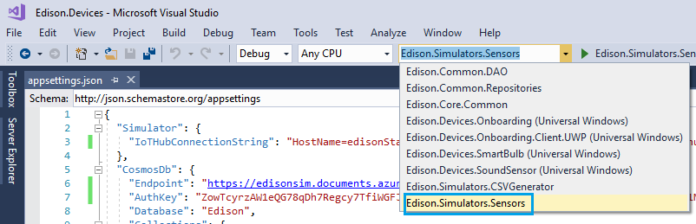

1. Select **Edison.Simulators.Sensors** Project and click **Properties Icon** as shown in below Screen.

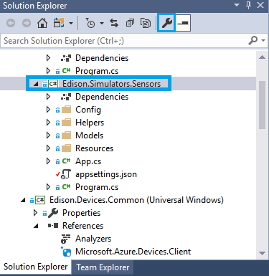

1. Make sure that the **Output type** of the application should be **Console Application,** toopen command promptafter successful built**.**

