# Create an AAD tenant

Follow these steps to create an AAD tenant:

1. Go to the Microsoft Azure portal at http://portal.azure.com.

2. In the upper left column, select Create a resource, and then select Azure Active Directory from the list. If it does not appear in the list, type “Azure Active Directory” in the search window and then select it from the search results.

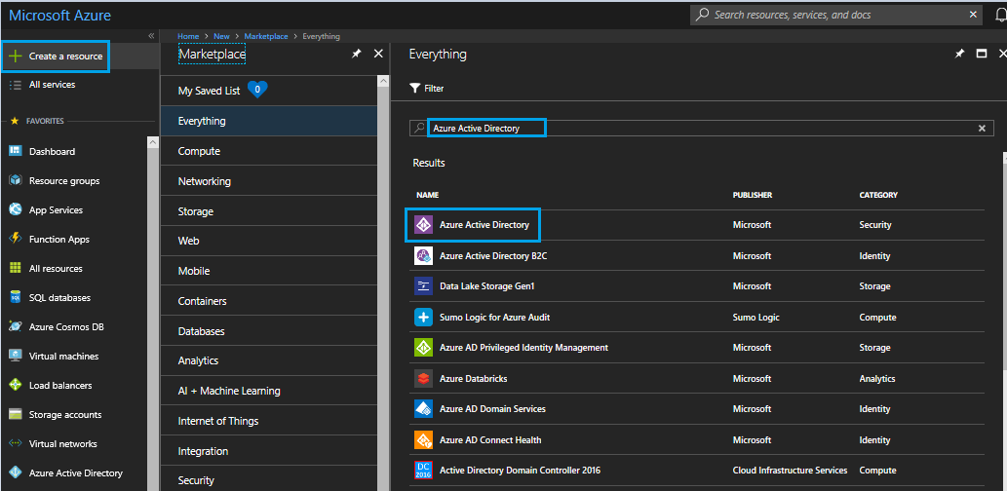

3. At the bottom of the Azure Active Directory pop-up window, select Create.

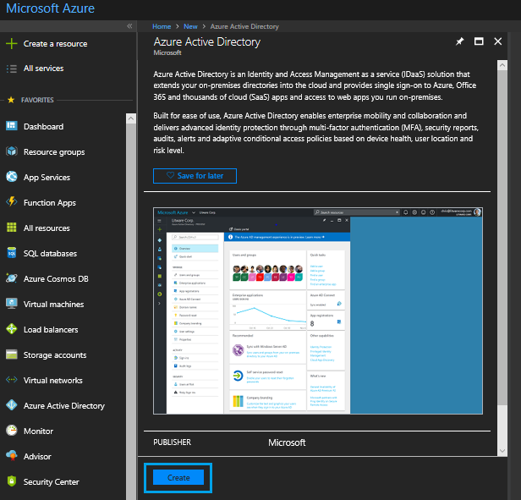

4. In the Create Directory window, set the organization name to a friendly name. The name should start with “SDE” and end with the customer name.

5. Set the initial domain name with “**sde**” as a prefix.

6. Set the country or region to **United States**.

7. Select **Create** at the bottom of the dialog to create the directory. Directory creation typically takes about a minute to complete. To monitor progress, look for a bell icon in the notification area in the upper right of the window.

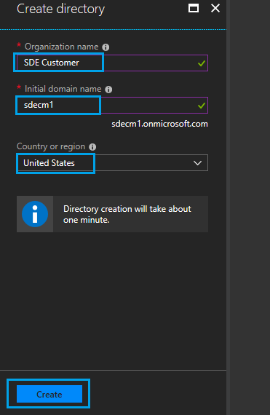

8. When creation is complete, you will see a link to manage your new Azure Active Directory tenant below the Country or region box. Select here to manage the tenant.

9. You can manage the tenant later by selecting the tenant from the Avatar drop down menu in the upper-right corner of window.

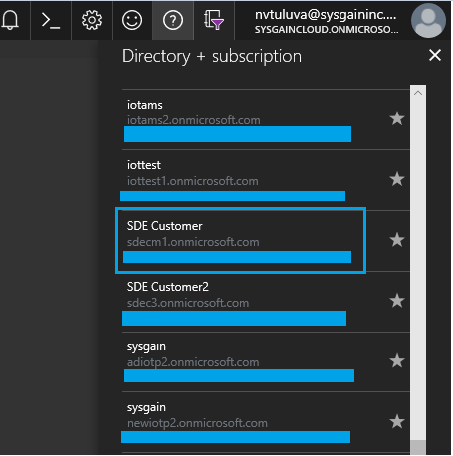

# Create a user account in your tenant

After you create the tenant, you must create a user account in the tenant. To create an account:

1. Go to your **AAD dashboard**, select **Users**, and then click **New user**:

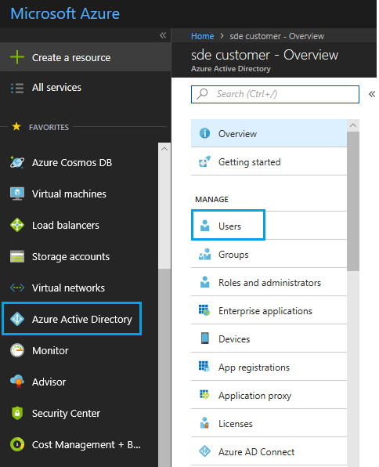

2. Type a name and a user name. We ask that all users within a company share a single user account. Click outside the input boxes to activate the Create button.

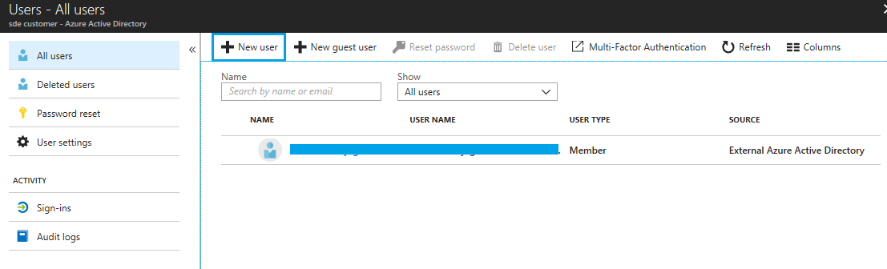

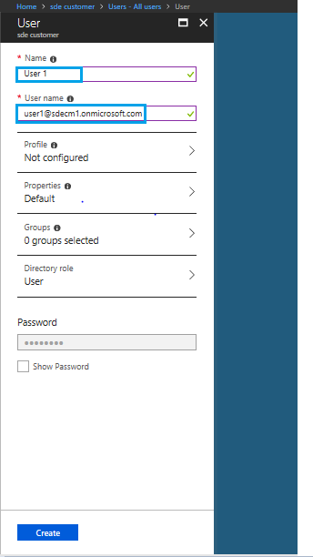

3. The password for the account will be generated automatically. The password must be changed the first time anyone logs in to the account.

Now you can see the user created.

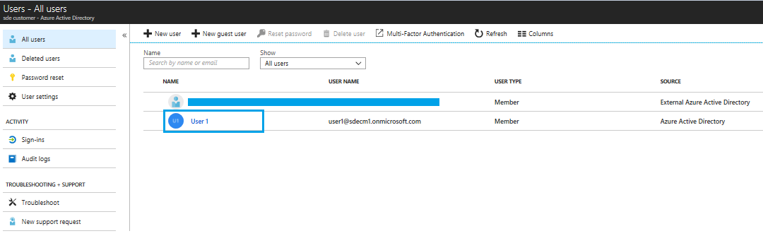

4. Select Properties in the AAD dashboard and record the Directory ID. You will need to supply this information to your Microsoft representative to add your tenant to the Azure Sphere tenant.

# 3. Add your AAD tenant to the Azure Sphere Tenant

Microsoft adds your tenant to the Azure Sphere tenant. To initiate this process:

* If you have an active Engagement with Microsoft in Collaborate, raise a bug titled, “Create Azure Sphere tenant for Organization Name.” Use the same organization name you specified in the Create Directory dialog. In the Description, provide the Directory ID you noted in the previous step.

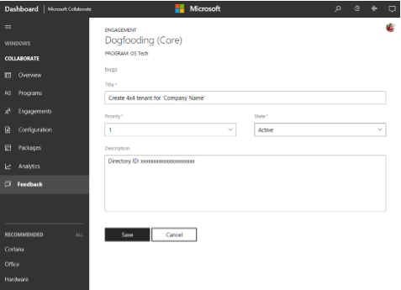

* If you do not have an engagement in Collaborate, email your Microsoft Representative and ask to have your tenant added to the Azure Sphere tenant. Be sure to include the Organization Name you specified in the Create Directory dialog and the Directory ID for your tenant.