# Steps to deploy MSIoT Solution Accelerator

* You will need to install Azure PowerShell and RM module installed on your machine.

Steps to install PowerShell-

<https://docs.microsoft.com/en-us/powershell/azure/install-azurerm-ps?view=azurermps-5.2>.0

* After installing, start PowerShell console or cmd in admin mode.
* You will need an Azure account with subscription.
* Go to location where your PowerShell script file is located (e.g. cd c://powershellscript).
* The script accepts two parameters
  + **ApplicationName**- any unique name (Application name should contain only alphanumeric characters, underscore and hyphen)
  + **Location** - location from the set of locations - ("australiaeast","australiasoutheast","centralindia","centralus","eastasia",

"eastus","eastus2","japaneast","japanwest","northeurope","southindia",

"southeastasia","uksouth","ukwest","westcentralus","westeurope",

"westus","westus2")

* To execute the script type (e.g**.\MSIoTDeploy.ps1 newmsiotdeploy centralus)**

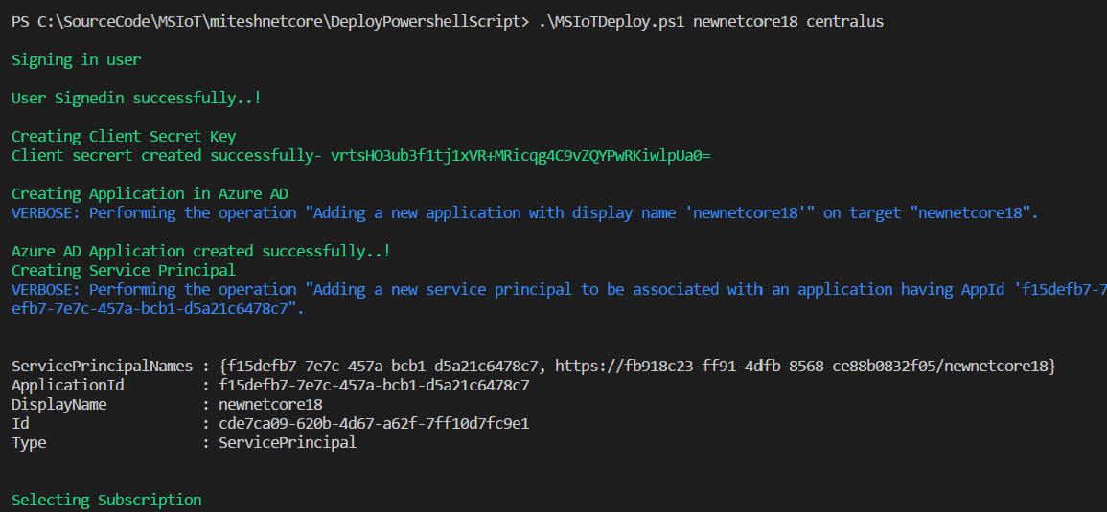

* It will take approximate 3-5 minutes to deploy the entire script.
* After deploying the script, it will open the Datapacket designer link in default browser. Use the same account to login into Data packet designer.

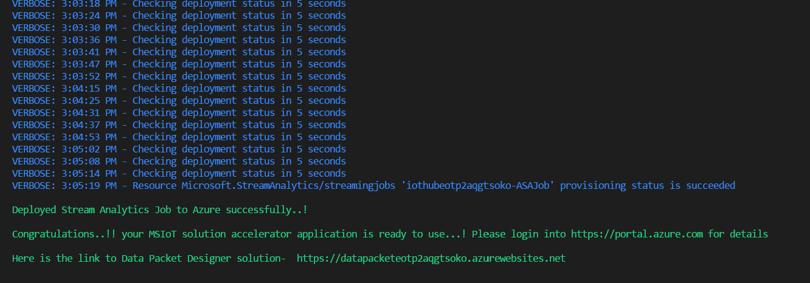

* For best results open the link in Edge/chrome.
* You can also verify the deployed solution by login into Azure Portal <https://portal.azure.com>
* The resource group with your application name will be created.
* The deployed resources will be-
  + DataPacketdesigner App Service
  + App Service plan
  + IoT hub
  + CosmosDb
  + Stream Analytics Job.

