**MarkLogic Deployment Architecture**

**High level architecture diagram for MarkLogic deployment (with 3 nodes) with external load balancer**

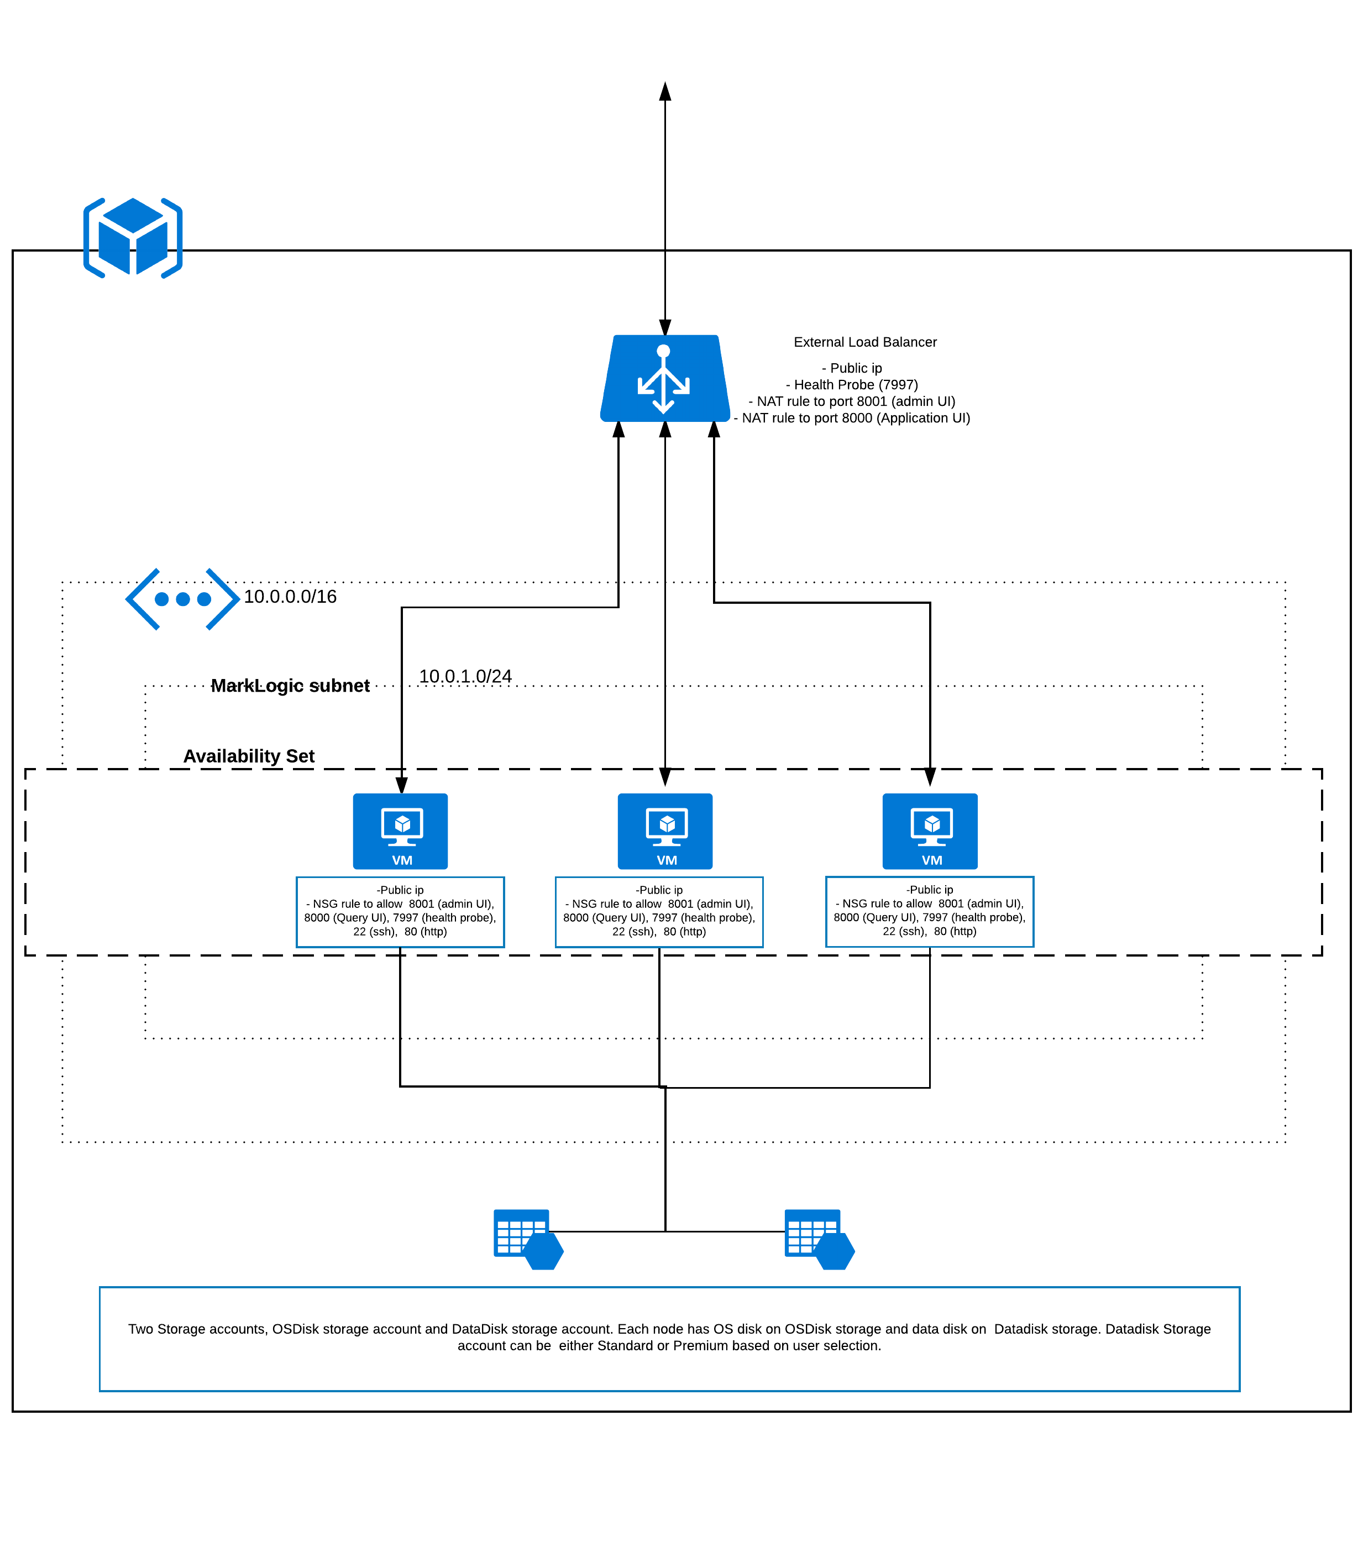

**High level architecture diagram for MarkLogic deployment (with 3 nodes) with internal load balancer**

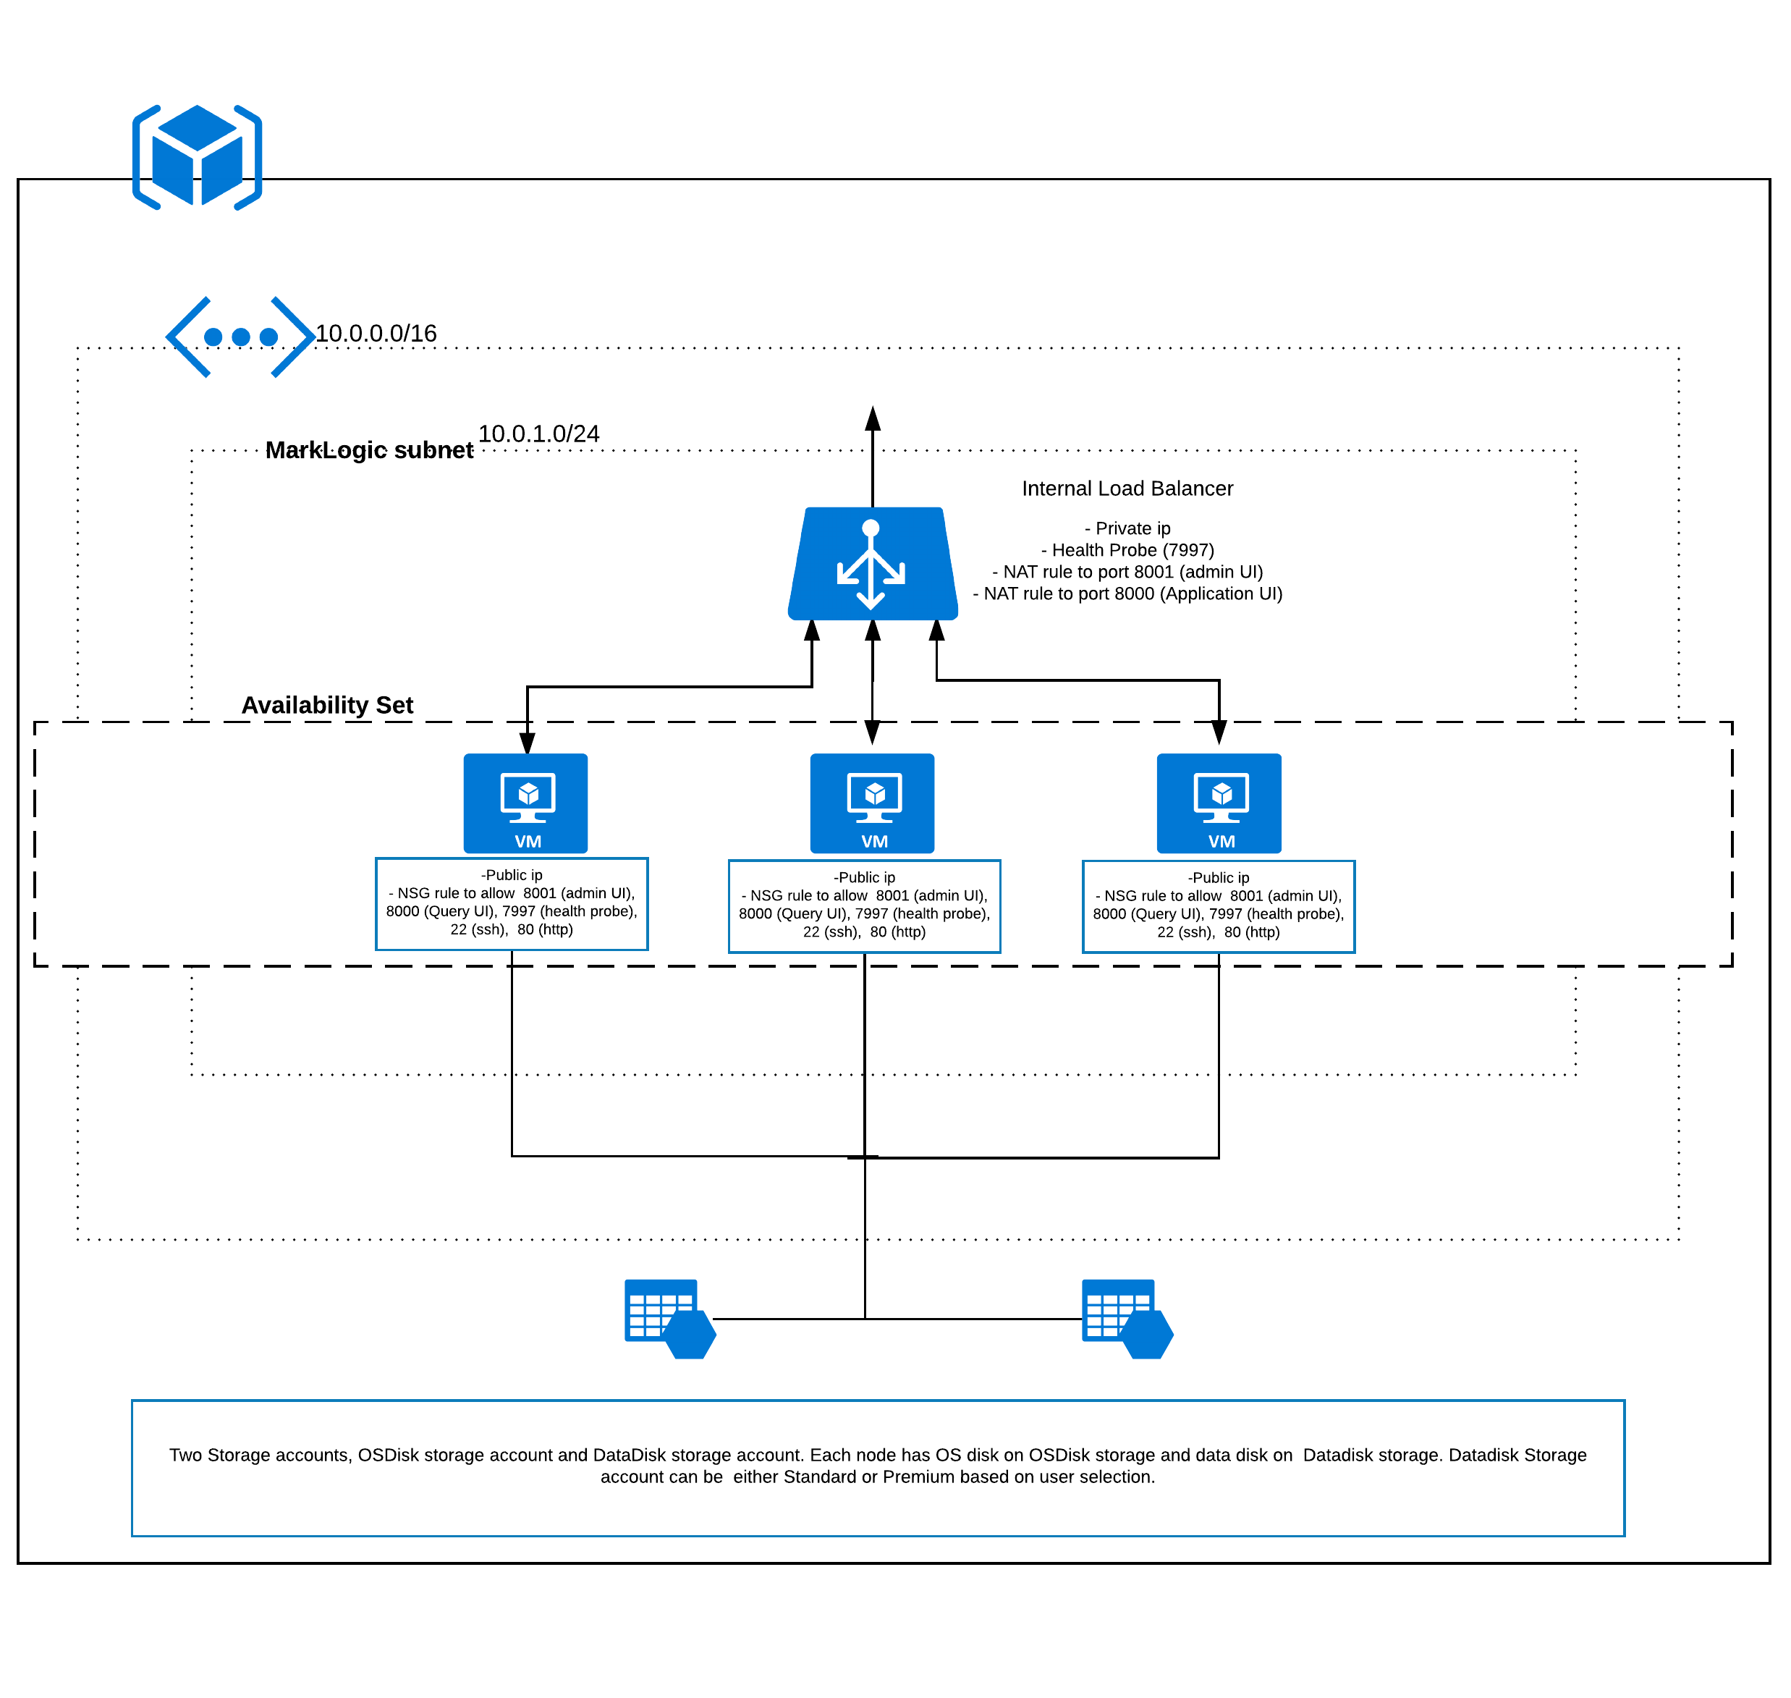

**MarkLogic 3 node cluster with external/Internal load balancer** looks as shown in the above images. Template deployment deploys a virtual network and a subnet or user can use existing virtual network or subnet. Also, an availability set is deployed where all the cluster nodes reside.

Two storage accounts are deployed, one to store cluster nodes OS disks and other to store cluster nodes data disk (premium or standard storage account).

Public IP and Network interfaces are created for all the nodes. Network Security group is created and attached to VMs. Network security group allows port 22, 80, 7997, 8000, 8001 as part of deployment.

External load balancer or Internal load balancer is deployed based on the user selection, external load balancer has public IP and internal load balancer has private IP and it takes a private IP associated with the subnet. Private IP for internal load balancer is taken as input from user.

Both External and Internal load balancers have same load balancing rules, health probe at port 7997, NAT rule for port 8001 (admin UI) with frontend ports 2200, 2201… for node1, node2… respectively. Similarly, NAT rule for port 8000 (query UI) with frontend ports 3300, 3301… for node1, node2… respectively. As part of deployment there is no load balancing rule, user must configure once the deployment is done based on user preference.

Virtual machine with MarkLogic 8 image is created and extensions such as data disk mount extension (to mount data disk), first node configuration (to configure first node), additional nodes configuration (to configure additional nodes) are executed as part of deployment.