Contents

1. Introduction 2

2. Create Firebase Account 2

2.1. Sign in to Firebase 2

2.2. Add Firebase to Android App 4

2.3. Download google-service.json file 5

2.4. Add Firebase to IOS Application 8

2.5. Download the GoogleServices-info.plist 12

# 1. Introduction

Firebase is a backend platform for building Web, Android and IOS applications. It offers real time database, different APIs, multiple authentication types and hosting platform.

# 2. Create Firebase Account

## 2.1. Sign in to Firebase

1. Sign in to Firebase console application using below link.

<https://console.firebase.google.com/>

1. Enter your valid E-Mail and password to login or You can also create an account to Login.

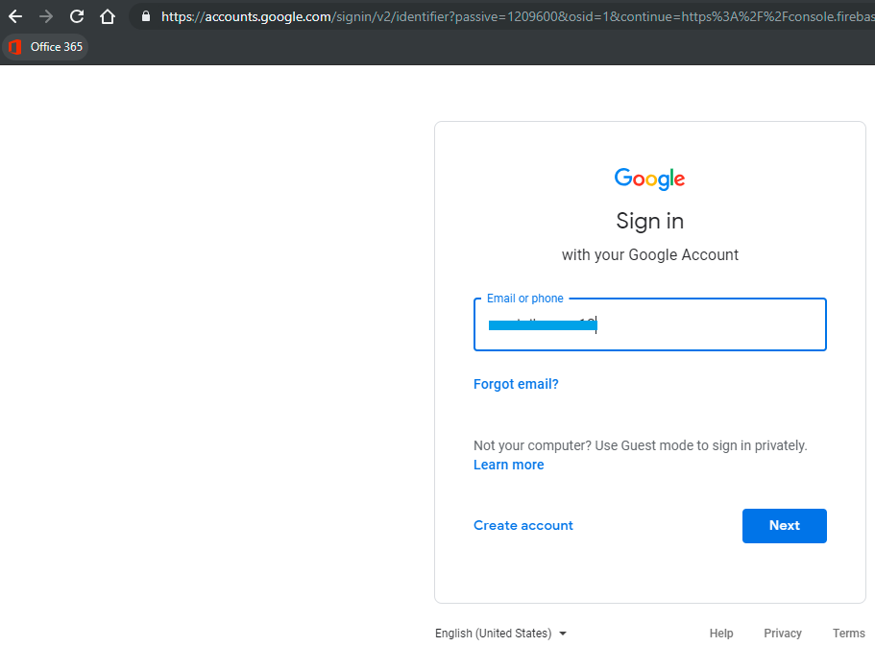

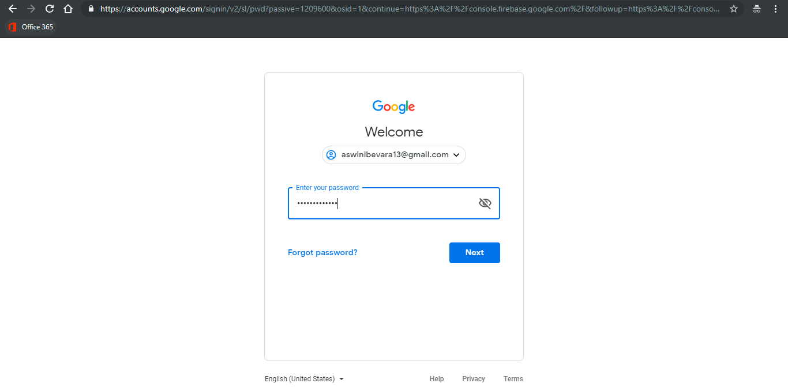

1. Create a new Firebase project if there is no existing one Click **Add project**.

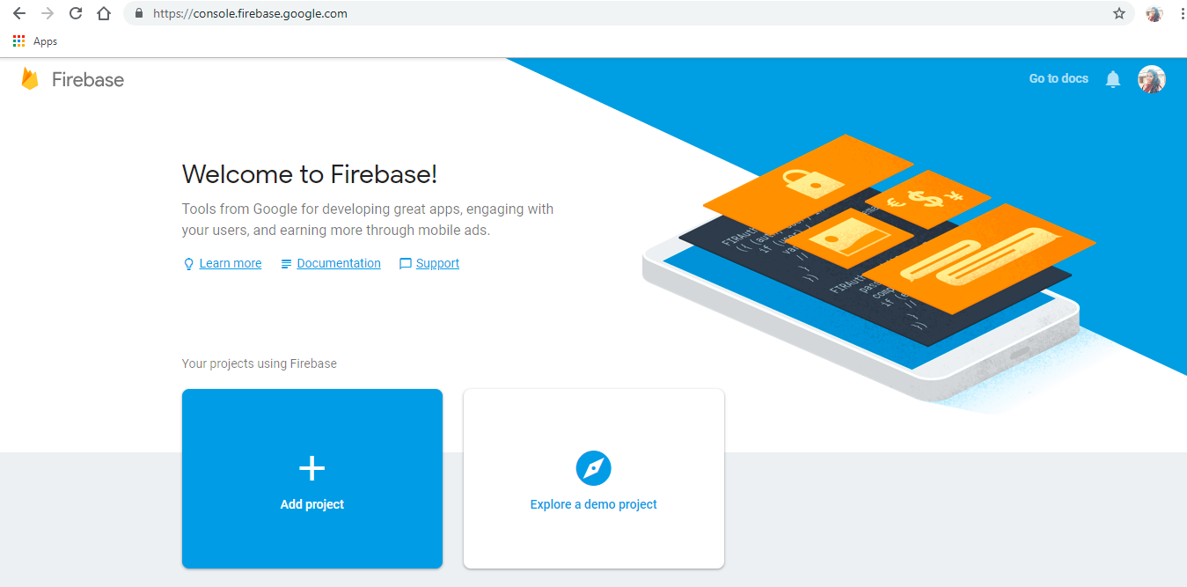

1. Enter **Project name** and Accept Terms & Conditions agreement and click on **Create project**.

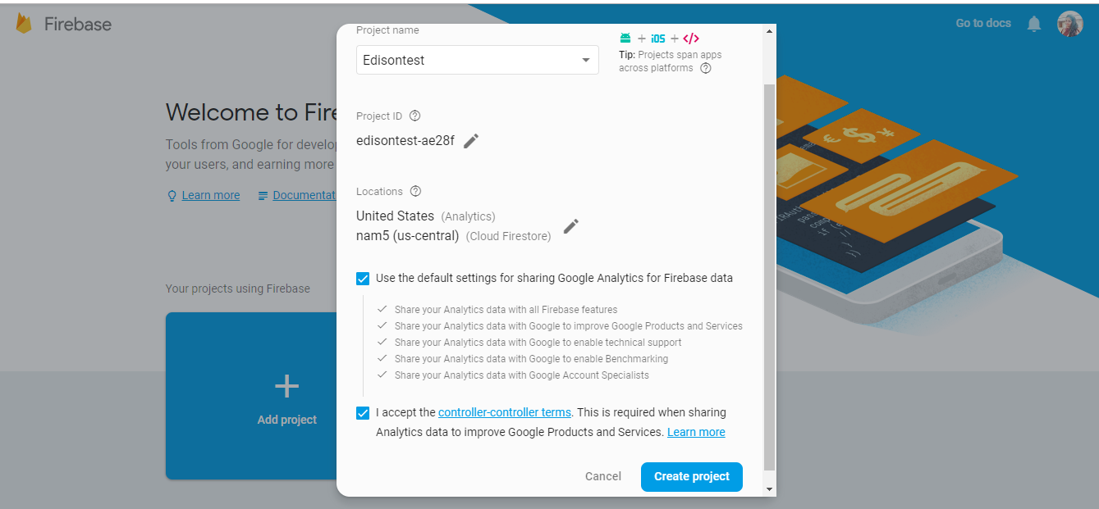

1. Click Continue.

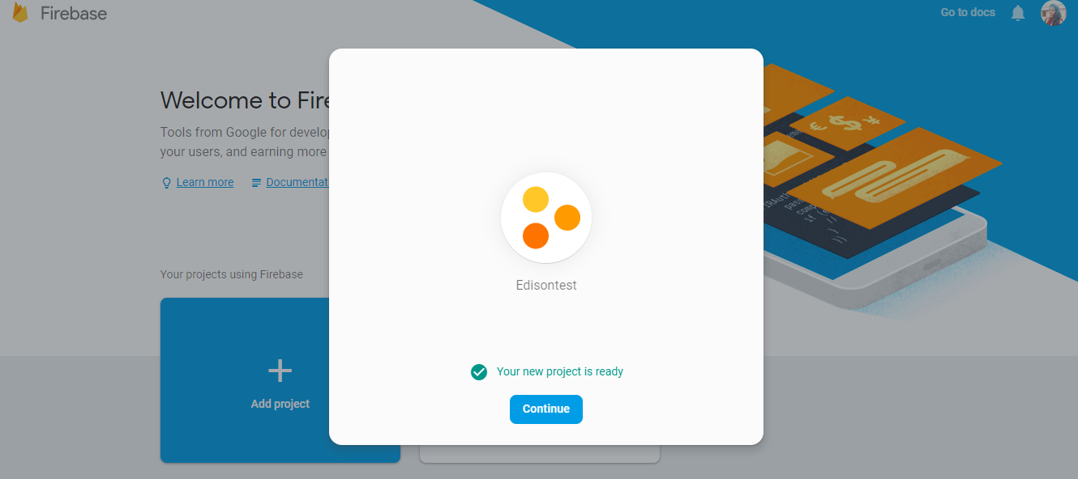

## 2.2. Add Firebase to Android App

1. After creating a new project , select **Add Firebase to your Android app**.

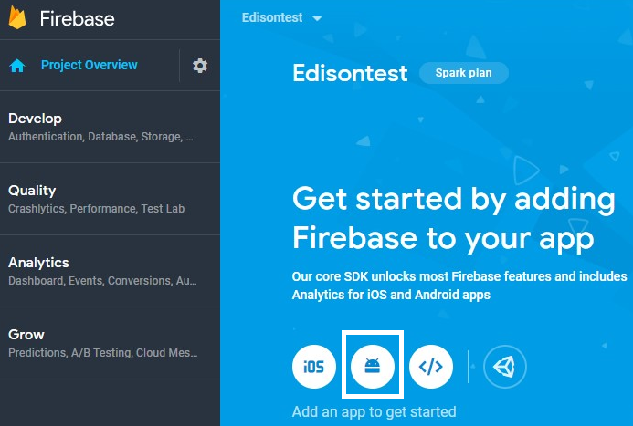

1. Enter Android package name and click on Register app.

Ex: com.<company name>.<app name>

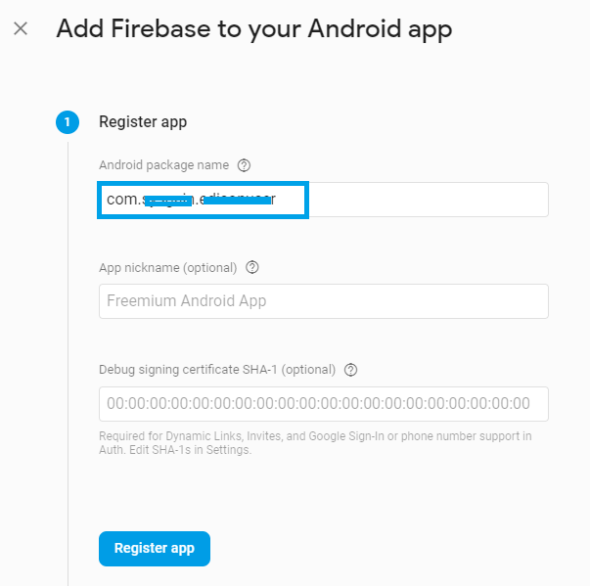

## 2.3. Download google-service.json file

1. Click on **Download googl-service.json** and save it in your local machine.

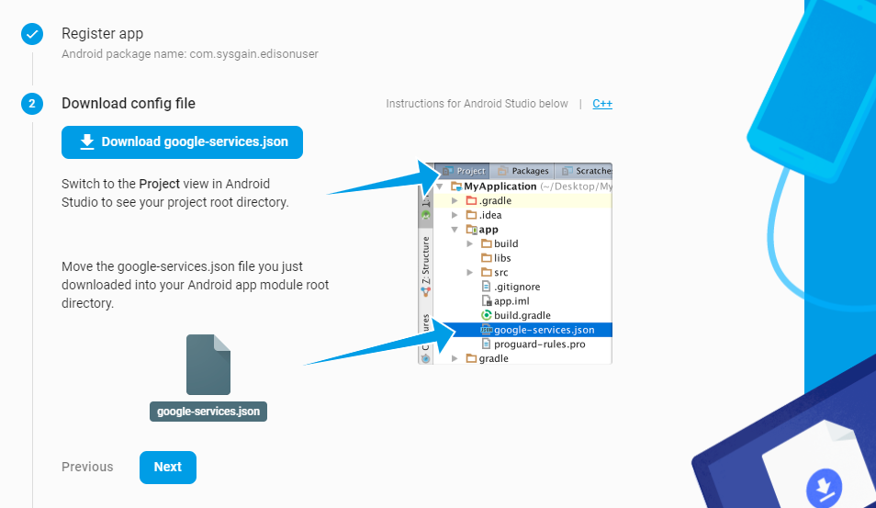

1. Click **Next**.

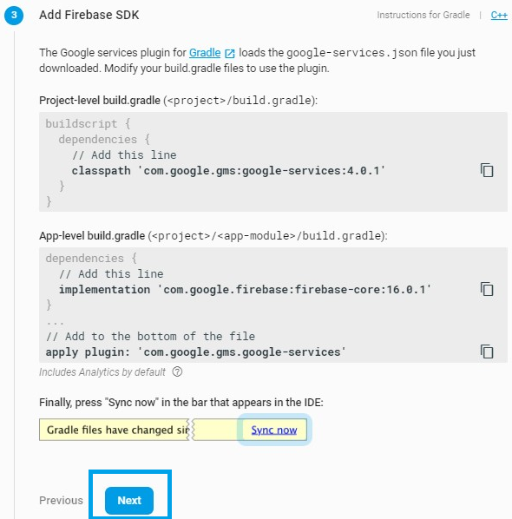

1. Select **Skip this step** on the page.

**Note** : This phase is for validation hence we do not require it at this step we can click on skip for now.

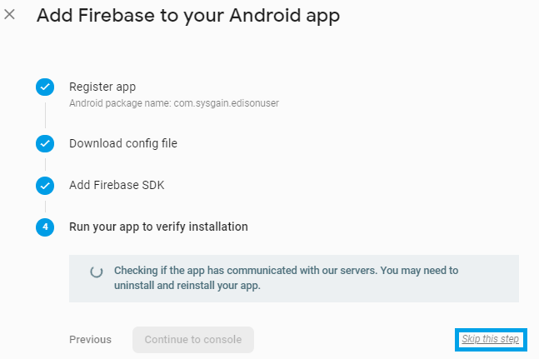

## 2.4. Add Firebase to IOS Application

1. From the General menu scroll down to app section and click on Add App.

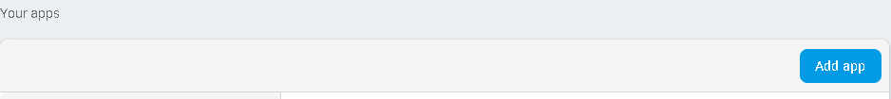

1. Select IOS platform from the shown pop up.

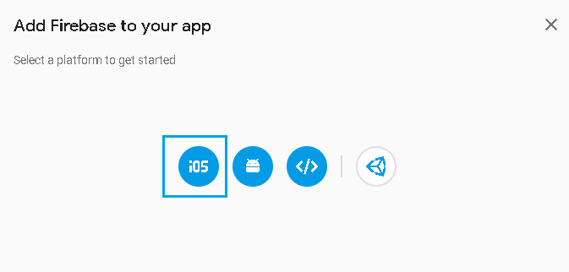

1. Enter IOS Bundle ID in the given box as shown below and click on **Register** APP

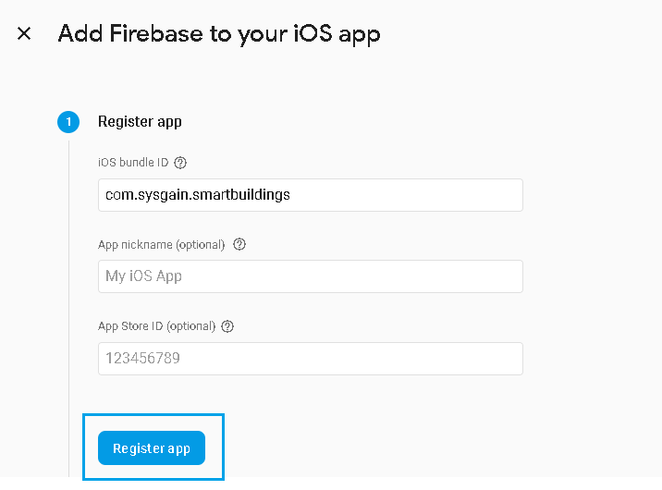

1. After clicking on the “Register app”, you see a new screen pop up where you can click on **Next** to continue further

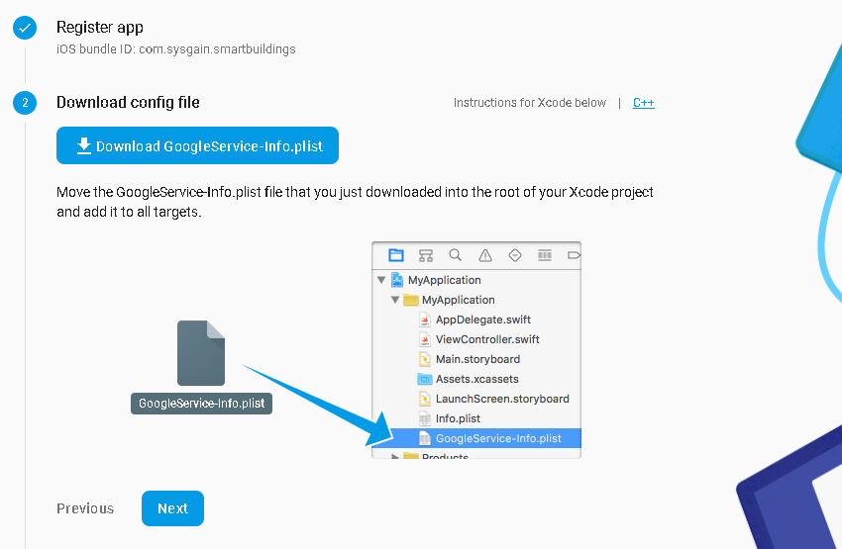

1. Click on “Continue to Console” to complete the setup.

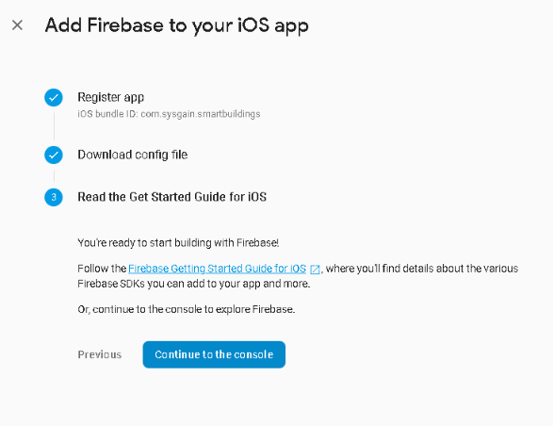

## 2.5. Download the GoogleServices-info.plist

1. Download **GoogleServices-info.plist** file by clicking on “General” menu of Firebase application.

