LAB 2 — Inverse Kinematics, DH Calibration & Hand-Eye Calibration

Learning Objectives
By the end of this lab you will be able to:
- Formulate and solve inverse kinematics for a 6-DOF serial manipulator using numerical optimisation (Levenberg-Marquardt).
- Analyse convergence behaviour, multiplicity of solutions, and the influence of initial guesses.
- Execute a vision-assisted geometric calibration experiment that jointly identifies DH parameter errors and the hand-eye transform using an ArUco board constraint.
- Understand orientation conventions (extrinsic vs intrinsic Euler angles, axis-angle representations) and their impact on calibration accuracy.
- Compare hand-eye-only calibration against joint DH+hand-eye calibration and interpret the results.

Part A — Numerical Inverse Kinematics in MATLAB

Background
Inverse kinematics solves the reverse mapping: given a desired end-effector pose T_target ∈ SE(3), find joint angles q = [q₁, …, q₆]ᵀ such that T(q) = T_target. For a 6-DOF robot with generic geometry, closed-form analytical solutions exist but are algebraically complex. Numerical solutions are more practical.
The numerical method minimises an error vector that stacks position and orientation residuals:
$$e\left(q\right)=\left[\begin{matrix}p_{current}-p_{target} \\ φ\end{matrix}\right]$$
where p ∈ ℝ³ is the Cartesian position and φ_rot ∈ ℝ³ is the axis-angle representation of the rotation error between the current and target orientation matrices. The Levenberg-Marquardt algorithm iteratively updates q until ‖e(q)‖ falls below a tolerance.

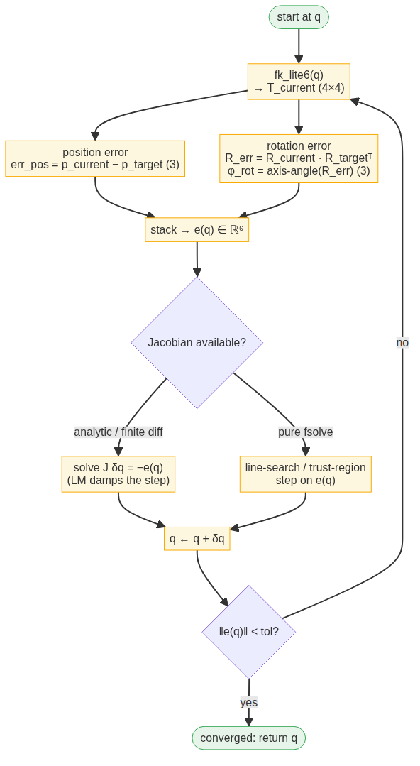

Joint Limits — UFACTORY Lite 6
Joint | Minimum (°) | Maximum (°)
J1
J2
J3
J4
J5
J6
Fill in the minimum and maximum joint limits (in degrees) from the UFACTORY Lite 6 user manual.

Supporting Functions
The following files are provided in the MATLAB_IK/ directory. Note that fk_lite6.m is intentionally missing — you will write it yourself in Task A0.
File | Purpose
ik_objective.m | Computes the 6-element error vector [position; orientation] for a given q
ik_solve.m | Wraps MATLAB's lsqnonlin (with bounds) or fsolve (unbounded) to solve IK
pose_to_matrix.m | Converts [x, y, z, roll, pitch, yaw] to a 4×4 homogeneous matrix (intrinsic ZYX convention)
matrix_to_pose.m | Extracts [x, y, z, roll, pitch, yaw] from a 4×4 homogeneous matrix (intrinsic ZYX convention)
ik_numerical.m | Main demonstration script — runs three test cases

Task A0 — Implement Forward Kinematics
Forward kinematics maps joint angles to an end-effector pose. Given the Standard DH parameters below, each joint contributes a 4×4 homogeneous transform Tᵢ built from θᵢ = qᵢ + θ_offset,i, dᵢ, αᵢ and aᵢ:
% Nominal DH parameters, columns: [theta_offset(deg), d(mm), alpha(deg), a(mm)]
dh_nominal = [
0, 243.3, -90, 0;
-90, 0.0, 180, 200;
-90, 0.0, 90, 87;
0, 227.6, 90, 0;
0, 0.0, -90, 0;
0, 61.5, 0, 0 ];
Complete fk_lite6.m so that it accepts q (6×1, radians) and returns the base-to-end-effector transform T = T₁ · T₂ · … · T₆. Only the highlighted lines need filling in:
function T = fk_lite6(q)
% ... unpack dh_nominal into d, a, alpha, theta_offset (check units!) ...
T = eye(4);
for i = 1:6
theta = q(i) + ____; % <-- fill in
Ti = % <—- fill in
T = T * Ti;
end
end
Then verify your implementation against the robot controller:
q_home = deg2rad([-180, 0, 4, 0, -45, 0]);
T_home = fk_lite6(q_home);
disp(T_home(1:3,4) * 1000) % should agree with the controller within ~1 cm
Sanity check: with all joints at zero, where is the end-effector? Is the result plausible when compared with the robot’s dimensions? (Hint: sum the link lengths along the z-axis.)

Task A1 — Run the Demonstration Script
- Open Lab_2/ik_numerical.m in MATLAB.
- Read through the script structure:
  - Test 1 (Home Position): Starts from a perturbed guess near home and verifies convergence.
  - Test 2 (Elbow Down): Uses a different initial guess to find an alternative solution branch.
  - Test 3 (Complex Pose): Tests convergence from a challenging configuration. In this section, you are expected to test multiple different robot poses and perform its Inverse Kinematics to obtain a joint configuration. The code attempts five different initial guesses for the same target pose to demonstrate solution multiplicity.
- Run the script. Observe the iterative output displayed by fsolve/lsqnonlin. Note:
  - How many iterations does each test require?
  - What is the final error norm?

Task A2 — Analyze Solution Multiplicity
For a 6-DOF arm, multiple joint configurations can place the end-effector at the same pose. This arises from "elbow up" vs "elbow down" and "wrist flipped" vs "wrist not flipped" symmetries.
Modify ik_numerical.m to try at least 4 different initial guesses for the position target. Record which guesses converge and to which solution.
Group the converged solutions by comparing joint angle vectors. How many distinct solutions did you find? Does this match your expectation for a 6-DOF arm?

Task A3 — Explore Failure Modes
Try solving IK for a target pose that is outside the reachable workspace, for example:
% Target far beyond maximum reach (~530 mm)
target_T = eye(4);
target_T(1,4) = 0.8; % x = 800 mm (too far!)
[q_sol, success, err] = ik_solve(target_T, [0; 0; 0.5; 0; 0; 0], joint_limits_rad);

What happens? Does the solver report failure? What is the residual error?

Part B — Vision-Assisted DH & Hand-Eye Calibration
Background
The DH parameters published by the manufacturer are nominal. Manufacturing tolerances, assembly misalignment, thermal expansion etc. introduce systematic errors. Additionally, the hand-eye transform T_ee_cam (from end-effector flange to camera optical centre) is unknown after mounting.
Traditional calibration measures the end-effector pose directly (e.g., via laser tracker or the robot's own controller-reported cartesian coordinates). However, the controller-reported poses use the same uncalibrated DH model internally, so they carry the same systematic errors — calibrating against them is circular.
Our approach uses an ArUco board as an external ground-truth reference. The board is fixed in space. At each robot configuration i, we measure:
- Encoder angles q(i) from the robot controller
- Camera-to-board transform T_cam_board(i) from monocular ArUco detection
The frame chain is:
Base → FK(ζ, q(i)) → EE → T_ee_cam → Camera → T_cam_board(i) → Board
Since the board is stationary, the composed transform T_base_board must be constant across all poses:
$$T_{base}^{board}\left(i\right)={FK}_{i}\left(ζ\right)⋅T_{EE}^{cam}⋅T_{cam}^{board}\left(i\right)=con\tan{t}$$
We jointly estimate ζ (24 DH parameters) and T_ee_cam (6 parameters) = 30 total parameters, constrained by the requirement that T_base_board(i) ≈ T_base_board(j) for all pairs (i, j).
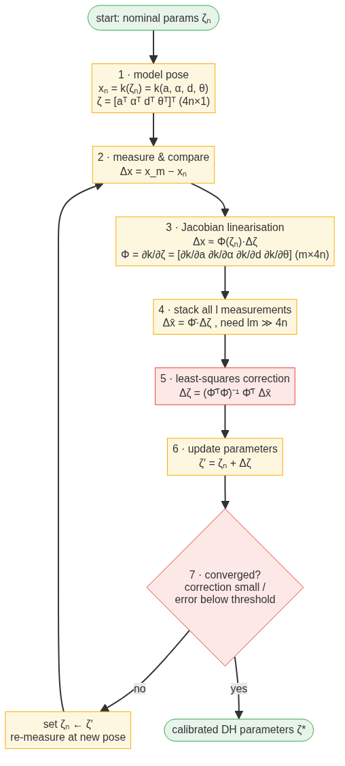

Why This Works Better Than Controller-Based Calibration
The ArUco board provides an external measurement independent of the robot's internal kinematic model. This breaks the circular dependency: the calibration cost depends only on encoder angles (accurate) and ArUco-detected board poses (external ground truth), never on the controller's FK computation.

Two-Stage Calibration Strategy
Rather than attacking all 30 parameters simultaneously from scratch, we use a two-stage approach:
Stage 1 — Hand-Eye Only: Fix DH at nominal, optimise T_ee_cam alone (6 parameters). This absorbs the bulk of systematic error quickly and establishes a good initialisation basin. This process is the same as in Lab 1
Stage 2 — Joint DH + Hand-Eye: Starting from Stage 1's T_ee_cam, jointly optimise all 30 parameters with L2 regularization toward nominal values. The regularisation prevents wild parameter drift caused by structural coupling between adjacent link offsets and the hand-eye transform.
This strategy produces physically reasonable corrections and avoids the large spurious shifts seen when optimizing all 30 parameters from a rough identity initialization.

Parameter Vector Layout
The combined parameter vector packs DH parameters followed by the hand-eye transform:
ξ = [a₁…a₆, α₁…α₆, d₁…d₆, θ_offset₁…θ_offset₆, px, py, pz, ωx, ωy, ωz]ᵀ

where the last six elements encode T_ee_cam as [position, axis-angle].

Code Structure
The calibration pipeline is organized into four modules in
python_dh_optimization/:
File | Purpose
so3.py | SO(3) helpers: rotation_log_map, rotation_exp_map, transform vectorization
fk_functions.py | Standard D-H forward kinematics from packed ζ vector
calibration_model.py | T_base_board prediction, residuals/Jacobian computation, hand-eye initialization (two-pose and Horaud AX=XB solvers)
lm_optimizer.py | Generic Levenberg-Marquardt solver with adaptive damping, regularization, SVD masking
run_calibration_twostage.py | Entry point: loads data, runs Stage 1 (HE-only), then Stage 2 (joint), prints comparison
collect_data.py | Vision-assisted data collection using ArUco board and robot encoders

Task B1 — Study the Calibration Pipeline
Open the files listed above and skim them. This task is intended to familiarize you with the code used. Only subtask 1 requires you to write any code. The rest simply point towards important functions in the pipeline and hint towards the math behind the black box.
- fk_from_zeta() in fk_functions.py — chains six Standard DH transforms, exactly like your MATLAB implementation in Task A0. Complete the function fk_from_zeta in fk_functions.py so it returns the base-to-end-effector transform for a given ζ vector and joint angles q:
Cross-check: call fk_from_zeta with the nominal ζ and q = 0, and compare the resulting position with the output of your MATLAB fk_lite6 at the same joint values.
- levenberg_marquardt() in lm_optimizer.py — Consider the following: what role does the damping parameter λ play, and why is it adapted during the iteration?
- rotation_log_map() and rotation_exp_map() in so3.py. These functions are used to calculate orientation errors, and this is used to populate the error vector used in Step 2. In theory, these are the matrix logarithms and matrix exponentials. Consider the following: Why are matrix logarithms used to calculate the orientation error instead of just subtracting rotation matrices or euler angles?

Task B2 — Collect Calibration Data
- Place the ArUco board somewhere visible from the robot's wrist-mounted camera throughout the planned motion range.
- Ensure the robot is powered on and connected.
- Open collect_data.py. This is the program you’ll use to collect calibration data. Find the definition of the robots IP address (You may simply run the find function in your IDE) and verify it is correct. Your robots IP address can be found on the label stuck to its control box.
- Activate the python virtual environment and run the data collection script. :
python collect_data.py
This opens up a window with camera view. In the UFactory web interface (http://<IP address:18333), switch the robot to manual mode. Holding down the button on the end effector of the robot, move the robot through several poses while ensuring the ArUco board is visible in the frame and can be detected. At each pose, capture the configuration of the robot and the transformation from camera to board by pressing ‘c’ on your keyboard. If the text on the camera window does not show an increment in captured poses, ensure that it is the active window by clicking on it. It is also possible that the pose is rejected simply because the reprojection error is too high, in which case the pose is inadmissible. Try a different one. Ensure that the robots base and the board itself are stationary as this can affect the quality of calibration. Capture as many varied poses as you can. Note that there are 30 parameters being optimized, so it is recommended to collected around 60 configurations to ensure the optimizer has enough data to work with. When you have enough data (the text on screen indicates number of samples collected), press ‘s’ to save the collected data. Press ‘q’ to quit the window.

Task B3 — Run the Two-Stage Calibration
With data collected, run the full calibration pipeline:
python run_calibration_twostage.py
This executes both stages sequentially and prints a side-by-side comparison. Examine the output carefully:
Stage 1 results:
- How much did T_ee_cam change from initialization?
- What is the remaining T_base_board spread after hand-eye-only calibration?
Stage 2 results:
- Which DH parameters received the largest corrections?
- Are the corrections physically plausible (sub-millimetre link lengths, sub-degree joint offsets)?
- Compare the Stage 2 T_ee_cam to the Stage 1 result — did it shift significantly?
Comparison table:
- What percentage improvement does joint calibration achieve over HE-only?
- Is the improvement worth the complexity, or is HE-only "good enough"?
- How can the calibration be improved? Hint: Think about the steps you followed and potential sources for error or variations.

Task B4 — Observability Analysis
The SVD of the weighted Jacobian reveals which parameter combinations are identifiable:
# J is computed inside run_calibration_twostage.py — uncomment the SVD lines there,

# xi_test = np.concatenate([zeta0, tee_init])
# _, J = compute_residuals_and_jacobian(xi_test, Q, Tcb_list, n=6)
# _, s, _ = np.linalg.svd(J, full_matrices=False)
# print("Singular values:", s)
# print("Condition number:", s[0]/s[-1])
Run the script with these lines uncommented, then answer:
- Looking at the printed singular values: roughly how many are clearly larger than the smallest few?
- Based on the output, name one DH parameter that received a correction larger than expected, and one that barely moved. What might explain the difference?
- In 2–3 sentences, explain why some DH parameters are harder to identify than others (hint: think about structural coupling between neighbouring links).

