Array

Arrays are used to store multiple values in a single variable, instead of declaring separate variables for each value.

To declare an array, define the variable type with **square brackets**:

String[] cars;

Following are some important point about Java arrays.

* In Java all arrays are dynamically allocated.
* Since arrays are objects in Java, we can find their length using member length. This is different from C/C++ where we find length using sizeof.
* A Java array variable can also be declared like other variables with [] after the data type.
* The variables in the array are ordered and each have an index beginning from 0.
* Java array can be also be used as a static field, a local variable or a method parameter.
* The **size** of an array must be specified by an int value and not long or short.
* The direct superclass of an array type is [Object](https://www.geeksforgeeks.org/object-class-in-java/).
* Every array type implements the interfaces [Cloneable](https://www.geeksforgeeks.org/marker-interface-java/) and [java.io.Serializable](https://www.geeksforgeeks.org/serialization-in-java/).

Array can contains primitives data types as well as objects of a class depending on the definition of array. In case of primitives data types, the actual values are stored in contiguous memory locations. In case of objects of a class, [the actual objects are stored in heap segment](https://www.geeksforgeeks.org/g-fact-46/).

[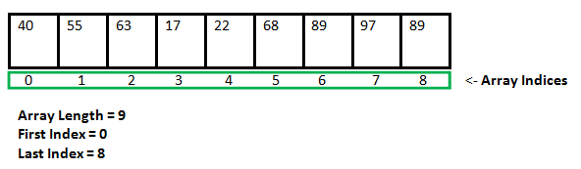](http://cdncontribute.geeksforgeeks.org/wp-content/uploads/Arrays1.png)

**Creating, Initializing, and Accessing an Array**

**One-Dimensional Arrays :**   
The general form of a one-dimensional array declaration is

type var-name[];

OR

type[] var-name;

An array declaration has two components: the type and the name. *type* declares the element type of the array. The element type determines the data type of each element that comprises the array. Like array of int type, we can also create an array of other primitive data types like char, float, double etc. or user defined data type(objects of a class).Thus, the element type for the array determines what type of data the array will hold.

**Multidimensional Arrays**

Multidimensional arrays are **arrays of arrays** with each element of the array holding the reference of other array. These are also known as [Jagged Arrays](https://www.geeksforgeeks.org/jagged-array-in-java/). A multidimensional array is created by appending one set of square brackets ([]) per dimension. Examples:

int[][] intArray = new int[10][20]; //a 2D array or matrix

int[][][] intArray = new int[10][20][10]; //a 3D array