# Introduction

|  |
| --- |
| ***Digital Design and Computer Architecture***   **Lab 7: Temperature Control** |

In this lab you will use a C program on the PIC32 microcontroller to control the temperature of an ohmic heater. Your program should keep the temperature of the heater as close as possible to 60 degrees Celsius. The circuit used in this lab is based on that of the PID temperature control lab in E102. The temperature sensor outputs a voltage that varies linearly with its temperature. After an op-amp gain stage, an analog-to-digital converter (ADC) built into the PIC samples the voltage to determine the temperature of the heater. Power to the heater is switched on or off with a power transistor, activated by an output pin on the PIC.

# Background: Feedback Control Systems

As computer technology has become increasingly powerful and more miniaturized, inexpensive microcontrollers have seen increasing use in all sorts of control applications. Systems from simple kitchen appliances to car engines now employ digital components to control behavior previously governed by mechanical devices and analog control circuits.

Most generally, feedback control is when a system uses its current or past state (or output) to control its future state. As students who have taken E102 will know, there are many types of feedback control systems that can be implemented in either the analog or the digital domain. You will be using one of the simplest techniques, called “bang-bang” control (or on-off control).

The three crucial elements of a feedback control system are the current output value of the system under control (the ‘plant’), a means of input to the plant, and a controller to determine the appropriate input to keep the plant output within a set of parameters. In this lab, the heater block is the plant system, with the ‘output’ being its current temperature. The temperature sensor attached to it provides a means for the controller, in this case the PIC, to know the state of the system. The power transistor, controlled by an I/O pin on the PIC, determines the input to the plant.

Bang-bang control works by comparing the current state of the system to a desired value, the set point. In our case, the PIC is programmed with a fixed temperature as the set point. If the temperature sensor indicates that the heater is below the set point, it activates the power transistor to increase the temperature. If the temperature is above the set point, the PIC switches the power transistor off.

**1. Circuit Implementation**

You will be using the same resistive heater in this class as in E102. If you have already taken E102, you may reuse your breadboarded circuit. If you haven’t, go to the stockroom and obtain a lab kit and small breadboard for this lab. The kit for this lab should contain seven parts: an LM35 temperature sensor, an LM324 op-amp, a TIP31A power transistor, and four resistors: a 10 Ω (the heater), a 270 Ω, a 10 kΩ and a 22 kΩ. Extra parts (including some resistors and TIP31As) are located in the black cabinet in the E85 lab. The kit is yours to keep; hold onto it and plan to reuse it in E102.

The circuit diagram is shown below. Check the LM35, LM324 and TIP31A datasheets for pinout information (links to the datasheets are below). Don’t forget to attach the power/ground pins for the LM324. Attach the 10 Ω heater resistor to the LM325 temperature sensor with the screw and nut provided so the two are at the same temperature. Build the circuit on your own breadboard. Leave four wires to connect your breadboard to 5V, GND, RB11, and RE0 on the big breadboard (the µMudd32 board), but don’t make those connections yet. You may find it helpful to add an LED and appropriate resistor, as shown in the box labeled “Optional”, to help you tell when the heater is switched on or switched off. You can also lightly touch the “heater” (the 10Ω resistor) to see if it is heating. (It will take a few seconds to start heating up.)

<http://www.national.com/ds/LM/LM35.pdf>

<http://www.national.com/ds/LM/LM124.pdf> (also covers LM324; choose one of the 4 op-amps)

<http://www.fairchildsemi.com/ds/TI/TIP31A.pdf>

Note that the collector of the TIPS31A is connected to both the middle pin (pin 2) and the large flat metal at the top of the device. You will connect the 10Ω resistor directly to the large flat metal (the collector) with a machine screw and nut. For now, connect the transistor base via the 270Ω resistor to ground. Do not connect the LED directly to ground without a resistor, as the total current supplied by any given PIC pin is limited.



**Figure 1:** Temperature control circuit diagram. LED to indicate heater status is optional.

The LM35 produces a voltage output Vout = 0.01 * T, where T is the temperature in degrees Celsius. For our desired set point of 60 C, the output is just 0.6V. The Analog-to-Digital Converter (ADC) on the PIC has a range from 0V to 3.3V and provides 10 bits of resolution. Thus, a least significant bit corresponds to 3.3 / 210 = 3.2 mV, or 3.2 degrees. To increase the accuracy of your control, the LM324 op-amp is set up as a non-inverting amplifier with DC gain of 3.2. This produces a voltage of 0.6V × 3.2 = 1.92V at the set point, making more use of the ADC’s range. Each least significant bit of the ADC output will now correspond to 1 degree.

Turn on the 5V power supply. Since RE is low by default, the power usage should be low. If it is not (about 0.5A or greater), the heater is probably on. Go back and check your circuit. Check that you connected the appropriate signals to the appropriate pins on each device. If the problem persists, ask a tutor or professor.

Measure the voltage from the LM35, and makes sure it matches your expectations given the temperature of the room. Next, verify that the op-amp output voltage is 3.2 times the LM35 voltage.

Now disconnect the 270 Ω resistor from RE0 and hook it to 3.3 V instead. Continue to measure the op-amp output voltage. After a few seconds, the voltage should start to steadily rise, corresponding with the increase in temperature of the resistor. Once you are satisfied that the circuit is working properly, reconnect the 270 Ω resistor to RE0 to shut off the heater. You should feel the resistor starting to warm up.

**2. Control Program**

You are now ready to connect the circuit to the utility board and write your temperature control program. On the PIC32, PORTB doubles as the ADC input pins. The initIO() function is already configured to set up RB11 as an analog input, and RE0 as a digital output. Use four wires to connect your breadboard to the 5 V, GND, RB11, and RE0 pins on the big breadboard in the lab.

Write your program. It is recommended that you use the initIO(), writeE0(), and analogReadB11() functions from e85.c to simplify your code. If you keep your program simple, it will be very short.

Debugging programs that depend on interaction with I/O devices like the ADC can be challenging, since the program must run in real time for its behavior to be properly observed. You will find it useful to print the current temperature after it is returned from the ADC.

Run your program. Does the temperature rise and stabilize as expected? Measure the rise time of your circuit from room temperature to the first crossing of the set point, and how much the temperature overshoots the desired value. The temperature will likely oscillate around the set point, but should stay within 3 or 4 degrees of the desired value.

You can introduce a disturbance to the system by blowing on the heater. This decreases temperature by a few degrees in just a few seconds. Watch your measured temperature drop, then rise back up. Does your controller deal with the disturbance effectively?

If you have the chance, you may find it interesting to observe the sensor voltage on an oscilloscope in the lab. Figures 2 and 3 show the transient behavior and the oscillation around the set point.

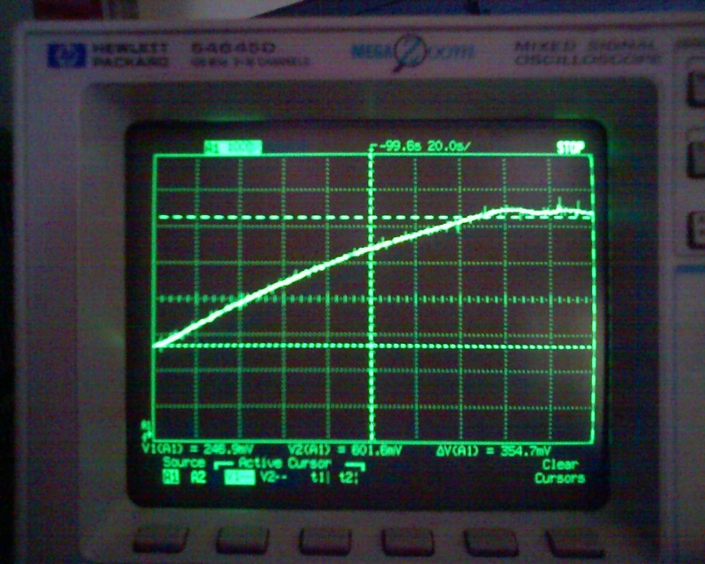

**Figure 2:** Rise and oscillation of the heater temperature under proper control.

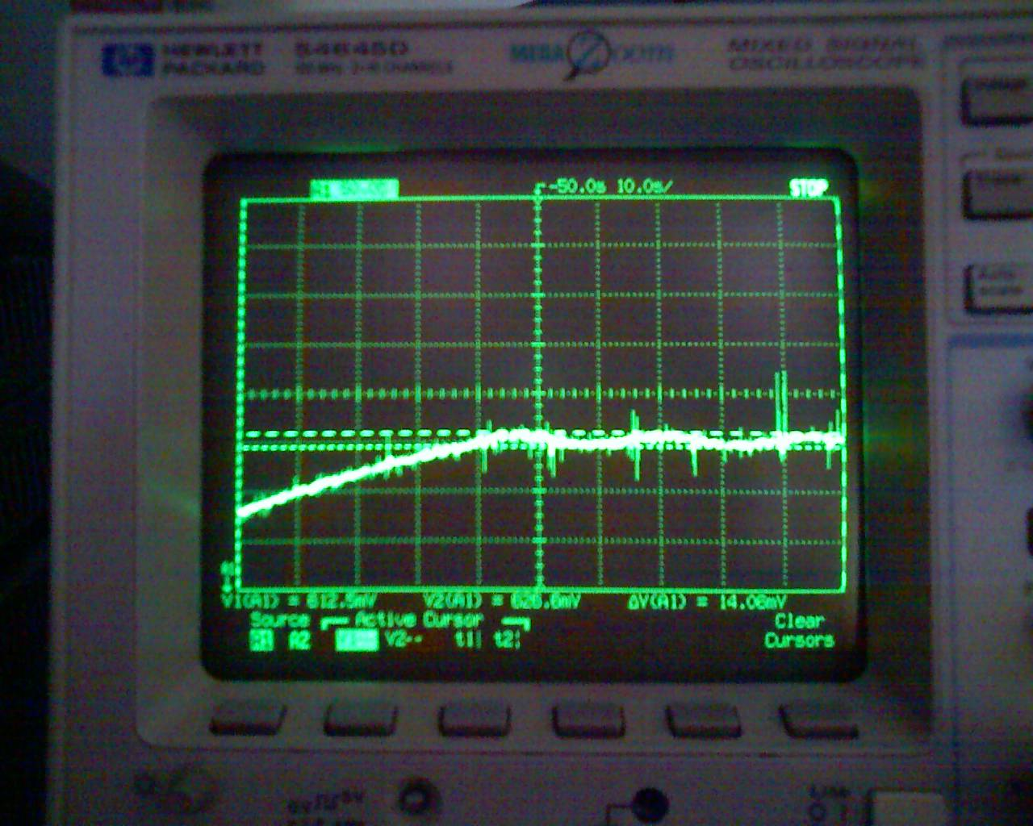

**Figure 3:** Measurement of set point oscillations.

**What to Turn In**

Include each of the following items in your submission **in the following order**.

1. How many hours did you spend on this lab? This will not count toward your grade (unless omitted entirely).
2. Your C program. It should be clean and well commented.
3. The rise time and overshoot measurements of your system.

**Acknowledgements:**

This lab was developed by Leo Altmann based on the E102 lab developed by Prof. Tony Bright.