GPIO Drivers:
- GPIO mapping GPIO
- PIGPIO -- i2c driver for raspberry PI
  - http://abyz.me.uk/rpi/pigpio/index.html
  - Reevaluate -- noticed HIGH CPU (constant 6% on RPI model B.) consider: sending developer email asking for thoughts?
  - LOTS of documentation:
  - PISCOPE -- could use this when debugging the anemometer
  - API docs: https://pkg.julialang.org/docs/PiGPIO/8aGxa/0.1.0/api/
- I2C, SMBus, and Raspbian Linux -- tutorial:
    - Use sudo i2cdetect -y 1
    - This command will show all i2c devices attached to the i1c bus
  - https://www.abelectronics.co.uk/kb/article/1/i2c--smbus-and-raspbian-linux
  - smbus --- direct smbus support --
    - modified code and now have working versions of both
    - don't see CPU overhead that i noticed with PIGPIO
MySQL for Python:
- https://pypi.org/project/MySQL-python/#description
BMP280
- http://www.pibits.net/code/raspberry-pi-and-bmp280-sensor-example.php#codesyntax_1
- Original code was developed for SMBBUS -- i have converted it to work with PIGPIO
MMA8451 accelerometer
- https://ontario-geofish.blogspot.com/2016/03/linux-python-driver-for-mma8451.html
LIPO SHM -- power raspberry pi zero
- https://shop.pimoroni.com/products/lipo-shim
- Low battery warning at 3.4V (asserts GPIO #4 low)
- clean shutdown: https://github.com/pimoroni/clean-shutdown

anometer: https://www.swharden.com/wp/2016-10-10-raspberry-

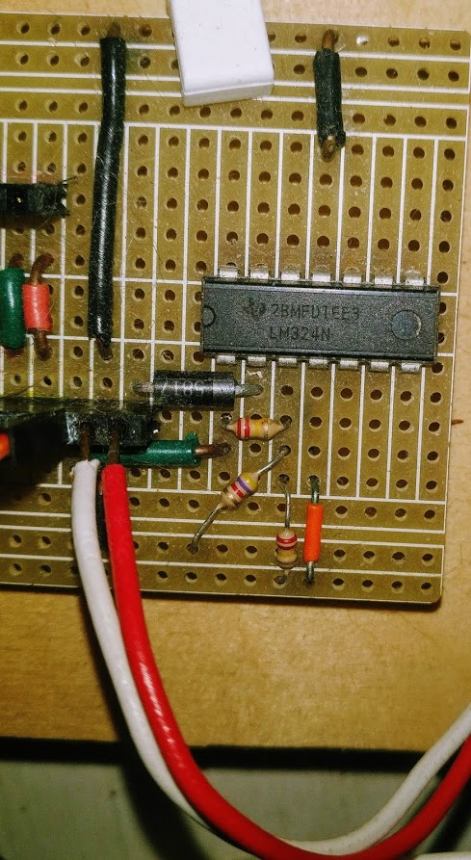

Remote Debuging - GDBServer
GDBServer allows remote debugging from Eclipse on local machine to the Raspberry PI (or any remote computer). Start remote application with the GDBServer and Eclipse connects into the port.
https://www.thegeekstuff.com/2014/04/gdbserver-example/

GPS Module
U-blox device protocol specification
https://www.u-blox.com/sites/default/files/products/documents/u-blox6_ReceiverDescrProtSpec_%28GPS.G6-SW-10018%29_Public.pdf

LiPo Shim

Power GPIO Trigger..

https://github.com/pimoroni/clean-shutdown

ESP8266
Building a FLASH Board
How to Flash ESP-01 Firmware to the Improved SDK v2.0.0 - Projects

Pinout
ESP8266 Module (WRL-13678)
ESPtool
https://github.com/espressif/esptool#readme

Command issued to flash (check difference between -fm dio vs -fm qio. qio seemed to work. dio did not..

esptool.py --port /dev/ttyUSB2 --baud 115200 write_flash --flash_size=detect -fm qio 0 ~/Downloads/esp8266-20191220-v1.12.bin
esptool.py --port /dev/ttyUSB2 read_mac
esptool.py --port /dev/ttyUSB2 chip_id
esptool.py --port /dev/ttyUSB2 flash_id
esptool.py --port /dev/ttyUSB2 --verify

ESP32

ESP32 comes with built in microusb flash capability and much easier to flash. Just plug in the usb, and use epstool.py

Flashed worked for ESP32 Wroom
esptool.py --chip esp32 --port /dev/ttyUSB7 write_flash -z 0x1000 esp32-idf3-20200725-unstable-v1.12-658-gfd2ff867a.bin

Pinout
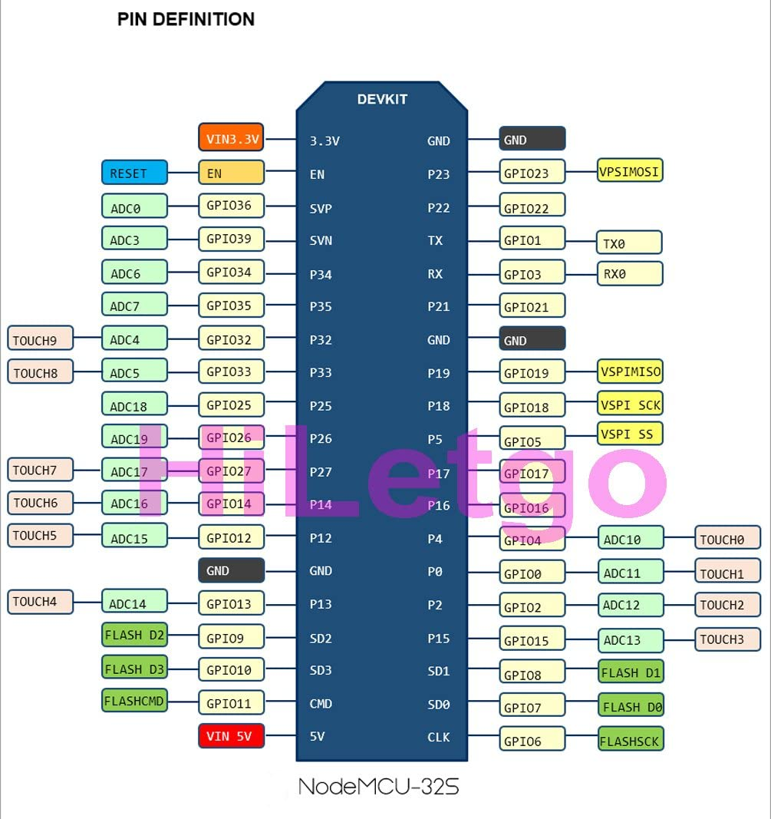

ESP8266 Module (WRL-13678)
ESPtool
https://github.com/espressif/esptool#readme

Command issued to flash (check difference between -fm dio vs -fm qio. qio seemed to work. dio did not..
esptool.py --port /dev/ttyUSB2 --baud 115200 write_flash --flash_size=detect -fm qio 0 ~/Downloads/esp8266-20191220-v1.12.bin
esptool.py --port /dev/ttyUSB2 read_mac
esptool.py --port /dev/ttyUSB2 chip_id
esptool.py --port /dev/ttyUSB2 flash_id
esptool.py --port /dev/ttyUSB2 --verify

Setup / Burn Firmware
- Mount chip onto burner
- Reboot into BURN Mode
  - Set DTR Pin to GND and Reset power -- this sets the chip into burn mode
  - Flash firmware
    - esptool.py --port /dev/ttyUSB0 --baud 115200 write_flash --flash_size=detect -fm qio 0 ~/Downloads/esp8266-20191220-v1.12.bin
  - Use REPL to modify ESP8266
    - Minicom -D /dev/ttyUSB0 -b 115200

Deploy code
Once MicroPython Firmware is burned onto the microcrontroller then the code can be deployed.
#!/bin/bash
# transfer files to ESP microcontroller
echo Send data to the ESP devide via webrpl_cli.pi
echo parm1 = $1
webrepl_cli.py -p $1 boot.py 192.168.1.163:boot.py
webrepl_cli.py -p $1 main.py 192.168.1.163:main.py
webrepl_cli.py -p $1 BME280.py 192.168.1.163:BME280.py

MicroPython
I have successfully built an esp8266 boot loader. The MicroPython firmware has been installed on esp-jay-01.

https://docs.micropython.org/en/latest/esp8266/quickref.html

"""I2C functions: scanning, etc...

Wiring:
NodeMCU I2C
----------------- -----
GND GND
Pin D1(GPIO05) SCL
Pin D2(GPIO04) SDA
"""

from machine import Pin, I2C

def i2c_init():
i2c = I2C(scl=Pin(5), sda=Pin(4), freq=100000)
return i2c

def i2c_scan(i2c):
"""Scan the I2C bus"""
devices = i2c.scan()
for dev in devices:
print("*** Device found at address %s" % dev)
return devices

if __name__ == '__main__':
i2c = i2c_init()
i2c_scan(i2c)

GPX Software
Validating GPX Files

How tracking apps analyse your GPS data: a hands-on tutorial in Python

DashBoard

The dashboard is based on mysql with pandas, plotly and DASH.

pip install dash
pip install dash_bootstrap_components
pip install pandas

https://www.freedesktop.org/software/systemd/man/systemd.exec.html

