Overview:
These are my notes to build a MQTT based IOT mesh network based application. The code is based on Python with the microcontrollers using Micropython.

THe overall data is captured into a centralized database -- i chose mysql running local. Analytics and dashboard capabilities leveraging pandas, plotly, and dash

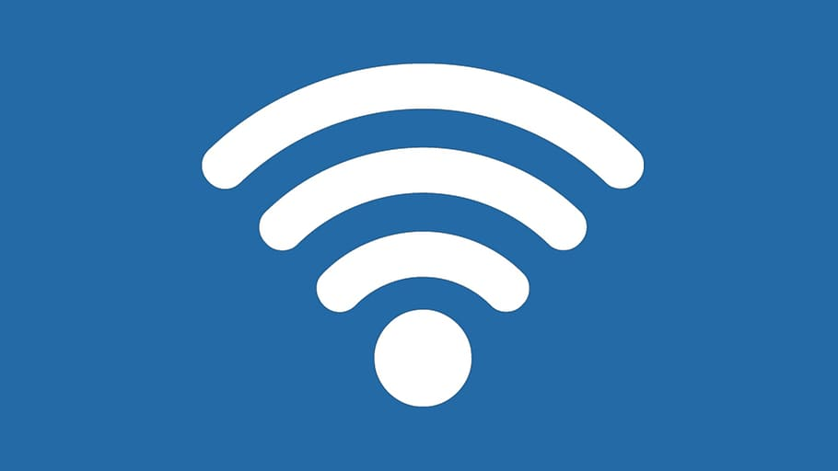
Esp32
RPi
mosquito
Payload Broker
sensordata
Graphing and monitoring
ES8266
1
2
3
4
5

ESP8266
Building a FLASH Board
How to Flash ESP-01 Firmware to the Improved SDK v2.0.0 - Projects

Pinout
ESP8266 Module (WRL-13678)
ESPtool
https://github.com/espressif/esptool#readme

Command issued to flash (check difference between -fm dio vs -fm qio. qio seemed to work. dio did not..
esptool.py --port /dev/ttyUSB2 --baud 115200 write_flash --flash_size=detect -fm qio 0 ~/Downloads/esp8266-20191220-v1.12.bin
esptool.py --port /dev/ttyUSB2 read_mac
esptool.py --port /dev/ttyUSB2 chip_id
esptool.py --port /dev/ttyUSB2 flash_id
esptool.py --port /dev/ttyUSB2 --verify

MicroPython
Micropython is a process that allows the

ESP32
USB FLashing

Install Webrepl

Use webrepl.cli

Access esp via serial terminal

