SonarQube – It is a CodeAnalysis tool which can be used for any programming lang.

It provides all the suggestions, best practices and suggestions to avoid vulnerabilities in the code.

It’s a very powerful Code Analyzing Tool.

Official Site is : Sonarqube.org

SonarQube Analyse Code Quality and Code Security.

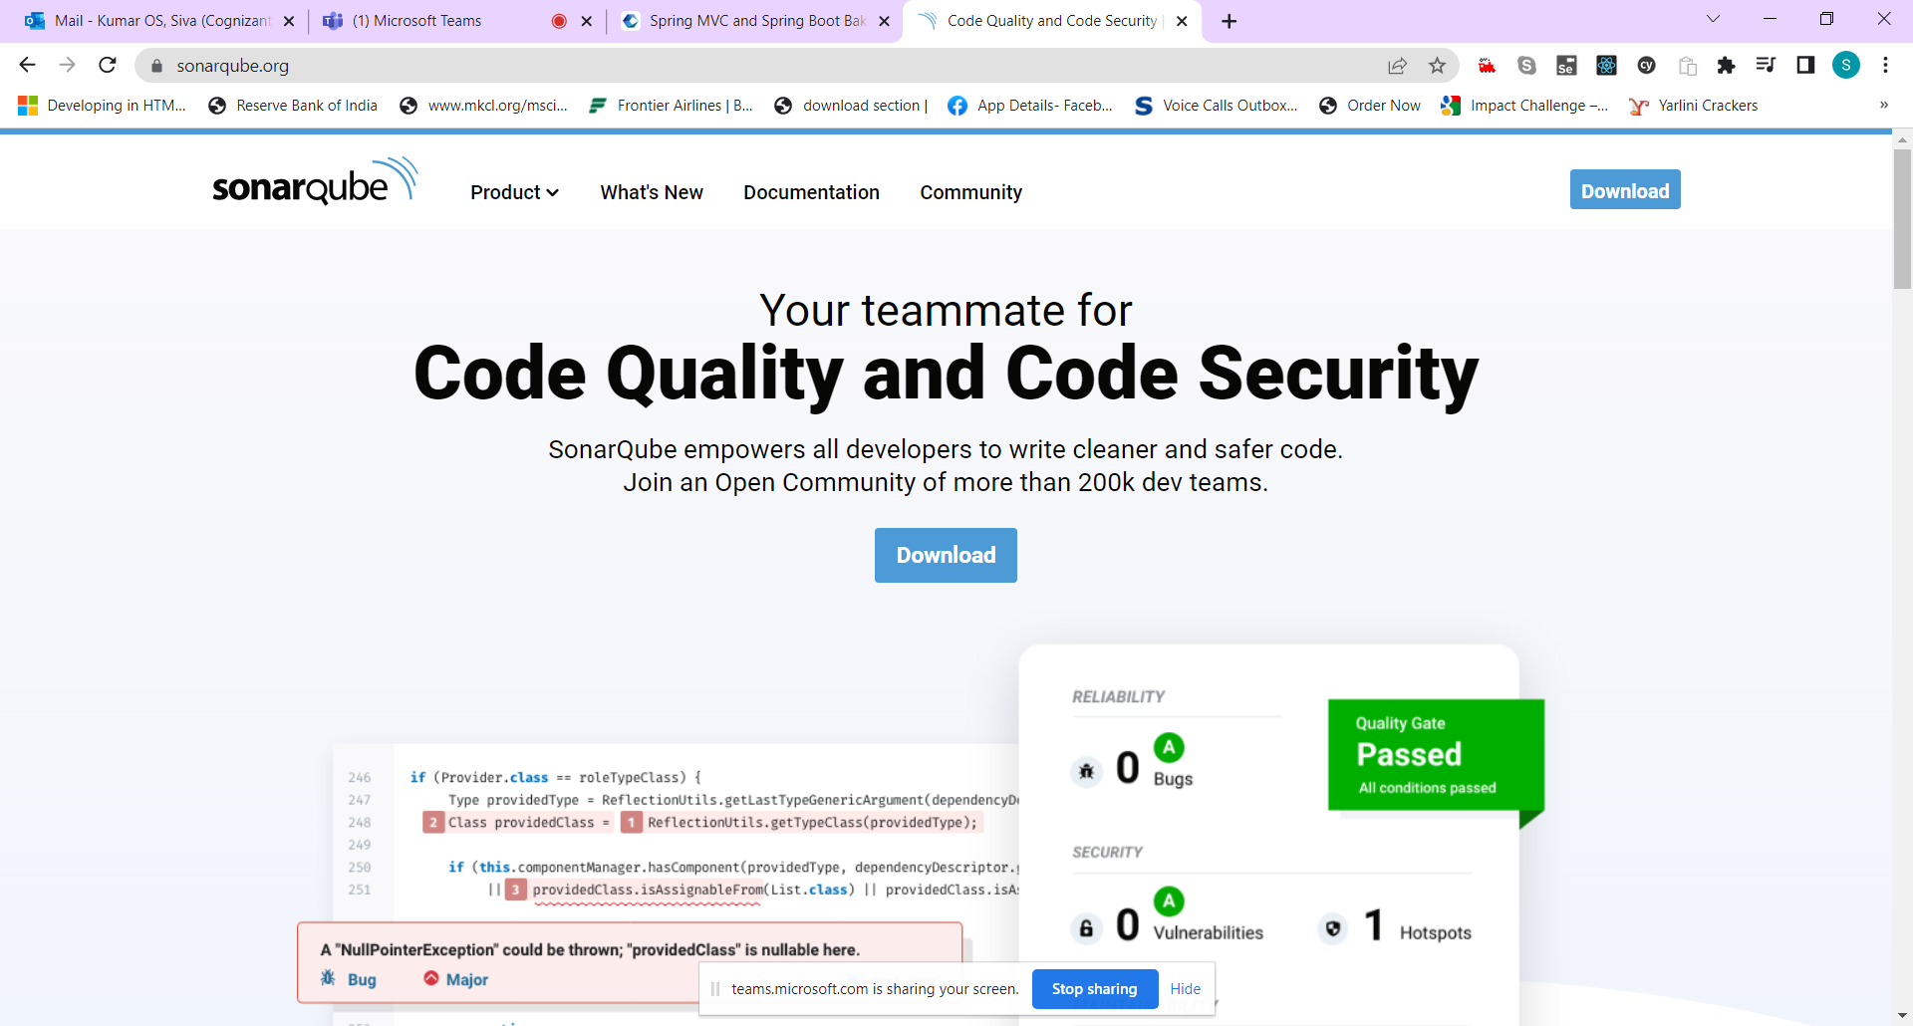

Sonar Qube Stand alone Editions (Community, Developer, Enterprise, Data Center)

Sonar Qube – For Cloud – Sonar Cloud

Sonar Qube – as a Eclipse Plugin – Sonar Lint

Pre-Requisite : Java11 (Minimum)

<https://docs.sonarqube.org/latest/setup/get-started-2-minutes/>