1. Client-Side Load Balancing using Ribbon
2. Configuring Actuator
3. Docker & K8S
4. JWT & OAuth
5. AJAX Example

Environments – profile

Development (dev)

Testing (test)

Pre-production (pre-prod)

Production (prod)

Automatic Backups, Replica, Load balancing, Logging, Caching, CI/CD pipelines, Docker Containers, K8S

<https://howtodoinjava.com/spring-cloud/spring-boot-ribbon-eureka/>

<https://howtodoinjava.com/wp-content/uploads/2018/10/spring-boot-ribbon.zip>

Docker

VM – virtual Machine (VM Ware)

Docker – Linux Kernel

Docker desktop (docker client)

Docker Deamon (docker server)

Enable Virtualization (BIOS) Hyper-V (OS)

WSL-2 = Window SubSystem for Linux

Docker desktop cli

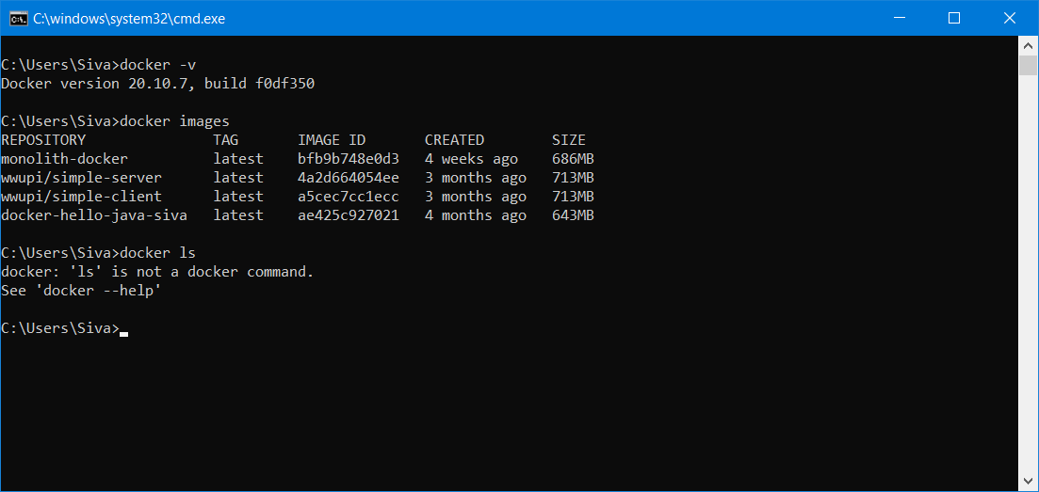

Docker -v == display the version of docker

Docker images === display all the docker images

Docker ps -a === display all container

Kubernetes – K8S – OpenSource Container Orchestration Tool

POD, Node, ReplicaSet, Service , Cluster

https://kubernetes.io/docs/tasks/tools/install-kubectl-windows/