Revisit Hibernate

JAVA 8 New Features

Lambda, Functional Interface, Predicate, Streams

Project Setup

Create a github private repository.

SignIn/Signup for github account.

Github.com

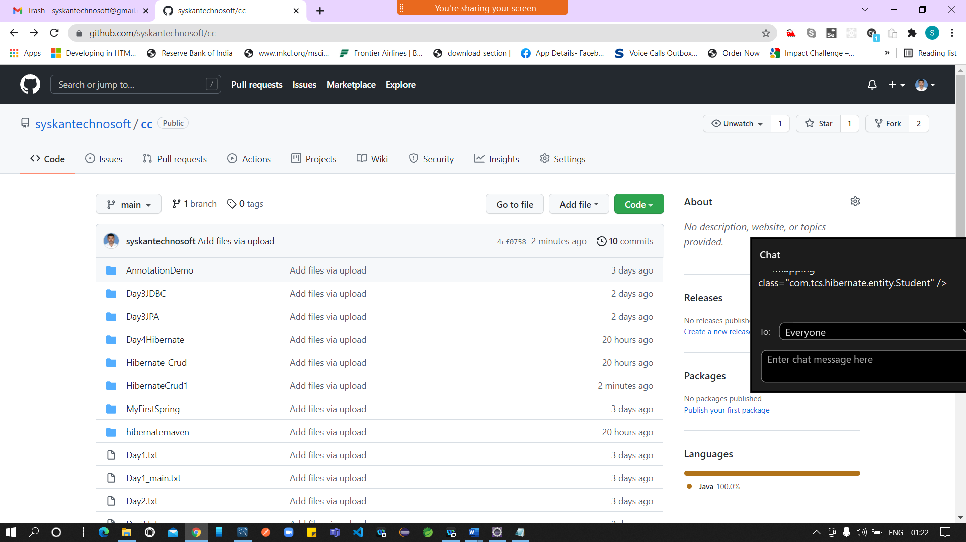

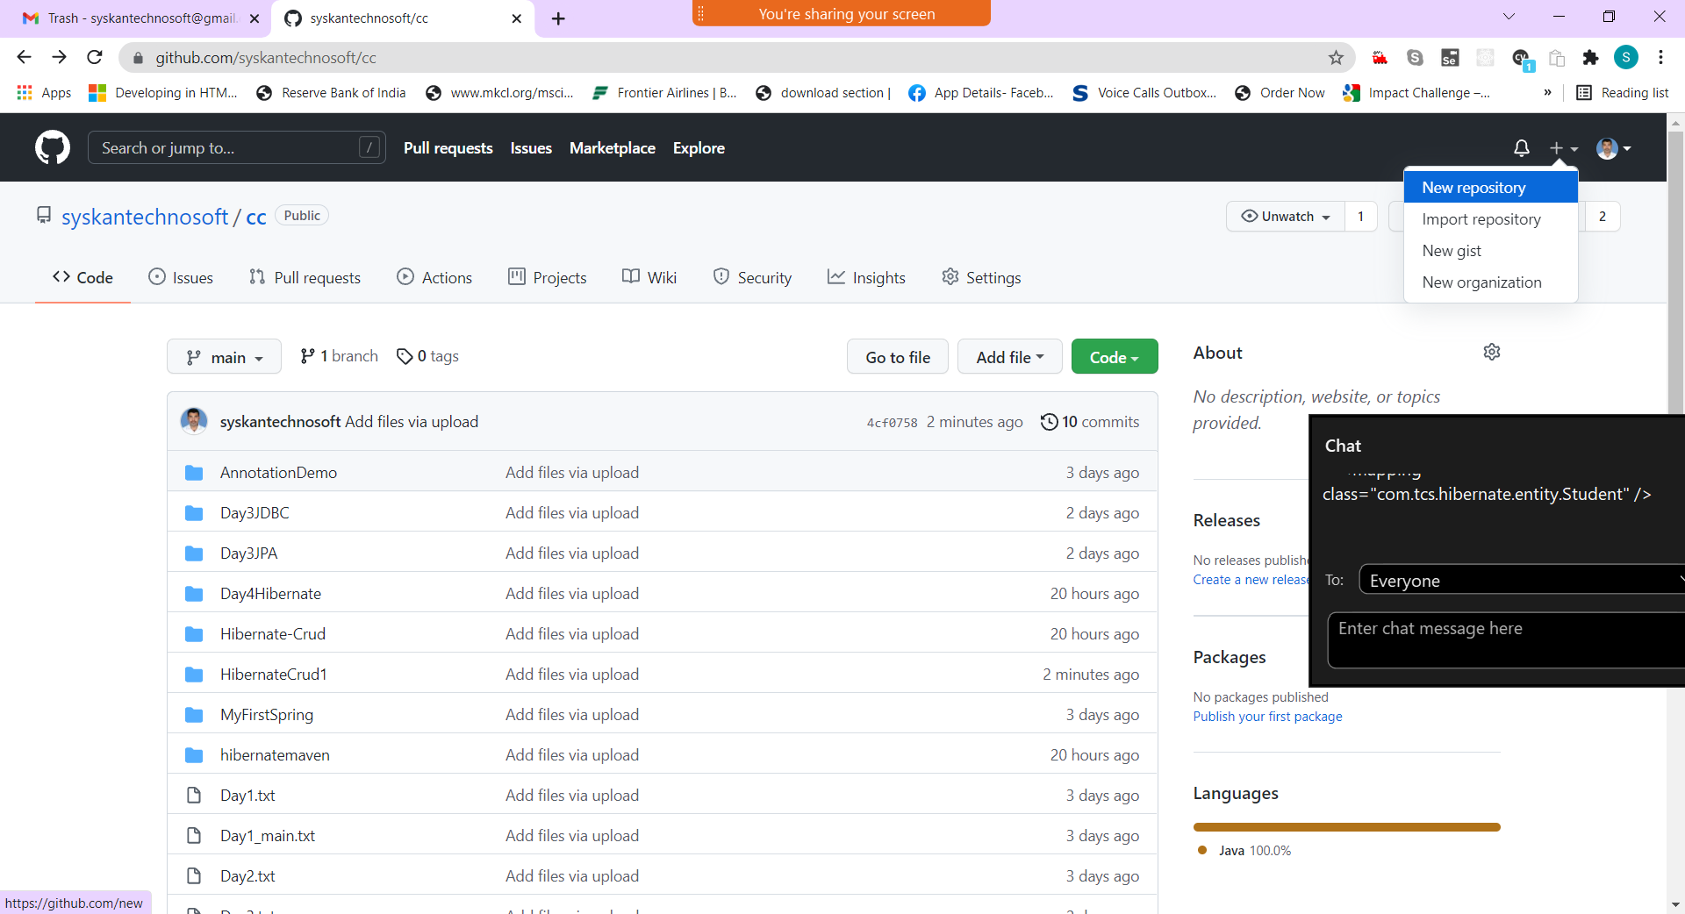

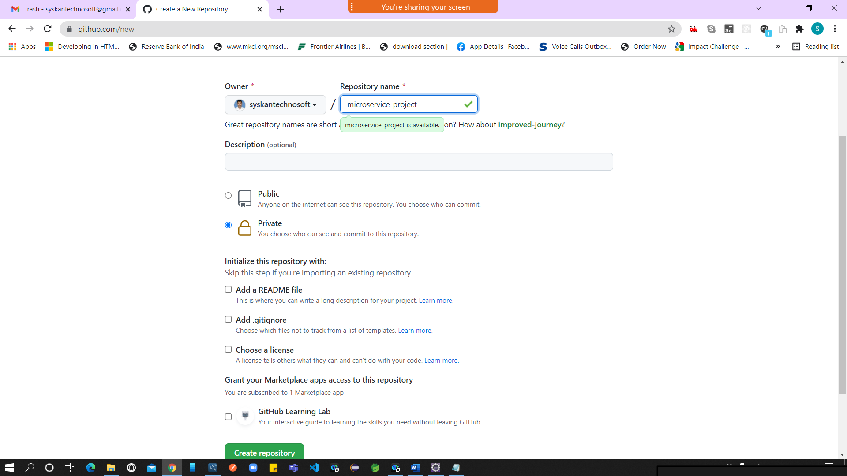

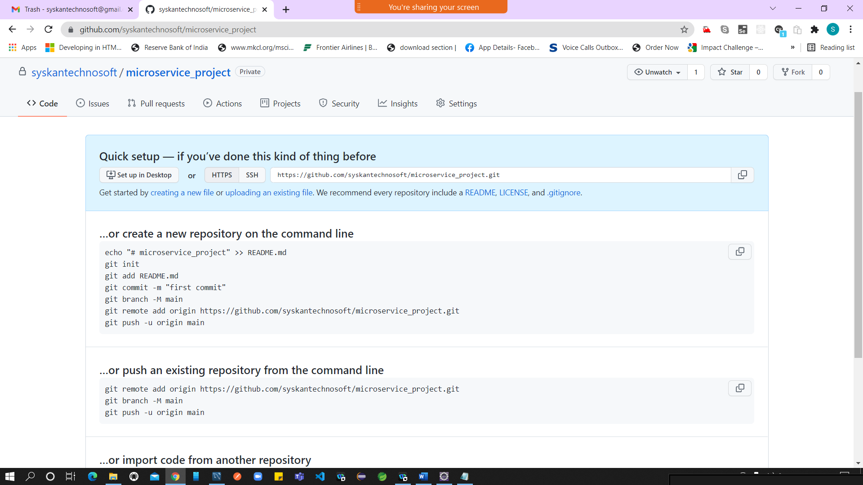

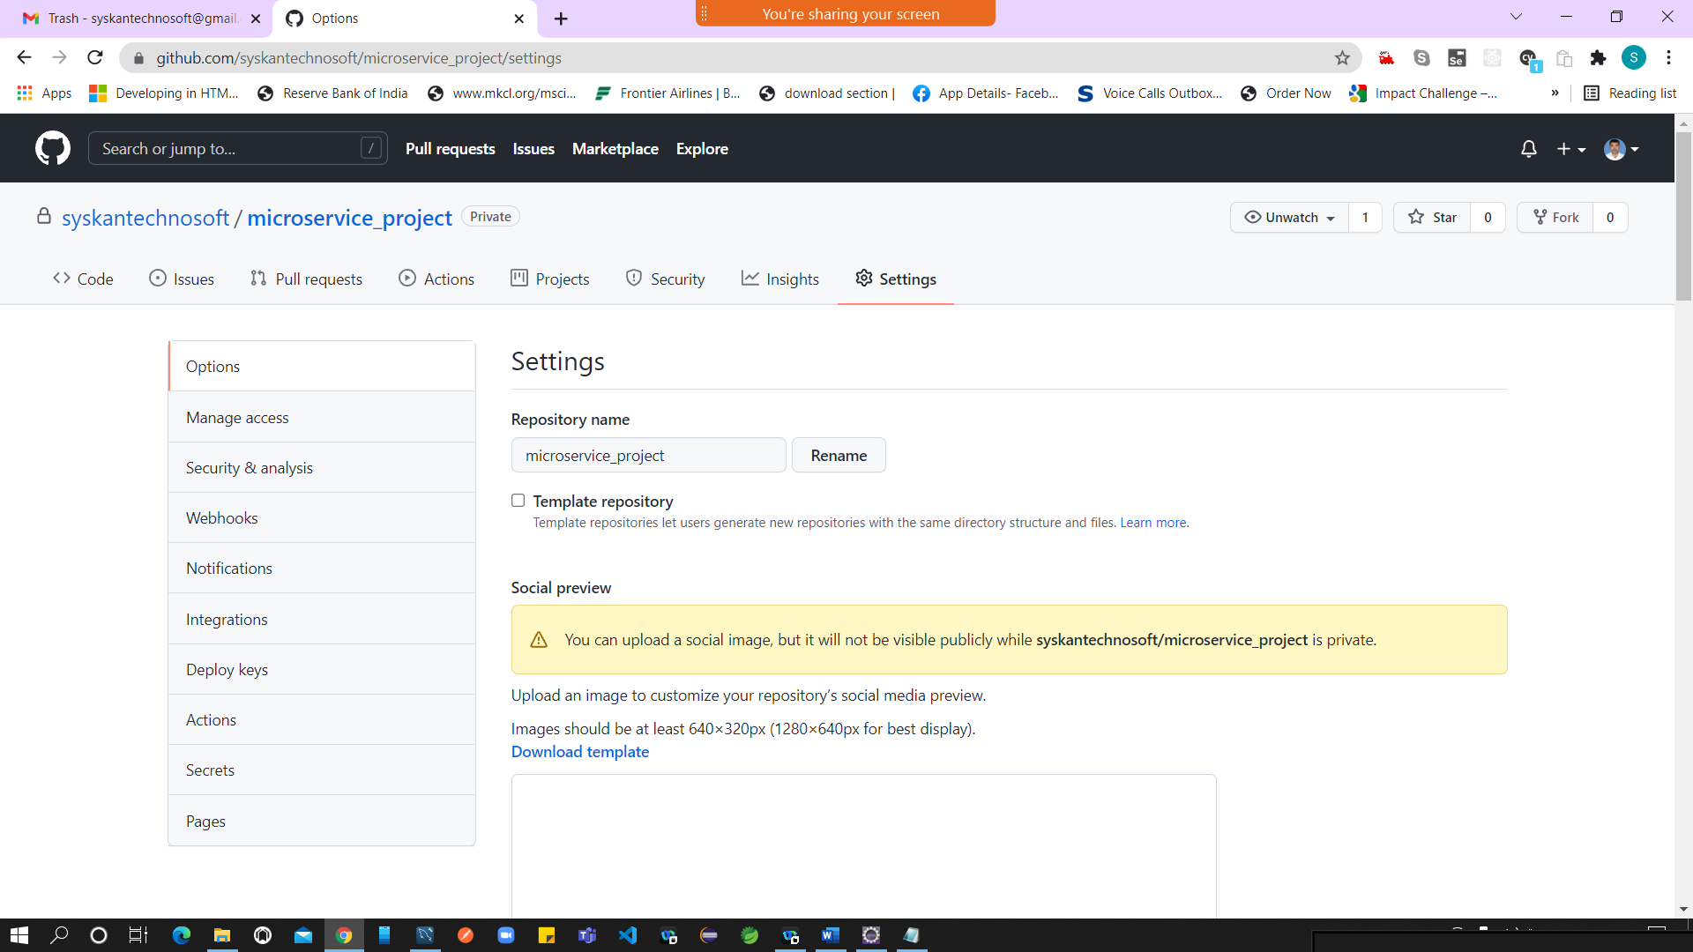

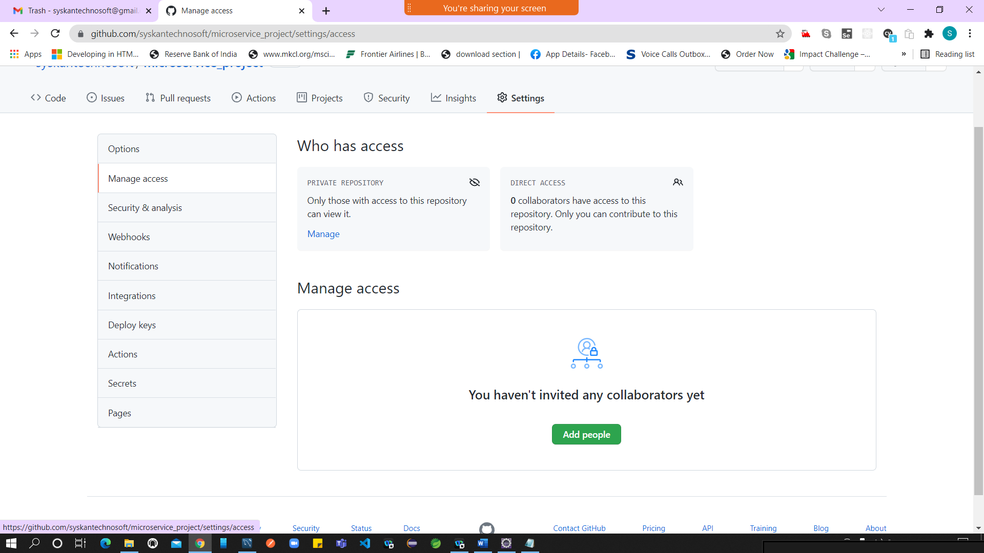

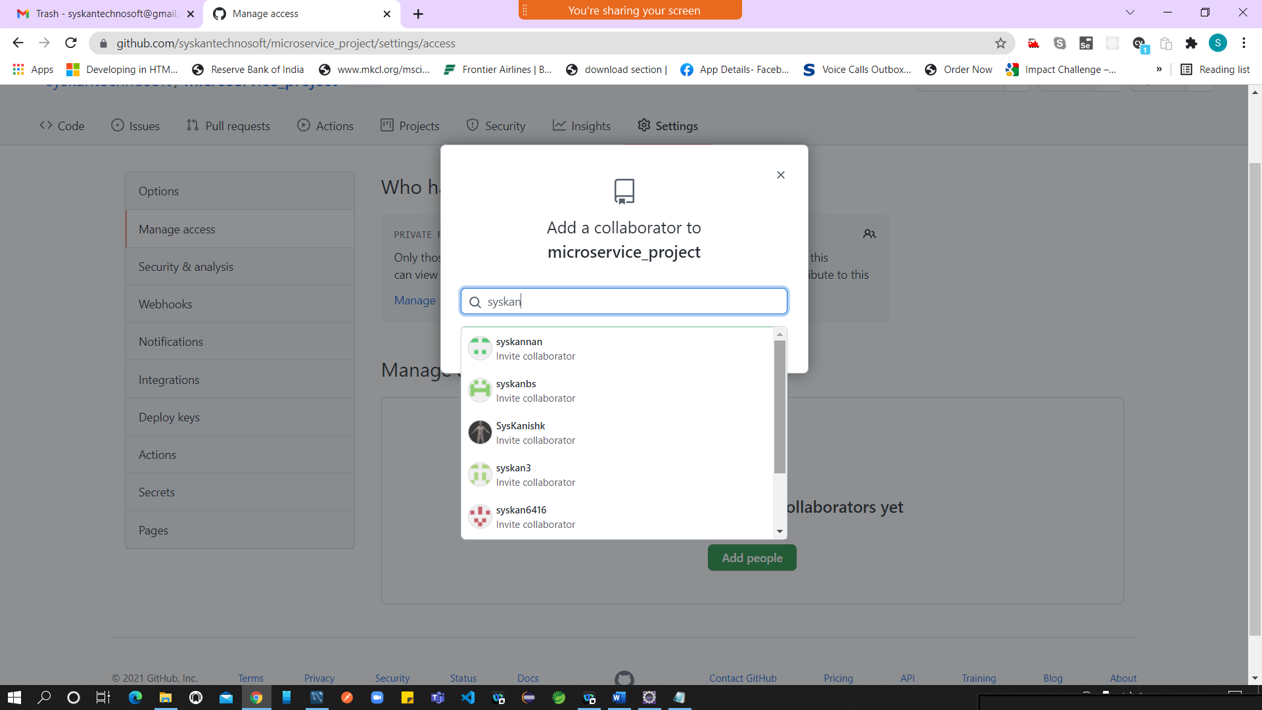

Project

Food_Item

User

Rating

Cart

Java 8 Features

Lambda

Lambda – Anonymous Function (nameless)

Public void function_name( type , list of args) --- function definition/ signature

Public void (types, list of args) {} // specifying the access modifier not necessary

Void (type,list of args) { }

If(condition)

True section

Else

False section

Anonymous function – inline function --- one/single line function

Void (type, list of args)

N -> System.out.println(N); --- simple lambda (arrow function)

You can store the lambda in a variable

Functional Interface -- A Interface with only one abstract method is called as function interface

1. A Functional Interface should have only one abstract method
2. It can have any number of default & static method

Marker Interface – A Interface with no methods

Wrapper Classes

Boxing – Process of converting primitive to it’s corresponding object

AutoBoxing – Collections

UnBoxing == converting Object into it’s primitive type

Consumer - Functional Interface (java.util.funtion)

E – Element

T – Type (Any Data Type)

K – Key

V – Value

<https://docs.oracle.com/javase/tutorial/java/javaOO/lambdaexpressions.html>

<https://www.w3schools.com/java/java_lambda.asp>

<https://docs.oracle.com/javase/tutorial/java/javaOO/lambdaexpressions.html>

Streams

Predicate

Functional Programming -- Doing more operation in a single line

Database Design

PrimaryKey – Foreign Key

1. **public** **class** JavaStreamExample {
2. **public** **static** **void** main(String[] args){
3. Stream.iterate(1, element->element+1)
4. .filter(element->element%5==0)
5. .limit(5)
6. .forEach(System.out::println);
7. }
8. }

CREATE TABLE `account` (

`id` int NOT NULL AUTO_INCREMENT,

`account_type` varchar(45) DEFAULT NULL,

`interest_rate` float DEFAULT NULL,

`min_balance` int DEFAULT NULL,

PRIMARY KEY (`id`)

) ENGINE=InnoDB DEFAULT CHARSET=utf8mb4 COLLATE=utf8mb4_0900_ai_ci;

SELECT * FROM tcs.student;

CREATE TABLE `customer` (

`id` int NOT NULL AUTO_INCREMENT,

`name` varchar(45) DEFAULT NULL,

`email` varchar(45) DEFAULT NULL,

`password` varchar(45) DEFAULT NULL,

PRIMARY KEY (`id`)

) ENGINE=InnoDB DEFAULT CHARSET=utf8mb4 COLLATE=utf8mb4_0900_ai_ci;

CREATE TABLE `customer_account` (

`id` int NOT NULL AUTO_INCREMENT,

`customer_id` int DEFAULT NULL,

`account_id` int DEFAULT NULL,

`balance` float DEFAULT NULL,

PRIMARY KEY (`id`),

KEY `fk1_idx` (`customer_id`),

KEY `fk2_idx` (`account_id`),

CONSTRAINT `fk1` FOREIGN KEY (`customer_id`) REFERENCES `customer` (`id`),

CONSTRAINT `fk2` FOREIGN KEY (`account_id`) REFERENCES `account` (`id`)

) ENGINE=InnoDB DEFAULT CHARSET=utf8mb4 COLLATE=utf8mb4_0900_ai_ci;