Spring Data JPA (h2, MySQL & Postgres DB)

H2- In memory Database (Written in JAVA, 2mb in size)

MySQL 8.0.x Community version (mysql command line client, MySQL Workbench)

Postgres 12.x (psql, pgAdmin)

Web Service using Spring Data JPA

JPA – Java Persistence API (Hibernate, Eclipse Link)

Step 1: Create a new Spring Starter project in STS

File->New->Spring Starter Project

“springdatajpa”

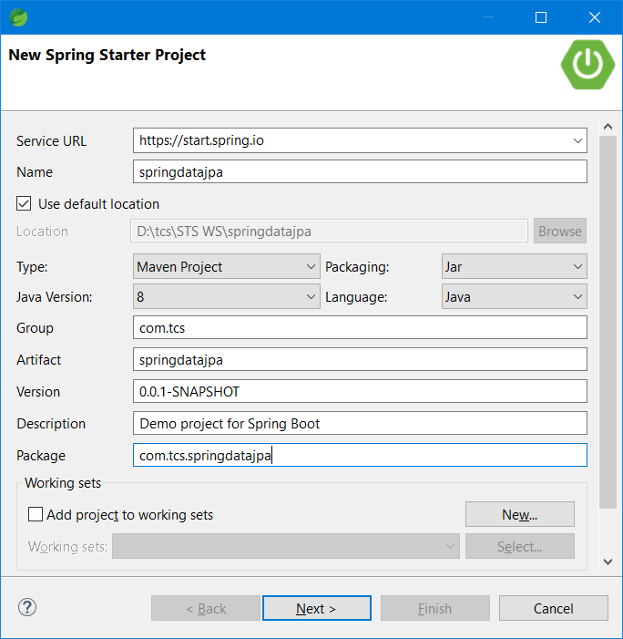

Add the following dependencies to the project and click finish.

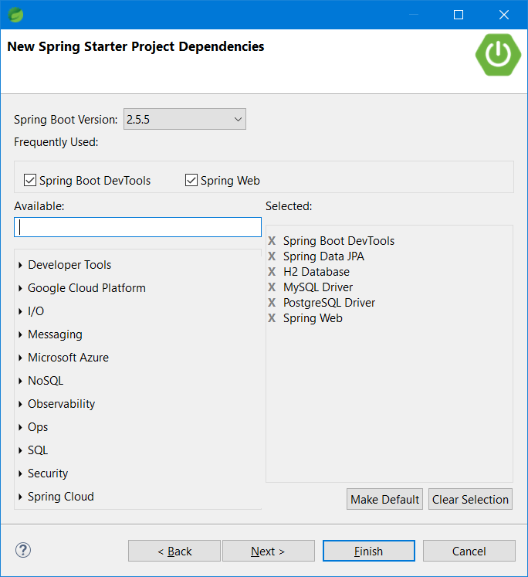

Add the following packages

Base package – com.tcs.springdatajpa

Sub packages- model, controller, repository, service, util, exceptions, config

Step 2: Adding necessary sub-packages to the base package

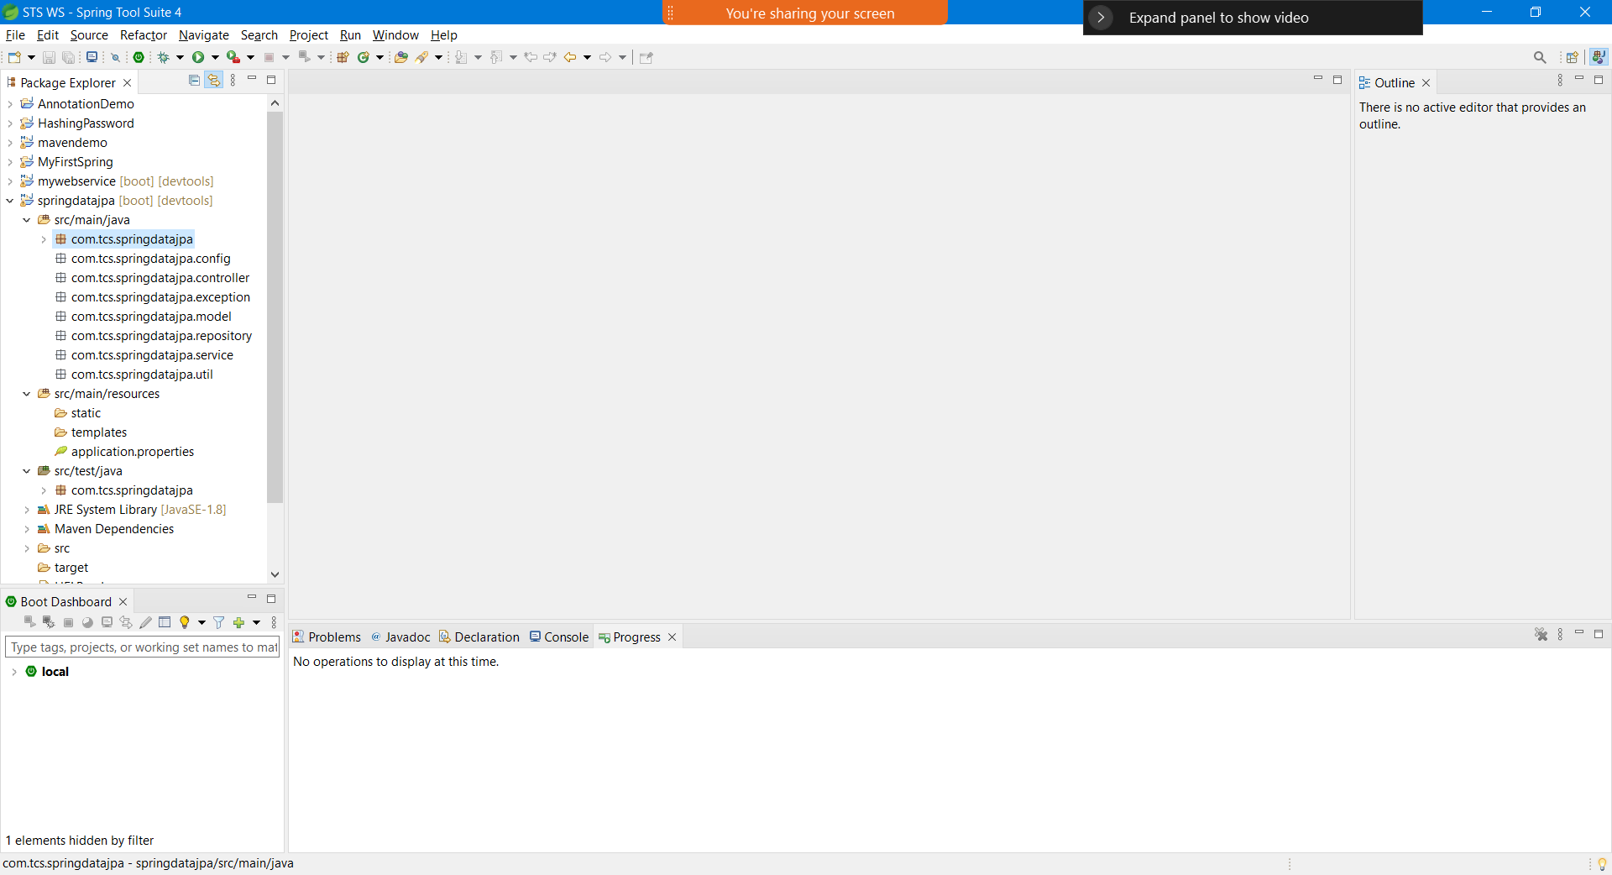

Step 3: Adding the model Class, Service Interface & Class and Controller class code.

Repository – DAO Implementation (Data Access Object)

Interface <repo_name> extends jparepo or crudrepo

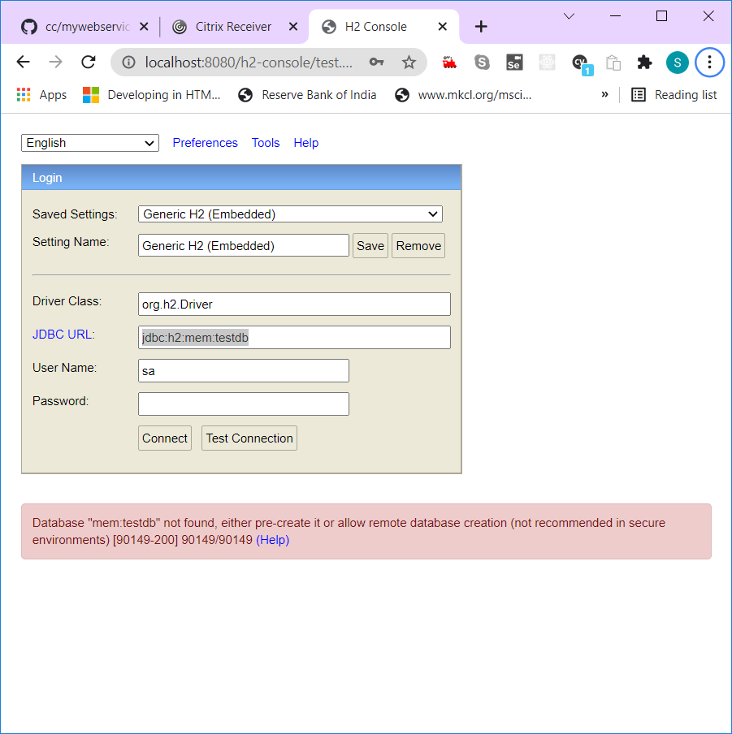

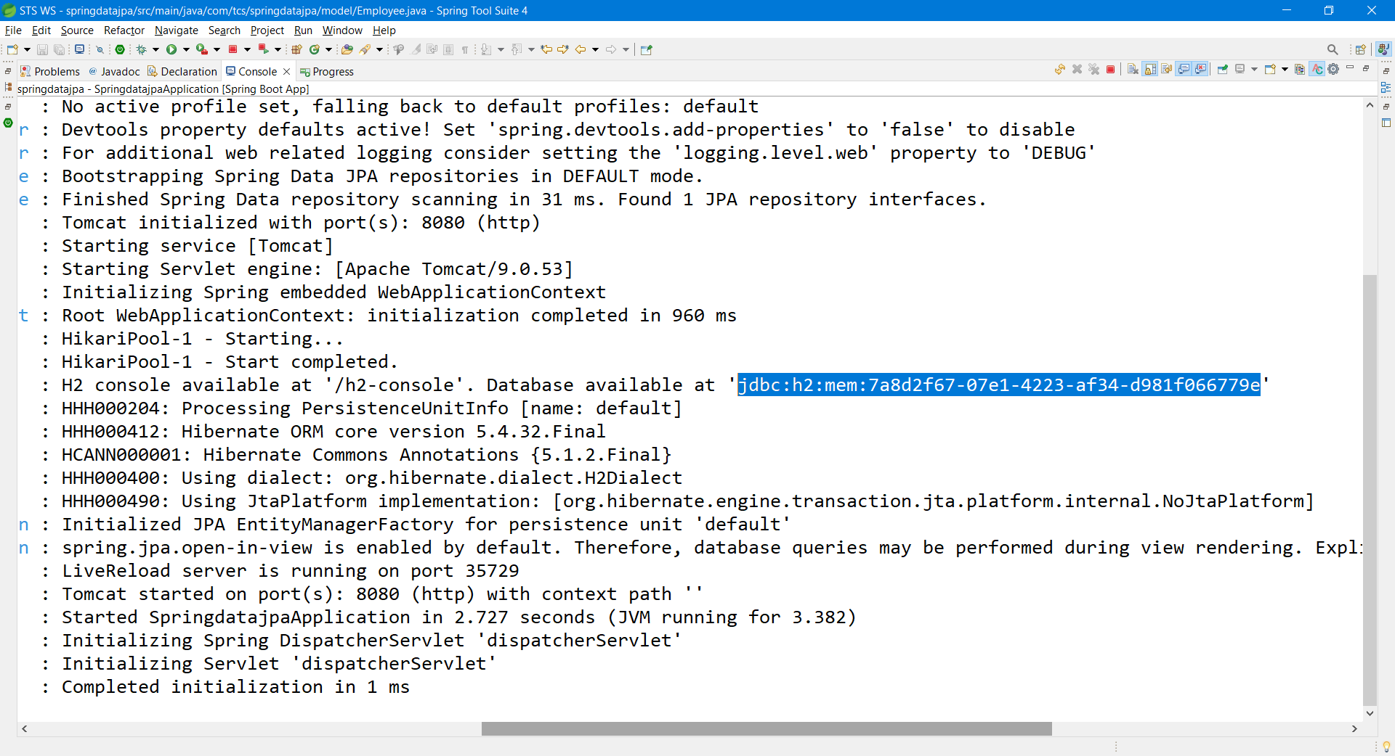

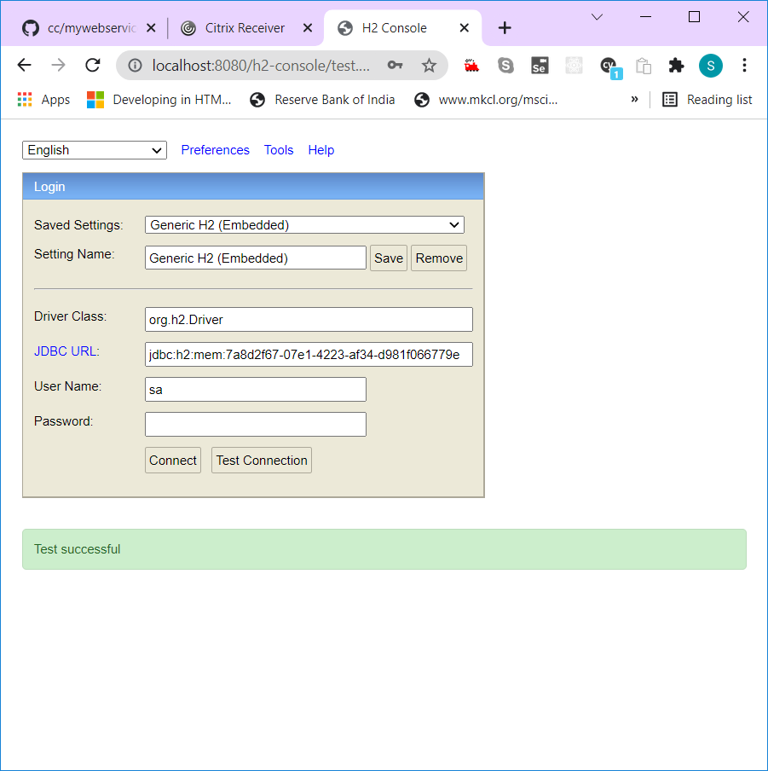

Ctrl+/ -- Toggle Comment (jsp,java, properties,js except xml)