AI-Enabled Java Full Stack Developer: 12-Week Project Blueprint
The curriculum already introduces Core Java, JDBC, SQL, MongoDB, React, Spring Boot, Spring Data JPA, Spring Security, Kafka, Docker, CI/CD, Python, FastAPI, LangChain, vector databases, and agentic AI across Weeks 1–12. The project plan below maps these topics into progressively more complex deliverables.
The key design decision is to use one common business domain for P1, P2, P3, and P4, so learners build reusable domain knowledge while demonstrating four different architectural approaches.

1. Recommended project portfolio

P1 — Core Java standalone application
Individual project
Technology: Java, OOP, Collections, JDBC, MySQL/PostgreSQL.
Build a secure CLI-based banking application covering account management, deposits, withdrawals, fund transfers, transaction history, SQL transactions, validation, and exception handling.
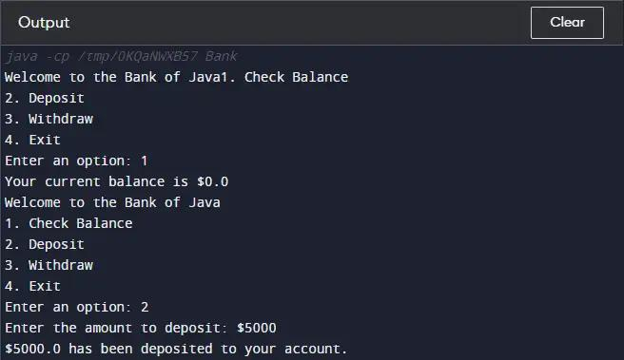
Figure 1 — Example P1 console session

P2 — Enterprise monolithic application
Team project · 6 members
Technology: Java, Spring Boot, React, PostgreSQL/MySQL, MongoDB.
Build a Learning Management System (LMS) with six independently developed functional modules, integrated into one deployable application.
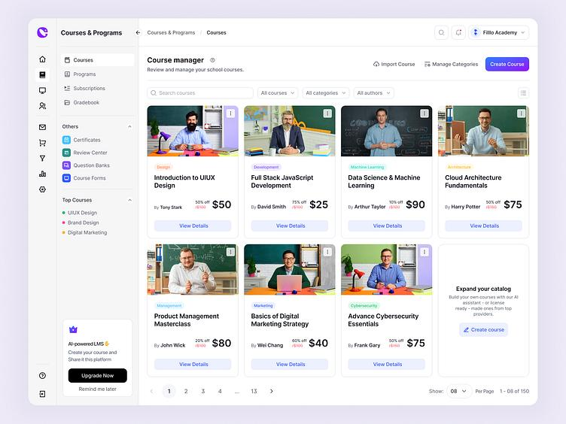
Figure 2 — Example LMS course-management interface

P3 — LMS microservices implementation
Team project · 6 members
Technology: Spring Boot microservices, Spring Cloud, React, PostgreSQL/MySQL, MongoDB, Kafka, Docker.
Re-engineer the P2 business functionality into independently deployable services, with API gateway routing, service discovery, event-driven communication, and security.
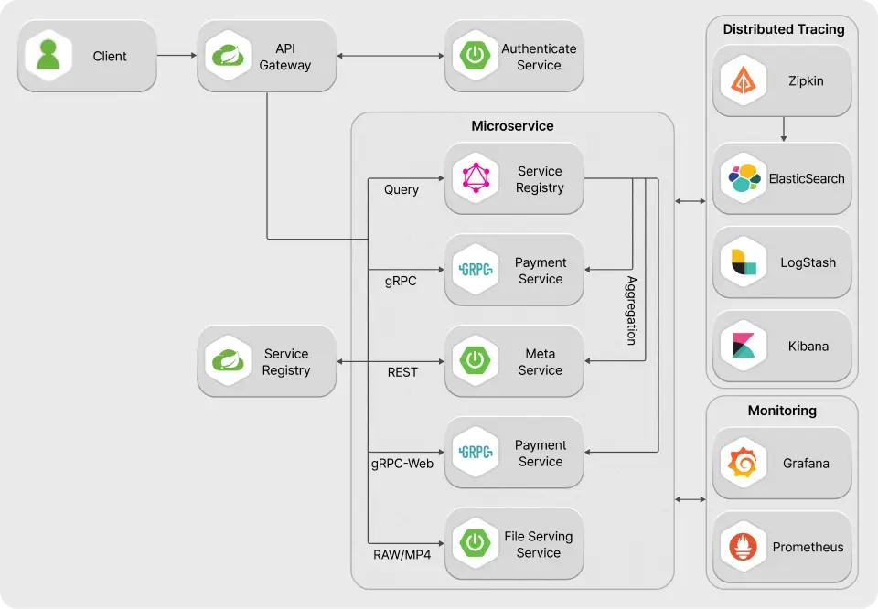
Figure 3 — Example microservices reference architecture

P4 — Python RAG and enterprise AI assistant
Team project · 6 members
Technology: Python, FastAPI, LangChain, embeddings, vector database, LLM, React integration.
Build an AI assistant that answers questions from approved course, learner, trainer, and system documentation, provides source citations, and integrates with P3 through secured APIs.
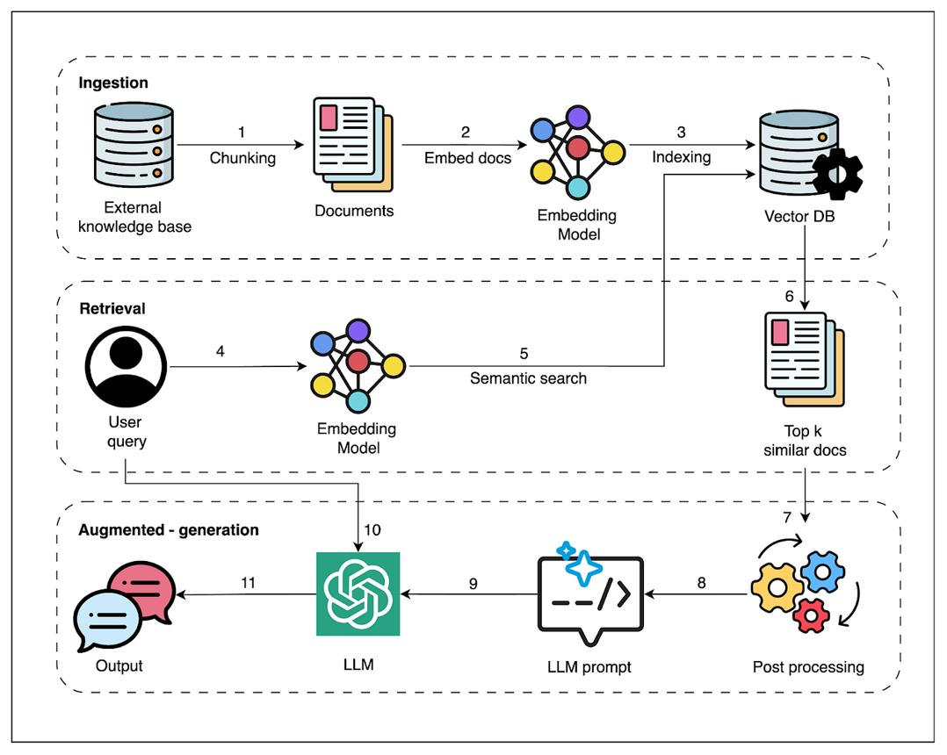
Figure 4 — Example RAG pipeline (ingestion, retrieval, augmented generation)
Proposed common domain: Learning and Training Management System (LMS). This is a recommendation rather than a requirement explicitly stated in the uploaded curriculum. It provides a coherent business context for CRUD operations, relational and dynamic data, security, microservices, events, and RAG.

2. Project governance and team structure
Each team contains six members. Every member owns one module, including its implementation, tests, documentation, and integration with the other modules.
Project | Development model | Team structure | Primary outcome
P1 | Individual | Every learner works independently | Working Java CLI application
P2 | Monolith | Six members per team | One deployable full-stack LMS
P3 | Microservices | Same six-member team where possible | Six independently deployable services
P4 | Python RAG | Six members per team | Six integrated AI components

For P2, P3, and P4, assign one technical integration lead per team. The lead remains responsible for one module but also coordinates shared contracts, code reviews, merge conflicts, integration tests, and release readiness. Rotate the lead between projects if practical.

Mandatory engineering practices
- GitHub repository with feature branches, pull requests, and code reviews.
- Agreed coding standards, package naming, API conventions, and error formats.
- Unit tests for business logic and integration tests for persistence and APIs.
- AI-assisted coding with human review, generated-code validation, and no sensitive data in prompts.
- README, architecture diagram, setup instructions, API documentation, and test evidence.
- Regular integration builds; modules must not be developed independently until the final demo.
- A module is complete only when it works through the agreed integration contract, not just on the developer’s machine.

3. P1 — Individual Core Java standalone project
Project: Secure Banking CLI
Recommended duration: Weeks 2–4, with final evaluation in Week 4.

3.1 Business objective
Build a menu-driven banking application that supports customer registration, bank accounts, deposits, withdrawals, fund transfers, transaction history, and secure access using Core Java and JDBC.
The application must run in a terminal without Spring Boot, React, or any web framework. This ensures that learners demonstrate genuine Core Java, SQL, and JDBC competency.

3.2 Functional requirements
ID | Requirement | Acceptance criteria
P1-F01 | Customer registration | Create customers with unique identifiers and validated details.
P1-F02 | Authentication | Authenticate using securely hashed passwords; never store plain-text passwords.
P1-F03 | Account management | Create savings/current accounts with unique account numbers and an initial balance of zero.
P1-F04 | Deposit | Accept valid positive amounts and update the account balance and transaction ledger.
P1-F05 | Withdrawal | Reject invalid amounts and insufficient funds.
P1-F06 | Fund transfer | Debit one account and credit another atomically; roll back both operations if any step fails.
P1-F07 | Balance enquiry | Display the authenticated customer’s account balance.
P1-F08 | Transaction history | Display paginated transactions with date, type, amount, status, and reference.
P1-F09 | Timeout and logout | Implement inactivity timeout, session invalidation, and explicit logout.
P1-F10 | Input validation | Reject invalid numbers, malformed input, negative values, and invalid account references.
P1-F11 | Database integrity | Use primary keys, foreign keys, unique constraints, and prepared statements.
P1-F12 | Audit trail | Record transaction references, timestamps, statuses, and relevant account changes.

Additional requirements
- Use OOP, encapsulation, inheritance or composition where appropriate, interfaces, collections, enums, custom exceptions, and the Java Date/Time API.
- Use a DAO/repository layer to isolate JDBC code from business logic.
- Use try-with-resources, structured logging, and appropriate exception handling.
- Apply JDBC transactions with commit() and rollback() for fund transfers.
- Add JUnit tests for valid operations, validation failures, and transaction rollback.
- Document the difference between authentication timeout and database transaction timeout.
Security note: This is an educational banking simulation, not a production banking system. Password hashing, authorization checks, session timeout, SQL injection prevention, and auditability are required learning outcomes; production-grade banking controls are out of scope.

3.3 Suggested package structure
banking-cli/
├── src/main/java/com/example/banking/
│ ├── app/ # Main class and menu navigation
│ ├── model/ # Customer, Account, Transaction
│ ├── dao/ # JDBC persistence
│ ├── service/ # Banking business rules
│ ├── security/ # Authentication and session timeout
│ ├── validation/ # Input and business validation
│ ├── exception/ # Custom exceptions
│ └── util/ # DB connection, configuration, logging
├── src/test/java/
├── sql/schema.sql
├── sql/sample-data.sql
├── pom.xml
└── README.md

3.4 Architecture diagram
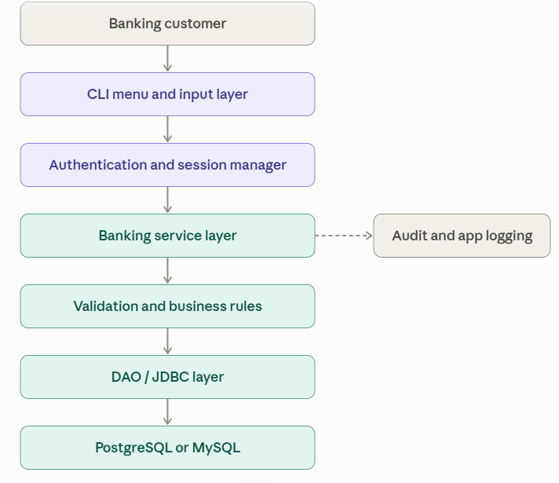
Figure 5 — P1 layered architecture

3.5 Database design
Recommended relational tables:
- customers: customer ID, name, email, phone, password hash, status.
- accounts: account ID, customer ID, account number, account type, balance, status.
- transactions: transaction ID, reference number, source account, destination account, type, amount, timestamp, status.
- login_audit: customer ID, timestamp, outcome, and relevant audit metadata.
The balance and transaction ledger must remain consistent. Use database transactions, suitable locking or isolation, and database constraints rather than relying only on Java-side validation.

3.6 P1 evaluation rubric
Evaluation area | Weight
Core Java, OOP, and code quality | 25%
JDBC, SQL, and schema design | 20%
Banking functionality and transaction integrity | 25%
Exception handling, validation, and security | 15%
Unit testing, Git, and documentation | 15%

4. P2 — Full-stack monolithic LMS
Project: Learning and Training Management System
Recommended implementation: Weeks 5–8; final demo in Week 8.

4.1 Business scenario
A corporate training organization needs one web application to manage trainers, learners, courses, learning content, enrolments, assessments, reviews, and notifications.
The system must support three primary roles:
- Administrator: manages users, permissions, course approval, and reporting.
- Trainer: creates courses, publishes modules and learning resources, and manages assessments.
- Learner: discovers courses, enrols, studies content, submits assessments, and reviews completed courses.

4.2 Six team modules
Module | Owner | Scope
Module 1 — Identity, users, and roles | Member 1 | Registration, login, user profiles, role-based access, account status, and access-controlled endpoints. Implement Spring Security and JWT or a suitable session-based approach.
Module 2 — Course and curriculum management | Member 2 | Course catalogue, categories, trainer assignment, learning objectives, prerequisites, course lifecycle, and course search. Store structured course information in the relational database.
Module 3 — Learning content and delivery | Member 3 | Modules, lessons, reading materials, links, attachments metadata, learner progress, completion tracking, and dynamic content metadata stored in MongoDB where appropriate.
Module 4 — Enrolment and assessment | Member 4 | Enrolment, assessment creation, question banks, submissions, scoring, completion status, and learner progress reports.
Module 5 — Reviews and learner feedback | Member 5 | Ratings, written reviews, review moderation, course feedback, and course rating summaries. Enforce one review per eligible learner per course.
Module 6 — Notifications and reporting | Member 6 | In-app notifications, enrolment and assessment alerts, course completion summaries, and administrative dashboard reports.

4.3 Mandatory functional requirements
- Users can log in and see role-appropriate navigation and operations.
- Trainers can create, edit, publish, and archive courses.
- Published courses contain ordered modules and lessons.
- Learners can search the catalogue, enrol, access learning materials, and record progress.
- Assessments can be submitted and scored, with attempts and results retained.
- Learners can rate and review eligible courses.
- Course and assessment events produce notifications.
- Administrators can view course counts, enrolment summaries, and completion metrics.
- All modules expose documented internal service interfaces and/or REST APIs, even though they run in one application.
- Unauthorized access, invalid state transitions, and duplicate enrolments must be rejected.

4.4 Technology and data requirements
Layer | Required technology | Responsibility
Frontend | React, JavaScript or TypeScript | Routing, forms, dashboards, API calls, state management
Backend | Java and Spring Boot | REST APIs, validation, business logic, security
Relational data | PostgreSQL or MySQL | Users, courses, enrolments, assessments, results, reviews
Dynamic data | MongoDB | Flexible content metadata, notification payloads, configurable question content where suitable
Persistence | Spring Data JPA, Spring Data MongoDB, JDBC where appropriate | Relational and document persistence
API documentation | OpenAPI/Swagger UI | Contract and endpoint documentation
Testing | JUnit, Mockito, API integration tests, React tests | Verification at each layer
Packaging | Maven, Docker optional for P2 | Reproducible build and deployment

Use the relational database for records that require strong relationships, constraints, and transactions. Use MongoDB only where the document structure genuinely benefits from flexibility; do not duplicate the same source of truth in both databases.

4.5 Monolithic architecture
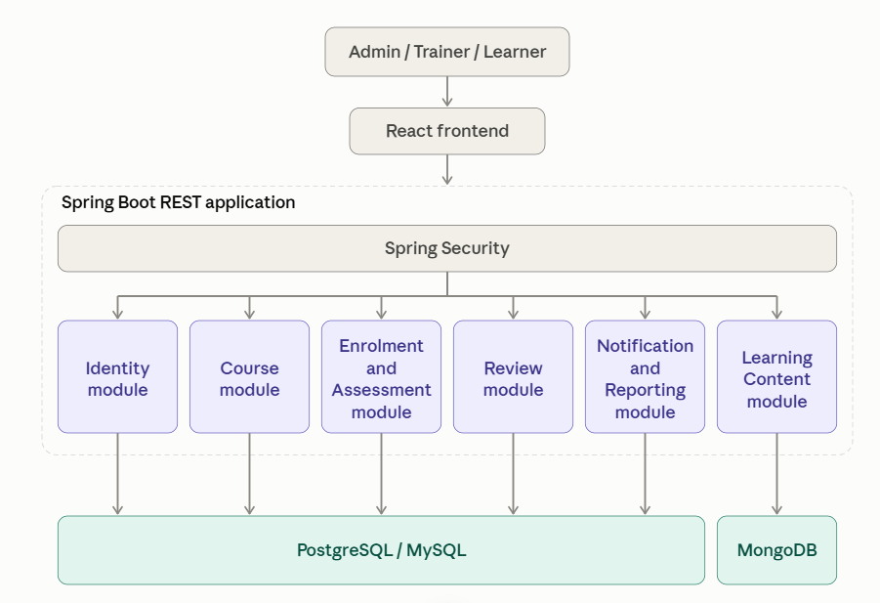
Figure 6 — P2 monolithic LMS architecture
Deployment constraint: P2 is one backend application and one deployable backend artifact, with six logical modules. It may use separate databases, but those databases do not turn it into a microservices architecture.

4.6 Module contract and integration rules
Each member must deliver:
- A defined scope and data ownership statement.
- REST endpoint specifications with request and response examples.
- DTOs and validation rules.
- Persistence implementation and migration scripts.
- Unit tests and integration tests.
- An API error model and logging.
- A short integration guide and demo dataset.
Before implementation, agree on shared identifiers (userId, courseId, enrolmentId), timestamp formats, pagination conventions, error response formats, and API naming. Shared DTOs should not expose JPA entities directly.

5. P3 — Microservices version of P2
Project: LMS Microservices Platform
Recommended implementation: Weeks 8–10, building on P2.
P3 must preserve the business capabilities demonstrated in P2 while changing the architecture. Teams should not simply split the existing Java packages into six folders and call them microservices.

5.1 Six services and ownership
Member | Microservice | Responsibilities | Data ownership
1 | Identity Service | Registration, authentication, users, roles, access policies | Identity database
2 | Course Service | Course catalogue, categories, publication, trainer assignment | Course database
3 | Learning Content Service | Modules, lessons, resources, learner progress | MongoDB or service-owned data store
4 | Enrolment & Assessment Service | Enrolment, assessment attempts, results, completion | Enrolment/assessment database
5 | Review Service | Ratings, reviews, moderation, rating aggregates | Review database
6 | Notification & Reporting Service | Notifications, event consumers, operational summaries | Notification/reporting database

Infrastructure components are shared responsibilities, not additional business modules: API Gateway, service discovery, centralized configuration, Kafka, observability, and container orchestration.

5.2 Mandatory architecture requirements
- Each service has its own Spring Boot application, build configuration, Dockerfile, and deployment configuration.
- Services own their data. No service directly reads or writes another service’s database.
- The React application accesses backend APIs through the API Gateway.
- Use Spring Cloud Gateway for routing and an appropriate discovery mechanism such as Eureka.
- Use synchronous REST calls for request/response operations where suitable.
- Use Kafka for asynchronous domain events such as CoursePublished, LearnerEnrolled, AssessmentCompleted, and ReviewSubmitted.
- Implement centralized authentication and authorization, preferably with JWT validation and role-based access.
- Implement health checks, structured logging, metrics, and distributed tracing.
- Add service-level tests and end-to-end tests across multiple services.
- Demonstrate independent service deployment and failure isolation.

5.3 Microservices architecture diagram
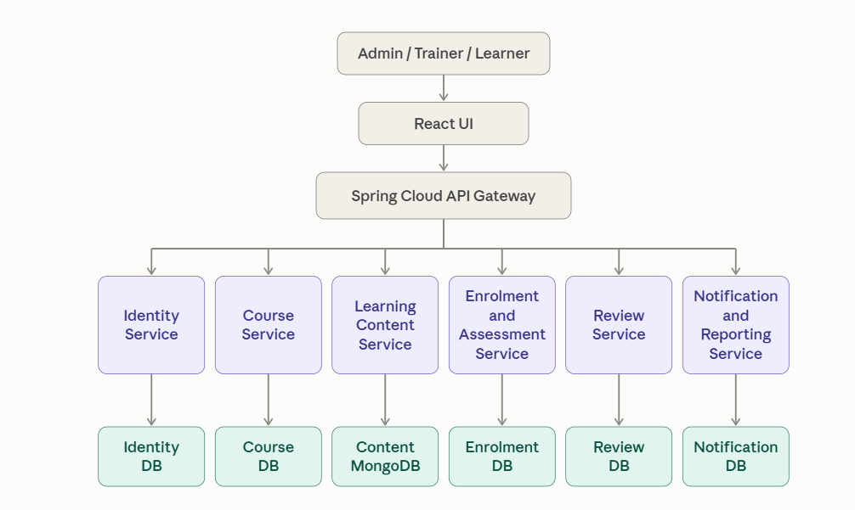
Figure 7 — P3 request path: gateway, services, and databases
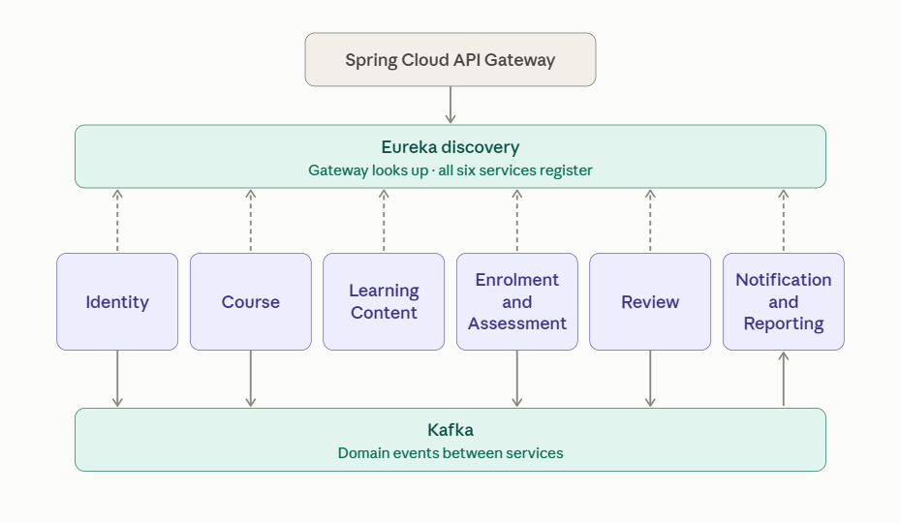
Figure 8 — P3 platform wiring: Eureka registration and Kafka events

5.4 Integration scenarios to demonstrate
Scenario A — Course publication
- A trainer publishes a course using the Course Service.
- The service stores the course and publishes a CoursePublished event.
- The Notification Service consumes the event and creates notifications.
- The learner can discover the published course through the gateway.
Scenario B — Learner enrolment
- A learner authenticates and requests enrolment.
- The Enrolment Service validates eligibility and records enrolment.
- A LearnerEnrolled event is published.
- The Notification Service generates the corresponding notification.
- Duplicate requests must not create duplicate enrolments.
Scenario C — Assessment completion
- The learner submits an assessment.
- The Enrolment & Assessment Service evaluates the submission and stores the result.
- An AssessmentCompleted event is emitted.
- The Notification Service generates an alert.
- The learner can retrieve the result using the API Gateway.
For event delivery, demonstrate retry handling and idempotent consumers. If time permits, introduce the transactional outbox pattern to prevent a database update from succeeding while its corresponding event is lost.

5.5 DevOps and deployment requirements
- Docker Compose for local integration of the gateway, six services, databases, Kafka, and supporting infrastructure.
- GitHub Actions pipeline to build, test, and package each service.
- Automated container image builds and publication to a registry.
- Kubernetes manifests or Helm charts as an advanced deployment exercise.
- Health endpoints, Prometheus metrics, and a Grafana dashboard.
- Centralized logs and trace correlation where the available time and infrastructure permit.
The six business services are the minimum team-owned deliverables. Infrastructure should be allocated across the team through shared ownership and code review.

6. P4 — Python RAG application integrated with P3
Project: AI-Powered LMS Knowledge Assistant
Recommended implementation: Weeks 10–12, final integration and demonstration in Week 12.

6.1 Business objective
Provide a conversational AI assistant that answers questions about training programmes, course materials, learning policies, technical documentation, and learner guidance using approved knowledge sources.
P4 must use retrieval-grounded answers rather than simply passing a user question to an LLM. The assistant should retrieve relevant documents, generate a response, identify sources, and enforce authorization before retrieving protected information.

6.2 Six Python RAG modules
Member | Module | Detailed responsibilities
1 | Document ingestion | Upload or import PDF, Markdown, text, and approved HTML documents; validate formats; extract text and metadata; handle duplicates and document updates.
2 | Chunking and embeddings | Configure chunk size and overlap, generate embeddings, retain document metadata, and support repeatable re-indexing.
3 | Vector retrieval | Store embeddings in a vector database, perform similarity search, apply metadata filters, and return ranked chunks with source references.
4 | RAG orchestration | Build LangChain chains, prompts, retrievers, context assembly, grounded answer generation, and source citation formatting.
5 | FastAPI integration | Implement REST endpoints, Pydantic request/response models, authentication integration, validation, error handling, and API documentation.
6 | Evaluation and P3 integration | Implement retrieval and answer-quality tests, citation validation, latency/token metrics, integration with P3 APIs, and a demonstrable user workflow.

6.3 Functional requirements
ID | Requirement | Acceptance criteria
P4-F01 | Document ingestion | Valid documents are ingested, indexed, and associated with source metadata.
P4-F02 | Text chunking | Chunking strategy is configurable and preserves useful source references.
P4-F03 | Embeddings | Embeddings are generated using a documented model and stored in the vector database.
P4-F04 | Retrieval | Relevant chunks are retrieved for a user question using similarity search and optional metadata filters.
P4-F05 | Grounded generation | The LLM receives the question and retrieved context and is instructed not to invent unsupported facts.
P4-F06 | Citations | Responses contain identifiable source document names and page, section, or chunk references where available.
P4-F07 | Abstention | The system says when available sources do not support a reliable answer.
P4-F08 | Conversation context | Follow-up questions work within a controlled session, without allowing history to override source evidence.
P4-F09 | FastAPI | Provide documented endpoints for health, question answering, and approved document-management operations.
P4-F10 | P3 integration | The assistant can retrieve approved course and learning information from P3 using authenticated APIs.
P4-F11 | Access control | Protected data is filtered by authorization before retrieval; users cannot retrieve other learners’ private information.
P4-F12 | Evaluation | A fixed test set measures retrieval relevance, answer correctness, citation validity, and unsupported claims.
P4-F13 | Observability | Record latency, retrieval counts, errors, and token usage where available, without logging secrets or sensitive prompt contents.

6.4 RAG architecture
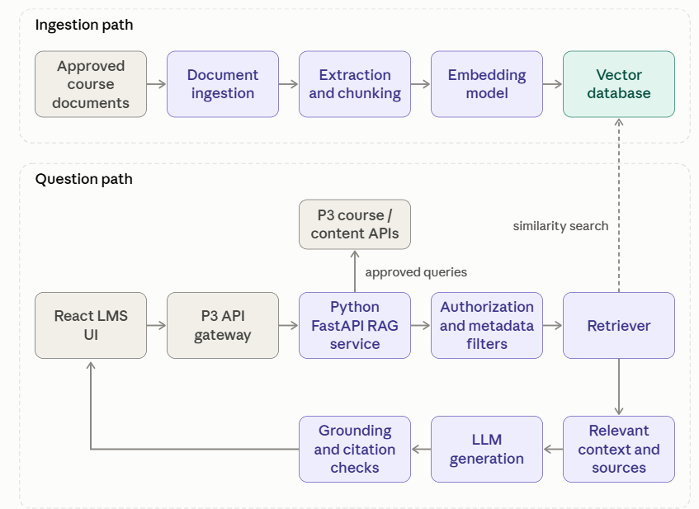
Figure 9 — P4 RAG service architecture

6.5 Suggested API contracts
Endpoint | Purpose | Example request
GET /health | Health status | No request body
POST /api/v1/ask | Ask a knowledge question | {"question":"What are the prerequisites for Java training?"}
POST /api/v1/documents | Ingest an approved document | Multipart file and metadata
GET /api/v1/documents/{id} | Retrieve document processing status | Document ID
POST /api/v1/reindex | Rebuild or update an index | Approved document identifiers

Example answer contract
{
"answer": "The prerequisites are ...",
"sources": [
{
"document": "java-course-guide.pdf",
"page": 4,
"chunk_id": "java-guide-004"
}
],
"grounded": true
}

These are proposed API contracts, not existing endpoints from the uploaded curriculum.

6.6 RAG quality and security requirements
- Build a test set of at least 30–50 representative questions with expected source documents or expected abstention.
- Compare retrieval quality at different values of top_k, chunk size, and overlap.
- Verify that each cited source actually supports the associated claim.
- Test questions whose answers are absent from the corpus.
- Protect against prompt injection inside retrieved documents.
- Keep API keys and database credentials in environment configuration or secrets management.
- Avoid indexing private learner information unless the use case is explicitly approved and authorization is enforced.
- Track latency, errors, token usage, and retrieval quality; report the measured results rather than claiming an unverified accuracy percentage.
Advanced extension: Use LangGraph to create a workflow with retrieval, relevance checking, answer generation, and a controlled retry or abstention path. MCP can be explored for tool interoperability, but neither should block the core RAG deliverable.

7. Twelve-week delivery schedule and demo dates
The schedule below aligns the projects with the uploaded curriculum’s progression. It assumes a Monday–Friday training week, with weekly reviews and milestone demonstrations on Fridays.
Date convention: The curriculum attachment does not specify the cohort’s calendar start date. Therefore, the dates below are relative to Week 1 rather than invented calendar dates. Once the start date is confirmed, each Friday checkpoint can be converted into an exact date.

Project milestone calendar (Fridays)
Week | Milestone | Scope
W2 | P1 — Design and database demo | CLI flow, class design, SQL schema, connection setup, and initial JDBC operations.
W3 | P1 — Functional checkpoint | Deposits, withdrawals, transfers, validation, exceptions, and transaction rollback.
W4 | P1 — Final individual viva | Completed application, tests, database demonstration, security checks, and code walkthrough.
W5 | P2 — Requirements and UI demo | Team formation, six module assignments, use cases, database design, wireframes, and API contracts.
W6 | P2 — Backend and frontend checkpoint | Spring Boot foundation, React components, authentication skeleton, persistence, and working APIs.
W7 | P2 — Module integration demo | All six modules integrated into one running monolith, with core business workflows and database operations.
W8 | P2 — Final monolith demo and P3 design review | Full LMS workflow, security, API documentation, tests, and architecture decomposition proposal.
W9 | P3 — Service integration demo | Six services, gateway routing, service discovery, database separation, and initial Kafka events.
W10 | P3 — Final microservices demo | End-to-end LMS workflows, security, event consumption, container deployment, and CI/CD evidence. P4 architecture review.
W11 | P4 — RAG prototype demo | Document ingestion, chunking, embeddings, vector search, FastAPI, and source-grounded responses.
W12 | P4 — Final AI integration demo and programme showcase | RAG integrated with P3, authorization, citations, evaluation results, full architecture presentation, and final viva.

7.1 Detailed week-by-week activity plan
Week | Curriculum alignment | Development activities | Friday deliverable
1 | AI orientation, Linux, Git, prompt engineering | Introduce all projects, AI usage policy, repository workflow, project briefs | Project briefing and tooling readiness
2 | Core Java, OOP, Maven | P1 class design, menu structure, JDBC connection, schema | P1 design review
3 | SQL, JDBC, collections, exceptions, unit testing | P1 business services, transfers, transaction integrity, tests | P1 functional review
4 | NoSQL, advanced Java, JDBC review | P1 hardening, timeout, logging, test coverage, viva | P1 final
5 | HTTP, HTML, CSS, JS/TS, React orientation | P2 requirements, module boundaries, wireframes, schemas | P2 design review
6 | React, TypeScript, state, API integration | P2 UI and backend implementation; introduce Spring Boot APIs | P2 vertical-slice demo
7 | Spring Boot, REST, JPA, MongoDB, security | P2 module development, API integration, testing | P2 integrated alpha
8 | Spring Data JPA, Kafka, Spring Security, microservices introduction | P2 release and evaluation; P3 service decomposition | P2 final; P3 design approval
9 | Microservices, Docker, DevOps, GitHub Actions | P3 service deployment, gateway, discovery, Kafka | P3 integration demo
10 | CI/CD, cloud, Kubernetes, Python/FastAPI foundations | P3 release; P4 ingestion and retrieval prototype | P3 final; P4 prototype
11 | Python, LangChain, RAG, vector databases | P4 chunking, embeddings, retrieval, generation, citations | P4 functional review
12 | Agentic AI, LangGraph, MCP, enterprise AI | P4 evaluation, P3 integration, hardening, documentation | P4 final and showcase

Weeks 8 and 10 contain overlapping milestones. Plan the P2 and P3 activities so that the earlier project is frozen and evaluated before its successor consumes the team’s attention. P4 can be developed alongside the later microservices work, but the core P3 APIs should stabilize before full RAG integration.

7.2 Recommended demo format
For a 60-minute team milestone review:
- 5 minutes — business problem, architecture, and member responsibilities.
- 25 minutes — live demonstration of the agreed acceptance scenarios.
- 10 minutes — code review and module ownership.
- 10 minutes — testing, failure handling, security, and data integrity.
- 10 minutes — technical questions and feedback.
For P1, use a shorter individual viva where appropriate. For the final showcase, reserve additional time for cross-project comparison and individual contribution verification.

8. Integration strategy across all four projects
The projects should form a progression rather than four unrelated assignments.
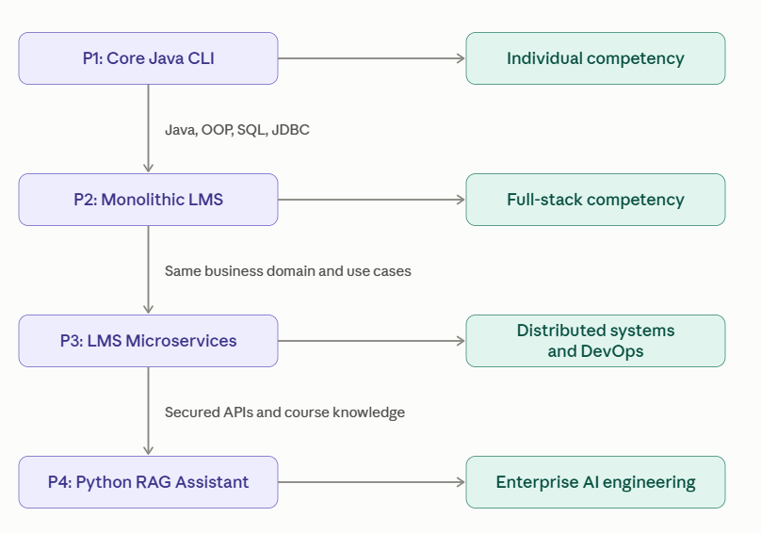
Figure 10 — Progression from P1 to P4
Use these integration checkpoints:
- P1 to P2: Carry forward sound Java design, validation, exception handling, SQL knowledge, and testing practices. The banking domain itself does not need to be embedded in the LMS.
- P2 to P3: Reuse the LMS requirements, use cases, React experience, and API contracts. Reimplement backend capabilities as independently deployable services.
- P3 to P4: Provide authenticated APIs for course catalogues and approved learning content. The Python application uses those APIs as additional knowledge sources or tools.
- End-to-end demonstration: A learner logs in to the LMS, searches for a course, accesses learning content, and asks the AI assistant a question about that content. The assistant responds with a grounded answer and identifiable source references.

9. Submission checklist and deliverables
Every project must include a defined submission package.
P1
- Source code and Maven build
- SQL schema and sample data
- JUnit tests and test results
- CLI demonstration and README
- Individual viva
P2
- React and Spring Boot source code
- Relational and MongoDB schema/configuration
- Six module ownership and API documentation
- Integration tests and test dataset
- Monolith architecture diagram and demo
P3
- Six service repositories or clearly separated service directories
- Dockerfiles and Docker Compose
- Gateway, discovery, Kafka and database configuration
- API contracts and integration tests
- CI/CD evidence, architecture diagram and demo
P4
- Python/FastAPI source code
- Ingestion and RAG pipeline
- Vector database and model configuration
- Evaluation dataset and measured results
- P3 integration, citations and demo

10. Recommended evaluation framework
Use a common evaluation approach while adjusting the technical criteria for each project.
Evaluation area | P1 | P2 | P3 | P4
Functional correctness | 30% | 25% | 20% | 20%
Architecture and design | 15% | 15% | 20% | 15%
Data, integration, and reliability | 20% | 15% | 20% | 15%
Security and validation | 15% | 10% | 10% | 10%
Testing and quality | 15% | 15% | 15% | 15%
Documentation and demonstration | 5% | 10% | 5% | 10%
AI/RAG quality and evaluation | — | 10% | 10% | 15%
Total | 100% | 100% | 100% | 100%

For P2–P4, award both a team score and an individual contribution score. Individual evaluation should include code ownership, pull requests, test contributions, module walkthrough, and the ability to explain design decisions. A team member should not receive full credit simply because another member’s module works.

11. Trainer governance and quality gates
I recommend enforcing five release gates:
- Gate 1 — Design approval: use cases, module assignments, schema, architecture, and contracts reviewed.
- Gate 2 — Individual module readiness: module runs independently and passes its unit tests.
- Gate 3 — Integration readiness: APIs and data contracts are compatible; the combined build passes integration tests.
- Gate 4 — Release readiness: security, negative scenarios, error handling, documentation, and deployment verified.
- Gate 5 — Final viva: every member demonstrates their own contribution and explains the end-to-end workflow.
Use weekly GitHub project boards with tasks assigned to individual members. Require a working integration build every week rather than waiting for the final demonstration.

12. Finalize the calendar dates
I can convert the relative schedule into an actual cohort calendar, including exact demo dates and submission deadlines.

Cohort schedule configuration
Setting | Options | Used in the calendar
Week 1 start date | Set to the actual cohort start date | 16 Oct 2026
Training days per week | 5 days — Monday to Friday; 6 days — Monday to Saturday | 5 days
Standard Friday demo start time | 10:00 AM; 2:00 PM; 3:00 PM | 2:00 PM (14:00)
Standard demo duration | 30 minutes; 60 minutes; 90 minutes | 30 minutes

The proposed default is Monday, 26 October 2026. Change it to the actual cohort start date.
Recommendation: Retain the LMS domain for P2–P4, keep P1 as an independent Core Java banking exercise, and make Friday milestone demonstrations mandatory throughout the 12 weeks. This gives every learner individual Java fundamentals, collaborative full-stack experience, distributed-systems exposure, and a demonstrable AI engineering outcome.

Finalized 12-Week AI-Enabled Java Full Stack Project Calendar
Cohort: October 16 – December 31, 2026 · Five-day training week · India Standard Time (IST)
The calendar below follows the attached AI Enabled Java Full Stack Developer v2 – Cognizant Canada curriculum, preserving its progression from Core Java and JDBC through React, Spring Boot, microservices, DevOps, Python, RAG, and enterprise AI.
Scheduling convention: Friday demonstrations run from 14:00 to 14:30 IST. Week 1 is a kickoff-only Friday, October 16. Week 12 runs Monday–Thursday, December 28–31, so the final showcase is on Thursday, December 31. The Christmas Day checkpoint is moved to Thursday, December 24.

1. Programme calendar at a glance
Programme start  16 Oct 2026  Kickoff and orientation | Final showcase  31 Dec 2026  Thursday · 14:00–14:30 | Project count  4 projects  Individual + three team projects | Team structure  6 members  One owner per team module

Planning note: December 25 is Christmas Day. The final week has four training days and ends December 31, as requested. Any additional institutional holidays or trainer availability constraints should be reflected in the delivery calendar.

2. Exact 12-week milestone schedule
Week | Training dates | Curriculum focus | Project milestone / demo
W0 | Fri, Oct 16 | AI orientation, Git, tools | Kickoff, project briefing, team formation
W1 | Oct 19–23 | Core Java, OOP, Maven | P1 design and database demo — Oct 23
W2 | Oct 26–30 | SQL, JDBC, exceptions, testing | P1 functional demo — Oct 30
W3 | Nov 2–6 | Collections, MongoDB, advanced Java | P1 final demo — Nov 6
W4 | Nov 9–13 | HTTP, HTML/CSS, JavaScript, React | P2 requirements and UI demo — Nov 13
W5 | Nov 16–20 | React, TypeScript, API integration | P2 vertical-slice demo — Nov 20
W6 | Nov 23–27 | Spring Boot, REST, JPA, MongoDB | P2 integrated monolith demo — Nov 27
W7 | Nov 30–Dec 4 | Security, Kafka, microservices foundations | P2 final demo — Dec 4
W8 | Dec 7–11 | Microservices, gateway, discovery, Docker | P3 integration demo — Dec 11
W9 | Dec 14–18 | DevOps, CI/CD, cloud, FastAPI | P3 final demo — Dec 18
W10 | Dec 21–25 | Python, LangChain, RAG, vector databases | P4 RAG prototype demo — Dec 24
W11 | Dec 28–31 | RAG evaluation, LangGraph, MCP, integration | P4 final demo and programme showcase — Dec 31

The curriculum’s original topic sequence is retained. Project demonstrations are milestones within the learning plan; they do not replace the scheduled technical instruction.

3. Exact submission deadlines and demo schedule
All submission deadlines below are proposed programme rules. They were not specified in the original curriculum, so they can be adjusted to match the training provider’s assessment policy.
The standard rule is submission by 17:00 IST on the preceding working day, with the trainer receiving the repository URL, README, test evidence, and demo instructions.
Date and time (IST) | Milestone | Required submission
Fri, Oct 16, 14:00–14:30 | Programme kickoff | Project brief, working agreements, GitHub setup
Thu, Oct 22, 17:00 | P1 design submission | Class diagram, schema, CLI flow, repository
Fri, Oct 23, 14:00–14:30 | P1 Demo 1 | Class design, JDBC connection, initial SQL operations
Thu, Oct 29, 17:00 | P1 functional submission | Deposit, withdrawal, transfer, validation, tests
Fri, Oct 30, 14:00–14:30 | P1 Demo 2 | Working transaction workflows and rollback
Thu, Nov 5, 17:00 | P1 final submission | Source code, SQL scripts, tests, README
Fri, Nov 6, 14:00–14:30 | P1 final demo and viva | Live execution and individual code walkthrough
Thu, Nov 12, 17:00 | P2 design submission | Six module specifications, schema, wireframes, API contracts
Fri, Nov 13, 14:00–14:30 | P2 Demo 1 | Requirements, UI wireframes, data model, module boundaries
Thu, Nov 19, 17:00 | P2 vertical-slice submission | One complete React-to-Spring Boot-to-database workflow
Fri, Nov 20, 14:00–14:30 | P2 Demo 2 | Working vertical slice and module ownership
Thu, Nov 26, 17:00 | P2 integration submission | All six modules, API integration, test evidence
Fri, Nov 27, 14:00–14:30 | P2 Demo 3 | Integrated monolith and core LMS workflows
Thu, Dec 3, 17:00 | P2 final submission | Full application, tests, documentation, architecture
Fri, Dec 4, 14:00–14:30 | P2 final demo | Complete LMS, security, MongoDB, API documentation
Thu, Dec 10, 17:00 | P3 integration submission | Six services, gateway, discovery, database ownership
Fri, Dec 11, 14:00–14:30 | P3 Demo 1 | Service registration, routing, service-to-service workflows
Thu, Dec 17, 17:00 | P3 final submission | Services, Kafka, Docker, CI/CD, test evidence
Fri, Dec 18, 14:00–14:30 | P3 final demo | End-to-end microservices workflow and deployment
Wed, Dec 23, 17:00 | P4 prototype submission | Ingestion, embeddings, vector retrieval, FastAPI
Thu, Dec 24, 14:00–14:30 | P4 Demo 1 | RAG prototype, retrieved context, source citations
Wed, Dec 30, 17:00 | P4 final submission | Complete RAG solution, evaluation results, P3 integration
Thu, Dec 31, 14:00–14:30 | P4 final demo and programme showcase | Integrated LMS + AI assistant, architecture and viva

Final submission acceptance rules
Each submission should include:
- A tagged Git commit or release identifying the submitted version.
- A README with setup instructions, environment variables, test commands, and demo credentials for non-production test accounts.
- Source code, schema/migration scripts, and relevant configuration files.
- Unit and integration test results.
- A short list of known limitations and incomplete features.
- A contribution record identifying each member’s module and integration work.
Do not include passwords, API keys, production personal data, or other secrets in repositories or submitted documents.

4. Team formation and six-member module assignments
Use the same six-member teams for P2 and P3 where possible. This allows learners to compare the monolith and microservices designs without changing the business domain or losing ownership of their work.

P2 — Monolithic LMS ownership
Team member | Module | Key deliverables
Member 1 | Identity, users, and roles | Authentication, user profiles, access control
Member 2 | Course and curriculum | Course catalogue, categories, publication
Member 3 | Learning content | Lessons, modules, resource metadata, progress
Member 4 | Enrolment and assessment | Enrolment, submissions, scores, completion
Member 5 | Reviews and feedback | Ratings, reviews, moderation
Member 6 | Notifications and reporting | Notifications, dashboard summaries, reporting

Shared responsibilities: Member 1 coordinates security integration, Member 2 coordinates shared course identifiers and contracts, and Member 6 coordinates release packaging and demo readiness. These coordination duties do not remove their module ownership.

P3 — Microservices ownership
Team member | Service | Key deliverables
Member 1 | Identity Service | Authentication, authorization, identity data
Member 2 | Course Service | Course catalogue, publication, course events
Member 3 | Learning Content Service | Content APIs, progress, content storage
Member 4 | Enrolment & Assessment Service | Enrolment, assessments, results, events
Member 5 | Review Service | Reviews, ratings, rating events
Member 6 | Notification & Reporting Service | Kafka consumers, notifications, reporting

The team jointly owns the API Gateway, service discovery, Kafka infrastructure, Docker Compose environment, CI/CD integration, and observability. Rotate integration coordination across team members where feasible.

P4 — Python RAG ownership
Team member | Module | Key deliverables
Member 1 | Document ingestion | File parsing, metadata, ingestion pipeline
Member 2 | Chunking and embeddings | Chunking, embedding generation, indexing
Member 3 | Vector retrieval | Similarity search, filters, ranked results
Member 4 | RAG orchestration | Prompts, retrieval chains, grounded answers
Member 5 | FastAPI integration | Endpoints, Pydantic schemas, validation
Member 6 | Evaluation and P3 integration | Test set, citations, metrics, secured LMS integration

The trainer should assign actual participant names after the cohort roster is confirmed. Each module owner must have visible commits and must be able to explain the implementation during the viva.

5. Team integration checkpoints
These checkpoints are essential because the team projects require six independently developed modules to operate as one system.
Date | Project | Checkpoint | Focus
Oct 22 | P1 | Checkpoint 1 — Design approval | Validate Core Java class design, SQL schema, repository setup, and the CLI workflow before substantial implementation.
Nov 12 | P2 | Checkpoint 2 — Contract freeze | Approve the six module boundaries, shared identifiers, API contracts, relational schema, MongoDB document design, and role model.
Nov 26 | P2 | Checkpoint 3 — Monolith integration | Integrate all six modules, verify the core learner workflow, run integration tests, and resolve shared database or API conflicts.
Dec 3 | P2 → P3 | Checkpoint 4 — Architecture transition | Freeze the P2 release. Approve the six-service decomposition, independent database ownership, gateway routing, discovery, and Kafka event contracts.
Dec 10 | P3 | Checkpoint 5 — Distributed integration | Verify service registration, gateway routing, authenticated API calls, Kafka consumption, independent database access, and failure handling.
Dec 23 | P4 | Checkpoint 6 — RAG integration | Verify document ingestion, relevant retrieval, citations, insufficient-context handling, FastAPI contracts, and secured calls to P3.
Dec 30 | Final | Checkpoint 7 — Release readiness | Freeze the final release, run the end-to-end regression suite, verify deployment instructions, prepare the demonstration dataset, and confirm every member’s speaking role.

6. Final showcase acceptance criteria — December 31
The final showcase should demonstrate the outcome of the complete learning journey, not merely a collection of slides.
Project | Mandatory evidence
P1 | Java CLI banking operations, JDBC persistence, atomic fund transfers, validation, tests, and individual viva
P2 | One running React and Spring Boot monolith, six integrated modules, relational and document data, security
P3 | Six independent services, API Gateway, service discovery, Kafka events, independent persistence, container deployment
P4 | Python RAG assistant, document ingestion, vector retrieval, grounded responses, source citations, quality evaluation, secured P3 integration

For the end-to-end scenario, demonstrate a learner accessing an approved course in the LMS, asking a question about its learning material, and receiving an answer with traceable source references. Also demonstrate what happens when the answer is not supported by the available documents.
Recommended final assessment: 70% implementation and technical quality, 20% individual contribution and viva, and 10% documentation and demonstration. Apply the same assessment rules consistently across teams.

7. Trainer’s final operational checklist

Programme readiness
- Publish the 12-week calendar and project briefs
- Create GitHub repositories and team project boards
- Confirm six-member team rosters and module owners
- Publish shared API, database, security, and coding standards
- Schedule all milestone demos and submission reminders
- Prepare assessment rubrics and viva questions
- Confirm PostgreSQL/MySQL, MongoDB, Kafka, Docker, and Python environments
- Prepare an approved RAG document corpus and evaluation questions
- Reserve the December 31 final showcase slot
- Collect final tagged releases, test evidence, and contribution records
Calendar decision: This plan uses October 16, 2026, as the partial-week kickoff; October 19 as the start of the first full training week; Friday demonstrations at 14:00–14:30 IST; and December 31, 2026, as the final showcase date. The only standard demo-day exception is the P4 prototype review on Thursday, December 24, because Friday, December 25, is Christmas Day.

