Syslist Companion Agent Documentation

Introduction

The Syslist Companion Agent is a simple executable that can be installed on Mac OS X or Windows machines. It will then run in the background, reporting any changes to the machines’ configuration on a regular basis (daily, weekly, etc).

The Companion Agent can detect most fundamental hardware (such as processors, hard drives, video cards, etc) and nearly all software installed on a machine. It will also detect the machine’s hostname. However, the Companion Agent is incapable of determining the physical location of a machine or determining the primary user of a machine; there is simply no reliable way to detect this data automatically. This information can be specified manually within the Syslist website itself.

If you do not care about the locations or individual users of your machines, we highly recommend using the remote install method to quickly deploy the Companion Agent to all your computers. If you do care about these things, you may wish to consider manually installing the agent on each computer in your inventory. It will take more time, but it will give you a natural opportunity to immediately update each PC profile in Syslist with pertinent information such as user, physical location, etc. The manual install process has been streamlined to make this sort of activity as convenient as possible.

If you have any difficulty installing or configuring the Companion Agent, please contact support@syslist.com. Remember to provide all pertinent information, including:

- Whether you were using manual or remote install,
- Any error messages you received,
- The hardware and operating system configuration of the machine you were trying to inventory (and, if using remote install, the operating system of the machine you were installing from),
- The configuration of your Syslist server (what version of PHP you are running, what web server, etc.) If you can, please also provide us with the output from phpinfo().

We hope you enjoy using the Syslist Companion Agent. Thank you very much for your business!

Sincerely,
Syslist Support

Requirements for the Syslist Companion Agent 3
Windows Installation Requirements: 3
Mac OS X Installation Requirements: 3
Installation of the Companion Agent 4
Windows Installation 4
Syslist Companion Agent Local Install Program - SCA_Manual 4
Companion Agent Remote Installer – SCA_Remote 5
Mac OS X Installation 10
Single Installations 10
Remote Installations 11
Re-installing the Companion Agent on a Formatted Machine 12
Usage and Configuration of the Companion Agent 13
Companion Agent Setup Program - SCAConf 13
Display Fields: 16
Display Buttons 17
Trouble Shooting 19
General Things to Know 19
Local Installation 20
Configuration Program 21
Errors While Executing the Collector 22
Recurring Runs 25
Remote Installation 25
General Errors: 25
System Operation: 26
Network Scanning Errors 28
OpenSSL 30

Requirements for the Syslist Companion Agent

Windows Installation Requirements:

CPU: Intel 486 based or better.
Disk Space: ~ 2MB
Memory: Virtual memory sufficient to run ~500KB resident program.
Operating systems:
- Windows 98 Second Edition (SE)
- Windows ME
- Windows NT w/ Service Pack 6.0 and Internet Explorer 5.0
- Windows 2000
- Windows XP

Network(Remote) Installation supports Window NT, 2000, and XP only.

Use of the Companion Agent on Windows NT Requires Windows NT service Pack 5 and Microsoft Internet Explorer 4.0 or later.

The Syslist Companion Agent may work with systems not shown here, but no guarantees can be made, as other configurations are not tested.

Windows 98 and NT machines that have Windows Management Instrumentation (WMI) installed will return richer information – on par with Windows ME, 2000, and XP. The WMI redistributable install is available from:

- Microsoft (http://www.microsoft.com/downloads/details.aspx?FamilyID=afe41f46-e213-4cbf-9c5b-fbf236e0e875&DisplayLang=en)
- Syslist.com (http://www.syslist.com/thirdpartyfiles/wmicore.exe)

Downloading the WMI from Microsoft, if possible, will insure that you have the most recent, stable version.

Mac OS X Installation Requirements:

CPU: PowerPC G3 G4 or G5 as supported by Mac OS X v 10.2 or later
Disk Space: ~ 2MB
Memory: Virtual memory sufficient to run ~1MB resident program
Operating Systems:
- Mac OS X 10.2.8 or later

Installation of the Companion Agent

Installation of the Companion Agent differs between Mac OS X and Windows. The instructions for each operating system are presented in separate sections that follow.

Windows Installation

Syslist Companion Agent Local Install Program - SCA_Manual

This program installs and configures the Syslist Companion Agent. It is a standard Windows executable (.exe). Note that it is not an MSI installer as MSI installers place additional requirements on the host operating system that would restrict or frustrate installation on older machines.

The installer must be run by an account with administrative privileges!

It is sometimes necessary to run the installer as a command line program. For example, when you must create logon scripts to remotely install on Window 98 and ME machines. SCA_Manual will install to the standard programs folder if run from the command line.

Arguments Accepted by SCA_Manual

- /S – Run the installer silently – no interactive items are displayed
- /User <Username> - Specifices the Syslist Account User name with which to configure the resulting install.
- /Pwd <Password> - Specifies the Syslist Accout Password with which to configure the resulting install.
- /AccountID <ID> : Specifies the Syslist ASP Account Account Code.
- /Server <URL> – Specifies the URL of the Syslist Server for the resulting install
- /Method <Frequency> - Specifies the frequency/method of the automated inventory. The <Frequency> parameter is one of the following:
  - Disable – No automated inventory
  - Startup – On system startup
  - Day – Once a day, aligned to install time
  - Week – Once a week, aligned to install day of week and time.
  - Month – Once a month, aligned to install date in month and time.
- /ProxyMethod – Specifies the proxy configuration method
  - Direct – No Proxy Server
  - Manual - Proxy as specified by /ProxyServer
  - IE – Use Internet Explorer settings.
- /ProxyServer – Specifies the address and port of the proxy server to use. In the form <Address>:<Port>
- /Language – Specifies the language that SCAConf uses as either the ISO number or ISO 3 letter identifier for the language.

Companion Agent Remote Installer – SCA_Remote

This program allows for the installation of the Syslist Companion Agent to remote machines on the Windows Network.

This program must be run on a Windows NT, 2000 or XP machine to run successfully.

Windows XP Home machines require additional manual steps to be taken in order for the remote installer to work as all logins to Windows XP home are defaulted to the “Guest” account. Please examine the following for more information:

- http://www.microsoft.com/resources/documentation/Windows/XP/all/reskit/en-us/Default.asp?url=/resources/documentation/Windows/XP/all/reskit/en-us/prde_ffs_ypuh.asp
- http://www.microsoft.com/technet/security/advisory/906574.mspx
- http://www.windowsnetworking.com/articles_tutorials/wxphdoms.html
- http://www.winsupersite.com/showcase/windowsxp_home_pro.asp
- http://www.staffkit.com/resources/join_domain_windows_xp_home.htm

Furthermore, this program can only install remotely to NT, 2000, and XP machines. To remotely/automatically install to Window 98 or ME machines, use log on scripts to run the Syslist Companion Agent installer via command line.

The remote installer may also fail if your network rules are particularly strict (after all, the program is trying to distribute an executable to every PC on your network!) A common example: some administrators disable NetBios to prevent viruses from taking advantage of it. This hinders the remote installer. Another example: the administrative account used to deploy the agent must have batch logon rights – otherwise remote deployment will fail.

If you experience difficulties, you can still use logon scripts (or any proprietary software distribution system) to distribute the Companion Agent instead. Please see these resources.

- http://www.windowsnetworking.com/kbase/WindowsTips/WindowsNT/AdminTips/Logon/WindowsNTLoginScriptTricksandTips.html
- http://windows.about.com/od/scripting/l/aa031200a.htm
- http://www.windowsnetworking.com/articles_tutorials/wxpplogs.html

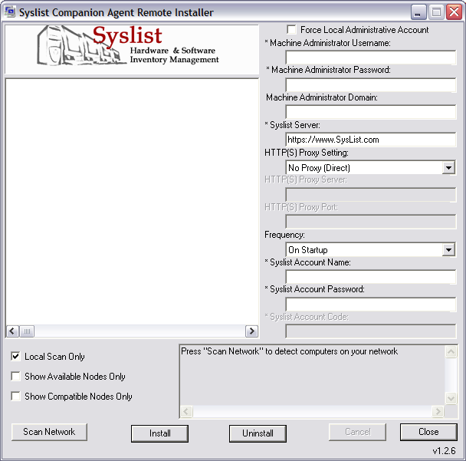

SCA_Remote Window

Display Fields:

- Syslist Server: This is the server that the Companion Agent will report to. If you are using the ASP then this must be set to https://www.Syslist.com. If you are using your own Syslist server then this must be set to the URL corresponding to the installation, including any subdirectories. The URL must always be a properly formatted URI string for either HTTP or HTTPS (i.e. it must begin with either http:// or https://).

- HTTP(S) Proxy Settings: This field determines how the contacts the reporting page on the web server. Choices are as follows:

  - No Proxy (Direct): The Companion Agent will contact the web serrver without the use of any proxy.
  - User Internet Explorer Settings: The proxy settings in Microsoft Internet Explorer will be used.
  - Manual Proxy Server: The settings typed into the HTTP(S) Proxy Server and HTTP(S) Port will be used to contact the web server.

- HTTP(S) Proxy Server: This field is only active if you have chosen Manual Proxy Server fro the HTTP(S) Proxy Server field. This is the DNS name or IP Address of a HTTP proxy server that will be used to send the information collected by the Companion Agent

- Frequency: This specifies how frequently the Companion Agent will inventory the system. Your choices are:

  - Disabled: Never inventory the machine. Only manual updates will cause the inventory information to be updated
  - Startup: Updates inventory information whenever the destination machines are booted.
  - Once A Day: Updates the inventory information every 24 hours, aligned to current time on the destination machines.
  - Once A Week: Updates the inventory information every week. Aligned to current day of week and time on the destination machines.
  - Once A Month: Updates the inventory information every 30 days. Aligned to current date in month and time on the destination machines.

The date related inventory frequency settings are aligned to the time that you set up the destination machine. That is, if you choose once a day, and you are setting up the machine at 10:00 am, then every 24 hours at 10:00 am, the machine will by inventories. If you choose once a month, and you are setting up the machine on the 21st at 10:00 am then every month on the 21st at 10:00 am the machine will be inventoried.

The inventory program itself is small, and non-intrusive. An interactive user on the machine should not be able to notice its activity.

- Machine Administrator User Name
&
Machine Administrator Password:
The SCANet remote install process must log into the destination machines to execute the installer. A valid user name and password is required as a result. The User selected should have administrative privileges so that the destination machines can be properly configured.

The User and Password is only used for purposes of remote install and is not stored on either the install machine or any of the target machines.

- Syslist Account User Name / Syslist Account Password: This is the account and password that the Companion Agent will use when reporting inventory information to the server. This information is encrypted when stored to prevent casual and maclicious users from seeing them.

- Syslist Account Code: This field is only active in the ASP versions of Syslist.

Display Controls

- Local Scan Only: This checkbox tells the network installer to only scan for machines in the local workgroup or domain. If you have a large network consisting of multiple domains and workgroups it is recommended that this option be used to limit the scope of the network scan and thus the network install.

- Show Available Nodes Only: Your machine may display machines that are no longer available on the netwoek. This box forces the Network Tree to display only those nodes that respond to NETBIOS requests at the time of the network scan. Checking this option off will cause the network scan to take longer as it contacts each machine out on the network to verify that it is active.

- Show Compatible Nodes Only: Some machines that respond to NETBIOS requests may not be compatible with the network install. This box forces the Network Tree to show only those machines that claim to be compatible with the guidelines set out at the beginning of this section. Some machines falsely report version information and will be included

- Scan Network: This button causes SCARemote to start scanning the network for computers. The search may take quite some time depending on how many computers are on your network, how your network is configured, and if you choose to do a local scan or an exhaustive scan. While working, a series of dots will be added the log.

- Network Tree: This is the largest area on the display. It is filled only when the Scan Network button is pressed. A tree showing the computers located on the network is displayed here. Clicking in the check boxes next to the name of a computer will add or remove it from the list of computers that will have the Syslist Companion Agent installed. Clicking on checkboxes for networks and domains will add or remove all machines under that network or domain.

- Install: This button starts installation of the Syslist Companion Agent on all computers that have a check mark besides their names. Installation proceeds from the top of the Network Tree, one machine at a time. As nodes succeed or fail the installation, their status is added to the log.at the bottom of the screen. Reasons for failure to install to a computer are also added to the log.

- Cancel: Stops SCARemote from scanning the network or performing a network install. If no network scan or install is in progress this button causes SCARemote to dismiss itself.

- Close: Dismisses SCARemote.

Installation Log:

This area of the screen shows the progress of network scans and installation. A companion file “SCALog<Date>.txt” is written out to the directory in which SCARemote resides with the same information.

Mac OS X Installation

Single Installations

The companion agent is supplied as a standard Mac OS X disk image (.dmg) containing a standard Apple installer package (.pkg). Drag and Drop installation of the Companion Agent is not supported as some resident programs must be installed in addition to the configuration and inventory programs.

Simply Double on the disk image (.dmg) to mount it, and then double click on the contained package to install the program.

An administrator must install the program in order to work properly. The Mac OS X installation services will prompt you for and administrator account if necessary.

Command Line Installations

Mac OS X provides a means to install standard package programs from the command line. Unfortunately the Installer application does not pass on command line arguments to our installer, necessitating a two command line operations once the program has been installed on the machine for proper operation. The steps required are listed below.

- Perform the base installation via the Apple Installer program:

> installer –pkg <path to .pkg file> -target /

- Perform the configuration of the software using the SCAConfig executable in the Syslist install folder

> cd /Applications/Syslist\ Companion\ Agent/
> SCAConfig.app/Contents/MacOS/SCAConfig –no_ui [Config Arguments]
> SCACollector

The last command above runs the collector – it should return status 0 (no error in UNIX terms). Any other number indicates a failure.

The configuration arguments are as follows:

- -no_ui: Required for command line install – instructs the configuration application to not show the user interface.
- -user <username>: Syslist account server user name. Optional if previously specified
- -pwd <password>: Syslist account server password. Optional if previously specified
- -accountid <accountid>: Syslist account account id. Optional
- -serverurl <url to server>: The full url to the Syslist account. Optional if previously specified.
- -serverport <port number>: The port on the server to which to connect.
- -frequency <collect frequency>: The sampling interval for data collection. Optional if previously specified. May be one of the following:
  - <empty string> – No automated inventory.
  - startup – On system startup
  - day – Once a day, aligned to install time
  - week – Once a week, aligned to install day of week and time.
  - month – Every 30 days, aligned to install date.
- -proxymethod <method>: How to deal with proxies when connecting. Optional if previously specified. May be one of the following:
  - <empty string> - No proxy
  - system – Use system settings
  - manual – manual proxy setting as per the –proxyserver and –proxyport arguments.
- -proxyserver <address>: The IP address or DNS name of the proxy server.
- -proxyport <port number>: The port number on the previously specified proxy server to which to connect.

Remote Installations

Apple Computer recommends use of Apple Remote Desktop or SSH (secure Shell) sessions for remote software installation.

Apple remote desktop is available from Apple Computer at an additional cost. (http://www.apple.com/remotedesktop/).

SSH is built in to the operating system and provides a command line interface into the system from which scripts and commands may be executed. Once logged in to a remote machine using SSH, you may use the command line install instructions to install the program. We will be releasing a proprietary script that assists with this process in the future. There are no further utilities currently provided by Literal Technology for remote installation on Mac OS X systems.

Re-installing the Companion Agent on a Formatted Machine

- If a machine is inventoried via the Companion Agent, then wiped clean somehow (either by hard drive format, or Ghost, etc), reinstalling the agent on that machine will re-sync the machine to its former record in Syslist AS LONG AS:
  - Its hostname has not changed, and,
  - The MAC address of either of its first two NICs has not changed.

If the hostname or NIC MAC addresses have changed, the Companion Agent will assume this is a new machine, and create a new record for it. The old record will then need to be manually deleted.

Note: for this reason (among other good ones), you should be sure that every PC in your inventory has a unique hostname, and that hostnames are not swapped among different PCs. This insures that PCs, even if their NICs are replaced, will always be inventoried correctly.

Usage and Configuration of the Companion Agent

Companion Agent Setup Program - SCAConf

This program is used to configure how the companion agent will run. SCAConf is also run upon installation of the Syslist Companion Agent. SCAConf should always be run by an administrator to avoid any problems with configuring the Companion Agent. Note that no Start Menu item is created for SCAConf – you must navigate to the install directory to execute it.

On Windows, SCAConf is SCAConf.exe located in the chosen installation folder.
On Mac OS X, SCAConf is SCAConf.app located in the standard installation folder.
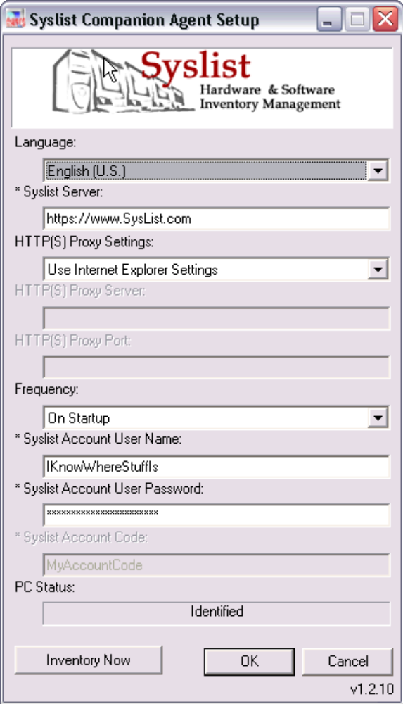

Windows Configuration
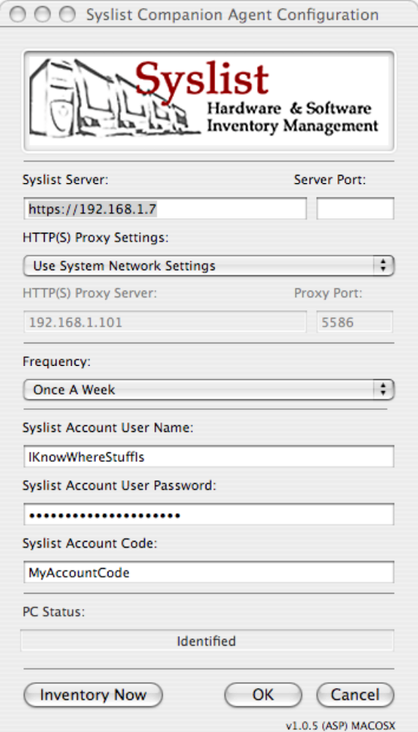

Mac OS X Configuration

Display Fields:

- Language (Windows Only): This is the language that the configuration program will use. This setting corresponds to the setting chosen during installation.

- HTTP(S) Proxy Settings: This field determines how the contacts the reporting page on the web server. Choices are as follows:

  - No Proxy (Direct): The Companion Agent will contact the web serrver without the use of any proxy.
  - User Internet Explorer Settings (Windows): The proxy settings in Microsoft Internet Explorer will be used.
  - Use System Settings (Mac OS X): The proxy settings for the system as set by the current location in the network settings will be used.
  - Manual Proxy Server: The settings typed into the HTTP(S) Proxy Server and HTTP(S) Port will be used to contact the web server.

- Proxy Settings
  - HTTP(S) Proxy Server: This field is only active if you have chosen Manual Proxy Server for the HTTP(S) Proxy Server field. This is the DNS name or IP Address of a HTTP proxy server that will be used to send the information collected by the Companion Agent

  - HTTP(S) Proxy Port: This field is only active if you have chosen Manual Proxy Server fro the HTTP(S) Proxy Server field. This is the TCP/IP Port on which the HTTP Proxy specified in HTTP(S) Proxy Server operates.

- Syslist Server: This is the server that the Companion Agent will report to. If you are using the ASP then this must be set to https://www.Syslist.com. If you are using your own Syslist server then this must be set to the URL corresponding to the installation, including any subdirectories. The URL must always be a properly formatted URI string for either HTTP or HTTPS (i.e. it must begin with either http:// or https://).
  - Port Settings:
    - Windows: You may enter a port by appending it after the URL using a colon. <Server URL>:<Port #>
    - Mac OS X: The port field allows you to enter the port number. Leave this blank to use the default port for your chosen protocol.

- Frequency: This specifies how frequently the Companion Agent will inventory the system. Your choices are:

  - Disabled: Never inventory the machine. Only manual updates will cause the inventory information to be updated
  - On Startup: Updates inventory information whenever the machine is booted.
  - Once A Day: Updates the inventory information every 24 hours, aligned to time of the first inventory.
  - Once A Week: Updates the inventory information every 7 Days. Aligned to current day of week and time.
  - Once A Month: Updates the inventory information every 30 days. Aligned to current date in month and time.

The date related inventory frequency settings are aligned to the time that you set up the machine. That is, if you choose once a day, and you are setting up the machine at 10:00 am, then every 24 hours at 10:00 am, the machine will try inventories. If you choose once a month, and you are setting up the machine on the 21st at 10:00 am then every month on the 21st at 10:00 am the machine will be inventoried.

The inventory program itself is small, and non-intrusive. An interactive user on the machine should not be able to notice its activity, nor should it interfere with any server activity.

- Syslist Account User Name / Syslist Account Password: This is the account and password that the Companion Agent will use when reporting inventory information to the server. This information is encrypted when stored to prevent casual and maclicious users from seeing them.

- Syslist Account Code: This field is only active in the ASP versions of Syslist.

- PC Status: This non-editable field indicates whether the machine has been successfully inventoried. It reads “Not Identified” if the machine has never successfully inventoried and tranmitted inventory information to the Syslist Server. It read “Identified” if the machine has at least once before been inventoried and has tranmitted the inventory information to the Syslist Server.

Display Buttons

- Inventory Now: Pressing this button will cause a full inventory to occur. The settings displayed will be written to the system registry. A web browser will be brought up immediately after to show the results of the inventory. Note also that the inventory is executed as the current interactive user on the machine.

- OK: This button will SCAConf to write all settings to the system registry (Windows) or System Library (Mac) and quit. The machine will also be set up to run to Inventory the machine at the specified interval in the future. If SCAConf is being run during installation, this button will cause the machine to be inventoried and data transmitted to the syslist server. SCAConf will quit and its window will be dismissed immediately after.

- Cancel: This button will cause SCAConf to quit without any further changes to the setup of the Syslist Companion Agent since the last inventory or the last time the OK button was pressed.

Trouble Shooting

The following sections

This document contains all error messages for problems that may be encountered while using the Syslist Companion agent and its associated configuration and installation sub-programs. Where possible, the common reasons and solutions for these messages and problems are also listed.

Below, error messages are provided in bold text, and situational messages are provided in bold italic text.

General Things to Know

- Though stated many times elsewhere the only officially supported operating systems are as follows – Run these program on other operating systems at your own risk:
  - Windows 98 Second Edition
  - Windows ME (Millenium Ediition).
  - Windows NT 4.0 Service Pack 6 w/Internet Explorer 5 or later.
  - Windows 2000
  - Windows XP
  - Mac OS X v10.2.8 or later

- You can redirect the output from the agent by changing the “Syslist Server” field to be a file reference like “file://c:\somedir\somefile”. The system may be picky about the direction of your directory separators.
  - You will most likely get an error when you do this, but the file will still be written out to your specified location.

- There is a file that is written out with every contact to the Syslist Server. In the Syslist installation directory you will find a file named “HTTPResponse.txt”. This file contains what was returned from the server. It is useful for diagnosing server related errors. Only one file is kept.
  - On the Mac this file is written into the root of your file system

- There is a file that is written out whenever the Syslist Companion Agent time check daemon runs. It is located in the Syslist Installation folder and is useful for diagnosing reports about failure to do a regularly scheduled inventory. A Sample is below. Only one file is kept
  - On the mac this file is written into the root of your file system

SCATimeCheck Log
Execution check time is: [2004-3-5]:[2-55-33.0] UTC
The last collection occured at: [2004-1-31]:[22-3-27.937] UTC
There is no aligned run time.
The next Collection time is User Dependent
Check Method is Startup
This is a startup check.
The Check Returned: TRUE
The Collector executed without error.

- When doing a remote install there is a file written out with the contents of the installation log with the file name in the format “SCALog-YYYY-MM-DD-HHMM-SS.txt”. A new file is written out for every execution of the remote installer.
- A pair of hex numbers in parenthesis accompanies some error messages. These two numbers are useful for our engineers to further track down a problem or to provide a solution. These numbers are used when a general problem has multiple steps that can generate identical error messages, allowing a finer diagnosis.
  - The first number is a code location.
  - The second number is the windows system error number.
  - Typically the error messages from remote install will include these two numbers.
  - Some messages generated by the configuration program will also contain these numbers.

Local Installation

The remote installer will execute the local installer on the remote machine. Some of the error messages seen here may appear in the remote installer.

- You must of course have permissions to copy the files from the installation archive into the target directory.
- You need to have enough temp space available to expand the archive into installable files. Various error messages will appear concerning either Disk I/O failure or Temp Space failure.
- The installer was unable to set up accounts and services. Please check account permissions and try again:
- On windows 98/ME, the installation attempts to install a program that runs at startup (the Time Check Daemon : SCATimEx). If anything is preventing access to the registry including having run out of registry space, then the install will fail.
  - If you are installing over an old copy, then the original is killed, and a new copy is installed
  - On windows NT/2000/XP, the installation attempts to install a system service that will run at startup time (SCATimEx: the time check daemon). If the account you are using has no permissions to install a service then the installer will fail with “The installer was unable to set up accounts and services. Please check account permissions and try again”
  - On windows NT/2000/XP, the installation attempts to create a user and give it rights to run in batch mode. If the account used to install does not have permissions to create an account and give it various rights, then the install will fail with the message “The installer was unable to set up accounts and services. Please check account permissions and try again”

Configuration Program

These messages are generated by the SCAConf executable.

Many of the messages seen here are actually generated by the collection program SCAInv.exe. SCAInv.exe has no user interface and returns error numbers that are then translated into some of the messages seen here. Error messages that are preceded by a number are messages generated by SCAInv.exe and translated by SCAConf.exe. If an error number is received corresponding to a HTTP code, then that was the error received by the client while talking to the server.

The remote installer executes SCAConf.exe on every target machine. You will also see the error messages preceded by numbers in the logs and status window for remote installer.

Note that no error message will be given for an incorrect command line: There are defaults as described in the first set of program documentation that explain how thing are set in the absence of arguments.

General Errors:

- This program must be run by an Administrator :As of version 1.1.6 if the person running the configuration program (SCAConf) is not an administrator, and the program is running on windows NT/2000/XP or later, the program will put up a message box saying “This program must be run by an Administrator”.
  - Version 1.1.6 prevented anyone running window 98, or Windows NT 4.0 from running the program. This was fixed in version 1.1.7.
- Information needed by this program is missing from the windows registry: This error message appears for exactly the reason that it states: there is installation registry information missing.
  - This may happen if the system has run out of registry space on some versions of windows
  - This may happen if the install was cancelled, interrupted or incomplete
  - Registry corruption will also cause this to happen
  - There is no recourse for this problem other than a re-install of the program. Sometime it will be necessary to re-install the operating system or repair the registry.
- Configuration was cancelled. No changes to your Syslist reporting will be made. If reporting was disabled then this machine will not report to the Syslist server: The user hit the “cancel” button or the “X” on the configuration program. Note that “unsaved changes” portion of the message refers to the last time an inventory was performed in the configuration UI – that is to say running an inventory saves your changes to the registry.
- The companion agent is unable to open a web browser to display this PC’s inventory to you. You may review the data manually by logging into Syslist: The configuration program couldn’t start Internet Explorer and set it to the user visible reporting page.
  - Only Internet Explorer is used. No other browser can be used because there is no known way to do a “POST” to an arbitrary browser using system interfaces.
- The companion agent was unable to write back configuration information to the Windows Registry. Please make sure you have sufficient permissions: Either on exit from the program or upon attempting to run the agents collection program, the agent was unable to write back information into the registry.
  - A full registry (on some versions of windows) will cause this
  - Registry permissions are also a possible cause
  - Corrupted registries can cause this
  - Other programs holding on to the registry key can also cause this to happen.

Errors While Executing the Collector

Most of the errors presented here are applicable to both the Windows and Mac OS X versions of the program.

- The Agent Failed to complete collection within 5 minutes: The agent started collection, but we timed out waiting for it to complete. There is no specific recourse for this problem.
- The Companion Agent data collector did not run successfully: The program SCAInv.exe could not be run. There is no specific recourse for this problem other than to check the installation and registry values.
- (-8) The inventory completed, but no ID was received from the Syslist Server: a response was received from the server, but the agent could not find an ID with which to associate itself.
  - Malformed HTML or HTTP will cause this
  - Misconfigured servers will also cause this
  - Redirection is not supported at this time
- (-7) The evaluation period for this software has expired. No further inventories will occur until a full version of the Syslist Companion Agent is installed.: This only happens on demo versions of the agent that are time limited. There is no recourse for this problem.
- (-6) The Companion Agent was unable to communicate with the specified Syslist Server. Please check your Syslist Server URL address: The agent was unable to resolve the DNS address for the syslist server supplied or no connection was made to the syslist server.
  - This is most often due to mistyping and DNS resolution errors
  - Firewalls will also prevent proper connection
- (-5) The Companion Agent was unable to read configuration information: Syslist information needed to run was detected missing by the agent.
  - Incomplete/Halted/Cancelled installations can cause this.
  - Corrupt registries are also a cause.
  - Full registries can get you into this case as well
  - Though rare, registry permissions can also cause this.
- (-4) The Companion Agent was unable to finish collecting system information: The agent started collecting, but a critical collection function failed. This should be a rare error, as the agent first leaves out any information it cannot collect before resorting to this message.
  - This is usually indicative of a more systematic/low level problem with collection. Examples of problems that would cause this are memory and disk I/O problems.
- (-3) The Syslist server specification is either missing a protocol orhas a protocol entry that is not understood. Please start the server name with http:// or https:// : The agent could not decipher the setting for the Syslist Server.
  - The agent does not accept shortcuts for URLs and URIs.
  - No special parsing or fixing of the URL/URI is done, small mistakes will cause this error to show up.
- (-2) The Companion Agent could not save the hardware identifier into the Windows registry: Collection finished, and an ID was received but for some reason, the ID could not be written back
  - Corrupt registries can cause this
  - Full registries can cause this
  - Registry permissions can also cause this to happen, but should be a rare event.
- (1) The Syslist Server has indicated that the inventory ID stored on this PC is invalid. Please run the Companion Agent again to retrieve the correct ID or crate a new one: Inventory completed but the server has indicated that there is a problem with the ID supplied by the agent.
  - These problems must be diagnosed by examining the server.
  - The server may indicate the problem in the HTTPResponse.txt file.
- (2) The user name and Password do not match any account on the Syslist server: While trying to send inventory information to the syslist server, the server responds back that the user name or password are not recognized.
  - These types of problems must be diagnosed by examining the server
  - Misspellings are an obvious and common cause for this problem.
- (3) The Syslist server did not receive a complete inventory record from this system: The collection completed, and the information was sent to the server, the server indicates that an incomplete inventory transmission was received.
  - What the server considers incomplete is completely up to the server implementation.
  - This is best diagnosed by dumping the collection information to a file as explained in the General section of this document.
- (4) The Syslist Server did not receive enough information to correctly inventory this system: The collection completed and the information was sent to the server. The server indicates that the machine cannot be uniquely identified based on the information received.
  - This is best diagnosed by dumping the collection information to a file as explained in the general section of this document.
  - Missing IP, Name and MAC information are typically the cause, but that is left up to the server implementation to decide on what is really needed.
- (9) Syslist has not been configured with a valid license key: The collection completed and the information was sent to the server. The server indicates that it cannot find a license key.
  - This must be diagnosed on the server end.
- (10) You have reached the maximum number of systems you are permitted to add under your current license. The Companion Agent will no longer Process new systems: The collection completed and the information was sent to the server. The server indicated that the license has been maxed out in terms of the number of systems allowd
  - This must be diagnosed on the server end.
- (404) The Companion Agent could not find the reporting endpoint on the Syslist server: The collection completed, and the agent managed to reach a web server as specified by the user, but the web server returned a 404 error: no such page.
  - Check the HTTPResponse.txt file to see what the web server says.
  - Misspellings are typically the cause of this.
- The Companion Agent encountered an error communicating with the Syslist server: This is the catch all message that applies when none of the above items have happened. Typically the server returned an unknown HTTP code, or the syslist server returned a code that cannot be identified.
  - Redirects often cause this to happen
  - Up to Version 1.1.6, some proxies and servers caused this message to be displayed due to their end of line formatting.
- The companion agent was unable to start the windows Task Scheduler. This will prevent the agent from running as per your specification. Please make sure you have sufficient permissions to run and install this program. This is an obsolete error message. Older versions of the agent used the Task Scheduler to get scheduled runs, and only administrators can use the task scheduler. You should no longer be seeing this message.
- The companion agent was unable to schedule future inventory points. This will prevent your data from being updated automatically in the Syslist Database. Please make sure that you have sufficient permissions to run and install this program: This is an obsolete error message. Older versions of the agent used the task scheduler to get scheduled runs. This message indicates that you had sufficient permissions to attempt to schedule a run, but that some other problem prevented the configuration program from setting up the future runs. You should no longer be seeing this message.

Recurring Runs

These messages are generated by the system daemon/service SCATimEx.
SCATimEx runs the collection portion of the agent at set intervals.

If a general error occurs that prevents this service/daemon from running, the you will have to look at the system logs and service setup control panel to get error messages and numbers. Only windows system errors and numbers appear in those two places.

The only real errors you will see are in the log file as explained in the “General Things to Know section of this document. If an error occurs during the execution of SCAInv by SCATimeEx then the error number returned by SCAInv is on the last line of the log file as follows:

- The collector returned an error: NNNN: where NNNN is a decimal number returned by SCAInv. Look in the “Configuration Program” error message section to see if the number is located preceding an error message there. Also look to see if the number is an HTTP status code. Failing these two numbers making sense, the number returned may be one of the thousands of windows system error codes.

Remote Installation

These error messages are generated by the program SCARemote.

As previously mentioned, because this remote installation program ends up calling the local installation program and the local configuration program on the remote machine, all of the error messages seen there can appear here as well.

It should be noted that this program can only run on Windows NT/2000/XP based machines. Furthermore only Windows NT/2000/XP machines can have remote installations performed on them. This is a limitation of the architecture of windows that can only be addressed by having installed other programs on Window 98SE/ME machines to allow remote installation.

General Errors:

- This program must be run by an Administrator: As of version 1.1.6 if the person running the configuration program (SCAConf) is not an administrator, and the program is running on windows NT/2000/XP or later, the program will put up a message box saying “This program must be run by an Administrator”.
  - Version 1.1.6 prevented anyone running window 98, or Windows NT 4.0 from running the program. This was fixed in version 1.1.7.
- The program exits if I do not agree to the license terms: Of course!

System Operation:

This section goes through the deep details of remote installation. If you have machines that are failing the remote install, reading this section may help you diagnose your problem.

Prerequisites for remote install:

- If you intend to install to machines on a Windows NT domain, your machine and account must belong to that domain.
- Only Windows NT based machines may make use of the remote installer. Windows 98 and ME machines do not exposed the service management interfaces necessary.
- Windows XP machines that are not part of a Windows NT domain cannot be installed to at this time because all network access is treated as “Guest”
  - This is a “feature” Windows XP meant as a security measure
- The account that is logged into the local machine must have full administrative rights on the remote machine
- At least one of the default shares must be available. The default administrative shares are $IPC, $ADMIN, $C etc…
  - The drive shares $C through $G are all tried
- RPC calls (used for DCOM communication) must be operating correctly within the network and on all machines involved.
  - Some network/system admins disable various parts of windows networking and RPC in an attempt to secure the network.
  - Be especially sure to not have disabled services that allow remote administration, or the service manager itself.

The Syslist Network Installer takes the following steps to install the Syslist companion agent on to your computer:

- Searches for one of the following shared network locations on the remote machine to write the installation programs, and copies to the first location that will accept the file
  - $IPC
  - $ADMIN
  - $C
  - $D
  - $E
  - $F
  - $G

This may fail for the following reasons:
- You have made the default shares on the remote machine have read only permissions.
- You have disabled the default shares on the remote machine
- The current user on the local machine does not have sufficient permissions on the remote machine.
- You are not part of the Windows Domain.

- Installs a service on the remote machine starting from the location it previously copied the installer executables.

This may fail for the following reasons:
- You have disabled the service control manager
- You have disabled one of the necessary components for remote service administration
- You do not have sufficient permissions to install a service on the remote machine
- You are not part of the windows domain
- The local account does not have sufficient permissions to read/execute from the target disk on the remote machine.
- The remote account does not have sufficient permissions to read/execute from the target disk on the remote machine

- Starts the service

  - The service will run the installer executable and return it’s status to the machine from which the install was pushed.

This may fail for the following reasons
- You do not have sufficient permissions to run a service on the remote machine
- You are not part of the windows domain
- The local account does not have sufficient permissions to read/execute from the target disk on the remote machine.

- Checks the return and success status of the remote task execution. If the remote install execution has failed, the network installer is made aware of it at this point.

The installs’ success is based largely on the success of the installation executable on the remote machine at this point. If you have not properly configured the dialog on the remote installer with the arguments for the remote machine, it will fail and a message will be supplied.

- If an error occurred, the installer attempts to read an error file from the location it copied the installer to.

The install does not fail if this step does not succeed.

- Stops the service on the remote machine and uninstalls it from the service manager.

The install does not fail if this step does not succeed.

Network Scanning Errors

- A particular machine does not appear in the list of machines, but I know it’s connected to my network: The network installer uses standard windows NETBIOS/SMB calls to detect machines. If your machine is not correctly set up on the network (any one of a thousand ways to mess that up) you will not see your machine in the list. If you are on a Windows NT/2000/2003 network, and the machine you are executing the remote installer on is joined to the domain, then the network installer is getting its information from a Domain Server – look there to see what is and is not available.
- Sometimes the scan appears to take a hang for a while (about 30 seconds): Most likely, you have the “Show only compatible machines” checkbox activated. The nature of NETBIOS/SMB and windows networking is that sometimes machines that are not currently on the network show up as available for listing to programs. The network installer contacts each machine to see if it is a supported machine when the “Show compatible machines” checkbox is activated, and when a machine that is not on the network is contacted, the scanner has to wait until the connection times out.
- Machines that are not currently on the network show up in my list and (obviously) fail installation: See the above explanation. This is the nature of windows networking.
- I have the Demo version of the Syslist Agent and Network installer, I can only see 10 machines on my network, and it’s never the same 10 machines!: Demo versions of the network installer are limited to scanning for 10 machines. The nature of windows network scanning does not guarantee the order in which those 10 machines will appear.
- I have a linux/freebsd/MacOSX/SunOs… etc. machine on my network and it appears in the list of machines detected by the scan!: These machines are most likely running SAMBA or NETWARE products that allow them to appear as members of a windows network. The installation to these machines will simply fail. Mac OS X machines will also show up depending on how they are configured (they are running SAMBA behind the scenes).

Installation Errors:

Almost all of the error messages below are accompanied by the text of the windows error message involved. That error message is useful only in conjunction with these error messages. Again, any one of the windows error messages may appear – so I am certainly not going to cover all of them here. For the most part they explain what happened, but not how to fix the problem.

- I can’t install to any Windows XP Home Edition machines: The default configuration of Windows XP Home Edition prevents the type of activity needed for a remote install. This is done to secure the majority of home users from malicious attack.
- I am not on a Windows NT domain and I cannot install to any Windows XP machines: As above, even Windows XP Professional has a feature that attempts to prevent most of the installation from working – This only kicks in if the machine is not joined to a domain. We have made recent strides in this area to overcome this, but there are still some configurations that we cannot work around.
- Unable to Copy Necessary files to Remote Machine: Part of the remote copy process is to copy the local installer and a daemon to the remote machine. This message shows up when that is not possible.
  - User Permissions are the number one reason for this. There are all sorts of ways to mess this up, and I can’t cover them all. Watch out for domain problems, hidden accounts and underspecified login names.
  - The account used for installation should also have sufficient permissions to allow it to log in to the remote machine and then to copy to the one of the standard shares: $C, $D, $E, $F, $G, $ADMIN, or $IPC
  - The standard shares must also be available. It is common practice to secure a machine by disabling some of the standard shares. The installer tries all standard shares from $C to $G and then $ADMIN and $IPC.
- Could not start services on remote machine: The remote installer attempts to install and start a windows service/daemon temporarily on the remote machine. If this fails the remainder of the installation is impossible.
  - Account permissions are again the number one reason for this not working. See above for common reasons.
- Could not Execute Remote Task: Once the service is started, it will attempt to execute local installer in silent mode on the remote machine. This message appears if this cannot be done. Disk, Directory, and User permissions (account permissions as a whole) are the number one problem here.
- Error from Remote Host: This message is followed by additional error text. If you get past all of the above potential problems, the remaining error messages are usually from the remote machine running the local installer. Look at the messages in the “Local Install” section for diagnoses.

OpenSSL

The Syslist Companion Agent software makes use of the OpenSSL library for HTTPS SSL connections. As required by the license terms for use and redistribution of OpenSSL the following notice is reproduced here.

This package is an SSL implementation written
by Eric Young (eay@cryptsoft.com).
The implementation was written so as to conform with Netscapes SSL.

This library is free for commercial and non-commercial use as long as
the following conditions are aheared to. The following conditions
apply to all code found in this distribution, be it the RC4, RSA,
lhash, DES, etc., code; not just the SSL code. The SSL documentation
included with this distribution is covered by the same copyright terms
except that the holder is Tim Hudson (tjh@cryptsoft.com).

Copyright remains Eric Young's, and as such any Copyright notices in
the code are not to be removed.
If this package is used in a product, Eric Young should be given attribution
as the author of the parts of the library used.
This can be in the form of a textual message at program startup or
in documentation (online or textual) provided with the package.

Redistribution and use in source and binary forms, with or without
modification, are permitted provided that the following conditions
are met:
1. Redistributions of source code must retain the copyright
notice, this list of conditions and the following disclaimer.
2. Redistributions in binary form must reproduce the above copyright
notice, this list of conditions and the following disclaimer in the
documentation and/or other materials provided with the distribution.
3. All advertising materials mentioning features or use of this software
must display the following acknowledgement:
"This product includes cryptographic software written by
Eric Young (eay@cryptsoft.com)"
The word 'cryptographic' can be left out if the rouines from the library
being used are not cryptographic related :-).
4. If you include any Windows specific code (or a derivative thereof) from
the apps directory (application code) you must include an acknowledgement:
"This product includes software written by Tim Hudson (tjh@cryptsoft.com)"

THIS SOFTWARE IS PROVIDED BY ERIC YOUNG ``AS IS'' AND
ANY EXPRESS OR IMPLIED WARRANTIES, INCLUDING, BUT NOT LIMITED TO, THE
IMPLIED WARRANTIES OF MERCHANTABILITY AND FITNESS FOR A PARTICULAR PURPOSE
ARE DISCLAIMED. IN NO EVENT SHALL THE AUTHOR OR CONTRIBUTORS BE LIABLE
FOR ANY DIRECT, INDIRECT, INCIDENTAL, SPECIAL, EXEMPLARY, OR CONSEQUENTIAL
DAMAGES (INCLUDING, BUT NOT LIMITED TO, PROCUREMENT OF SUBSTITUTE GOODS
OR SERVICES; LOSS OF USE, DATA, OR PROFITS; OR BUSINESS INTERRUPTION)
HOWEVER CAUSED AND ON ANY THEORY OF LIABILITY, WHETHER IN CONTRACT, STRICT
LIABILITY, OR TORT (INCLUDING NEGLIGENCE OR OTHERWISE) ARISING IN ANY WAY
OUT OF THE USE OF THIS SOFTWARE, EVEN IF ADVISED OF THE POSSIBILITY OF
SUCH DAMAGE.

The licence and distribution terms for any publically available version or
derivative of this code cannot be changed. i.e. this code cannot simply be
copied and put under another distribution licence
[including the GNU Public Licence.]

