Mancala: Object diagrams

Object diagrams are based on user stories (numbers in brackets are representing the number of user story).

Artjom wins the game (US33)
Preconditions: The pits on the gaming board contain the following amount of seeds: pit 1 – 0, pit 2 – 0, pit 3 – 0, pit 4 – 0, pit 5 – 0, pit 6 – 2, pit 7 – 0, pit 8 – 2, pit 9 – 4, pit 10 – 0, pit 11 – 1, pit 12 – 0. There are 16 seeds in Ulno's store and 11 seeds in Artjom's store. It is Ulno’s turn to make a move.
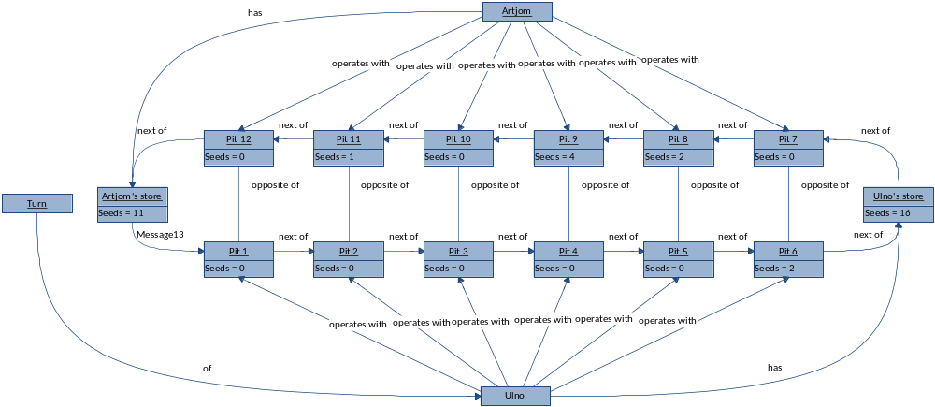

Postcondition: The pits on the gaming board contain the following amount of seeds: pit 1 – 0, pit 2 – 0, pit 3 – 0, pit 4 – 0, pit 5 – 0, pit 6 – 0, pit 7 – 0, pit 8 – 0, pit 9 – 0, pit 10 – 0, pit 11 – 0, pit 12 – 0. There are 17 seeds in Ulno's store and 19 seeds in Artjom's store. Artjom wins the game.
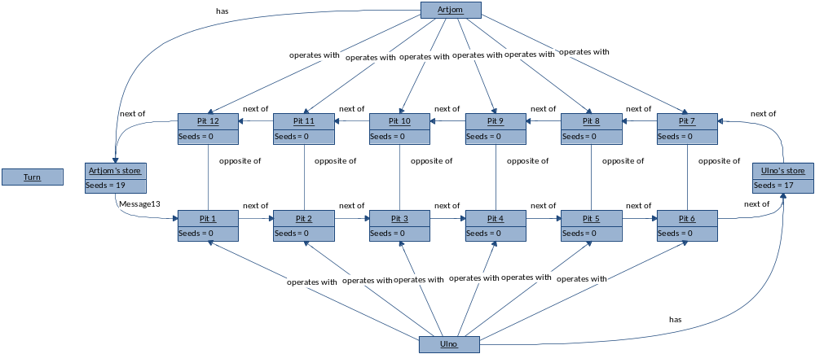

Artjom wins the game (US34)
Preconditions: The pits on the gaming board contain the following amount of seeds: pit 1 – 0, pit 2 – 0, pit 3 – 0, pit 4 – 0, pit 5 – 0, pit 6 – 6, pit 7 – 0, pit 8 – 2, pit 9 – 2, pit 10 – 2, pit 11 – 5, pit 12 – 5. There are 6 seeds in Ulno's store and 8 seeds in Artjom's store. It is Ulno’s turn to make a move.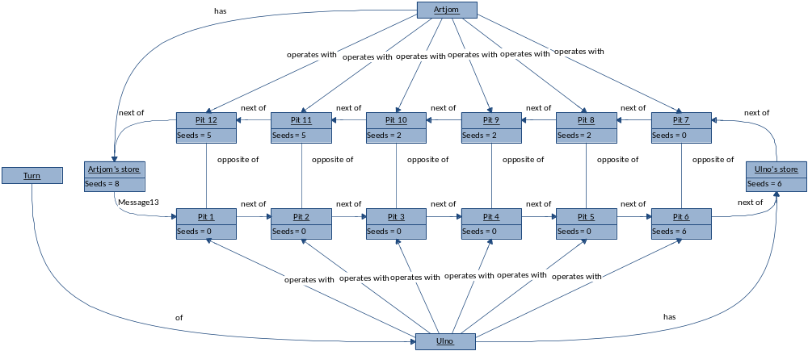

Postcondition: The pits on the gaming board contain the following amount of seeds: pit 1 – 0, pit 2 – 0, pit 3 – 0, pit 4 – 0, pit 5 – 0, pit 6 – 0, pit 7 – 0, pit 8 – 0, pit 9 – 0, pit 10 – 0, pit 11 – 0, pit 12 – 0. There are 7 seeds in Ulno's store and 29 seeds in Artjom's store. Artjom wins the game.
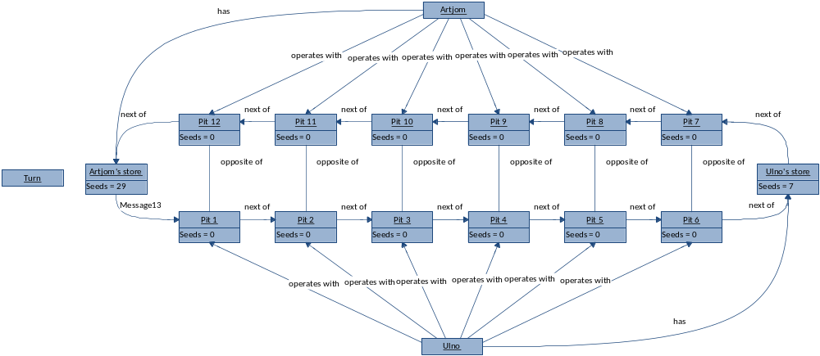

Ulno wins the game (US38)
Preconditions: The pits on the gaming board contain the following amount of seeds: pit 1 – 0, pit 2 – 0, pit 3 – 0, pit 4 – 2, pit 5 – 2, pit 6 – 0, pit 7 – 0, pit 8 – 0, pit 9 – 0, pit 10 – 0, pit 11 – 0, pit 12 – 1. There are 17 seeds in Ulno's store and 14 seeds in Artjom's store. It is Artjom’s turn to make a move.
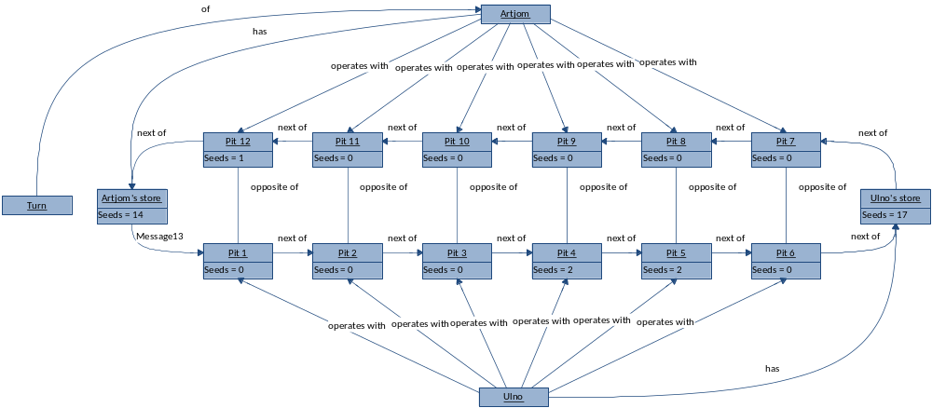

Postcondition: The pits on the gaming board contain the following amount of seeds: pit 1 – 0, pit 2 – 0, pit 3 – 0, pit 4 – 0, pit 5 – 0, pit 6 – 0, pit 7 – 0, pit 8 – 0, pit 9 – 0, pit 10 – 0, pit 11 – 0, pit 12 – 0. There are 21 seeds in Ulno's store and 15 seeds in Artjom's store. Ulno wins the game.
