Compilation Project Part 2 – Parsing

Overview: The second part of the IC Compiler which handles parsing and building the abstract syntax tree simultaneity.

Input: The parser can get up to 3 arguments; the first is mandatory:
- The .ic file to parse
- Either –print-ast which prints the ast of the parsed ic (and library file) or –L<path of library file>. Of course there can be both.

Output: If no error occurred and the parsing process was successful a message of "Successfully parsed…" will appear, if an error has occurred then an error message (syntax or lexical) will appear with details.
If the command –print-ast is invoked then a printout of the ast will appear on the screen as well. The print out is in the format:
ID <description of node> -> { ID of children nodes separated by comma }

Code structure: In the main function of the Compiler class there several functions that handles the parsing and the printing:
- ParseICFile – parses the ic file given
- ParseLibraryFile – parses the library file
- AddLibraryToRoot – adds library ast to the main ast as a class
- LabeslAST – using propagating visitor to set ID the the nodes
- PrintASTCommand – prints the ast that was parsed
Also, we implemented the following:
- SyntaxError class that is thrown whenever a syntax error is encountered.
- Propagating Visitor in the ASTNode abstract class and in all the other nodes.
- Added id field in the ASTNode class (plus getter and setter) to support node labeling.

Testing strategy:
Phase 1 - After building each grammar (library and ic) and before building the ast commands we tested our grammars on different test files including syntactically correct programs and of course syntactically incorrect ones, also we tested our parser again with unsupported symbols in the tests.

Phase 2 – After we had our asts we wrote the Graphviz printing classes and tested our program and the asts outputs with the gedit program. Again, we tested against various programs, empty programs, and small programs with long expressions and sometimes small programs that correspond to a very few nodes in the ast.

Class hierarchy:

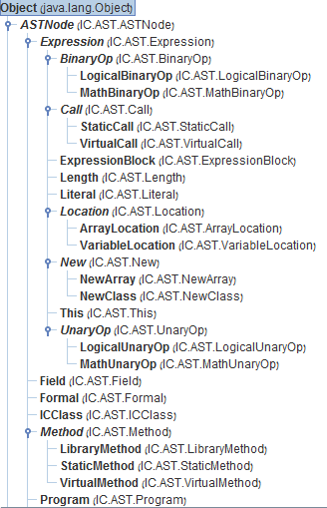
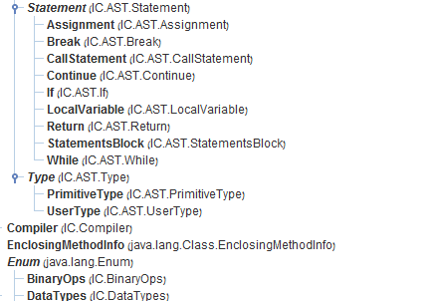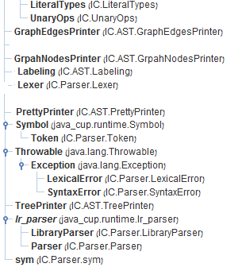

Major classes:
- Compiler – Explanation at the beginning of the document.
- Labeling – Enables to label the nodes (set id to each node). Works with Propagating Visitor pattern. The object that passes through the ast id the current id, each node increments it and returns its new id (which is id + 1).
- SyntaxError – New class that implements syntax errors. The Parser class uses it.
The IC Grammar:
We decided to create the grammar with choices of precedence according to the spec; we did use CUP's associative and precedence in order to resolve shift-reduce or reduce-reduce conflicts:
- precedence right ASSIGN;
- precedence left LOR;
- precedence left LAND;
- precedence left EQUAL, NEQUAL;
- precedence left GT,GTE,LT,LTE;
- precedence left PLUS,MINUS;
- precedence left MULTIPLY,DIVIDE,MOD;
- precedence left DOT,LB,LP,RB,RP;
- precedence right UNOP;
- precedence left ELSE;

We decided to give ELSE the highest priority and left associative because we decided the last else (if it is dangling) is connected to the last if, and the priority is given in order to connect the else and if no matter what expression is presented.

We found it very useful to separate the RHS of the grammar to prefix in different lengths in order to overcome conflicts (i.e MethodPrefix).

About the first bonus – we decided to implement the restrict of declaring a variable in a "one statement if" by not changing the grammar, we checked it in the java code of the If Statement rules and threw a syntax error if needed. We decided to resolve it that way because we didn't want to change to original grammar that is (hopefully) loyal to the spec.

===== Terminals =====
[0]EOF [1]error [2]ASSIGN [3]INTEGER [4]LP
[5]RP [6]LB [7]RB [8]LCBR [9]RCBR
[10]BOOLEAN [11]BREAK [12]COMMA [13]EQUAL [14]EXTENDS
[15]ELSE [16]FALSE [17]GT [18]GTE [19]ID
[20]IF [21]INT [22]LAND [23]CLASS [24]LENGTH
[25]NEW [26]LNEG [27]LOR [28]LT [29]LTE
[30]MINUS [31]MOD [32]MULTIPLY [33]NEQUAL [34]NULL
[35]PLUS [36]RETURN [37]SEMI [38]STATIC [39]STRING
[40]QUOTE [41]THIS [42]TRUE [43]VOID [44]WHILE
[45]CLASS_ID [46]PLUSPLUS [47]MINUSMINUS [48]PLUSEQUAL [49]MINUSEQUAL
[50]MULTIPLYEQUAL [51]CONTINUE [52]DIVIDE [53]DIVIDEEQUAL [54]DOT
[55]UNOP
===== Non terminals =====
[0]Program [1]ClassIC [2]ClassICEx [3]ClassContent [4]FieldOrMethod
[5]Field [6]FieldList [7]VirtualMethod [8]StaticMethod [9]MethodType
[10]Formals [11]StatmentOrEmpty [12]Type [13]TypeList [14]Statement
[15]InitVariable [16]Expr [17]ExprOrEmpty [18]Call [19]ElseStatement
[20]StaticCall [21]VirtualCall [22]Arguments [23]ArgumentsList [24]ExprDotOrEmpty
[25]LogicBinop [26]Binop [27]Unop [28]Literal [29]Location
[30]MethodPrefix [31]VirtualCallPrefix [32]StatementStar
===== Productions =====
[0] Program ::= ClassIC Program
[1] $START ::= Program EOF
[2] Program ::= ClassICEx Program
[3] Program ::=
[4] ClassIC ::= CLASS CLASS_ID ClassContent
[5] ClassICEx ::= CLASS CLASS_ID EXTENDS CLASS_ID ClassContent
[6] ClassContent ::= LCBR FieldOrMethod RCBR
[7] FieldOrMethod ::= Field FieldOrMethod
[8] FieldOrMethod ::= StaticMethod FieldOrMethod
[9] FieldOrMethod ::= VirtualMethod FieldOrMethod
[10] FieldOrMethod ::=
[11] Field ::= Type ID FieldList SEMI
[12] FieldList ::= COMMA ID FieldList
[13] FieldList ::=
[14] Type ::= INT
[15] Type ::= BOOLEAN
[16] Type ::= STRING
[17] Type ::= CLASS_ID
[18] Type ::= Type LB RB
[19] MethodPrefix ::= VOID ID LP
[20] MethodPrefix ::= Type ID LP
[21] VirtualMethod ::= MethodPrefix Formals RP LCBR StatementStar RCBR
[22] StaticMethod ::= STATIC MethodPrefix Formals RP LCBR StatementStar RCBR
[23] Formals ::= Type ID TypeList
[24] Formals ::=
[25] TypeList ::= COMMA Type ID TypeList
[26] TypeList ::=
[27] Statement ::= Location ASSIGN Expr SEMI
[28] Statement ::= Call SEMI
[29] Statement ::= RETURN ExprOrEmpty SEMI
[30] Statement ::= IF LP Expr RP Statement ELSE Statement
[31] Statement ::= IF LP Expr RP Statement
[32] Statement ::= WHILE LP Expr RP Statement
[33] Statement ::= BREAK SEMI
[34] Statement ::= CONTINUE SEMI
[35] Statement ::= LCBR StatementStar RCBR
[36] Statement ::= Type ID InitVariable SEMI
[37] StatementStar ::= Statement StatementStar
[38] StatementStar ::=
[39] InitVariable ::= ASSIGN Expr
[40] InitVariable ::=
[41] ExprOrEmpty ::= Expr
[42] ExprOrEmpty ::=
[43] Location ::= ID
[44] Location ::= Expr DOT ID
[45] Location ::= Expr LB Expr RB
[46] Call ::= StaticCall
[47] Call ::= VirtualCall
[48] StaticCall ::= CLASS_ID DOT ID LP Arguments RP
[49] VirtualCall ::= VirtualCallPrefix Arguments RP
[50] VirtualCall ::= ID LP Arguments RP
[51] VirtualCallPrefix ::= Expr DOT ID LP
[52] Arguments ::= Expr ArgumentsList
[53] Arguments ::=
[54] ArgumentsList ::= COMMA Expr ArgumentsList
[55] ArgumentsList ::=
[56] Binop ::= PLUS
[57] Binop ::= MINUS
[58] Binop ::= MULTIPLY
[59] Binop ::= DIVIDE
[60] Binop ::= MOD
[61] Binop ::= LAND
[62] Binop ::= LOR
[63] Binop ::= GT
[64] Binop ::= GTE
[65] Binop ::= LT
[66] Binop ::= LTE
[67] Binop ::= EQUAL
[68] Binop ::= NEQUAL
[69] Unop ::= MINUS
[70] Unop ::= LNEG
[71] Literal ::= INTEGER
[72] Literal ::= QUOTE
[73] Literal ::= TRUE
[74] Literal ::= FALSE
[75] Literal ::= NULL
[76] Expr ::= Location
[77] Expr ::= Call
[78] Expr ::= THIS
[79] Expr ::= LP Expr RP
[80] Expr ::= NEW CLASS_ID LP RP
[81] Expr ::= NEW Type LB Expr RB
[82] Expr ::= Expr DOT LENGTH
[83] Expr ::= Literal
[84] Expr ::= MINUS Expr
[85] Expr ::= LNEG Expr
[86] Expr ::= Expr PLUS Expr
[87] Expr ::= Expr MINUS Expr
[88] Expr ::= Expr MULTIPLY Expr
[89] Expr ::= Expr DIVIDE Expr
[90] Expr ::= Expr MOD Expr
[91] Expr ::= Expr LAND Expr
[92] Expr ::= Expr LOR Expr
[93] Expr ::= Expr GT Expr
[94] Expr ::= Expr GTE Expr
[95] Expr ::= Expr LT Expr
[96] Expr ::= Expr LTE Expr
[97] Expr ::= Expr EQUAL Expr
[98] Expr ::= Expr NEQUAL Expr

Library Grammar:
The library grammar was pretty straight forward to implement from the spec. We had one problem that we resolved though the code: we needed to overturn programs that are syntactically correct according to the library spec given but the class name was not Library. Instead of changing the Lexer to return a special symbol of CLASS_ID_LIBRARY for instance, we decided to check it manually in the code:
if(id.toString().compareTo("Library") != 0){ parser.syntax_error((Symbol) id); };

Here we didn’t use any precedence options because the grammar was simple enough.

===== Terminals =====
[0]EOF [1]error [2]ASSIGN [3]INTEGER [4]LP
[5]RP [6]LB [7]RB [8]LCBR [9]RCBR
[10]BOOLEAN [11]BREAK [12]COMMA [13]EQUAL [14]EXTENDS
[15]ELSE [16]FALSE [17]GT [18]GTE [19]ID
[20]IF [21]INT [22]LAND [23]CLASS [24]LENGTH
[25]NEW [26]LNEG [27]LOR [28]LT [29]LTE
[30]MINUS [31]MOD [32]MULTIPLY [33]NEQUAL [34]NULL
[35]PLUS [36]RETURN [37]SEMI [38]STATIC [39]STRING
[40]QUOTE [41]THIS [42]TRUE [43]VOID [44]WHILE
[45]CLASS_ID [46]PLUSPLUS [47]MINUSMINUS [48]PLUSEQUAL [49]MINUSEQUAL
[50]MULTIPLYEQUAL [51]CONTINUE [52]DIVIDE [53]DIVIDEEQUAL [54]DOT
[55]UNOP
===== Non terminals =====
[0]libic [1]libmethod [2]type [3]formals [4]typelist
[5]userclass
===== Productions =====
[0] libic ::= CLASS CLASS_ID LCBR libmethod RCBR
[1] $START ::= libic EOF
[2] libmethod ::= STATIC type ID LP formals RP SEMI libmethod
[3] libmethod ::= STATIC VOID ID LP formals RP SEMI libmethod
[4] libmethod ::=
[5] type ::= INT
[6] type ::= BOOLEAN
[7] type ::= STRING
[8] type ::= CLASS_ID
[9] type ::= type LB RB
[10] formals ::= type ID typelist
[11] formals ::=
[12] typelist ::= COMMA type ID typelist
[13] typelist ::=

Feedback:

