Compilation Project Part 1 (The Parser)
- Overview: This is the first part of the IC Compiler, implements the parsing phase of IC text code into token list. This step handles basic synthetic errors, end report accordingly.
- Input: The file receives any text file.
- Result: If the file is a valid synthetic IC code, the result would be a list of tokens representing the exact operation performed by the IC machine. If the text file contains synthetic errors the Parser reports the token, line and reason of the failure.
- Class Hierarchy:
- java.lang.Object
  - IC.Compiler - The IC Compiler.
  - IC.Parser.Lexer – The auto generated class, implements the IC.lex specification. (This is an implementation of the Parser DFA)
  - IC.Parser.sym – Static class holds all the symbols known to IC language. (This class will be auto generated by Java Cup from part 2 of the project.)
  - com.sun.java_cup.internal.runtime.Symbol
    - IC.Parser.Token – This class extends the basic Symbol class which is the result of each successful token read.
  - java.lang.Throwable (implements java.io.Serializable)
    - java.lang.Exception
      - IC.Parser.LexicalError – This is the thrown error for each failed attempt of parsing.
- Parser DFA and Regular Expressions:
  - The Finite Automat Machine:
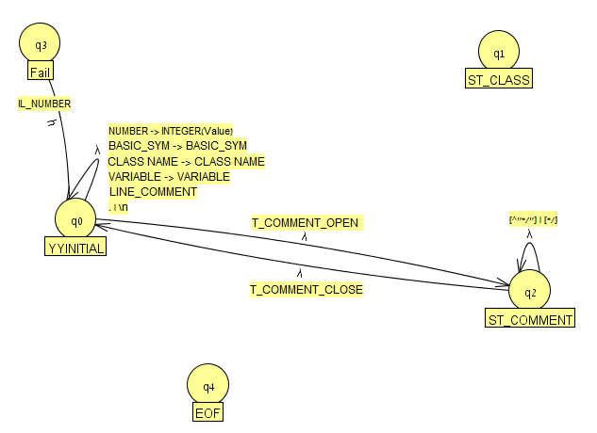
  - Regular Expressions:
POSITIVE_DIGIT = [1-9]
SMALL_LETTER = [a-z]
CAPS_LETTER = [A-Z]
DIGIT = 0 | {POSITIVE_DIGIT}
NUMBER = 0 | ({POSITIVE_DIGIT} {DIGIT}*)
IL_NUMBER = (0 [a-zA-Z0-9.]+)
LETTER = {SMALL_LETTER} | {CAPS_LETTER} | _
ALPHA_NUMERIC = {DIGIT} | {LETTER}
VARIABLE = {SMALL_LETTER}+ {ALPHA_NUMERIC}*
CLASS_VARIABLE = {CAPS_LETTER}+ {ALPHA_NUMERIC}*
LINE_TERMINATOR = [\r\n"\r\n"]
INPUT_CHARACTER = [^\r\n"\r\n"]
IGNORE = {LINE_TERMINATOR} | [ \t\f]
LINE_COMMENT = "//" {INPUT_CHARACTER}* {LINE_TERMINATOR}
T_COMMENT_OPEN = "/*"
T_COMMENT_CLOSE = "*/"
QUOTE = "\""
QUOTED_STRING = {QUOTE} {INPUT_CHARACTER}* {QUOTE}
- Testing Strategy:
The testing strategy started with some very simple IC files which has changed rapidly to test fundamental errors and to pass our Proof of Concept, after we have stable our code we start to form a general good testing file, and a tester for a lot of falling points behavior and making sure it works has we expected.

