Compilation Project Part 3 – Semantics

Overview: The third part of the IC Compiler which handles semantics checks and type checking on the ast constructed.

Input: Up to 4 arguments; the first is mandatory:
- The .ic file to parse
- Either –print-ast which prints the ast of the parsed ic (and library file) or –L<path of library file>. Of course there can be both.
- –dump-symtab: prints the symbols tables and the type table for the program.

Output: If no error occurred and the parsing process was successful a message of "Successfully parsed…" will appear, if an error has occurred then an error message (syntax or lexical) will appear with details.
If the command –print-ast is invoked then a printout of the ast will appear on the screen as well. The print out is in the format:
ID <description of node> -> { ID of children nodes separated by comma }
If the print symbol tables command is invoked then the program prints the symbol tables that were created and the type table.
We perform semantic checks and type checks on the input, a list of errors maybe be printed if a test failed, otherwise nothing is printed (except the successfully parsed).

Code structure: In the main function of the Compiler class there several functions that handle the construction of symbol tables and type table and semantic checks:
- BuildSymbolTables: Builds the symbol tables for the whole program also returns the semi built type table (It is semi built because it this step it only contains types for symbol table record)
- SemanticChecks: Perform semantic checks (scope rules, break-continue etc...)
- TypesChecks: Perform type checking.
- PrintSymbolTables and PrintTypeTable: prints the tables in the requested format.
We also implemented:
- SemanticError: Exception class.

Testing strategy:
We performed a series of tests:
- Tests that were built together with the spec – going through each related section and building corresponding tests.
- Examples from spec
- Programs that we created in order to try out as many cases as possible.
- Real IC programs that we built.
- All the test are in the test folder

Class hierarchy:

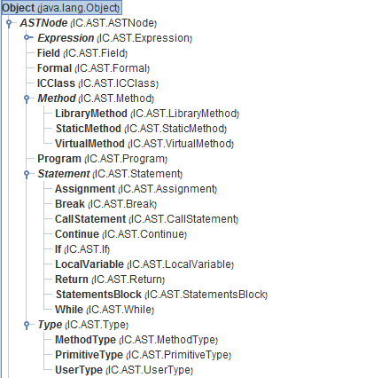
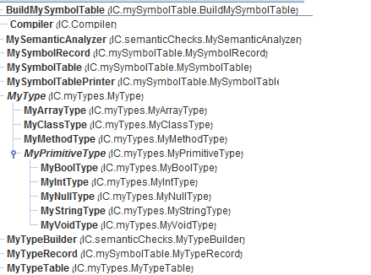

Packages:
In the "src" folder there is the main package IC. IC contains 5 sub-packages:
- AST
- Parser
- mySymbolTable: all the symbol tables and type table classes
- myTypes: all the types representations classes
- semanticChecks: all the semantic checks and types checks classes

Major classes:
- Compiler – explanation at the beginning of the document.
- MySymbolTable – implementation of symbol tables
- MyTypeTable – implementation of type table
- MyType – types for the type table, classes that extends MyType are standard to support the type table.
Bonus:
- We implemented the return check bonus
- We implemented the initialize before use bonus. We did not implemented it on array variables

Semantic Analysis:
We implemented the semantic analysis as clear as we could. We chose to separate the checks as much as reasonable and possible.

At the beginning we built the symbol tables for each scope:
- First we insert all the classes that have no super class.
- Then, we insert those who we have their super classes in our symbol table
- Hence, by the end of the algorithm all the classes that are defined will be in our symbol table. If an error occurred during this phase we know that either we have inheritance cycle or a class has a super class that is not defined.
- We associate each symbol table record with its type and insert it to the type table.
- We handle simple errors like trying to insert the same symbol record twice when it is forbidden.
- We handle the bonus of checking initialization here.

Then, we run our semantic analyzer that checks semantic errors:
- We check scope rules, static scope, instance scope.
- We check that reference to variables, functions, classes are all well defined according to the spec.

Finally, we build our full type table and make types checks:
- We use the subtypeof function in order to determine type conflicts (when its not equals).
- Each new type has an implementation of subtypeof, classes implement subtypeof with the symbol table in order to travel upwards on the inheritance tree.
- We check for type in expressions, functions arguments and all the other checks according to the spec again.

The bonus for the returns is implemented in a different visitor – just because we added it at the end and did not want to mess up any part.

Regarding semantic errors:
We try to accumulate as many semantic errors as possible before we reported and stop the evaluating process (or building process), so sometimes we throw perfectly clear error messages, but sometimes (depending on the error) we indeed throw the first error (which is always correct) but the ones after it can be a bit weird….

