**Methodology:**  
This chapter gives detailed descriptions as to the source of data (Whole-body PETCT scan Dicom image) and how the estimation of the patient’s weight was carried out using python programming language to script a code that carry out volumetric analysis through thresholding and anthropometric approximation calculation to obtain the Patient weights. Methods of Dicom image processing was used, following the steps of loading Dicom, Calibration, Binary Mask, patient segmentation using thresholding and finally obtaining the patient weight.

Data Collection:

Whole-Body PETCT Dicom images was obtained in the Cancer Imaging Archive website and embodi3D website. The whole-body image obtained from the embodi3D website where NRRT file format, which was converted to Dicom image format for the purpose of this project using 3D Slicer.

**Weight Calculation using volumetric analysis:**

In this method, we first read the raw volumetric CT scan that comes directly from the scanner. A raw CT scan gets stored as a dicom image and contains header tags along with pixel information. Using a combination of both this information, we extracted necessary information that will help us in calculating the patient’s weight.

**Process Flow Diagram:**

Input Dicom Image

Thresholding

Contouring

Retaining Body Contour

Applying Body Mask

Patient Volume

Patient Weight

We first read the dicom image and extracted the slice thickness of the CT scan using the header tags. Slice thickness will help us in getting the voxel level information using which we later interpolate the pixel information at a volumetric level. Once the dicom image is read, we then extract the volumetric pixel information that conforms to Hounsfield values that is found in CT scans. This will be a combination of the patient’s scan and also the surrounding regions that come as part of the CT scanner like the table on which the patient is laid.

To obtain the actual patient volume from the CT scan, we will have to separate the patient’s pixel information from the other unnecessary surroundings like the table outline. For this, we first apply a threshold to remove the air pixel values using air HU value. This will give us a binary mask that will contain the patient’s pixel information and also the table’s outline pixel information. We then apply contour-based segmentation approach to retain the largest contour from the binary mask obtained. We look up for all the contours in the binary mask, each contour represents a join of all pixels that are together. Since the patient and table are separated, these two will appear as two different contours. To obtain the patient’s contour we simply retain the largest contour as by default it represents the patient’s contour.

Once the patient’s body contour is obtained, we extract a binary mask from it and multiply with the original raw CT scanned image to get only the patient’s pixel information. We then calculate the patient’s volume using the obtained patient’s body mask. We sum up all the pixels along each direction and each slice to obtain an overall sum of all the pixels that the patient occupies in the scan. We then multiply the summed-up area along each axis with the voxel level information obtained earlier to get patient’s overall volume. Once the volume has been calculated, it is multiplied by the relative density of each voxel to obtain weight.

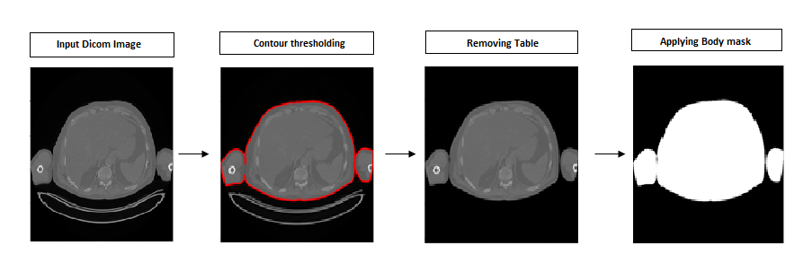

To calculate BMI, we use the equation given earlier. We use the obtained weight and also measure the patient’s height to calculate the patient’s BMI.

**Weight calculation using Anthropometric approximation method:**

In this method, we use two approaches to calculate the patient’s weight.

In the first method we simple find the circumference of the patient’s hip and waist directly using radiant dicom viewer software on the transverse plane. Patient’s height is also calculated along the coronal plane. Radiant comes with its own measurement tools for us to calculate the required measurement.

Once the circumference and height is measured, we use the following formula to calculate the weight.

For males:

weight = (0.6*height) + (waist_circumference*0.785) + (hip_circumference*0.392) -137.432

For females:

weight = (0.4*height) + (waist_circumference*0.325) + (hip_circumference*0.836) -110.924

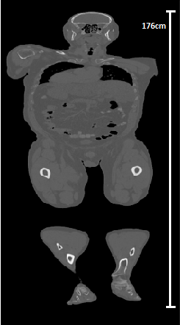

Patient Height

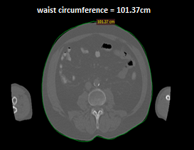 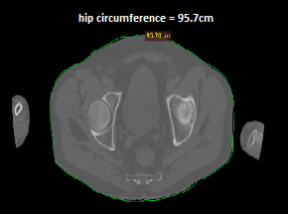

Waist circumference Hip circumference

In the second method, we calculate the circumference of the waist and hip using the long and short axis of the waist and hip region.

Once the measurements are done, we calculate the circumference using the formula:

circumference = 2*pi* (a2+b2)/2

This is done for hip and waist. Once the measurements are obtained, we calculate the weight using the formulas mentioned earlier.

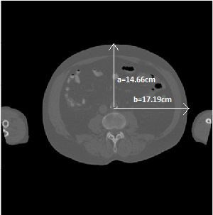 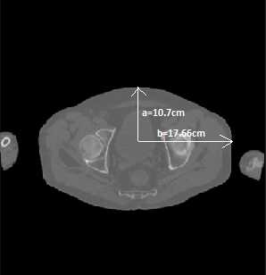

Waist measurements Hip measurements

Results:

|  |  |  |  |  |  |  |  |  |  |  |
| --- | --- | --- | --- | --- | --- | --- | --- | --- | --- | --- |
| S/N | Name of the DICOM File | Python code estimation of patient weight through DICOM image (PETCT) | | | | | | | | |
| Volumetric analysis  Using  image segmentation/  thresholding | | Anthropometric method of weight estimation | | | | | | |
| Open Polygon | | | | Eclipse | | |
| Height  (cm) | Waist  (cm) | Hip  (cm) | Weight(kg) | Height  (cm) | Waist radius & |  |
| Weight  (kg) | BMI |
| 1 | AC_CT_TBODY_1 |  |  | 152.46 | 78.82 |  | |  |  |  |
| 2 | CT_WB_2mm_1 |  |  |  |  |  | |  |  |  |
| 3 | 3.000000-PETWB-49172 |  |  |  |  |  | |  |  |  |
| 4 | test_wb_ct |  |  |  |  |  | |  |  |  |