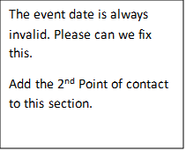
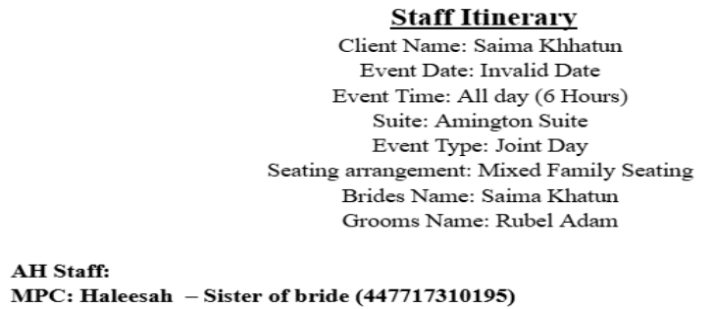

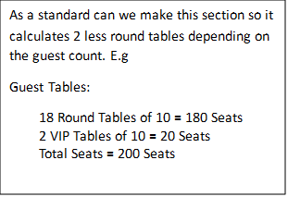
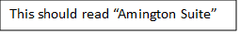
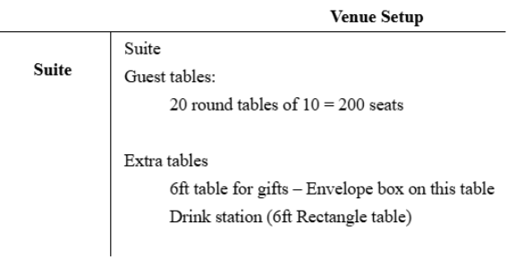

Add the option on Nendra to the foyer section on the Staff Itinerary only if selected.
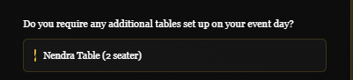
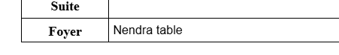

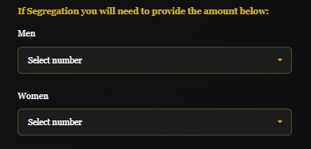
Ensure the men and women ratio is added onto the staff timeline.
So if the client has booked both suites. Both Amington Suite & Serenity Suite should be filled out on the Staff timeline with the numbers and the split of men and women. As Serenity does not hold VIP tables. E.g.
18 Round Tables of 10 = 180
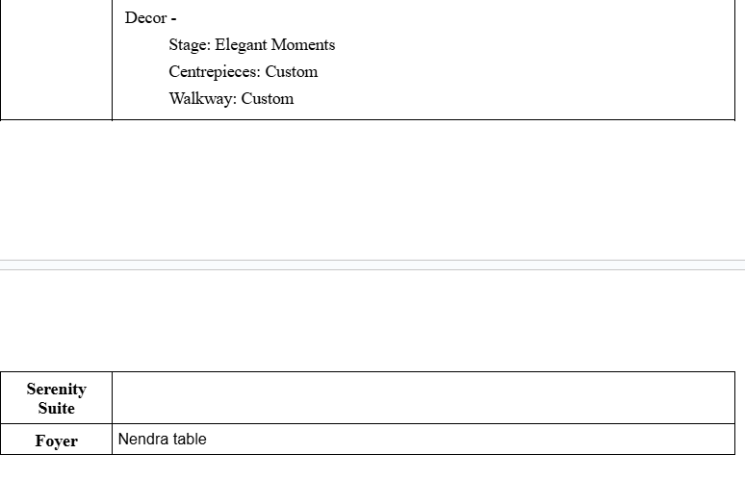

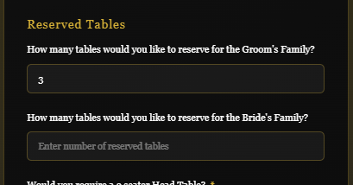
The reserved tables will need to be added on the staff timeline. Like the picture below. So if the client has selected 3 reserved tables. This should be automated as 1 VIP (If this was selected in the previous question) & 2 Round Tables.
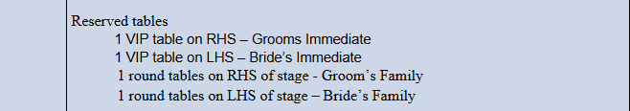
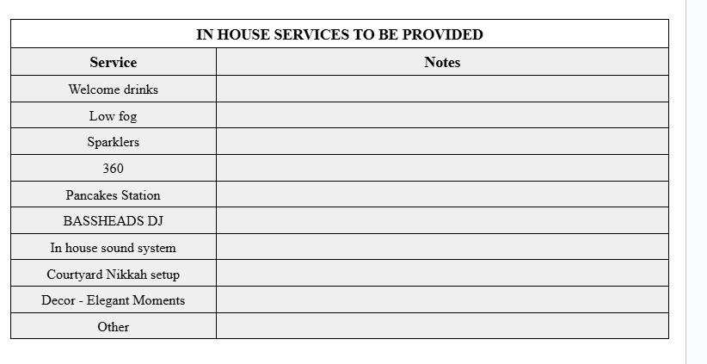
In this grey section to add Elegant moments and their contact details, and the description they add in the box below. If they also attach a copy of the description. The picture to bee added in the notes section also.

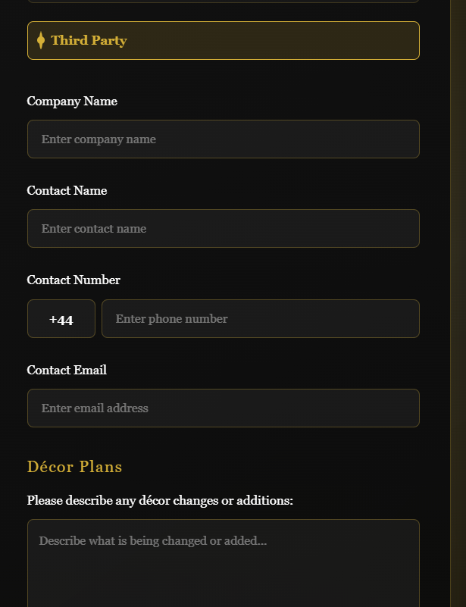

The third party option, alongside their contact details & Décor Plans description and if they do upload a picture it should be added onto the “External Vendors & Suppliers details”.
If no button has been selected then this should be added as “N/A” in the “External Vendors & Suppliers Details”. E.g.
And the décor section in the “Venue Setup” section should display “Standard” as shown below.

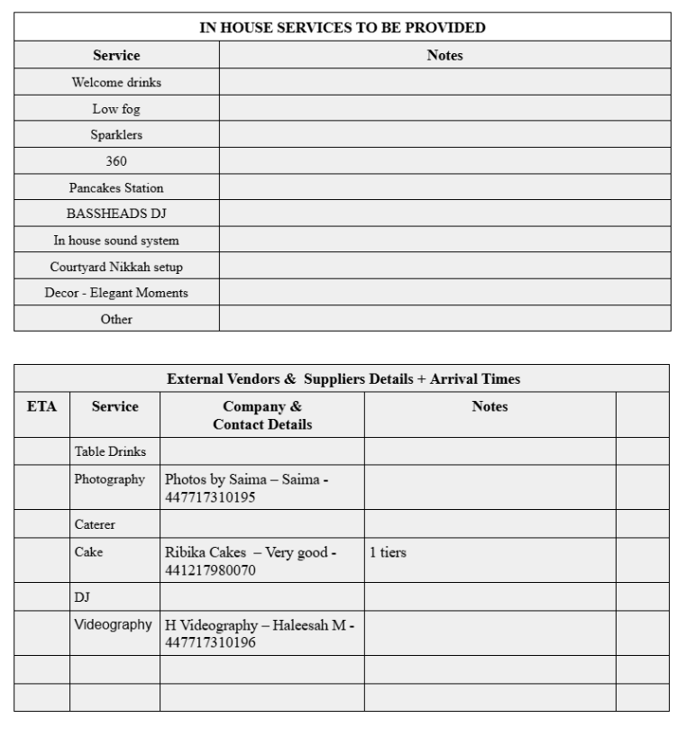

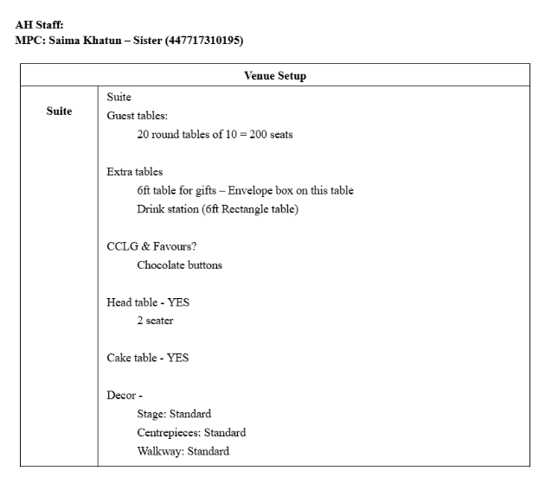

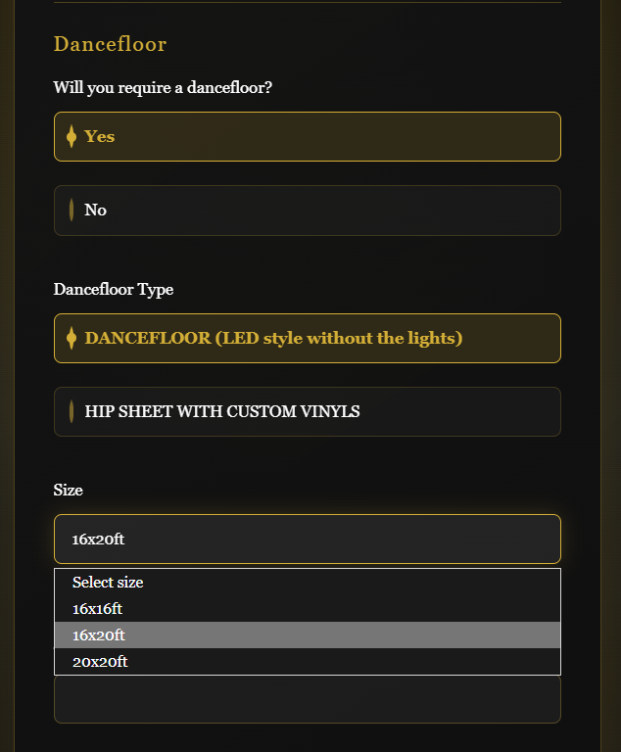

Dancefloor – If they do go ahead with the dancefloor, all this information will need to be added on the “In-house services to be provided list” it can get added as another line. E.g.



Dancefloor – If the answer for the dancefloor is “NO”. this should still be added onto the same section with “N/A” in the notes

Cake – All details of the cake to be added into the “External Vendors & Supplies details” e.g.

The “Notes” section to have the answer depending on what they select on the “Arrangements of the cake.”
If no details given in the cake section, then it should automatically come out as “N/A.” E.g.

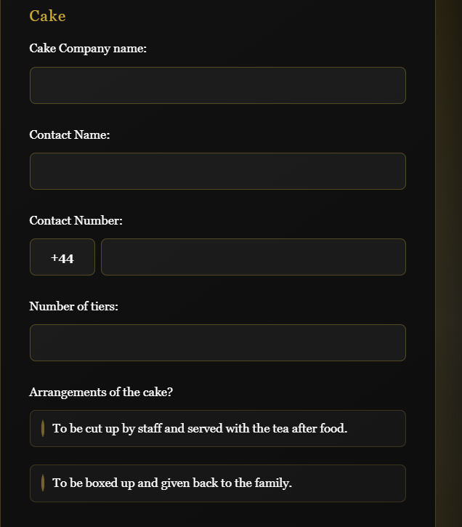

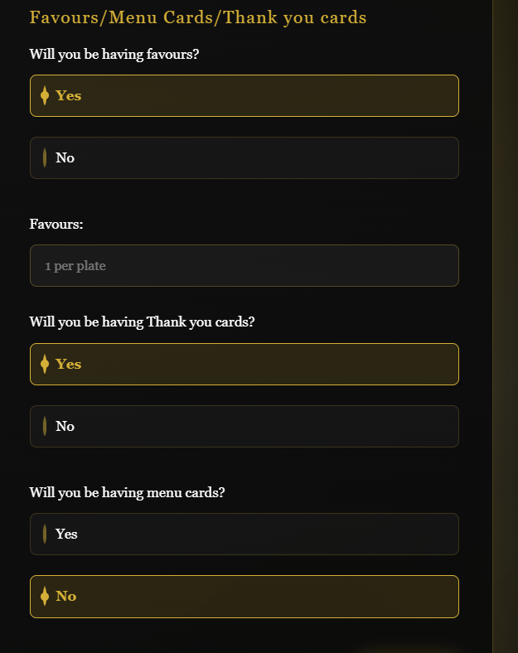

Change this to “Type of favour”
Favours - If answer is yes, then add this onto green boxed area. E.g

If the answer is “No” for Favours then it should be displayed as follows e.g

CCLG
Favours – YES
Chocolate Buttons – 1 per plate
Thank you cards – Yes
Menu cards - Yes

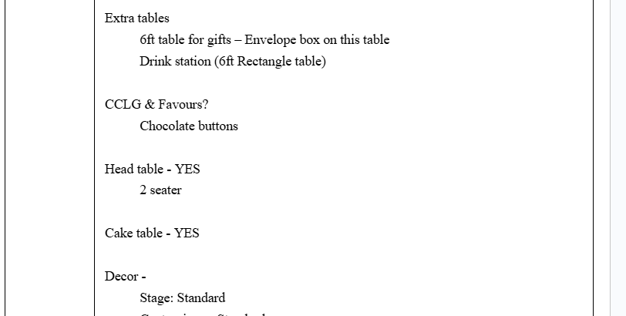

CCLG
Favours – NO
Thank you cards – No
Menu Cards - No

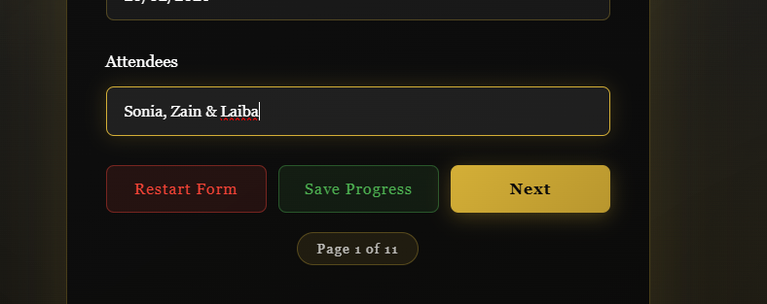
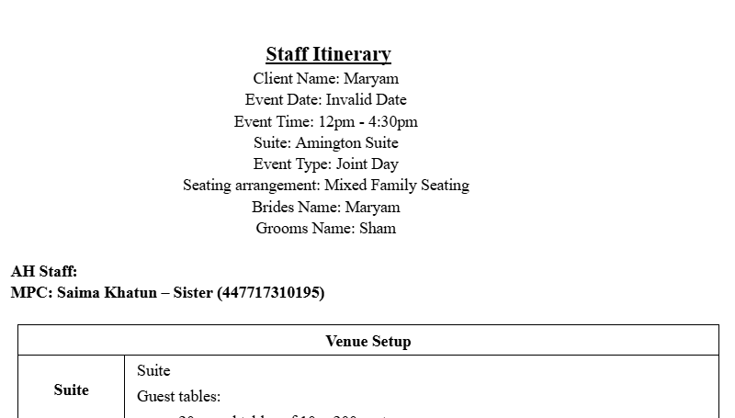
Add the list of Attendees underneath Groom’s Name, as follows:
“Attendees: Sonia, Zain, & Laiba”

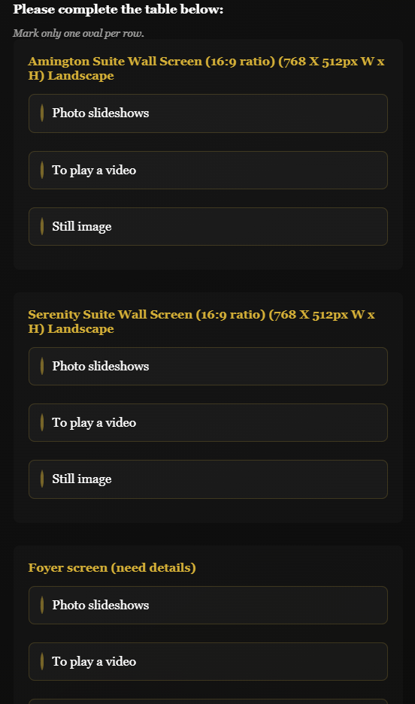
LCD/LED Screens – Once client has selected any option for the Amington Wall screen it should be added into the Staff itinerary. E.g.

This will be dependent on what the client answers with

Serenity Suite Wall Screen should look like the following:

This will be dependent on what the client answers with
Foyer Screen –
This will be dependent on what the client answers with.
If No answers are given. It should be displayed automatically in the Staff itinerary as
“LED/LCD – NON” in each section.
If they add anything in description, this should also be added into the relevant suite booked.

The LED/LCD section, will also depend on which suite has been booked. So if the client has only selected the use of Amington Hall then the Serenity Suite should be cancelled out completely. If Serenity Suite is only in use, then Amington Suite should be cancelled out completely.
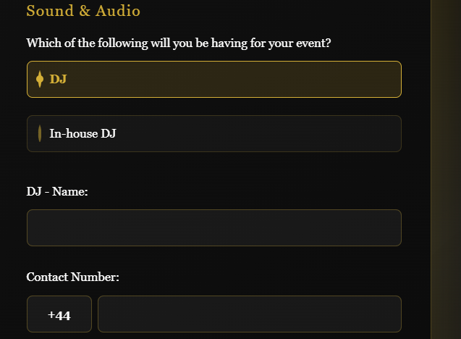
DJ/In-House DJ –
Once the client has selected “DJ” and all the information has been added, This should be added onto the Staff Itinerary in the “External Vendors & Suppliers Details”
If “In-House DJ” is selected then it should be added onto “In-house Services to be provided”

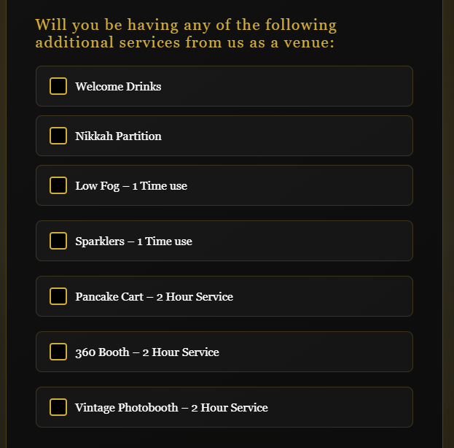
Additional Services from the Venue –
Any selected options to be added in the Staff timeline under the section of “In-house services.” This should include the “when will this be used” into the notes section depending on the answer e.g.

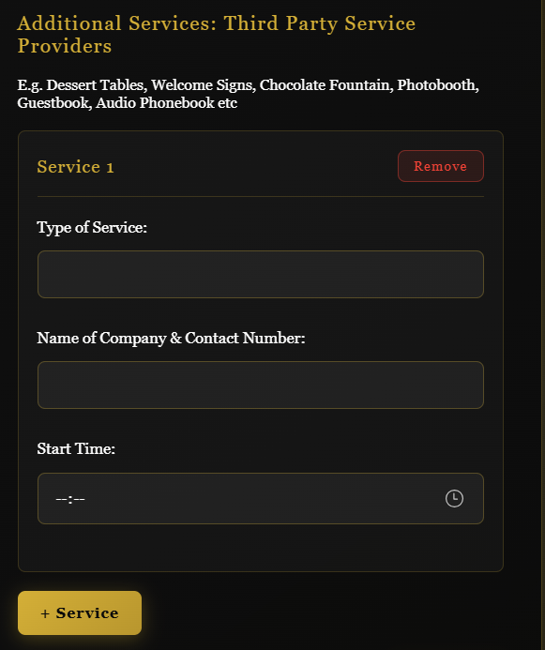
Additional Services – any additional Service Added will need to be added into “External Vendors & Suppliers” section. E.g.
If there is No Additional Third Party services added, then the staff Itinerary should have the “External Vendors & Suppliers” grid still visible.

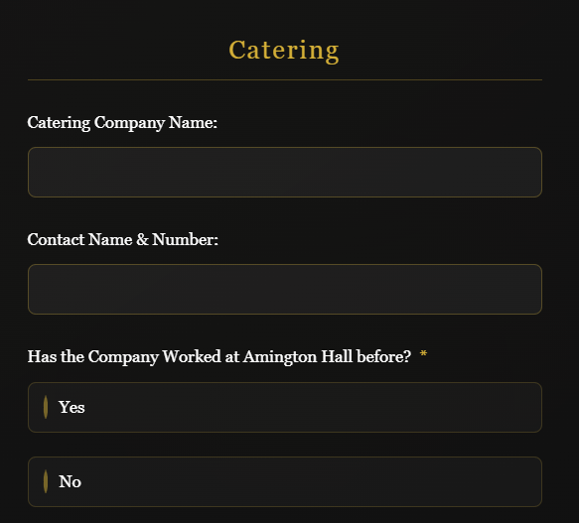
Catering – The Catering company will need to be added into the “External Vendors & Suppliers” e.g
If client does not add anything in the catering section, then Catering should automatically be added into the “External vendors & Suppliers Details….” Section. As it is above without contact details.
“Has The company worked at Amington Hall before?” – The response will need to be added into the “Key Notes” Section

External Vendors & Suppliers Details + Arrival Times
Service | Company name & contact No. | Notes
Catering, Table Drinks | MKB - 07243658376
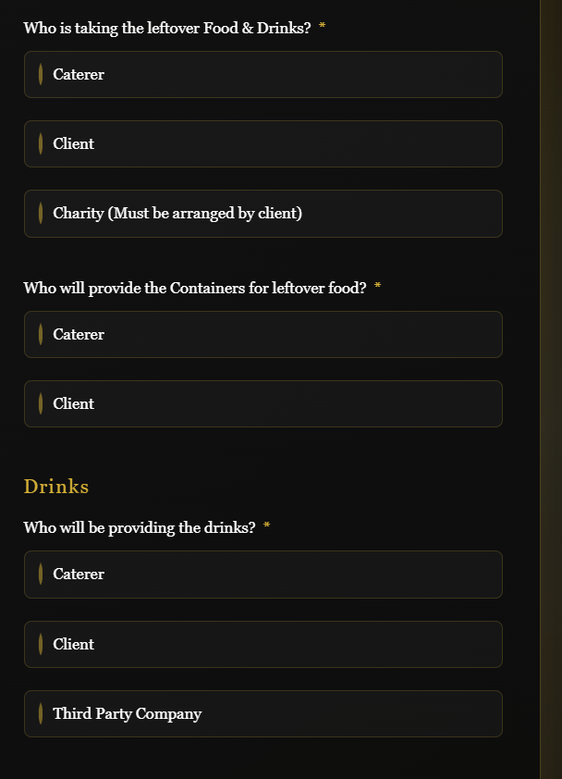
“Who is taking the Leftover Food?” – This will need to be added into the “Key Notes” Section e.g.
Depending on the answer given by Client.
“Who will provide the containers for leftover food?” – This will need to be added into the “Key Notes” section e.g.
Depending on the answer given by Client.
“Who will be providing the drinks?” – This will need to be added in different sections depending on which answer they select.
“Caterer” – To be added in the “External Vendors” section in Caterers section e.g.
“Client” – If they select this option, this will need to be added onto a separate section in the “External Vendors”

External Vendors & Suppliers Details + Arrival Times
Service | Company name & contact No. | Notes
Table Drinks | Client
Catering, Hot Drinks | MKB - 07243658376

“Third Party Company” – if the client selects this option then This should also be added as a separate row in the “External Vendors” Section.
Reception drinks – if Client selects the Yes option, again like before the “who is the supplier?” the response to this one will go into different areas, depending on the selection the user makes.
“Amington Hall” – This should be added into the “In-House Services” section, as shown below.

“Client” – if user selects this option, then this will need to be added in the “External vendors” section e.g.

“Third Party Company” – if user selects this option then this will need to be added in the “External Vendors” section

External Vendors & Suppliers Details + Arrival Times
Service | Company name & contact No. | Notes
Table Drinks | Bilal Food & Drinks - 07263547936
Catering, Hot Drinks | MKB - 07243658376
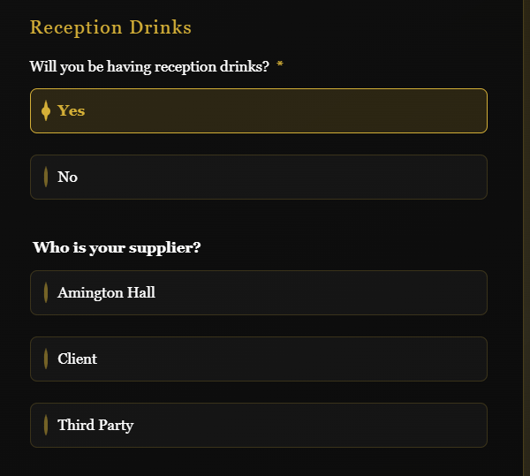

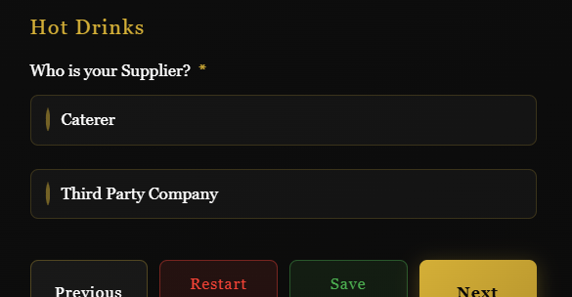
Hot Drinks – This option does not require an answer. So Asterisk can be removed.
“Caterer” – if this option is selected this will need to be added into the “External vendors” section in the Caterers Row e.g.

“Third party” – if this option is selected this will need to be added into the in the “External Vendors” Section e.g.

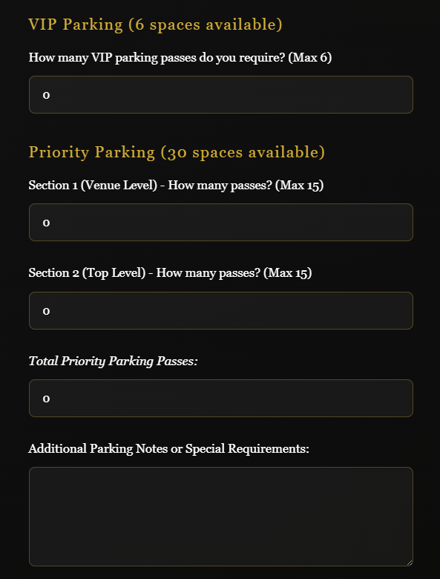
Car Parking – Remove This full section I have screenshot on the left. Do not remove the full Car Parking Section. Leave the Top part of it, but only remove the section I am showing you on the left.

Walk Through Register Form
- Can you remove Asterisk from the following Questions:
Page 10: Has the Company worked at Amington Hall before?
- Can you Add Asterisk on the Following:
Page 3: Table plan and reserved Tables
- When user wants to go to the next page, and it does not go to the next page, as a question has not been answered, can you add on the notification which question, has not been answered.
- Page 3: “Would you require a Head table for the Bride & Groom?” – Could you change it to this.
- Page 3: Can you remove the box at the bottom “Please Note: The above options are at an additional price. This will be discussed with you during your Walk through meeting.”
- Page 4: Can you add another option after Elegant Moments.
“Humsafar Wedding Services”

