CHAPTER 1
INTRODUCTION
  - Project Context
Technology is changing quickly in today's digital world, and it's changing the way people live, work, and talk to each other. New software and mobile computing technologies have made it easier and faster to do things we do every day. As a result, people now need smartphones and apps for work, school, and fun. Things are getting better all the time, but they're also getting harder to understand. This makes it harder for people to really get how their devices work. To keep your system running at its best, Google's Android Developers (2023) say you should keep an eye on apps, memory use, and background processes.
There are now a billion people in the world who have smartphones. People like Android phones and tablets because they are affordable, adaptable, and come in a lot of different brands. Statista says that Android is the most popular mobile operating system in the world (2023). Over 70% of people use it. People in different countries still have the same issues, though. For instance, apps crashing, running slowly, not having enough storage space, and having too many background processes. These problems show that even with new technology, many people still have trouble getting their devices to work. Because of this, people need better tools that can help them understand and use their phones.
A lot of people in the Philippines already use smartphones, especially students, workers, and small business owners. Many Filipinos prefer Android phones because they are cheaper and easier to find. DataReportal (2023) says that many people in the Philippines spend a lot of time on their phones. People use their phones to talk to each other, learn new things, and buy things. But a lot of people still have problems like lagging, not having enough storage, app crashes, and a system that runs slowly. Most of the time, these problems are caused by software, not hardware. A lot of people don't know how to fix technical problems, so they just restart the device or delete files to make it work again. But these don't always work.
A lot of people have problems with their smartphones, especially at places like Carlo Gadget Repair Shop and Accessories. A lot of the time, people bring in gadgets that don't work, run slowly, or freeze up. A lot of these problems are because the software isn't working right. Most of the time, technicians find these problems by hand by checking out the storage, the apps, and how well the system works. This method works, but it can take a long time and depends a lot on how skilled the technician is at it. You can't see some problems right away, so they are harder to fix and take longer to fix. We need a better and more dependable way to find out what's wrong.
People have made diagnostic tools to see how well smartphones work in order to fix these problems. These tools can tell you how much memory is being used, how well the storage is working, what apps are open, and how the whole device is working. According to Android Developers (2023), you should check on how the system is working to make sure the device runs well. But a lot of the tools that are already out there only give technical information that most people might not understand.
AI can help by giving you a choice that is better and easier to use. AI can look at the information in the system, spot patterns, and let you know what might be wrong with your phone. IBM (2023) says that AI systems can look at data and find patterns in it. Then, they can use those patterns to make predictions about what will happen next. This can help you figure out what's wrong with a system. AI can help you make sense of data by showing you problems with it, like apps that don't work right, too much memory being used, or too many processes running in the background. It doesn't just show numbers.
The Smart Hub: Diagnostic Application for Android Phone was made to help you find out what's wrong with your phone more quickly and easily. The system checks the most important parts of the computer, like how much space is left on the hard drive, what programs are running, and how well everything is working. Then it shows the results in a clear and organized way.
The system also has an AI tool that finds problems and suggests possible causes and fixes. People who don't know much about technology can learn more about how their device works more easily this way. Users can do things like manage apps, delete files they don't need, and speed up their computers based on what the system tells them to do.
The app is also useful for repair shop workers because it makes the diagnostic process faster and more accurate. When technicians use AI-generated data and system monitoring together, they can find problems more quickly. It also makes it easier for customers and technicians to talk to each other because it shows results in a way that is clear. People are more likely to trust and believe in the service when this happens.

  - Objectives of The Project
This study aims to develop and design Smart Hub: Diagnostic Application for Android Phone, a computer-based system designed to assist technicians and users in identifying and analyzing software-related issues in mobile devices. The system intends to improve the troubleshooting process by providing accurate and organized diagnostic results, making it easier to detect and understand smartphone problems.
Specifically, it sought to:
- To make the system easy to use so technicians can understand and operate it without difficulty.
- To provide accurate and reliable results when diagnosing phone problems.
- To develop a system that functions properly and minimizes errors during use.
- To test the usability of the system based on user feedback and experience

.1.3 Significance of The Study
This study provides a vital contribution to the advancement of mobile diagnostics, specifically in addressing software-related issues within the Android ecosystem. The following stakeholders directly benefit from this project:
Smartphone Users – This application offers users a straightforward way to monitor their device’s health. It provides a clear understanding of why a device experiences performance drops, empowering users to make informed decisions regarding proper maintenance and care.
Technicians – The system serves as an automated tool that significantly accelerates the troubleshooting process. Instead of relying on manual inspections, technicians receive accurate data and rapid results, which increases overall productivity and minimizes human error in diagnosing software malfunctions.
Carlo Gadget Repair Shop and Accessories – As the primary beneficiary, the shop gains a more organized and efficient workflow. The integration of this technology elevates the quality of their service, fostering greater trust and confidence from their customers.

Developers – Developing Smart Hub provides the developers with practical experience in system analysis, software development, database management, and implementing real-world applications. This allows them to apply theoretical knowledge to a functional system that addresses the diagnostic needs of the mobile repair industry.
Future Developers – The project serves as a reference for future developers and researchers aiming to create similar diagnostic platforms or service-oriented systems. Smart Hub demonstrates best practices in designing intuitive interfaces, integrating ADB-based diagnostic protocols, and managing device data efficiently.

  - Purpose and Description
The primary purpose of this study is to design and to develop a comprehensive diagnostic system entitled "Smart Hub: Diagnostic Application for Android Phone." This study states that as mobile software becomes more complex, there is a critical need to move away from manual, "guesswork-based" troubleshooting toward an automated and evidence-based approach. By centralizing diagnostic tools into a single workstation, the project seeks to provide a reliable method for identifying system inefficiencies and software defects that are often overlooked by the average user.
The project defines its solution as a Windows-based diagnostic workstation that establishes a secure communication link with Android devices via USB. Unlike standard mobile applications, this system is engineered to operate independently of the phone's built-in interface. This allows the workstation to function even in critical hardware scenarios such as devices with blank or broken screens where user interaction on the phone is impossible. the architecture integrates a PostgreSQL database for structured data logging and an AI Helper designed to translate complex system telemetry into actionable diagnostic reports that are easy for anyone to understand.
The necessity of this system is justified by the persistent software challenges identified in the project context, such as frequent application crashes, system lagging, and storage congestion. In environments like Carlo Gadget Repair Shop and Accessories, repair workflows are often delayed when technicians cannot access the device internals due to a non-functional display. By providing clear status indicators categorizing device health as Optimal, Needs Attention, or Critical Smart Hub ensures transparency and clarity in the repair process. Ultimately, this justifies the project's role in helping users and small business owners receive accurate assessments, leading to better device maintenance and longer-lasting technology.

  - Scope and Delimitation
This study focuses on the design, development, and evaluation of Smart Hub Diagnostics, an automated diagnostic system intended to assist in identifying and explaining common causes of USB connectivity failures and device-detection issues between a Windows computer and mobile devices especially scenarios where standard tools (e.g., ADB) cannot reliably connect due to driver problems, unstable USB enumeration, or low-level device modes. The system integrates a Windows-based diagnostic interface, an internal diagnostic service, and a companion Android application package used to support installation and guided checks when needed. The study primarily emphasizes automation-first diagnostics (minimizing manual troubleshooting steps) and producing actionable, human-readable results for troubleshooting and documentation. The scope of this study includes:
Developing a Windows desktop diagnostic interface that presents guided results, device status, and recommended actions based on collected evidence. Implementing automated host-side evidence collection such as USB device enumeration signals, stability sampling, and related system observations needed to infer likely connection states (e.g., normal USB operation vs. unstable or low-level modes). Providing structured diagnostic outputs (e.g., summaries/verdicts, transport or mode indicators, and timelines) to support troubleshooting, reporting, and repeatable testing. Packaging and distributing a companion Android application (APK) to support the overall workflow of the system (e.g., providing a controlled mobile-side component and a known installation artifact). Evaluating the system in terms of usability and effectiveness for intended beneficiaries such as IT support staff, technicians, and student researchers who handle device connection troubleshooting in real-world or laboratory settings.
Delimitations of the Study define the boundaries of what the study covers: The system is delimited to Windows-based host environments and does not aim to fully support macOS or Linux hosts. The mobile-side scope is delimited primarily to Android, using an APK artifact; iOS workflows and iOS-specific recovery/diagnostic modes are outside the primary coverage unless explicitly included as observational evidence on the host. The study focuses on diagnosis and decision support, not on guaranteeing full repair or resolution of all connectivity problems; it provides recommendations and evidence-based indications rather than hardware-level fixes. The system’s checks are delimited to USB-centric connection scenarios and related host observations; advanced network-based debugging and enterprise MDM-level device management are not the main focus. The scope is limited to the features implemented in the proposed software (Smart Hub Diagnostics), including automated connection checks, host evidence collection, mode/transport indication when detectable, and presentation of findings through the Windows UI and generated summaries—without extending into full forensic acquisition, data recovery, or unauthorized bypass of device security.

  - Definition of Terms
To provide a clearer understanding of the concepts used in this study, the following terms are defined based on their contextual meaning. These definitions are written in a simple and relatable way to help both technical and non-technical readers fully grasp the ideas presented in this research.
ADB (Android Debug Bridge). A command-line tool that allows a computer to communicate with an Android device for debugging and diagnostic purposes. In this study, ADB is used to collect detailed system information when the device permits access.
Android Device. A mobile device such as a smartphone or tablet that operates using the Android operating system. In this study, it serves as the primary subject being analyzed for software-related issues, performance problems, and system behavior.
ANR (Application Not Responding). A condition where an application becomes unresponsive for a certain period. In this study, ANR reports are analyzed to detect performance issues and application-related problems.
Application (App). A software program installed on a smartphone that performs specific functions such as communication, entertainment, productivity, or learning. Some applications may negatively affect device performance when they consume excessive resources or malfunction.
Artificial Intelligence (AI). A form of advanced technology that enables a system to analyze data, recognize patterns, and provide intelligent suggestions. In this study, AI is used to interpret diagnostic data and present possible causes of problems along with recommended solutions in a user-friendly manner.
Background Processes. These are operations or applications that continue running in the background even when the user is not actively interacting with them. While they support multitasking, excessive background processes may lead to slower performance and increased resource consumption.
Crash Reports. Detailed records created when an application or system unexpectedly stops working. These reports help in understanding the cause of failures and assist in diagnosing recurring problems.
Diagnostic Application. A specialized software tool designed to examine, monitor, and identify issues within a device. In this research, it refers to the Smart Hub system, which analyzes smartphone conditions and provides structured diagnostic results.
Lagging. A condition where the smartphone responds slowly to user actions, resulting in delays, freezing, or unresponsiveness. This is often caused by high resource usage, insufficient memory, or system inefficiencies.
Memory Usage (RAM Usage). The amount of Random-Access Memory (RAM) being utilized by the system and running applications. High memory usage can reduce device performance and may lead to app crashes or system instability.
Risk Analysis (App Risk Detection). The process of evaluating installed applications based on their permissions and behavior to identify potentially harmful or suspicious apps that may affect device performance or security.

Storage Capacity. The total amount of internal space available on a device for storing applications, files, and system data. When storage becomes limited or full, it can negatively affect system performance and overall usability.
System Logs. Records generated by the smartphone that contain detailed information about system activities, errors, and events. These logs are useful for identifying hidden issues that are not immediately visible to users.
System Performance. The overall efficiency and responsiveness of a smartphone when executing tasks. It reflects how smoothly the device operates, including app loading time, responsiveness, and multitasking capability.
Technician. A trained individual who specializes in diagnosing, repairing, and maintaining mobile devices. In this study, technicians use the Smart Hub system as a support tool to improve the accuracy and speed of their diagnostic process.
Troubleshooting. The systematic process of identifying, analyzing, and resolving problems within a device. This study aims to simplify troubleshooting by automating the detection and explanation of issues.
USB Debugging. A developer feature in Android devices that allows deeper communication between the smartphone and a computer. It enables advanced diagnostics, data access, and command execution, which are essential for detailed system analysis.
USB Enumeration. The process by which a computer detects and identifies a connected USB device. It helps determine whether the smartphone is properly recognized and connected to the system.
USB Triage Mode. A limited diagnostic mode used when full access to the device is not available, such as when USB debugging is disabled. It focuses on basic connection signals and system behavior to provide initial diagnostic results.

CHAPTER 2
REVIEW OF RELATED LITERATURE AND STUDIES
  - Review of related Literature and Studies
This section presents a review of related literature and studies that are significant to the development of Smart Hub: Diagnostic Application for Mobile Phone. This section is intended to provide major concepts, findings and technical insights from various sources that are relevant to the current study. The review focuses on automated diagnostic systems, Android system protocols, USB connectivity using ADB (Android Debug Bridge) and software defect evaluation. Furthermore, literature regarding system performance monitoring, background process management and storage congestion analysis is presented to address common issues like system latency and application crashes. These gathered materials are essential in understanding the challenges encountered in manual smartphone troubleshooting, especially in local repair shop settings. Finally, this review establishes the requirements for a computer-based diagnostic tool and provides a basis for evaluating the proposed Smart Hub system in terms of its functionality, reliability, and technical efficiency.

    - Review of related Literature
This section reviews the related literature on the study. It synthesizes the important findings and theories from various studies to provide a comprehensive understanding of the topic, emphasizing significant contributions, methodological approaches, and critical perspectives from prior research. Specifically, this review focuses on literature related to Android smartphone software issues, performance monitoring, background process management, storage congestion analysis, and automated diagnostic systems. These topics are directly relevant to the development of the Smart Hub: Diagnostic Application for Android Phone, which aims to identify and analyze software-related problems such as system latency, application crashes, and storage constraints. The literature gathered in this section establishes the technical foundation for understanding the challenges encountered in manual smartphone troubleshooting, particularly in local repair shop settings, and supports the need for a computer-based diagnostic tool like Smart Hub.

2.2.1 Foreign Literature
Recent studies emphasize that usability plays a significant role in the effectiveness of mobile and AI-based applications. According to MDPI research by Ghanzouri et al. (2024), usability is measured through efficiency, effectiveness, and user satisfaction, which directly influence how users interact with mobile systems. Similarly, Müller et al. (2022) highlighted that usability evaluation methods such as learnability and accessibility are essential in ensuring that applications can be used by both technical and non-technical users. Supporting this, Liang et al. (2023) found that systems with high usability significantly improve task completion rates and user adoption. These findings suggest that developing a user-friendly interface is crucial in ensuring that diagnostic systems can be easily understood and effectively utilized by technicians and smartphone users.
In terms of diagnostic accuracy and system reliability, several foreign studies highlight the importance of integrating artificial intelligence and data-driven approaches. Al-Zoghby et al. (2025) demonstrated that AI-driven mobile diagnostic systems significantly improve the accuracy of identifying system issues by analyzing large datasets in real time. Likewise, Haque et al. (2022) emphasized that explainable artificial intelligence (XAI) enhances both accuracy and user trust by providing transparent and interpretable results. In addition, Rahman et al. (2024) showed that machine learning techniques improve prediction accuracy in diagnostic systems, making them more reliable compared to traditional methods. These findings indicate that incorporating AI into diagnostic applications can enhance the precision and consistency of system outputs, which is essential for effective troubleshooting.
System functionality and error minimization are also critical aspects of mobile application development. Liu et al. (2022) explained that automated tools can detect compatibility issues in Android applications, ensuring consistent performance across different devices. These findings suggest that implementing automated detection mechanisms is essential in maintaining system stability and minimizing operational issues, particularly in environments where multiple device configurations are involved.
Finally, user feedback and acceptance remain essential in evaluating system performance and usability. Longoni et al. (2023) found that user trust and acceptance of AI systems are influenced by how well the system responds to user needs and expectations. This implies that systems must not only be technically accurate but also understandable and responsive to users. Continuous evaluation based on user experience helps ensure that diagnostic applications remain effective, user-centered, and widely accepted.

    - Local Literature
Recent studies in the Philippines emphasize the importance of usability, reliability, system performance, and user experience in mobile applications, particularly in Android-based systems. According to Department of Information and Communications Technology (2023), user-friendly systems are essential to increase digital adoption across the country, as many users rely heavily on mobile technologies for daily activities. This supports the idea that ease of use is a critical factor in ensuring that applications are accessible to a wide range of users. Similarly, Google Android Developers (2023) highlighted that applications should have simple navigation, responsiveness, and intuitive interfaces to improve usability and user satisfaction.
In terms of user acceptance, the study of Mark Joseph J. Gumasing et al. (2024) found that effort expectancy, or the perceived ease of using a system, significantly influences the adoption of mobile technologies in the Philippine context. This suggests that systems that are easier to understand and operate are more likely to be accepted and continuously used by users.
Moreover, system accuracy and reliability are crucial factors in mobile application performance. A report by Kaspersky Philippines (2023) emphasized that Android devices are often exposed to vulnerabilities, making reliable diagnostic systems necessary to maintain device performance and security. In addition, the Department of Information and Communications Technology (2023) stressed that system reliability plays a vital role in strengthening digital infrastructure, ensuring that applications function consistently without errors.
Furthermore, system functionality and error minimization are essential to enhance overall application performance. According to Google Android Developers (2023), developers should focus on reducing crashes, optimizing memory usage, and managing background processes to ensure smooth system operation. This is supported by findings from Kaspersky Philippines (2023), which identified common system inefficiencies and vulnerabilities affecting Android devices.
Lastly, usability testing and user feedback are important in evaluating and improving system performance. The study by Mark Joseph J. Gumasing et al. (2024) showed that user experience significantly affects behavioral intention to use technology. Likewise, Google Android Developers (2023) recommended conducting usability testing through user feedback and performance metrics to enhance application quality. These findings highlight the importance of incorporating user-centered evaluation in the development of diagnostic applications.
    - Review of related Studies
This section presents the review of related studies relevant to the Smart Hub: Diagnostic Application for Android Phone. The selected studies focus on automated Android diagnostics, USB connectivity troubleshooting, ADB-based tools, and computer-based systems used in smartphone repair and analysis. These studies are important in understanding how diagnostic tools assist technicians in identifying system issues efficiently.

    - Foreign Studies
The global landscape of mobile diagnostics has shifted toward automation and intelligent analysis. Foreign studies provide a strong technical foundation for Smart Hub: Diagnostic Application for Android Phone, which helps technicians and users identify software issues in mobile devices, even when the screen is blank or USB debugging is off using BSOD (Blue Screen of Death).
Several studies highlight the importance of user‑centered design. Andika et al. (2024), in “UI/UX Design Of Marketplace Service Mobile and Laptop Applications Using Design Thinking Method,” applied design thinking to create a repair service interface. Their evaluation proved that this approach produces high usability and reduces user errors. Rombaut (2024), in “Empowering Repair: a Smartphone Diagnostic tool for Consumers,” developed a diagnostic tool for non‑technical users and found that clear, structured data helps ordinary people understand device problems. These findings justify Smart Hub's simple, organized Windows interface. The system presents diagnostic results in human‑readable formats, allowing technicians at Carlo Gadget Repair to operate easily and enabling users to understand their phone's condition even with a broken screen.
Expert systems also support diagnostic workflows. As'saidy et al. (2023), in “System Expert Diagnosis Iphone Cellphone Damage Web‑Based,” created a web‑based expert system that uses rule‑based reasoning to guide repair decisions. Their work showed that storing past cases and applying logical rules can effectively support technicians. Smart Hub directly mirrors this approach by automating ADB‑based diagnostics—collecting build properties, battery health, system logs, crash reports, and ANR reports. The system also includes an offline AI helper that stores previous diagnostic cases and generates ranked suggestions for technicians, especially when USB debugging is unavailable.
Malware detection and risk analysis inform Smart Hub's security features. Dahiya, Singh, and Shrivastava (2025), in “PRAZdroid,” developed a permission‑based risk assessment that computes five risk levels (Level 0 to Level 4) and achieved 98.07% classification accuracy. Gupta, Sharma, and Garg (2024), in “Covalent Bond Based Android Malware Detection,” paired permissions with system calls, combining static and dynamic analysis to reach high accuracy. Zaidi and Abbas (2025), in “SNEL-DFF,” used Siamese networks and ensemble learning to improve detection and reduce false positives. Smart Hub adopts these methods by listing installed apps, collecting their permissions, computing risk scores, and flagging suspicious applications. This multi‑layer strategy ensures accurate diagnosis of app crashes, system lagging, and excessive memory usage.
Performance monitoring is critical for smartphone health. Alenizi et al. (2025), in “From Feedback to Failure,” created RevPerf, a tool that automatically reproduces performance bugs from user reviews, achieving a 72.73% success rate. Liu et al. (2025), in “XTrace,” developed a non‑invasive tracing framework that monitors Android apps without slowing them down, preserving both privacy and stability. Lima, Giusti, and Dias‑Neto (2024), in “LeakPred,” used machine learning to identify resource leaks in Android applications, achieving 81.25% accuracy and 96.15% coverage of leak classes. Smart Hub directly supports these functions by tracking RAM usage, storage capacity, background processes, thermal readings, and USB instability indicators. The system collects crash and ANR reports while keeping all data on the technician's workstation, consistent with XTrace's privacy‑first philosophy.
Finally, user feedback and usability testing drive continuous improvement. Abdelaziz, Codabux, and Schneider (2024), in “Review-Pulse,” built a dashboard that helps developers analyze user reviews and plan future updates. Danlee (n.d.), in “Development of an application for sustainable phone diagnostics,” created SmartCheck, a diagnostic app with automated testing and an accessible graphical interface for disabled users. These studies emphasize that accessible diagnostics promote sustainable device use and repair. Taken together, these foreign studies support Smart Hub's mission: to improve smartphone troubleshooting through automated checks, structured findings, and clear communication, helping repair shops like Carlo Gadget Repair diagnose issues faster and build customer trust.

    - Local Studies
Local research in the Philippines provides relevant insights into the development of diagnostic applications for mobile devices. Alvarez et al. (2024) developed "TECHAID: AI‑driven application for prognostic maintenance for mobile hardware using linear regression", an AI‑driven application that uses linear regression to predict hardware failures by analyzing historical performance data, demonstrating that AI can effectively identify trends and anomalies in mobile device behavior. Similarly, Fortuno et al. (2022) developed "MEKANIKA: An Automobile Troubleshooting and E‑learning Application" , a mobile application that guides users through step‑by‑step diagnostic procedures evaluated using ISO 25010 standards, receiving a "very satisfactory" rating, both local studies confirm the feasibility of using AI for mobile diagnostics and the value of structured evaluation frameworks.
These findings support Smart Hub's offline AI helper and its adoption of ISO/IEC 25010 for software quality evaluation. While TECHAID focuses on hardware prediction and MEKANIKA on automobile troubleshooting, Smart Hub applies AI and ISO 25010‑based evaluation to diagnose Android software issues such as app crashes, memory leaks, and excessive background processes, guiding technicians at Carlo Gadget Repair Shop and Accessories through structured, human‑readable diagnostic results.

2.2.6 Summary of Review Related Literature and Studies
This section presents the strengths and weaknesses of the reviewed literature and studies related to the Smart Hub: Diagnostic Application for Android Phone. It highlights the key advantages and limitations of existing research in areas such as Android diagnostics, performance monitoring, and automated troubleshooting. Through this analysis, the section evaluates the relevance of previous studies to the current research and identifies gaps that need to be addressed. These insights serve as a guide in improving the design, functionality, and overall development of the proposed system.
Table 2.1 Summary of Review Related Literature and Studies
Author | Advantages | Disadvantages
Gumasing et al. (2024) | Provides empirical data; uses a validated model (UTAUT2); Philippine-based context | Focused on smartwatch technology, not directly on Android diagnostic systems
Department of Information and Communications Technology (2023) | Government-backed source; highly relevant to the Philippine setting; broad applicability | General report; lacks specific experimental or technical validation
Google Android Developers (2023) | Industry-standard guidelines; practical and widely applicable; strong technical basis | Not a Philippine-based study; lacks empirical research data
Kaspersky (2023) | Based on real-world data; highlights system vulnerabilities; relevant to Android performance | Focuses more on security rather than usability or system design
Ghanzouri et al. (2024) | Provides a comprehensive evaluation of usability in AI-powered mobile applications; emphasizes efficiency, effectiveness, and user satisfaction which are essential for system design. | Focuses mainly on healthcare applications, which may limit direct applicability to general mobile diagnostic systems.
Müller et al. (2022) | Highlights multiple usability evaluation methods such as learnability and accessibility; supports designing systems for both technical and non-technical users. | May require multiple evaluation techniques, making the usability assessment process time-consuming and complex.
Liang et al. (2023) | Demonstrates that high usability improves user adoption and task efficiency; useful for designing user-friendly systems. | Focuses more on AI assistants rather than diagnostic systems, which may limit direct technical application.
Al-Zoghby et al. (2025) | Shows that AI-driven systems significantly improve diagnostic accuracy through real-time data analysis. | Requires large datasets and computational resources, which may not always be available in small-scale systems.
Haque et al. (2022) | Introduces explainable AI (XAI), improving transparency, trust, and understanding of system outputs. | Implementation of XAI can be complex and may increase system development time.
Rahman et al. (2024) | Demonstrates that machine learning improves prediction accuracy and reliability in diagnostic systems. | Focuses on a specific medical case, limiting its generalization to broader mobile diagnostic contexts.
Liu et al. (2022) | Identifies compatibility issues in Android systems, improving system stability and performance across devices. | Limited to compatibility concerns and does not fully address other performance issues like memory or storage.
Longoni et al. (2023) | Highlights the importance of user trust and acceptance in AI systems, which is critical for system adoption. | Focuses more on user perception rather than technical performance or system functionality.

Andika et al. (2024) | Uses Design Thinking to create a user-friendly interface for repair services; proven to reduce user errors and improve task completion. | The multiple stages of user testing can be time-consuming and require repeated iterations.
Rombaut (2024) | Gives non-technical users clear diagnostic data; promotes a "repair culture" and extends device lifespan. | Non-technical users might attempt risky physical repairs based on the diagnostic output.
As'saidy et al. (2023) | Provides a structured, rule-based diagnostic path for hardware damage; useful for technicians. | Expert rules must be manually updated every time a new phone model is released.
Dahiya, Singh, & Shrivastava (2025) | Achieves 98.07% accuracy; computes five risk levels (0-4); effective permission-based zoning. | May cause "alert fatigue" if many common permissions are flagged as risky.
Gupta, Sharma, & Garg (2024) | High accuracy (97.5%) by pairing permissions with system calls; combines static and dynamic analysis. | Sensitive to Android OS version updates that may change system call names or structures.
Zaidi & Abbas (2025) | Uses ensemble learning to detect zero-day malware; achieves high accuracy and low false positives. | Requires more processing time and computational resources than single-algorithm models.
Alenizi et al. (2025) | Automatically reproduces performance bugs from user reviews (72.73% success rate); saves debugging time. | May struggle to reproduce bugs that only occur on specific hardware models or OS versions.
Liu et al. (2025) | Monitors apps without slowing them down; preserves data privacy and system stability. | Cannot capture errors that occur deep within the kernel layer.
Lima, Giusti, & Dias-Neto (2024) | Identifies which component is leaking RAM; 81.25% accuracy, 96.15% coverage of leak classes. | May miss leaks caused by third-party background services not directly analyzed.
Abdelaziz, Codabux, & Schneider (2024) | Visualizes user feedback trends; helps developers prioritize bug fixes and feature updates. | Relies on the quality of user reviews; vague or unhelpful comments are hard to categorize.
Danlee (n.d.) | Features automated testing and an accessible GUI; promotes sustainable device use and repair. | Emphasis is on life-cycle management rather than deep technical repair capability.
Alvarez et al. (2024) – TECHAID | TECHAID Effectively uses Linear Regression to predict hardware failures and identify performance trends. | Primarily focused on hardware prognosis rather than deep software-level system logs.
Fortuno et al. (2022) - MEKANIKA | Provides a high-quality, step-by-step diagnostic guide validated through ISO 25010 standards. | The diagnostic logic is designed for automobiles, requiring adaptation for mobile software environments.
2.2 Synthesis
The review of related literature and studies suggests that day-to-day phone troubleshooting in small repair shops still depends heavily on manual checks, technician gut feel, and trial-and-error. When the steps are not standardized and evidence is not recorded, the same problem can be re-tested multiple times, service time becomes unpredictable, and it is harder to explain the diagnosis clearly to customers. Diagnostic platforms and workstation tools help reduce these issues by turning troubleshooting into a repeatable workflow: capture evidence in a consistent way, run checks in an ordered sequence, and summarize results in a format that can be reviewed and shared.
In practice, systems like this work best when requirements are clearly defined, the interface is simple enough for busy technicians, and the backend is stable and easy to maintain. Iterative development (such as Scrum) also matters because Android devices change quickly across brands and OS versions, so the tool needs to improve based on real shop feedback. Local constraints limited connectivity, privacy expectations, and cases where USB debugging is unavailable shape the design as well. Offline storage and USB-only evidence collection make the system usable in common no-debug situations. Finally, usability testing and technician feedback provide a practical way to validate whether the system is helpful, reliable, and acceptable in real repair workflows.
Overall, these findings support SmartHub as an offline-first diagnostics workstation that helps technicians assess Android devices, generate evidence-based reports, and deliver more consistent service. From a practical shop perspective, what matters most is not just finding the right answer, but finding it in a way that is repeatable, explainable, and safe. Customers often ask why a phone is failing, whether their data is at risk, and what steps were taken before recommending a repair or replacement. A diagnostic system that can capture connection logs, device identifiers, and a clear summary of observations helps build trust and reduces misunderstandings. At the same time, diagnostic tools must respect constraints that technicians face every day: locked devices, disabled debugging, different driver states on Windows, and the need to work quickly. SmartHub is positioned as a tool that supports these realities by offering both deeper ADB-based checks (when allowed) and careful USB-only evidence collection when the device cannot be fully accessed. Another common theme in the literature is that good tooling is not only about features, but also about usability and maintainability. A system that is hard to operate, too slow, or inconsistent in outputs will eventually be ignored, even if it is technically capable. For SmartHub , this means designing the UI so the next step is always obvious, the results are easy to interpret, and the overall workflow matches how technicians naturally think (identify the device, confirm stability, collect evidence, and produce a report).
  - Technical Background
Advancements in mobile computing and device management tools have changed how Android diagnostics can be done. A modern diagnostic workstation can combine evidence from several sources device identification, connection stability, USB/driver signals, and (when allowed) ADB command outputs to build a clearer picture of a phone s condition. In many traditional repair workflows, technicians still depend on experience and repetitive manual testing, which is often time-consuming and hard to document. A dedicated diagnostic platform addresses this gap by providing guided checks, repeatable procedures, and consolidated results. In Android diagnostics, the availability of evidence depends on permissions and device state. When USB debugging is enabled and the device is authorized, ADB can provide useful system information (for example, device properties, logs, and package/system signals).
However, many real cases especially in customer-facing repair settings do not allow ADB access: the phone may be locked, the screen may be broken, the user may not have enabled developer options, or the device may be unstable and repeatedly disconnect. Because of this, a practical workstation tool must also support no-debug evidence pathways. Windows itself provides signals through USB enumeration and PnP events. While these signals are not as detailed as ADB, they can still be valuable for basic triage, identifying the connection pattern, and documenting what the technician observed. SmartHub takes this mixed-evidence reality seriously. Instead of relying on one single diagnostic technique, it supports multiple modes and then consolidates results into a single report.
This helps technicians avoid switching between many separate tools and reduces the risk of missing key details during the troubleshooting process. SmartHub is designed as a local diagnostic workstation that supports both ADB-based diagnostics (when USB debugging is available) and USB-only/no-debug triage for devices with blue/blank/broken screens or restricted access. Through the system, technicians can run checks, capture evidence, and export results in a consistent format. By combining local tools with offline storage, SmartHub aims to improve diagnostic speed, clarity of findings, and consistency of reporting in a repair-shop environment.
2.4.1 Technicality of the Project
SmartHub is built around a technician-centered workflow. The application runs on a Windows workstation and provides a desktop UI that guides the technician through connection checks, diagnostic selection, evidence capture, and results generation. The architecture is intentionally local-only to reduce privacy risks and to keep the tool usable even when Internet access is unavailable. At a high level, SmartHub can be viewed as three cooperating parts on the same workstation: (1) a desktop shell that hosts the UI, (2) a local service that runs the diagnostic logic and coordinates tool execution, and (3) local storage where outputs, history, and optional AI memory are saved. Keeping these parts separate improves maintainability: the UI can focus on guiding the user, while the backend can focus on executing checks safely and returning structured results.
The diagnostic workflow starts by identifying connected devices and checking connection stability. From there, the technician chooses the most appropriate path based on the phone s state and permissions: an ADB-based mode for deeper evidence collection, or a USB-only/no-debug mode that focuses on host-side USB/PnP signals and other safe, observable indicators. For devices with display issues, an optional camera-based visual check can help confirm on-screen behavior without requiring the device to be unlocked. The system then consolidates the evidence into a structured report that the technician can review and explain to the customer.
In ADB mode, the system can run a curated set of commands and checks intended for diagnostics and evidence collection, then summarize what was found. In USB-only mode, the system focuses on what can be observed without bypassing security: connection patterns, device appearance to the host, and other host-side evidence. The key principle is safety and transparency SmartHub is designed to document what it can legitimately observe and to avoid steps that would require unauthorized access. To support consistency over time, SmartHub can store diagnostic history and an optional offline AI memory of previous cases. This allows the system to suggest likely causes or next steps based on similar evidence patterns seen before.
All stored data stays on the workstation (JSON files and SQLite databases), which supports offline use and simplifies deployment in small repair shops. In addition to helping technicians during a single session, stored history supports learning and quality control. Over time, the shop can review recurring issues (for example, connection failures tied to specific cables, ports, or device families) and improve their standard process. Even when the offline AI component is not used, a consistent history of runs makes it easier to compare before and after behaviors and to keep a record of what was done for each case

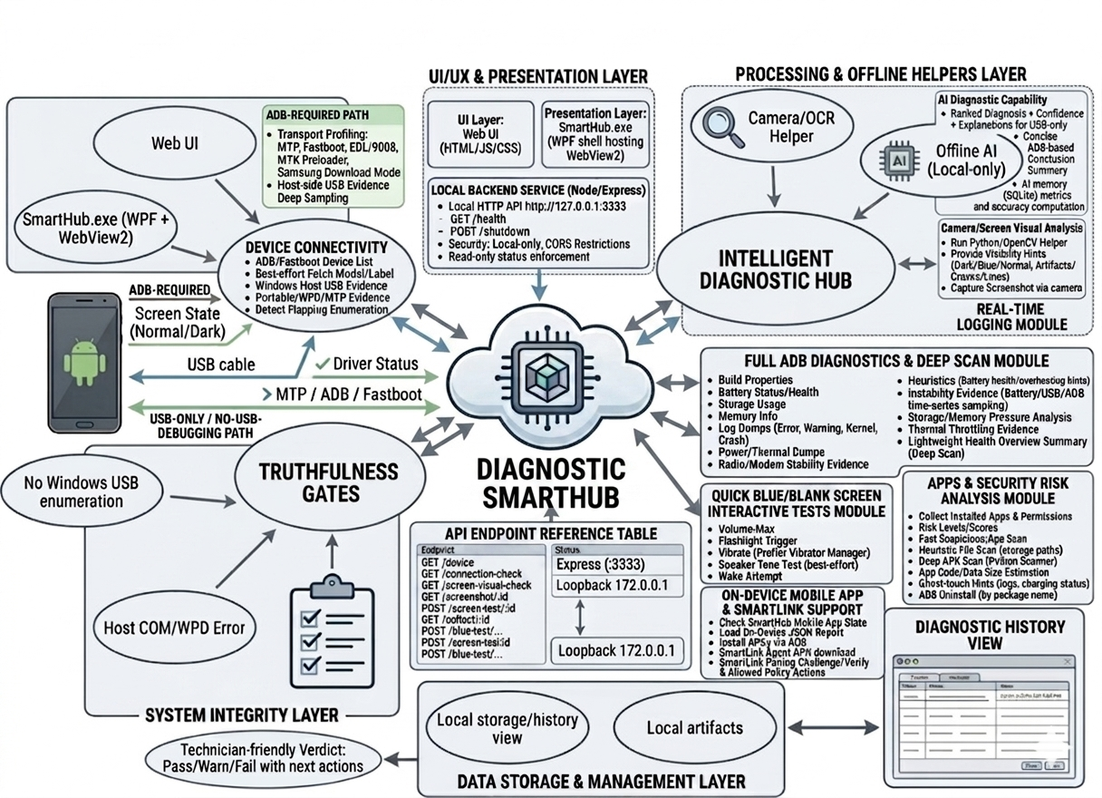
Conceptual Framework

The conceptual framework of SmartHub, as detailed in the diagram, is a centralized Input-Process-Output (IPO) system structured around a Core Logic Engine & Integration Hub. The flow begins on the left side, representing the Input phase, where the Device Connectivity component establishes a connection with the target Android phone via USB cable. This connection identifies whether the device is in standard states like MTP, ADB, or Fastboot. Recognizing common reliability issues like "Host COM/WPD Errors," the framework specifically routes these inputs through Truthfulness Gates. These gates act as internal validation filters to ensure that only accurate connection signals proceed to the process phase, avoiding standard Windows USB enumeration dependency. Initial technician commands are simultaneously fed into the core via the Web UI presented through the SmartHub.exe (WPF + WebView2) application.
The core process phase is orchestrated by the Central Hub, supported by a local Node/Express Backend Service acting through specific API Endpoints. The Hub coordinates comprehensive analysis by dispatching data to three specialized modules on the right: the Full ADB Diagnostics & Deep Scan Module, the Apps & Security Risk Analysis Module, and the Quick Blue/Blank Screen Interactive Tests Module. In challenging scenarios, such as "Blue/Blank/Broken Screen" states, the system utilizes the Intelligent Diagnostic Hub from the Processing & Offline Helpers Layer, which employs Camera/OCR Helpers, Screen Visual Analysis, and a localized Offline AI for diagnosis.
Finally, this analysis flows down to the System Integrity Layer, which generates the primary output: a Technician-friendly Verdict (Pass/Warn/Fail). This diagnostic outcome, along with session data managed by the Data Storage & Management Layer, is presented back to the user via the Diagnostic History View, completing the logical interaction loop.

Chapter 3
METHODOLOGY
This chapter presents the research design and the systematic process used to develop SmartHub: a Windows desktop diagnostic tool for Android phones. It details the selection of respondents, the primary and secondary sources of data, the instruments used for data collection, and the techniques employed for data analysis. Furthermore, this section discusses the development framework utilized to build the system, focusing on the Scrum framework. This iterative approach allows continuous refinement of technician workflows such as ADB-based diagnostics, USB-only/no-debug triage for blue/blank/broken-screen devices, and evidence-based reporting, ensuring that the final application meets operational requirements while maintaining high levels of development efficiency and adaptability. The primary stakeholder locale for this project is Carlo Gadget Repair Shop and Accessories.
This chapter outlines the technical framework and procedural steps taken to build SmartHub as online-first diagnostic workstation tool. It provides a comprehensive overview of requirements gathering, architectural design, implementation strategies, and the specific tools used to validate the system's performance. To ensure the final product is both technically sound and operationally relevant, the project uses a hybrid approach combining descriptive and developmental research. The descriptive component is used to document and evaluate existing diagnostic practices (including the limitations of no-USB-debugging cases), while the developmental component governs the actual engineering of the solution, including local evidence collection and optional online analysis. To maintain adaptability throughout the build, the Scrum framework is implemented. This allows the development team to refine features such as connection stability checks, no-debug triage, and report generation through continuous feedback loops and incremental updates.

3.1 Requirement Analysis
The project's methodology outlines the steps, data sources, tools, and data collection techniques that guide the development of SmartHub. In system and software engineering, requirements analysis involves identifying and understanding the needs that a diagnostic application must meet while also balancing the sometimes-conflicting priorities of various stakeholders, including technicians, support personnel, and device owners. This process includes thorough analysis, documentation, validation, and continuous requirements management to ensure the system remains technically sound and user-focused.
For SmartHub, the system requirements are clear, actionable, measurable, and aligned with the project's goal to produce technician-ready results supported by evidence. After collecting relevant information from stakeholders, the developers closely examine current diagnostic challenges, specifically the inefficiencies caused by fragmented evidence capture, intermittent USB behavior, and the difficulty of diagnosing blue/blank/broken-screen devices when USB debugging is unavailable.
At the same time, the developers envision a system that streamlines these manual tasks through a unified offline-first workstation interface, automated evidence collection via ADB/Fastboot when available, USB-only stability sampling when ADB is not available, and clear next-step guidance. Throughout the development process, all requirements are carefully reviewed and validated to ensure the final system directly addresses these gaps and remains within explicit safety boundaries (no security bypass claims, no remote enabling of USB debugging, and no exploit workflows).
At present, many troubleshooting activities rely on a mix of manual checks and ad-hoc tool usage. In no-debug cases, technicians often depend on inconsistent observations and lack standardized evidence. To address these issues, the development team conducts an in-depth assessment of existing workflows by observing diagnostic steps and interviewing intended users. The findings reveal key challenges, including unstructured record-keeping of evidence, limited visibility into device state, and difficulty reproducing intermittent problems.
These findings directly influence the design and functionality of SmartHub . The system is envisioned to provide a structured diagnostic summary with evidence (checks and reasons), confidence-aware conclusions, and recommended next actions. By replacing fragmented tools and manual notes with an integrated offline-first platform tailored to diagnostic workflows, SmartHub aims to minimize errors and reduce diagnostic time.

3.1.1 Population and Locale of the Study
The participants of this project consist of primary stakeholders who perform Android phone diagnostics using a Windows workstation. This group is composed of technicians and support personnel who use diagnostic tools daily. The developers use purposive sampling to select these individuals, as their daily interaction with diagnostic workflows provides the necessary firsthand insights into existing procedural difficulties and evidence collection gaps. In this study, these stakeholders are drawn from Carlo Gadget Repair Shop and Accessories.
The study is centered in a Windows-based diagnostic workstation environment at Carlo Gadget Repair Shop and Accessories (e.g., the service counter/repair area) where Android devices are connected via USB for inspection and evidence collection. This locale is ideal for evaluating an offline-first application that integrates local UI, a local companion service, and local device tooling.
To assess usability and user acceptance, the researchers may apply purposive sampling to a small group of intended users who run representative diagnostic scenarios and evaluate the system based on the ISO/IEC 25010 instrument.
3.1.2 Data Instrumentation
The project uses semi-structured interviews, document/tool analysis, direct observation, internet research, and ISO/IEC 25010 as the main tools for collecting data. These instruments help the developers identify current issues, user needs, and system requirements for SmartHub .
Semi-Structured Interview Guides. Qualitative data is primarily gathered through semi-structured interviews with technicians and support personnel. This flexible conversational format allows the researchers to ask prepared questions about operational challenges such as device detection, ADB availability, USB instability, and blue/blank-screen triage while leaving room for follow-up inquiries.
Document and Tool Analysis. To ensure the digital system mirrors necessary real-world evidence, the researchers perform an analysis of available diagnostic artifacts and signals (e.g., ADB outputs, Fastboot information, Windows USB enumeration). This analysis informs the design of read-only checks, local history logs, and the formatting of evidence shown to users.
Direct Observation. The researchers conduct on-site or controlled-environment observations of the diagnostic workflow. This provides first-hand insight into common failure modes and evidence capture practices, ensuring the SmartHub interface is optimized for actual use and supports consistent diagnostic conclusions.
ISO/IEC 25010. ISO/IEC 25010 is a standard created by the International Organization for Standardization (ISO) and the International Electrotechnical Commission (IEC) to evaluate software quality. It provides a model for checking and improving software quality through different characteristics and sub-characteristics, including security and compatibility.
The instrument based on ISO/IEC 25010 serves as a tool to measure how acceptable SmartHub is. It evaluates how well the software meets user expectations and needs based on factors such as functionality, performance, usability, and reliability. By including this evaluation, the developers ensure that the system meets technical standards, provides a good user experience, and maintains high reliability-supporting technician workflows for Android diagnostics.
To quantify these results, a Five-Point Likert Scale is utilized as the primary data collection tool. Using a scale ranging from 5 (Strongly Agree) to 1 (Strongly Disagree), the researchers gather perspectives on evidence clarity, speed, usefulness of suggested next steps, and overall usability.
Internet Research. Before developing SmartHub, internet research is used to collect secondary data and study existing tools and practices related to Android diagnostics, ADB/Fastboot utilities, and online-first workstation design. During this process, scholarly articles, documentation, and technical guides are reviewed. The goal is to learn effective practices and common diagnostic features that can be applied to the project while maintaining safe, evidence-based outputs.
3.2 Computer Hardware for Development and Software Requirement Development
This part shows an overview of the basic hardware and software implementation requirements needed to run SmartHub: Diagnostic Application for Android.
Table 3.2 Hardware and Software Requirements
Category | Requirement
Hardware | Windows 10/11 PC; at least 8 GB RAM; stable USB ports; data-capable USB cable; Android device(s) for testing; optional webcam for screen-visual checking
Software (Runtime) | .NET Desktop Runtime (WPF); Microsoft Edge WebView2 Runtime; Node.js; Android platform-tools (ADB/Fastboot); Python 3 for optional offline helpers
Connectivity | Not required for core operation (local-only). Remote access is disabled by default and should only be enabled explicitly in controlled environments

3.3 Software Requirements for System Development
The development of the system involved a range of tools and technologies that were chosen to ensure efficient performance and functionality. The following software and applications were used:
WPF + WebView2 - The Windows desktop host that packages and runs the diagnostic UI reliably on Windows. WPF provides the native application shell and system integration, while WebView2 embeds a Chromium-based browser to display the HTML/JS frontend. This hybrid approach gives a modern web UI with full access to Windows APIs, USB events, and local processes.
HTML/CSS/JavaScript - Used to create the user interface and interactive diagnostic flows. The UI is built with standard web technologies, making it easy to design responsive layouts and buttons. It communicates with the local Node service via fetch() requests, sending commands and receiving JSON responses.
Node.js + Express + TypeScript - Builds the local companion service and REST endpoints on localhost:3333. The service orchestrates ADB commands, launches Python helpers, caches diagnostic runs, and manages API secrets. TypeScript adds type safety, and Express provides simple routing for endpoints like /run-full-diagnostics.
JSON - The data-interchange format between the UI and the local service. Every command and response is a JSON object, which is lightweight, human-readable, and natively supported by both JavaScript and TypeScript. JSON is also used to store diagnostic payloads in PostgreSQL (jsonb columns) and to serialise session data.
PostgreSQL (Supabase) - Primary cloud storage for user accounts, diagnostic runs, devices, and shared AI context. Supabase provides a hosted PostgreSQL database with authentication, real-time sync, and Row Level Security. It ensures referential integrity, supports complex queries, and offloads user management from the local service.
Android platform-tools (ADB/Fastboot) - Used to collect device information and evidence when USB debugging is available. ADB commands (dumpsys, logcat, getprop) retrieve battery, display, and system logs; Fastboot handles lower-level operations. The local service invokes ADB as a child process, and the tools are bundled with SmartHub for easy deployment.
Python 3- Used for offline-only helpers such as webcam-based screen analysis and offline AI suggestion for no-debug cases. Python scripts (e.g., OpenCV for dead pixel detection, lightweight ML models) run locally when internet is unavailable. They are called by the Node service and bundled with an embedded Python environment, so technicians do not need to install Python separately.
3.4 System Framework
In this project, the system framework presents the structured process undertaken to design, develop, and evaluate SmartHub . The framework serves as a guide in organizing the activities involved in system development, from requirement analysis up to system implementation and evaluation. It ensures that the development process follows a systematic and organized approach aligned with the objectives of the study.
The development of SmartHub adopts the Scrum approach, a system development methodology that emphasizes iterative development, continuous collaboration, and frequent feedback from stakeholders. This approach allows the developers to divide the system into smaller functional components and develop them in short cycles called sprints. Through this method, system features such as device detection, ADB diagnostics, no-debug connection checks, optional visual checks, and offline evidence history are gradually developed, tested, and improved.
Scrum is suitable for this project because the system involves multiple diagnostic modes and real-world device variability. Each mode requires continuous refinement of system checks and user messaging. The iterative nature of Scrum ensures the system remains flexible and adaptable to changes, while also allowing improvements based on feedback gathered during development.

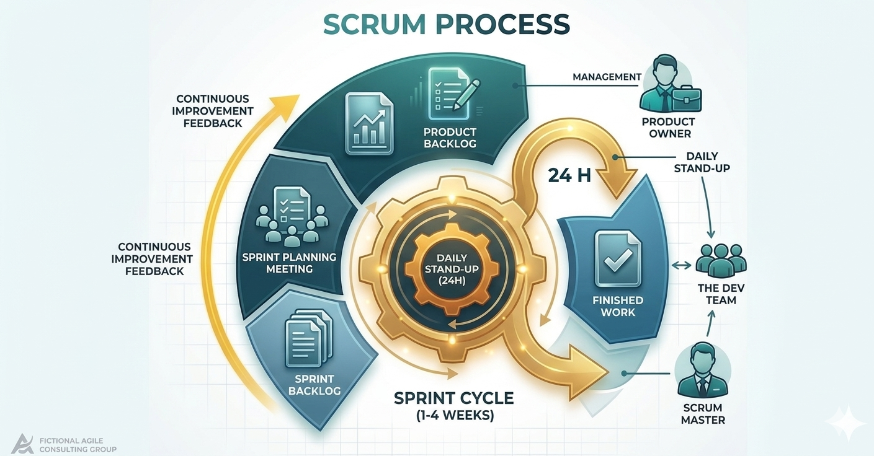
Figure 3.4.1 Scrum Development Framework
Figure 3.4.1 illustrates the Scrum Development Framework used in the development of SmartHub. This framework highlights the step-by-step process followed by the researchers in building the system, ensuring that all required diagnostic features are properly implemented and evaluated.
Phases of the Scrum Approach
Product Backlog - The Product Backlog is an ordered list of required features and diagnostic checks (Android Debug Bridge(ADB) evidence collection ,Media Transfer Protocol(MPT) visibility ,USB-only stability sampling, screen-visual checks, SmartHub AI suggestion, and local history) which, according to the Scrum Guide, serves as the single source of work for the team, and moreover, explicitly prioritising online and safety-critical items prevents technical debt in a diagnostic app.
Sprint Planning - Sprint Planning selects backlog items for a sprint and defines tasks and acceptance criteria based on evidence correctness and safety boundaries, which according to Scrum is a time-boxed event to set a Sprint Goal, and moreover, incorporating safety boundaries into acceptance criteria reduces liability when automating device tests.
Sprint Development - Sprint Development designs and implements core modules across UI and backend, integrates local tooling (Android Debug Bridge (ADB), PostgreSQL), and performs continuous testing, which according to Agile engineering practices requires iterative integration, and moreover, continuous testing of Android Debug Bridge (ADB) commands ensures that diagnostic evidence remains reliable across Android versions.
Sprint Review - Sprint Review presents and tests developed features to determine if they meet required specifications while gathering feedback on performance and usability, which according to Scrum validates the increment against stakeholder expectations, and moreover, usability feedback from technicians directly improves first-time fix rates.
Sprint Retrospective - Sprint Retrospective reviews the development process to identify areas for improvement in future sprints, which according to Scrum is a blameless team inspection, and moreover, reflecting on Android Debug Bridge (ADB) integration challenges helps optimise diagnostic speed and reliability.
System Deployment System Deployment System Deployment prepares the application for online workstation use and validates that dependencies and local-only security constraints are met, which according to deployment best practices requires environment-specific validation, and moreover, validating online constraints ensures technicians can diagnose devices with internet access.
To further illustrate the structure and processes of the system, modeling tools are used. These include Data Flow Diagrams (DFD), Use Case Diagrams, and Entity-Relationship Diagrams (ERD),Data Dictionary. These tools provide a clear visualization of how data flows within the system, how users interact with the application, and how different data entities are related.
3.5 Tools for Data Analysis - Data Flow Diagram, Use Case, ERD, Data Dictionary
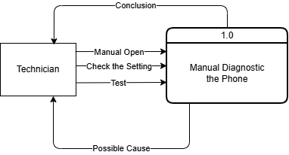
Figure 3.5.1 - Context Diagram of Manual Process of Diagnostic the Android Phone
The diagram shows a manual diagnostic workflow where the technician opens the manual process, checks device settings, performs manual diagnostic tests on the phone, and identifies possible causes leading to a conclusion; according to ISO/IEC 25010 (software quality model) and structured diagnostic procedures, manual testing requires user-initiated steps to verify functionality, record observations, and derive root causes without automation; moreover, this manual workflow is critical for technicians because it provides a reliable fallback when automated tools are unavailable or inapplicable, ensures that the technician’s hands-on expertise and observational skills are fully utilized, and supports diagnostic scenarios on devices that are locked, have broken communication ports, or otherwise cannot be accessed programmatically, thereby guaranteeing complete diagnostic coverage.

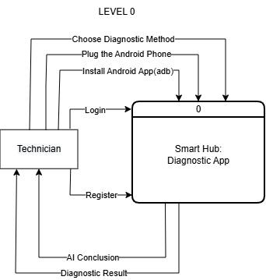

Figure 3.5.2 - Context Diagram of Smart Hub System
In this level it shows the complete high-level diagnostic workflow for the SmartHub Windows application, consisting of eight interconnected processes: choosing a diagnostic method, plugging in the Android phone, installing the Android app via ADB, logging in (or registering), generating an online AI conclusion (requiring internet), and producing a diagnostic result. The diagram also identifies two external entities: the Technician (user interacting with the app) and the Smart Hub: Diagnostic App (the system boundary). Data flows between these entities and processes include user commands, USB connection events (managed via MTP (Media Transfer Protocol) for initial device detection), ADB (Android Debug Bridge) commands for low-level device control and APK installation, authentication tokens, sensor data, cloud-based AI inference outputs, and final reports stored in PostgreSQL (via Supabase). MPT is used initially to verify device availability and file-level access, while ADB is used for all diagnostic commands (pulling logs, shell access, hardware interrogation).
The AI conclusion is fetched from a cloud model (e.g., OpenAI, custom ML API), and all diagnostic runs are persisted to Supabase PostgreSQL, not to a local SQLite database. According to structured systems analysis and Yourdon/DeMarco Data Flow Diagram (DFD) methodology, a Level 0 diagram (context diagram) represents the entire system as a single process, showing external entities, major data flows, and high-level inputs/outputs, without internal decomposition. According to Android developer documentation, MTP (Media Transfer Protocol) is a USB protocol for basic device identification and media file transfer, used here to confirm the phone is connected. ADB (Android Debug Bridge) is a command-line tool that provides deep device access (shell, logs, package management), required for running diagnostics. According to modern cloud architecture, online AI refers to a machine learning model that is hosted remotely and accessed via API, requiring continuous internet connectivity; it cannot function offline. PostgreSQL is a relational database management system; in SmartHub it is provisioned by Supabase as the primary cloud data store for user accounts, diagnostic runs, and device history.
Moreover, this context diagram is critical for SmartHub because it establishes system boundaries (technician and Android device as external, while authentication, ADB-based diagnostics, cloud AI inference, and PostgreSQL persistence are internal), identifies mandatory dependencies (USB with MTP+ADB and internet for online AI/Supabase, meaning no offline operation), clarifies protocol roles (MTP for handshake, ADB for privileged tests), corrects previous assumptions (no offline AI or SQLite; all intelligence and persistence are cloud-based), supports risk and security analysis (PostgreSQL RLS and HTTPS AI calls), serves as a traceability artifact linking backlog items to cloud services, and facilitates stakeholder communication (technicians need internet/USB debugging, developers see cloud dependencies, managers confirm offline fallback is unsupported) in summary, the Level 0 diagram reflects an online-first, cloud-native architecture where AI reasoning and data persistence rely on internet connectivity, making it an indispensable planning and communication tool that explicitly names MPT, ADB, online AI, and PostgreSQL to avoid confusion with offline or local-only alternatives.

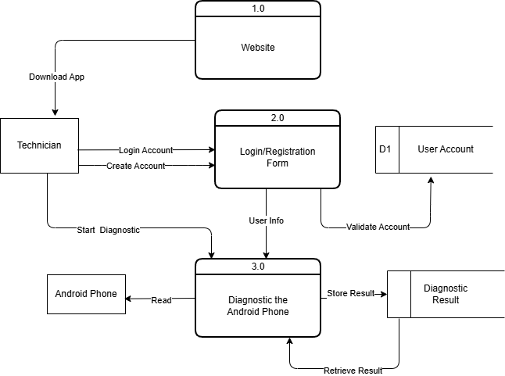

Figure 3.5.3 – Top Level Diagram of Smart Hub System
In this Level diagram it shows three main processes: 1.0 Website (where the technician downloads the app), 2.0 Login/Registration Form (where user info is collected and account validation occurs), and 3.0 Diagnostic the Android Phone (which includes sub-functions Read, Diagnostic the Android Phone, Store Result, and Retrieve Result). The diagram includes two external entities – Technician and Android Phone – and a persistent data store D2 Diagnostic Result. Data flows include: Download App from Website to Technician, User Info from Technician to Login/Registration, Validate Account (between Login/Registration and an implied user account store, though not explicitly shown as a data store in this diagram), Start Diagnostic from Technician to the Diagnostic process, Store Result from Diagnostic process to D2, Retrieve Result from D2 back to Diagnostic process, and Diagnostic Result from Diagnostic process to Technician. The Android Phone interacts directly with the Diagnostic process. According to structured systems analysis and Yourdon/DeMarco DFD methodology, this diagram represents a Level 1 decomposition of the system, showing the main functional processes, external entities, data flows, and a physical data store (D2 Diagnostic Result). The Website process handles application distribution; the Login/Registration Form process manages user identity and account validation; the Diagnostic process performs the core Android phone testing and result management. The data store D2 Diagnostic Result persists the outcomes of diagnostic runs. Moreover, this Level 1 diagram is critical for SmartHub because it reveals a missing dependency (no explicit flow from the Diagnostic process to the Login/Registration process, implying that Start Diagnostic could be executed without prior authentication – a security risk that should be corrected by linking diagnostic actions through Validate Account), shows a hybrid architecture (Website and Login/Registration are cloud-based while the Diagnostic process is a local Windows app, requiring careful inter-process communication such as API calls), identifies data persistence (diagnostic results are stored in D2 Diagnostic Result, aligning with the decision to use Supabase PostgreSQL rather than local SQLite, though the user account store is not shown and should be added as a separate data store), supports traceability (the Download App flow connects the marketing website to the technician, while Retrieve Result links diagnostic history back to the technician for personalised reporting and trend analysis), and highlights a missing flow (no AI Conclusion process or data flow – an AI inference step should be added between Start Diagnostic and Store Result to match the online AI requirement).
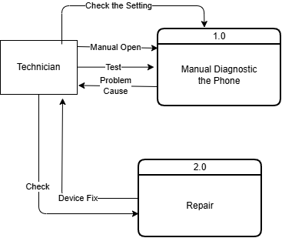
Figure 3.5.4 – Top Level Diagram of Manual Process of Diagnostic the Android Phone
The Diagram shows a manual diagnostic flow where the technician checks device settings, opens the manual process, performs manual diagnostic tests, identifies the problem cause, verifies the issue, applies a device fix, and completes the repair; according to ISO/IEC 25010 and manual testing best practices, this structured sequence ensures each step (observation, diagnosis, verification, remediation) is clearly separated to maintain traceability and repeatability; Justify moreover, this manual workflow is essential for technicians because it covers cases where automated diagnostic tools cannot be used (e.g., locked bootloaders, broken USB ports, unresponsive devices), empowers technicians to apply their hands-on expertise for ambiguous faults, and creates a documented repair trail that ensures accountability and supports quality control in repair shops.

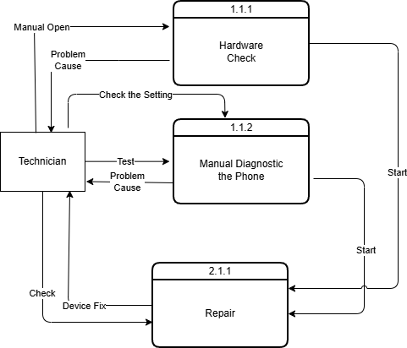
Figure 3.5.5 – Exploded Diagram of Smart Hub System
The Diagram details the manual diagnostic process where the technician starts the procedure, performs a hardware check, reviews device settings, tests the problem cause, executes manual diagnostic steps on the phone, proceeds to repair, and finally checks the device fix; according to ISO/IEC 25010 and manual troubleshooting guidelines, this decomposition separates hardware verification, setting validation, root cause testing, and repair verification into distinct sub-processes to ensure thoroughness and error isolation; moreover, this manual workflow empowers technicians to systematically isolate hardware faults from configuration issues, test each suspected cause independently, and confirm repairs before closing the case, thereby reducing repeat repairs and improving diagnostic accuracy without relying on any automated tools.

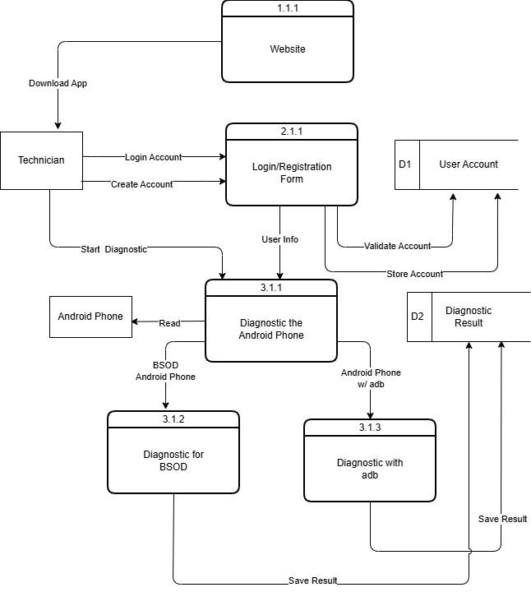
Figure 3.5.6 – Exploded Diagram of Smart Hub System
In this Exploded diagram it shows four detailed processes: 1.1.1 Website (delivers the app), 3.1.1 Login/Registration Form (handles account creation and authentication), 3.1.2 Diagnostic for BSOD (specifically diagnoses Blue Screen of Death issues on Android phones), and 3.1.3 Diagnostic with adb (performs deeper diagnostics using ADB commands). External entities include Technician, Android Phone, Android Phone w/ adb (phone with USB debugging enabled), and BSOD Android Phone (phone exhibiting crash symptoms). Two data stores are present: D1 User Account (persists user credentials and profile) and D2 Diagnostic Result (stores diagnostic outcomes). Data flows include: Download App from Website to Technician, Login Account and Create Account between Technician and Login/Registration, Start Diagnostic from Technician to the diagnostic processes, Read from Android Phone to Diagnostic for BSOD, User Info from Technician to Login/Registration, Collect Result from both diagnostic processes to D1 and D2, and interactions with Android Phone w/ adb for ADB-based diagnostics. According to structured systems analysis and Yourdon/DeMarco DFD methodology, this diagram represents a Level 2 decomposition (i.e., a detailed expansion of a Level 1 process, specifically process 3.0 “Diagnostic the Android Phone”). It shows the internal sub-processes (3.1.1, 3.1.2, 3.1.3), their interactions with external entities, and the two data stores. Level 2 DFDs are used to specify the actual logic and data flow at a granular level suitable for implementation planning.
Moreover, this Level 2 diagram is critical for SmartHub because it distinguishes two distinct diagnostic paths – BSOD detection (process 3.1.2) which may rely on visual or log-based heuristics, and ADB-based diagnostics (process 3.1.3) which uses privileged commands for hardware and system testing – thereby clarifying the need for both non-invasive and deep-access methods; it also explicitly shows that Collect Result writes to both D1 User Account (for user-level history) and D2 Diagnostic Result (for run-specific data), aligning with the decision to use Supabase PostgreSQL as the unified cloud data store; furthermore, the diagram includes Login Account and Create Account as separate flows, indicating that authentication is required before diagnostic execution, resolving the previous missing-dependency issue; finally, the presence of Android Phone w/ adb as a distinct external entity reminds that USB debugging must be enabled, and BSOD Android Phone acknowledges crash scenarios, ensuring the design covers edge cases.

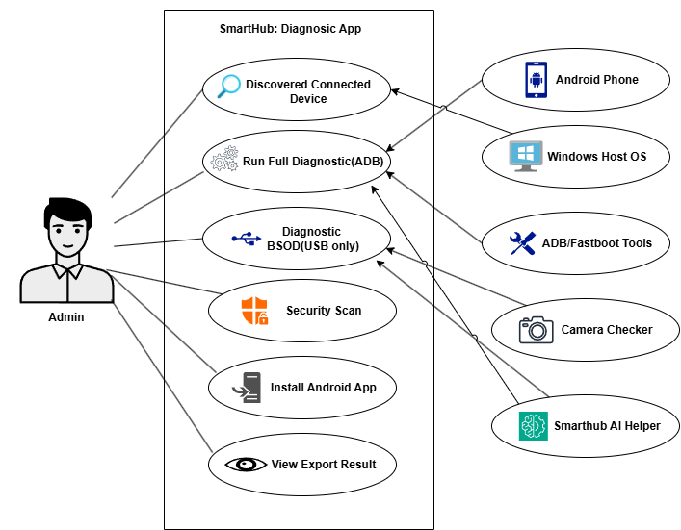
Figure 3.5.7 - Use Case Diagram
The Use Case Diagram lists the SmartHub Diagnostic App’s core user actions (“Discovered Connected Device”, “Run Full Diagnostic (ADB)”, “Diagnostic BSOD (USB only)”, “Security Scan”, “Install Android App”, “View Export Result”) and supporting tools (“ADB/Fastboot Tools”, “Camera Checker”, “Smarthub AI Helper”); according to software architecture and diagnostic workflow standards (e.g., ISO 25010, Android debugging best practices), these items represent the functional modules that must interact through defined data flows (USB/ADB for device control, MTP for BSOD file access, local or cloud AI for conclusions); moreover, this breakdown is critical for SmartHub because it separates hardware-dependent operations (ADB, MTP, camera checks) from user-facing features (install, view, export) and intelligence (AI helper), ensuring that each component can be developed, tested, and maintained independently while still delivering an integrated diagnostic experience for Android phones.
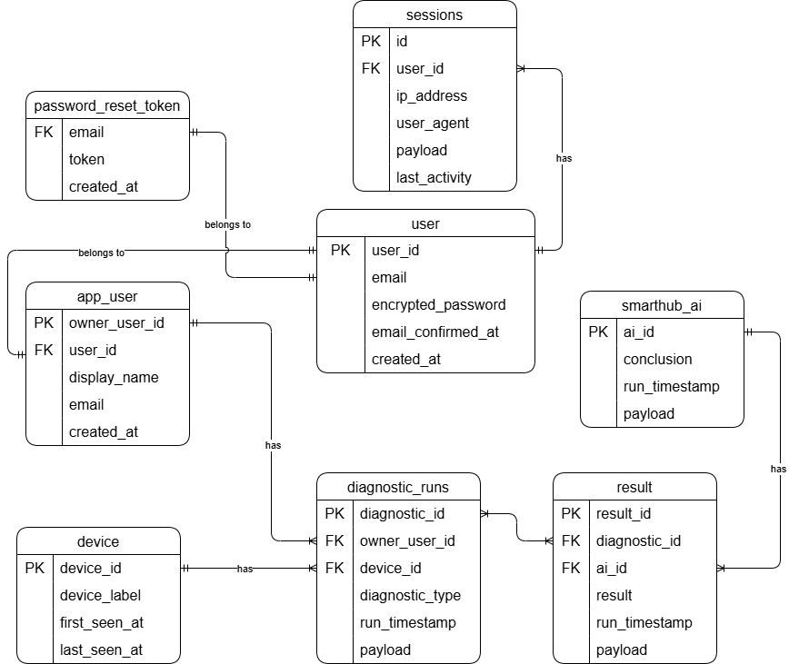
Figure 3.5.8 - Entity-Relationship Diagram (ERD)
The Crow’s Foot Notation ERD shows six tables (sessions, password_reset_token, run, app_user, device, diagnostics, diagnostic_runs) with primary and foreign keys that define relationships like run.owner_user_id → app_user.owner_user_id (one user, many diagnostic sessions), diagnostic_runs.run_id → run.run_id (one session, many individual test instances), and a direct diagnostic_runs.owner_user_id → app_user.owner_user_id for fast user centric queries, while the diagnostics table appears redundant; according to crow’s foot notation and entity relationship modeling (Martin, 1990), each foreign key implements a one to many relationship where the child table (holding the FK) gets the “many” crow’s foot and the parent table gets the “one” line – for example, app_user (one) → run (many), device (one) → run (many), run (one) → diagnostic_runs (many), plus the direct app_user → diagnostic_runs (many), and even password_reset_token.email (though unusual) still represents one to many moreover, this ERD directly maps to the SmartHub diagnostic app’s real workflow – authentication and session management (app_user, sessions, password_reset_token) secure each action, starting a diagnostic creates a run record, individual ADB or BSOD tests store results in diagnostic_runs linked to that run, viewing history uses joins across tables (or the direct FK for performance), the schema allows future offline queued writes if needed, and spotting the redundant diagnostics table saves future cleanup – so every foreign key and primary key corresponds to a concrete step in the “authenticate → select device → start session → run multiple tests → store each result → retrieve history” process, making this ERD a faithful blueprint for the app.

Figure 3.5.9 - Data Dictionary
This section defines the key tables and fields used by SmartHub to store diagnostic runs, device metadata, user authentication, and session tracking (user, app_user, run, device, diagnostic_runs, password_reset_token, sessions), with descriptions clarifying each field’s purpose according to ISO/IEC 25010 metadata registry standards (ensuring unambiguous data type, format, and relationship documentation), and moreover, this data dictionary provides a single source of truth that enforces referential integrity, supports both online (Supabase PostgreSQL) and potential offline workflows, and eliminates ambiguity for developers, testers, and future schema extensions.
Table 3.1 is entry for the user table documents six fields (instance_id, id, email, encrypted_password, email_confirmed_at, created_at) with their sizes, uuid/text/timestamptz types, formats, descriptions, and examples; according to ISO/IEC 25010 (software quality model), this specification ensures functional suitability by defining the user structure, reliability via timestamp and foreign key constraints, and maintainability through clear field and payload definitions; moreover, this entry is critical for SmartHub because it centralizes account identity and credential metadata required for authentication, confirmation, and lifecycle management.
Table 3.1 user
Data Name | Field Size | Data Type | Data Format | Description | Example
instance_id | 36 | uuid | UUID | Supabase auth instance identifier | 00000000-0000-0000-0000-000000000000
id | 36 | uuid | UUID | Primary key user identifier | f04d0dc8-7fef-4f8b-9d8b-1f0a12345678
email | 255 | text | email | User email | user@example.com
encrypted_password | 255 | text | hash | Stored password hash | $2a$12$...
email_confirmed_at | 8 bytes | timestamptz | datetime | Email confirmation time | 2026-04-19 09:55:00+00
created_at | 8 bytes | timestamptz | datetime | User creation timestamp | 2026-04-19 09:50:00+00
Table 3.2 run
Table 3.2 is entry for the run table documents six fields (owner_user_id, device_id, diagnostic_type, run_timestamp, payload, created_at) with their sizes, uuid/text/bigint/jsonb/timestamptz types, formats, descriptions, and examples; according to ISO/IEC 25010 (software quality model), this specification ensures functional suitability by defining the run structure, reliability via timestamp and foreign key constraints, and maintainability through clear field and payload definitions; moreover, this entry is critical for SmartHub because it links users, devices, and diagnostic types into a single session record, enabling accurate history tracking, performance analysis, and cloud based reporting across all diagnostic runs.
Data Name | Field Size | Data Type | Data Format | Description | Example
owner_user_id | 36 | uuid | UUID | Foreign key to app_user.owner_user_id | f04d0dc8-7fef-4f8b-9d8b-1f0a12345678
device_id | 64 | text | device id | Foreign key to device.device_id | R58M12345AB
diagnostic_type | 64 | text | text | Type of diagnostic | usb-no-debug
run_timestamp | 8 bytes | bigint | epoch ms | Diagnostic timestamp | 1713525123456
payload | variable | jsonb | JSON object | Diagnostic payload | {"diagStages":{...}}
created_at | 8 bytes | timestamptz | datetime | Row creation time | 2026-04-19 10:12:03+00
Table 3.3 is entry for the app_user table documents five fields (owner_user_id, user_id, display_name, email, created_at) with their sizes, uuid/text/timestamptz types, formats, descriptions, and examples; according to ISO/IEC 25010 (software quality model), this specification ensures functional suitability by defining the app user structure, reliability via timestamp and foreign key constraints, and maintainability through clear field and payload definitions; moreover, this entry is critical for SmartHub because it links identity records with profile attributes so user level ownership, display context, and communication details remain consistent.

Table 3.3 app_user
Data Name | Field Size | Data Type | Data Format | Description | Example
owner_user_id | 36 | uuid | UUID | Primary key for app user | f04d0dc8-7fef-4f8b-9d8b-1f0a12345678
user_id | 36 | uuid | UUID | Foreign key to user.id | f04d0dc8-7fef-4f8b-9d8b-1f0a12345678
display_name | 120 | text | text | Display name | Mark Lhemuel
email | 255 | text | email | User email copy | user@example.com
created_at | 8 bytes | timestamptz | datetime | Profile creation timestamp | 2026-04-19 09:51:00+00
Table 3.4 is entry for the device table documents four fields (device_id, device_label, first_seen_at, last_seen_at) with their sizes, text/timestamptz types, formats, descriptions, and examples; according to ISO/IEC 25010 (software quality model), this specification ensures functional suitability by defining the device structure, reliability via timestamp and foreign key constraints, and maintainability through clear field and payload definitions; moreover, this entry is critical for SmartHub because it preserves stable device identity and visibility windows, enabling accurate device mapping, auditability, and longitudinal diagnostics.
Table 3.4 device
Data Name | Field Size | Data Type | Data Format | Description | Example
device_id | 64 | text | device id | Primary key device identifier | R58M12345AB
device_label | 120 | text | text | Human-readable device label | Samsung A14 Bench Unit
first_seen_at | 8 bytes | timestamptz | datetime | First seen timestamp | 2026-04-19 09:40:00+00
last_seen_at | 8 bytes | timestamptz | datetime | Most recent seen timestamp | 2026-04-19 10:30:00+00
Table 3.5 is entry for the diagnostic_runs table documents five fields (owner_user_id, device_id, diagnostic_type, run_timestamp, payload) with their sizes, uuid/text/bigint/jsonb types, formats, descriptions, and examples; according to ISO/IEC 25010 (software quality model), this specification ensures functional suitability by defining the diagnostic runs structure, reliability via timestamp and foreign key constraints, and maintainability through clear field and payload definitions; moreover, this entry is critical for SmartHub because it captures diagnostic execution evidence that supports historical tracing, consistency checks, and report generation across repeated test cycles.

Table 3.5 diagnostic_runs
Data Name | Field Size | Data Type | Data Format | Description | Example
owner_user_id | 36 | uuid | UUID | Foreign key to app_user.owner_user_id | f04d0dc8-7fef-4f8b-9d8b-1f0a12345678
device_id | 64 | text | device id | Foreign key to device.device_id | R58M12345AB
diagnostic_type | 64 | text | text | Type of diagnostic | usb-no-debug
run_timestamp | 8 bytes | bigint | epoch ms | Diagnostic timestamp | 1713525123456
payload | variable | jsonb | JSON object | Diagnostic payload mirror | {"diagStages":{...}}
Table 3.6 is entry for the password_reset_token table documents three fields (email, token, created_at) with their sizes, text/timestamptz types, formats, descriptions, and examples; according to ISO/IEC 25010 (software quality model), this specification ensures functional suitability by defining the password reset token structure, reliability via timestamp and foreign key constraints, and maintainability through clear field and payload definitions; moreover, this entry is critical for SmartHub because it secures account recovery flows by validating reset tokens and timestamp windows, reducing unauthorized password resets.

Table 3.6 password_reset_token
Data Name | Field Size | Data Type | Data Format | Description | Example
email | 255 | text | email | Foreign key email reference to user | user@example.com
token | 255 | text | token | Password reset token value | 4xZs9u...
created_at | 8 bytes | timestamptz | datetime | Token creation timestamp | 2026-04-19 10:10:12+00
Table 3.7 is entry for the sessions table documents six fields (id, user_id, ip_address, user_agent, payload, last_activity) with their sizes, text/uuid/bigint types, formats, descriptions, and examples; according to ISO/IEC 25010 (software quality model), this specification ensures functional suitability by defining the sessions structure, reliability via timestamp and foreign key constraints, and maintainability through clear field and payload definitions; moreover, this entry is critical for SmartHub because it tracks authenticated activity, device access context, and session continuity for secure and traceable user access.

Table 3.7 sessions
Data Name | Field Size | Data Type | Data Format | Description | Example
id | 255 | text | session id | Primary key of session | s1cf4d8a...
user_id | 36 | uuid | UUID | Foreign key to user.id | f04d0dc8-7fef-4f8b-9d8b-1f0a12345678
ip_address | 45 | text | IPv4/IPv6 | Client IP address | 192.168.1.15
user_agent | variable | text | browser/agent | Client user-agent string | SmartHubDesktop/14.0
payload | variable | text | serialized | Session payload/body | {...}
last_activity | 8 bytes | bigint | epoch | Last activity epoch time | 1713525000

Table 3.8 is entry for the result table documents six fields (result_id, diagnostic_id, ai_id, user_agent, payload, last_activity) with their sizes, text/uuid/integer/bigint types, formats, descriptions, and examples; according to ISO/IEC 25010 (software quality model), this specification ensures functional suitability by defining the result structure, reliability via timestamp and foreign key constraints, and maintainability through clear field and payload definitions; moreover, this entry is critical for SmartHub because it binds computed outcomes to diagnostic and AI references, supporting dependable interpretation trails and reproducible technical reporting.
Table 3.8 result
Data Name | Field Size | Data Type | Data Format | Description | Example
result_id | 255 | text | session id | Primary key of session | s1cf4d8a...
diagnostic_id | 36 | uuid | UUID | Foreign key to user.id | f04d0dc8-7fef-4f8b-9d8b-1f0a12345678
ai_id | 4 bytes | INTEGER | IPv4/IPv6 | Foreign key to smarthub_ai.ai_id | 192.168.1.15
user_agent | variable | text | browser/agent | Client user-agent string | SmartHubDesktop/14.0
payload | variable | text | serialized | Session payload/body | {...}
last_activity | 8 bytes | bigint | epoch | Last activity epoch time | 1713525000

Table 3.9 is entry for the smarthub_ai table documents four fields (ai_id, conclusion, run_timestamp, payload) with their sizes, bigint/text/jsonb types, formats, descriptions, and examples; according to ISO/IEC 25010 (software quality model), this specification ensures functional suitability by defining the smarthub_ai structure, reliability via timestamp and key constraints, and maintainability through clear field and payload definitions; moreover, this entry is critical for SmartHub because it stores AI generated conclusions and evidence payloads required for consistent interpretation, traceable recommendations, and cloud based diagnostic intelligence reporting.
Table 3.9 smarthub_ai
Data Name | Field Size | Data Type | Data Format | Description | Example
ai_id | 8 bytes | bigint | integer | Primary key AI record identifier | 990010
conclusion | variable | text | text | AI generated conclusion summary | High probability of software-level UI freeze
run_timestamp | 8 bytes | bigint | epoch ms | Inference timestamp | 1713525123888
payload | variable | jsonb | JSON object | Full AI response payload | {"model":"gpt-4o-mini",...}

3.6 The Proposed Implementation
Planning Phase – The planning phase identifies stakeholder needs and documents scope, explicitly noting reliance on online AI and Supabase cloud database; according to ISO/IEC 25010:2011 (Software Quality Model), the requirements must address reliability (e.g., fault tolerance, recoverability) and security characteristics, which includes specifying how the system handles network failures, API rate limits, and secure authentication; moreover, upfront recognition of online-only services forces the team to design retry logic, exponential backoff, and graceful degradation, avoiding costly redesign later while ensuring the product meets its required quality attributes.
Designing Phase – The designing phase creates a high-level architecture (WPF WebView2 shell, local web UI, Node/Express service) with HTTPS clients for Supabase and AI APIs; according to ISO/IEC 25010:2023 (Systems and software Quality Requirements and Evaluation – Quality model), the architecture must address reliability (fault tolerance, recoverability), security (confidentiality, integrity), and maintainability (modularity, reusability), which translates to deployment constraints, security zones, and token caching strategies; moreover, decoupling the local UI from cloud services allows swapping AI providers without redeploying the app and enables queuing of diagnostic runs during transient network loss, directly supporting the quality characteristics of reliability and maintainability.
Development (Coding) Phase – The development phase implements REST endpoints, UI flows, ADB/Fastboot integration, and optional offline Python helpers, while storing all cloud credentials in environment variables; according to ISO/IEC 25010:2023 (Systems and software Quality Requirements and Evaluation), the coding practices must ensure security (confidentiality, integrity) by sanitising ADB commands and stripping personal data from payloads, and reliability (fault tolerance) by wrapping API calls with timeouts and exponential backoff retry logic; moreover, using online AI and Supabase enables real-time updates, server-side model improvements, and instant result sharing without updating the Windows client, directly supporting the quality characteristics of maintainability and performance efficiency.
Testing Phase – The testing phase conducts integration, system, and user acceptance tests using scenarios that include no-debug mode, slow/unstable internet, and AI rate-limit errors; according to ISO 25010, testing must cover functional suitability, reliability, security, and performance, including expired JWT tokens and network failures; moreover, simulating connectivity issues ensures the app shows meaningful error messages instead of crashing, and user acceptance testing verifies that the online dependency does not hinder technicians in real workshops.
Deployment Phase – The deployment phase packages the Windows application with all dependencies (Node, ADB, Python helpers) and ensures local-only security defaults, while requiring outbound HTTPS access to Supabase and AI endpoints; according to Microsoft deployment best practices, the installer must validate connectivity and warn if firewall rules block required domains; moreover, a one-time whitelisting of Supabase and AI domains gives technicians full cloud capabilities (centralised reporting, remote support, model updates) and a local health check guides them to resolve network issues immediately.
Review (Maintenance) Phase - The review phase collects feedback, monitors Supabase and AI logs, and releases updates to the Windows app, local service, or cloud functions; according to ISO/IEC 25010:2023 (which defines a product quality model applicable throughout the lifecycle), maintenance activities directly support the maintainability characteristic; ensuring corrective, adaptive, and perfective changes (including updating AI models without client-side releases) can be performed efficiently while preserving reliability, security, and portability; moreover, using online logs and A/B testing on AI endpoints allows the team to continuously improve diagnostic accuracy and schema performance over time without forcing every technician to reinstall the application, thereby enhancing the product’s long-term quality governance.
3.7 Statistical Tools
Statistical analysis provides the mathematical framework necessary to interpret the data collected during the system evaluation phase. In this project, these tools are used to analyze feedback from the ISO/IEC 25010 evaluation survey.
The mathematical formula for the weighted average mean is shown below.
Weighted Mean = (Σ(w × x)) / Σw
Where: w = weight assigned to each value; x = each individual response/frequency; Σ = summation.
The developers use the weighted arithmetic mean to determine the average response for each item based on the five (5) options in the questionnaire: 5 (Very Satisfied), 4 (Satisfied), 3 (Neutral), 2 (Unsatisfied), and 1 (Very Unsatisfied).
Table 2.3 Scales and Points of the Questionnaire Survey
Scale | Points
Very Satisfied | 5
Satisfied | 4
Neutral | 3
Unsatisfied | 2
Very Unsatisfied | 1

Table 2.4 Range of the Weighted Mean and its Interpretation
Range of Weighted Mean | Interpretation
4.21 - 5.00 | Respondents are Very Satisfied with the system overall result.
3.41 - 4.20 | Respondents are Satisfied with the system overall result.
2.61 - 3.40 | Respondents are Neutral with the system overall result.
1.81 - 2.60 | Respondents are Unsatisfied with the system overall result.
1.00 - 1.80 | Respondents are Very Unsatisfied with the system overall result.

3.8 Network Diagram
A network diagram serves as a visual representation of how devices and systems interact and exchange data within a digital environment. For this study, the diagram illustrates a local-only architecture, showing how SmartHub connects its users and technical components through localhost communication.
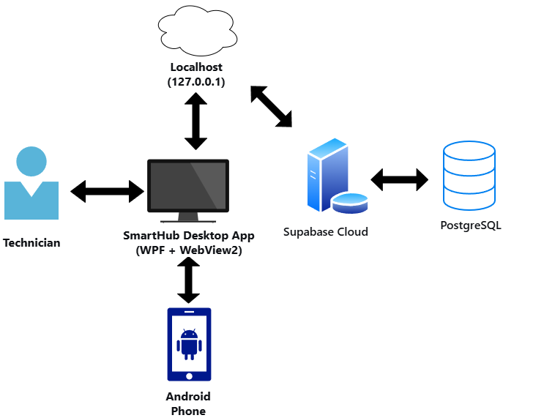
Figure 3.8.1 Network Diagram
Figure 3.8.1 illustrates the SmartHub workstation architecture where the technician uses a Windows desktop shell (WPF + WebView2) to access the diagnostic UI, which communicates via localhost with a local companion service that uses ADB/Fastboot for general diagnostics and MTP specifically for BSOD crash dump retrieval, then sends collected data to online AI APIs for conclusion generation and to Supabase PostgreSQL for cloud storage; according to cloud-native design patterns and zero-trust security principles (NIST SP 800-207), the architecture separates local USB protocol handling (MTP, ADB) from online intelligence and persistence, using HTTPS for all cloud communication and Supabase RLS for data access control moreover, this design ensures that BSOD analysis leverages MTP’s file-level access (avoiding ADB dependencies when the phone is unresponsive), while all diagnostic runs benefit from centralised online AI updates and cross-device history – making the workflow online-first but still capable of local caching for transient network issues, and eliminating the need for manual result backups.

References:
Andika, R., Permatasari, R., & Fitri, A. S. (2024). UI/UX design of marketplace service mobile and laptop applications using design thinking method. Jurnal Ekonomi dan Sistem Informasi (JESII), 5(1). https://e-journal.ukri.ac.id/index.php/jesii/article/view/3419

Rombaut, M. N. O. (2024). Empowering repair: A smartphone diagnostic tool for consumers (Master's thesis). Delft University of Technology. https://repository.tudelft.nl/record/uuid:a235f6a5-e55b-4139-8ed3-eaa7cbd43208

As'saidy, A., et al. (2023). System expert diagnosis iPhone cellphone damage web-based. Journal of Applied Informatics and Computing, 7(1). https://journal.upy.ac.id/index.php/joint/article/view/4635

Dahiya, A., Singh, S., & Shrivastava, G. (2025). PRAZdroid: A novel approach to risk assessment and zoning of Android applications based on permissions. Scalable Computing: Practice and Experience, 26(4). https://scpe.org/index.php/scpe/article/view/4439

Gupta, R., Sharma, K., & Garg, R. K. (2024). Covalent bond based Android malware detection using permission and system call pairs. Computers, Materials & Continua, 78(3), 4283–4301. https://doi.org/10.32604/cmc.2023.046891

Zaidi, A. R., & Abbas, T. (2025). SNEL-DFF: Android malware detection using Siamese networks with ensemble learning. Scientific African, 27, e02585. https://www.sciencedirect.com/science/article/pii/S2468227625002856

Alenizi, S., et al. (2025). From feedback to failure: Automated Android performance issue reproduction. arXiv preprint, arXiv:2508.11147. https://arxiv.org/abs/2508.11147

Liu, J., et al. (2025). XTrace: A non-invasive dynamic tracing framework for Android applications in production. arXiv preprint, arXiv:2512.21555. https://arxiv.org/abs/2512.21555

Lima, J. G., Giusti, R., & Dias-Neto, A. C. (2024). LeakPred: An approach for identifying components with resource leaks in Android mobile applications. Computers, 13(6), 140. https://doi.org/10.3390/computers13060140

Abdelaziz, O., Codabux, Z., & Schneider, K. (2024). Review-Pulse: A dashboard for managing user feedback for Android applications. In 2024 IEEE International Conference on Software Maintenance and Evolution (ICSME) (pp. 878–882). IEEE. https://ieeexplore.ieee.org/document/10795014

Danlee, M. (n.d.). Development of an application for sustainable phone diagnostics (Master's thesis). UCLouvain. https://thesis.dial.uclouvain.be/entities/masterthesis/9f800a14-51b2-4d48-a5bd-9c20d67cb952

Gumasing, M. J. J., et al. (2024). Exploring smartwatch adoption using UTAUT2 in the Philippines. Sustainability, 16(13), 5401. https://www.mdpi.com/2071-1050/16/13/5401

Department of Information and Communications Technology. (2023). Philippine Digital Strategy Report. https://dict.gov.ph

Google Android Developers. (2023). Android app quality and usability guidelines. https://developer.android.com

Kaspersky. (2023). Mobile security and system reliability report in the Philippines. https://www.philstar.com/headlines/2023/08/15/2288740

Ghanzouri, I., Amal, S., Ho, V., Safarnejad, L., Cabot, J., Brown-Johnson, C. G., Leeper, N., Asch, S., & Shah, N. H. (2024).
A comprehensive comparison and evaluation of AI-powered healthcare mobile applications’ usability. Healthcare, 13(15), 1829.
Shows that usability (efficiency, satisfaction, ease of use) is critical for mobile applications.

Müller, M., et al. (2022). Usability evaluation methods in mobile applications: A multi-method approach. Archives of Public Health.
Highlights that usability includes effectiveness, efficiency, and learnability.

Liang, J. T., Yang, C., & Myers, B. A. (2023). A large-scale survey on the usability of AI programming assistants. arXiv preprint.
Found that usability directly affects user adoption and task completion efficiency.

Al-Zoghby, A. M., et al. (2025). Diagnostic accuracy and feasibility of AI-driven smartphone imaging: A systematic review. ScienceDirect.
Shows AI systems can improve diagnostic accuracy in mobile-based environments.

Haque, A. K. M., Islam, A. K. M. N., & Mikalef, P. (2022). Explainable artificial intelligence (XAI): A synthesis of prior literature. arXiv preprint.
Emphasizes accuracy, transparency, and trust as key in AI systems.

Rahman, M. M., et al. (2024). Anemia disease prediction using machine learning techniques and performance analysis. IEEE Conference Proceedings.
Demonstrates that machine learning improves prediction accuracy in diagnostics.

Liu, P., Zhao, Y., Cai, H., Fazzini, M., Grundy, J., & Li, L. (2022). Automatically detecting API-induced compatibility issues in Android apps. arXiv preprint.
Shows automated tools can detect system errors across Android devices.

Longoni, C., Bonezzi, A., & Morewedge, C. K. (2019/2023 cited).
Resistance to medical artificial intelligence.
Highlights that user trust and feedback influence system adoption.

