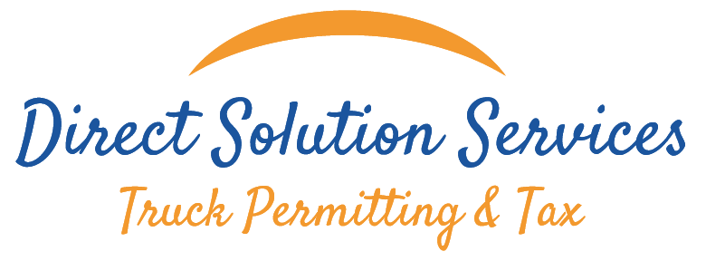



Certificate of Alcohol Result

{{ customer }}
DRIVER: {{ driver }}

On {{date}} was done the alcohol test and the result of the test #{{ lote }} was

{{result}}

DIRECT SOLUTION SERVICES
1248 Viscaya Pkwy Unit 2B
Cape Coral, FL 33990
Phone: 239-443-5846

Greisy Valdes
Compliance Specialist



