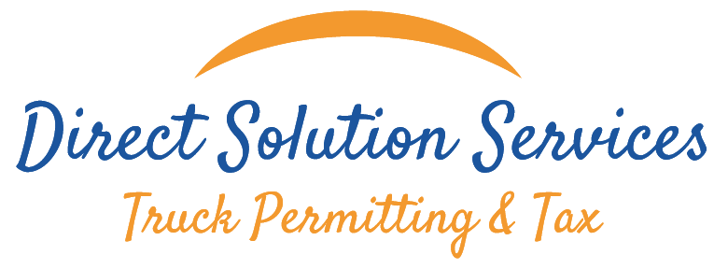



Certificate of Drug and Alcohol

{{ customer }}

Was done the drug and alcohol test the {{date}} and the result of test #{{ lote }} was

{{result}}

DIRECT SOLUTION SERVICES
1248 Viscaya Pkwy Unit 2B
Cape Coral, FL 33990
Phone: 239-443-5846

Greisy Valdes
Compliance Specialist



