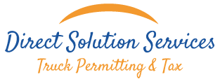

Direct Solution Services
Active Employee's Listing for Random
Controlled Substances and Alcohol Use Pool

{{ company_name }}/ USDOT# {{ dot_number }} is a member of DIRECT SOLUTION SERVICES Federal Compliance Controlled Substances and Alcohol Testing Random as of {{effective_date}}.

Their current roster consists of the following person(s):
{% for driver in drivers %}
- {{ driver.nombre }}
{% endfor %}

Direct Solution Services maintains an active quarterly calendar year Random Participation Controlled Substances and Alcohol Use Pool for all its affiliated companies who require and elect such service. The Random pool complies with the Federal Motor Carrier Safety Regulations (FMCSR), as prescribed in 49 CFR Part 40, Procedures for Transportation Workplace Drug and Alcohol Testing Programs and Part 382 Controlled Substances and Alcohol Use and Testing, Subpart C,Section 382.305,Random Testing.

For CY2014- 2015 a Random selection percentage of at least 50% for Controlled Substances and at least 10% for Alcohol is being maintained in accordance with these Federal Regulations.

GREISY VALDES


AGENT
DOT Safety/Compliance Specialist

