Зміст

Ex1 2

Ex2 3

Ex3 4

# Ex1

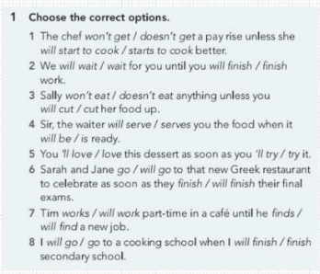

1. The chef won't get a pay rise unless she starts to cook better.

2. We will wait for you until you finish work.

3. Sally won't eat anything unless you cut her food up.

4. Sir, the waiter will serve you the food when it is ready.

5. You'll love this dessert as soon as you try it.

6. Sarah and Jane will go to that new Greek restaurant to celebrate as soon as they finish their final exams.

7. Tim works part-time in a café until he finds a new job.

8. I will go to a cooking school when I finish secondary school.

# Ex2

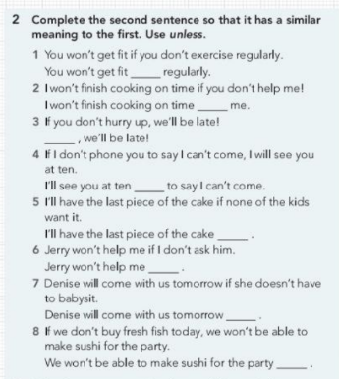

1. You won't get fit unless you exercise regularly.

2. I won't finish cooking on time unless you help me!

3. Unless you hurry up, we'll be late!

4. I'll see you at ten unless I phone you to say I can't come.

5. I'll have the last piece of the cake unless none of the kids want it.

6. Jerry won't help me unless I ask him.

7. Denise will come with us tomorrow unless she has to babysit.

8. We won't be able to make sushi for the party unless we buy fresh fish today.

# Ex3

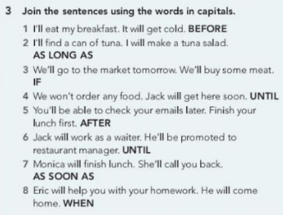

1. I'll eat my breakfast before it gets cold.

2. I'll find a can of tuna as long as I will make a tuna salad.

3. We'll go to the market tomorrow if we'll buy some meat.

4. We won't order any food until Jack will get here soon.

5. You'll be able to check your emails after you finish your lunch first.

6. Jack will work as a waiter until he'll be promoted to restaurant manager.

7. Monica will call you back as soon as she finishes lunch.

8. Eric will help you with your homework when he comes home.