Зміст

Ex5 p 159 2

Ex10 p161 3

Ex14 p162 5

Ex15 p165 9

Ex16 p167 13

# Ex5 p 159



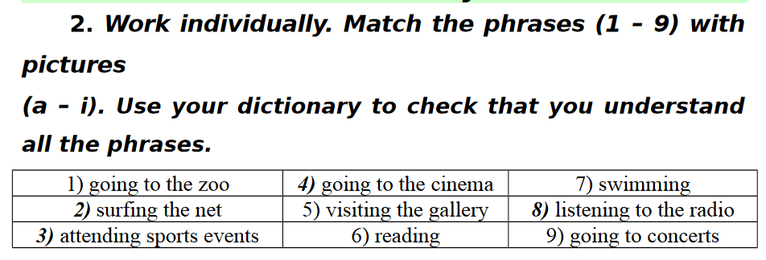

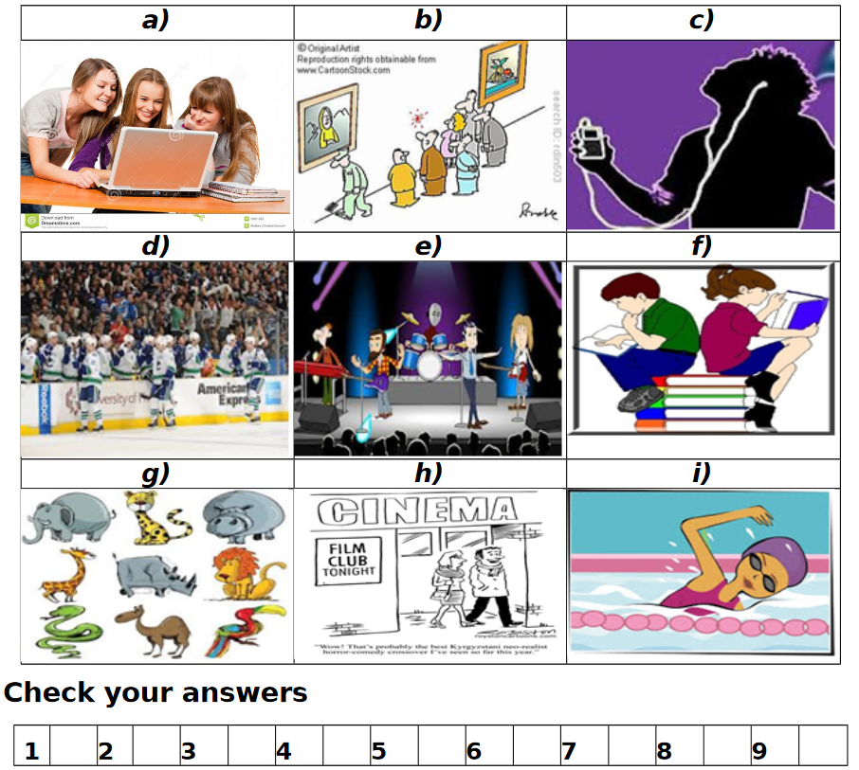

a) I love going to the zoo on weekends to see the exotic animals.

b) I spend hours surfing the net, researching various topics and browsing social media.

c) Attending sports events is always exciting, especially when it's a close match.

d) Going to the cinema is one of my favorite pastimes, especially for blockbuster movies.

e) Visiting the gallery allows me to appreciate different forms of art and creativity.

f) Reading is a hobby I indulge in every night before going to bed.

g) Swimming is not only a great form of exercise but also incredibly refreshing.

h) Listening to the radio in the morning helps me catch up on news and current affairs.

i) Going to concerts is an exhilarating experience, especially when it's your favorite band performing live.

# Ex10 p161

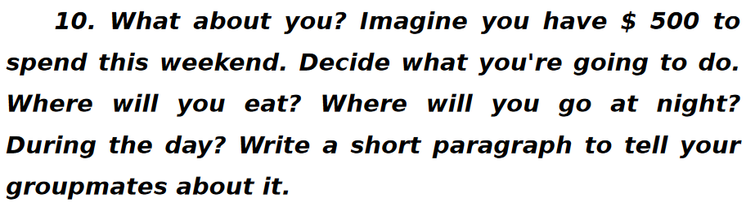

With $500 to spend this weekend, I'm envisioning a laid-back yet exciting time with friends. We'll kick off the day with a hearty brunch at McDonald's, indulging in our favorite burgers, fries, and milkshakes while catching up on each other's lives. After satisfying our appetites, we'll head to the cinema to catch the latest blockbuster film, immersing ourselves in an epic cinematic experience. As the sun sets, we'll amp up the energy and prepare for a night of partying. We'll hit up some local hotspots, dance the night away, and create unforgettable memories together. With good food, great company, and plenty of entertainment, this weekend is shaping up to be an absolute blast!

# Ex14 p162

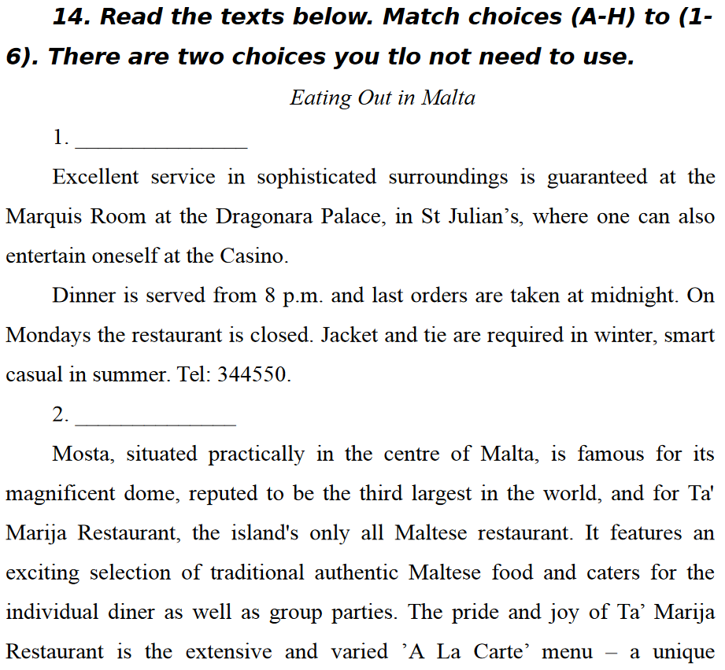

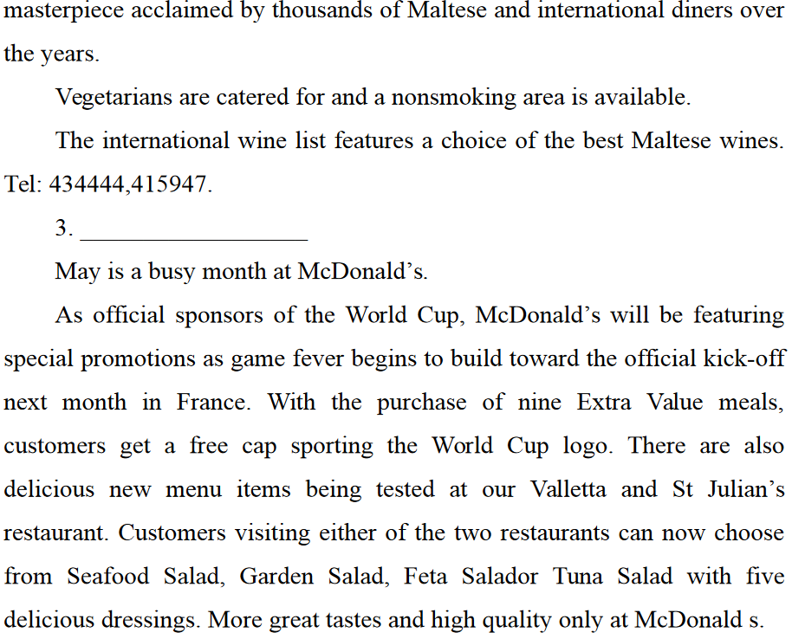

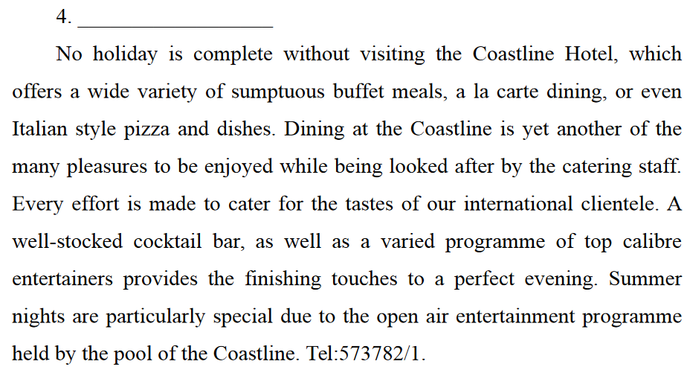

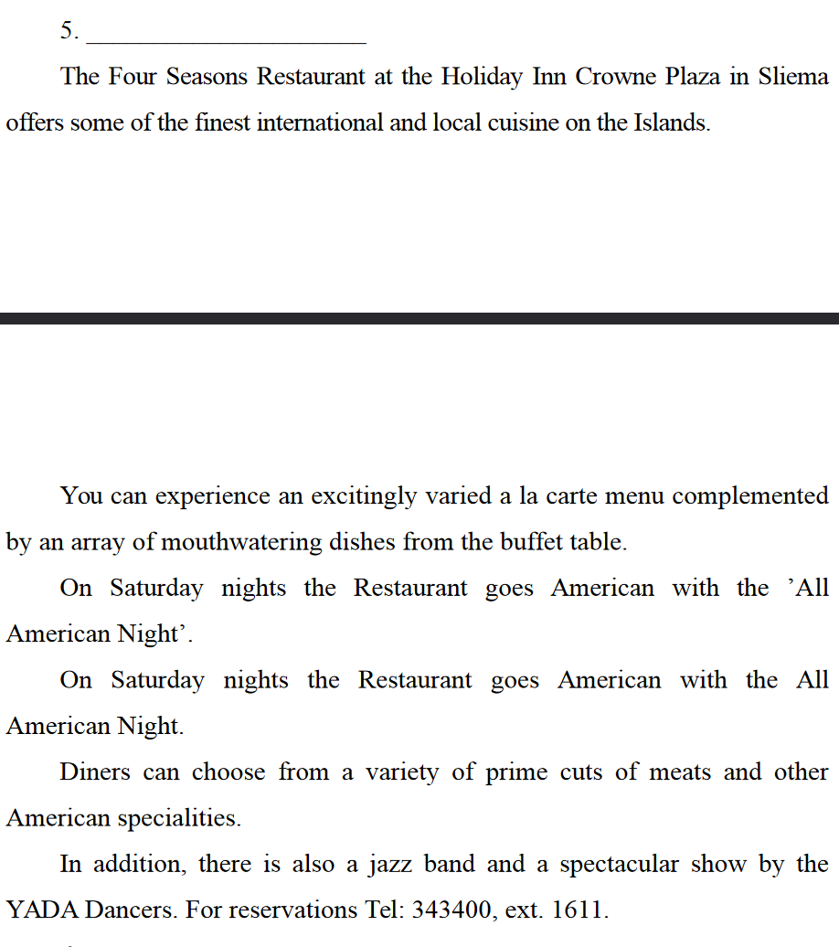

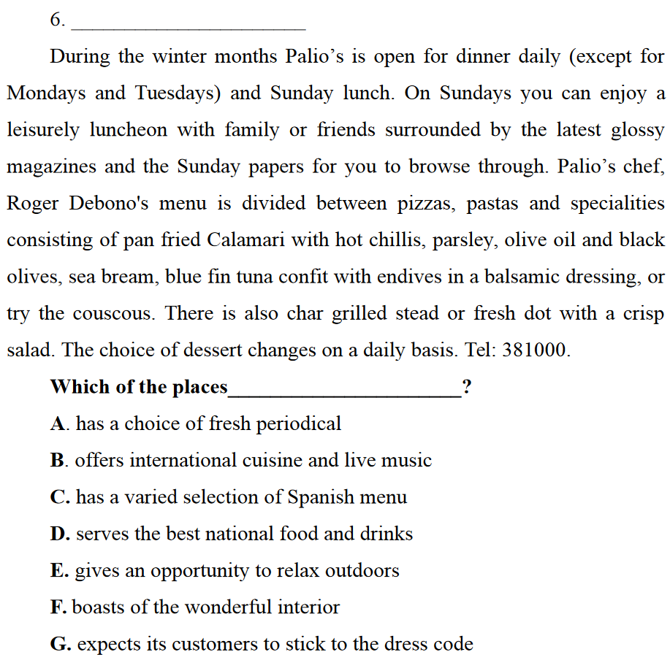

1. G

2. D

3. H

4. E

5. B

6. A

# Ex15 p165







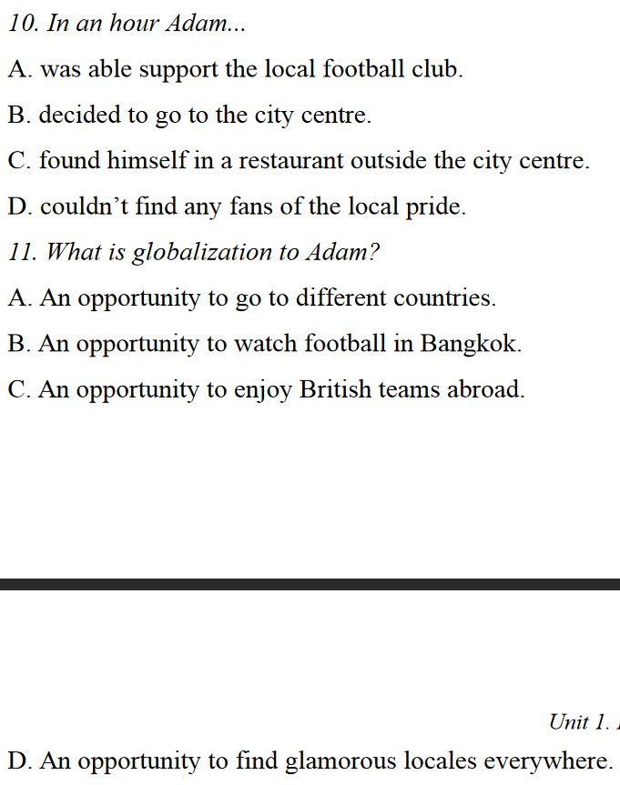

7. B

8. C

9. A

10. D

11. C

# Ex16 p167

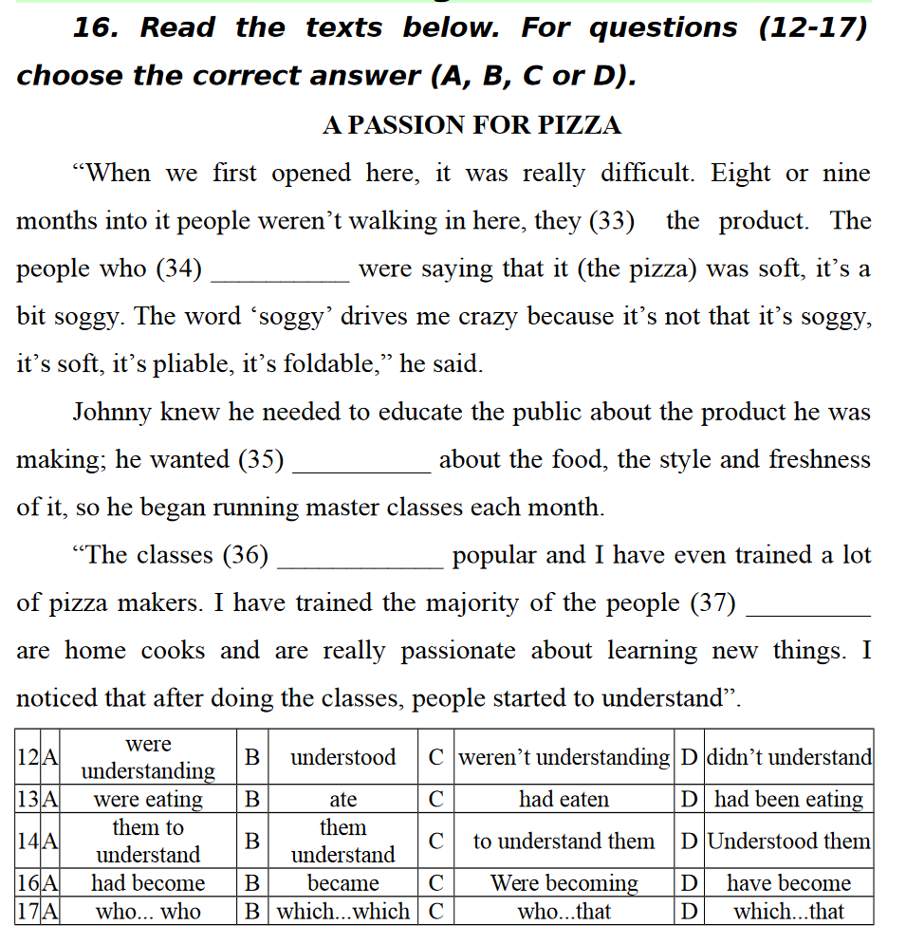

12. D

13. C

14. C

16. B

17. C