Лабораторна робота №3

Масиви у мові С#

Мета: набути практичного досвіду використання одновимірних та багатовимірних масивів у мові C#

Хід виконання

Посилання на віддалений репозиторій: https://git.ztu.edu.ua/vt231_ntg/university/tree/master/OOP/lab_03?ref_type=heads

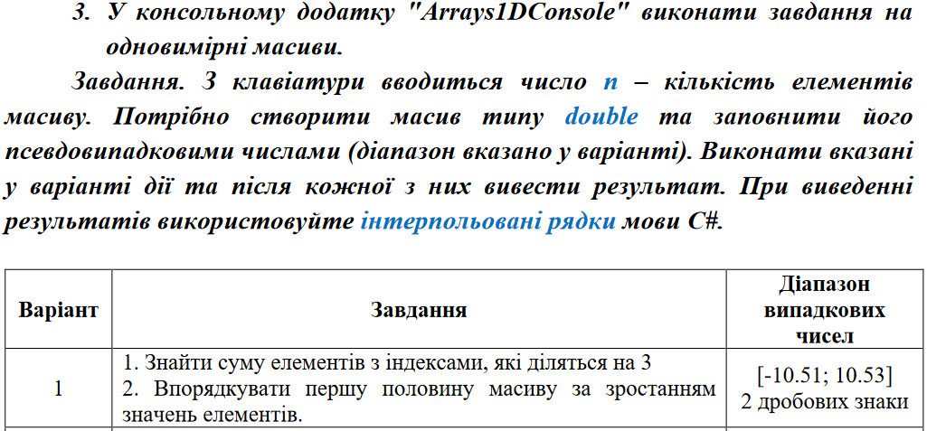

Лістинг програми:
using System;

namespace Arrays1DConsole
{
class Program
{
static void Main(string[] args)
{
System.Globalization.CultureInfo customCulture = (System.Globalization.CultureInfo)
System.Threading.Thread.CurrentThread.CurrentCulture.Clone();
customCulture.NumberFormat.NumberDecimalSeparator = ".";
System.Threading.Thread.CurrentThread.CurrentCulture = customCulture;

Console.WriteLine("Enter n:");
int n = int.Parse(Console.ReadLine());
double[] arr1 = new double[n];
Random rnd = new Random();

for (int i = 0; i < n; i++)
{
arr1[i] = rnd.Next(-1051, 1053) / 100.0;
Console.WriteLine($"[{i}] = {arr1[i]}");
}
double sum = 0;
for (int i = 0; i < n; i++)
{
if (i % 3 == 0)
sum += arr1[i];
}
Console.WriteLine($"Sum of elements with indices divisible by 3: {sum}");
int halfLength = n / 2;
double[] arr2 = new double[halfLength];
Array.Copy(arr1, arr2, halfLength);
Array.Sort(arr2);

Console.WriteLine($"Sorted first half of the array:");
for (int i = 0; i < halfLength; i++)
{
arr1[i] = arr2[i];
Console.WriteLine($"arr1[{i}] = {arr1[i]}");
}
}
}
}

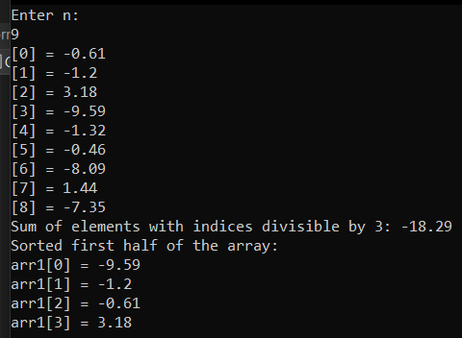
Результат виконання програми

Лістинг програми:
using System;
using System.Collections.Generic;
using System.ComponentModel;
using System.Data;
using System.Drawing;
using System.Linq;
using System.Text;
using System.Threading.Tasks;
using System.Windows.Forms;

namespace Arrays1DWinForms
{
public partial class Form1 : Form
{
public Form1()
{
InitializeComponent();
}

private void label1_Click(object sender, EventArgs e)
{

}

private void numericUpDownCount_ValueChanged(object sender, EventArgs e)
{

}

private void Form1_Load(object sender, EventArgs e)
{
System.Globalization.CultureInfo customCulture = (System.Globalization.CultureInfo)
System.Threading.Thread.CurrentThread.CurrentCulture.Clone();
customCulture.NumberFormat.NumberDecimalSeparator = ".";
System.Threading.Thread.CurrentThread.CurrentCulture = customCulture;

}
double[] arr1;
private void buttonGenerate_Click(object sender, EventArgs e)
{
int n;
n = (int)numericUpDownCount.Value;
dataGridViewArray.RowCount = 1;
dataGridViewArray.ColumnCount = n;
dataGridViewArray.RowHeadersWidth = 80;

for (int i=0; i<dataGridViewArray.RowCount;i++)
{
dataGridViewArray.Rows[i].HeaderCell.Value = i.ToString();
}
for (int i = 0; i < dataGridViewArray.ColumnCount; i++)
{
dataGridViewArray.Columns[i].HeaderCell.Value = i.ToString();
}

arr1 = new double[n];
Random rnd = new Random();
for (int i = 0; i < n; i++)
{
arr1[i] = rnd.Next(-1051, 1053) / 100.0;
dataGridViewArray[i, 0].Value = arr1[i];

}
}

private void buttonSolve_Click(object sender, EventArgs e)
{
double sum = 0;
for (int i = 0; i < arr1.Length; i++)
{
if (i % 3 == 0 && i != 0)
sum += arr1[i];
}

textBoxsum.Text = $"SUM = {sum}";
}

private void button1_Click(object sender, EventArgs e)
{

double[] arr2 = new double[arr1.Length / 2];
for (int i = 0; i < arr1.Length / 2; i++)
arr2[i] = arr1[i];
Array.Sort(arr2);

for (int i = 0; i < arr1.Length / 2; i++)
{
arr1[i] = arr2[i];
}
for (int i = 0; i < arr1.Length; i++)
{
dataGridViewArray[i, 0].Value = arr1[i];
}
}

private void dataGridViewArray_CellContentClick(object sender, DataGridViewCellEventArgs e)
{

}

private void textBoxsum_TextChanged(object sender, EventArgs e)
{

}

private void label1_Click_1(object sender, EventArgs e)
{

}
}
}

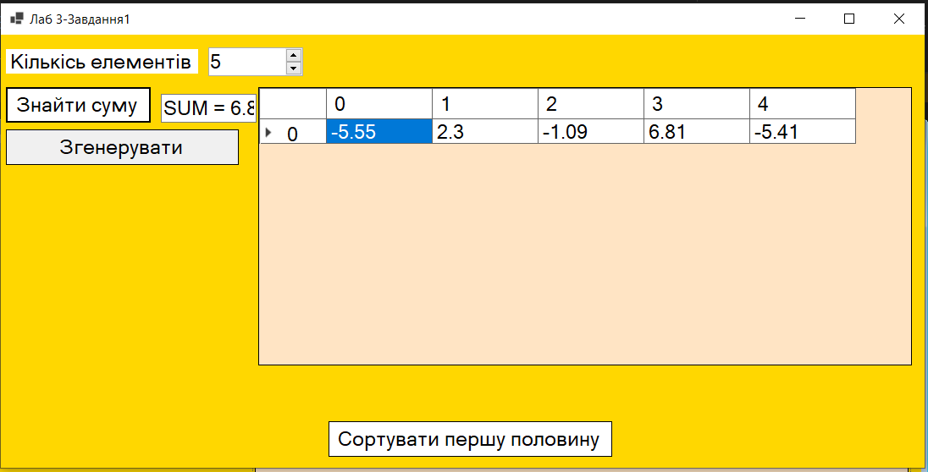
Результат роботи програми
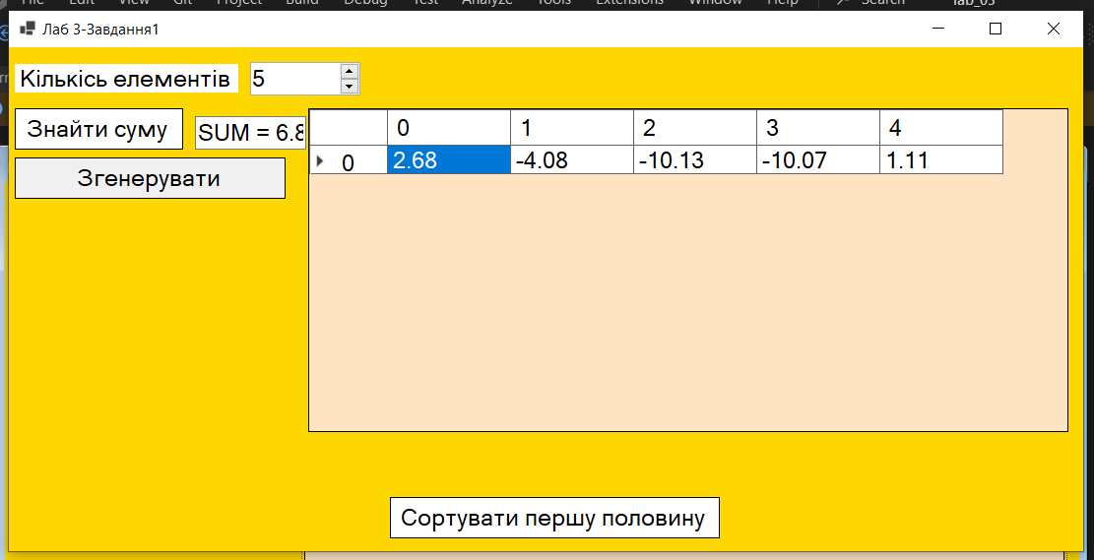
Результат роботи програми

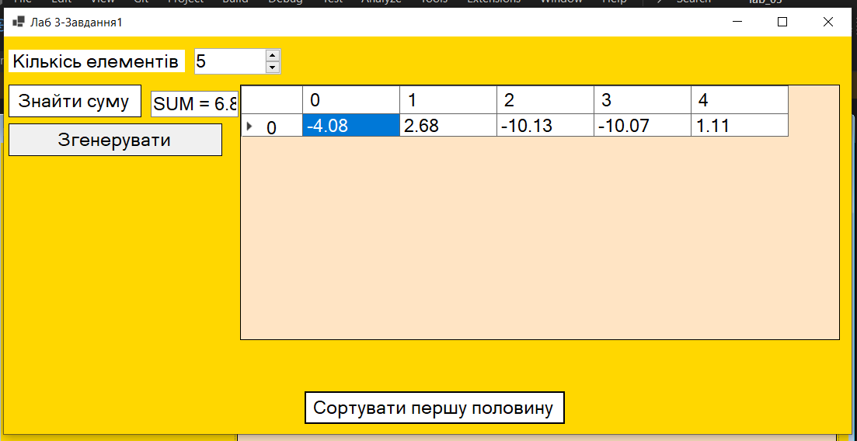
Результат роботи програми

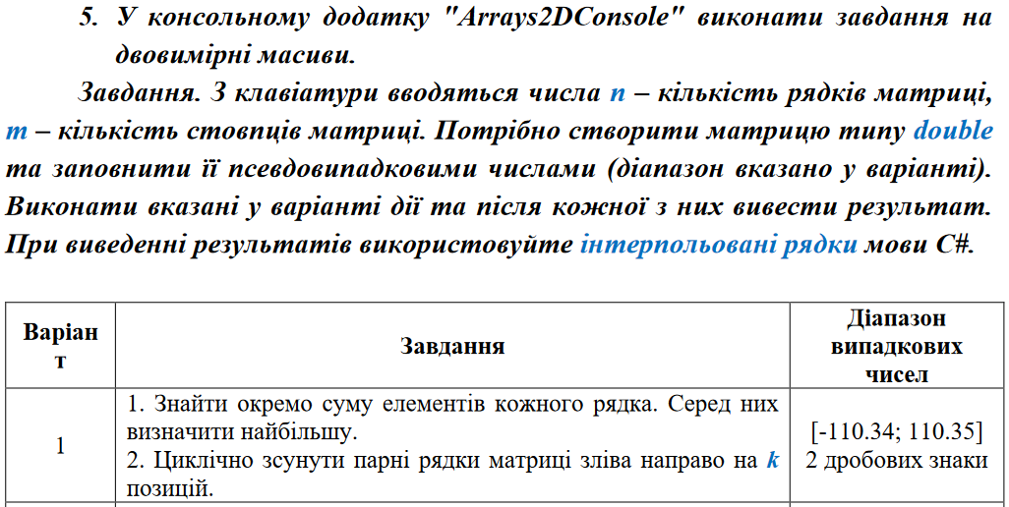
Лістинг програми:
using System;

namespace Arrays2DConsole
{
class Program
{
static void Main(string[] args)
{
System.Globalization.CultureInfo customCulture = (System.Globalization.CultureInfo)
System.Threading.Thread.CurrentThread.CurrentCulture.Clone();
customCulture.NumberFormat.NumberDecimalSeparator = ".";
System.Threading.Thread.CurrentThread.CurrentCulture = customCulture;

Console.WriteLine("Enter n = ");
int n = int.Parse(Console.ReadLine());
Console.WriteLine("Enter m = ");
int m = int.Parse(Console.ReadLine());
Console.WriteLine($"Array [{n};{m}]\r\n");
double[,] arr = new double[n, m];
Random rnd = new Random();

for (int i = 0; i < n; i++)
{
for (int j = 0; j < m; j++)
{
arr[i, j] = rnd.Next(-11034, 11035) / 100.0;
Console.Write($"{arr[i, j],8}");
}
Console.Write("\r\n");
}
Console.Write("\r\n");

double[] arrdo = new double[n];
double sum = 0, max = 0;

for (int i = 0; i < n; i++)
{
for (int j = 0; j < m; j++)
{
sum += arr[i, j];
if (j == m - 1)
{
arrdo[i] = sum;
sum = 0;
Console.Write($"sum[{i}] = {arrdo[i]:F2}\r\n");
}
}
}
Console.Write("\r\n");
for (int i = 0; i < n; i++)
if (arrdo[i] > max) max = arrdo[i];
Console.Write($"sum[max] = {max:F2}\r\n");

Console.WriteLine("Enter k = ");
int k = int.Parse(Console.ReadLine());
double temp;

for (int i = 0; i < k; i++)
{
for (int j = 0; j < n; j++)
{
if (j % 2 == 0 && j != 0)
{
temp = arr[j, 0];
for (int g = 0; g < m - 1; g++)
arr[j, g] = arr[j, g + 1];
arr[j, m - 1] = temp;
}
}
}

Console.Write("\r\n");
for (int i = 0; i < n; i++)
{
for (int j = 0; j < m; j++)
{
Console.Write($"{arr[i, j],8}");
}
Console.Write("\r\n");
}
}
}
}

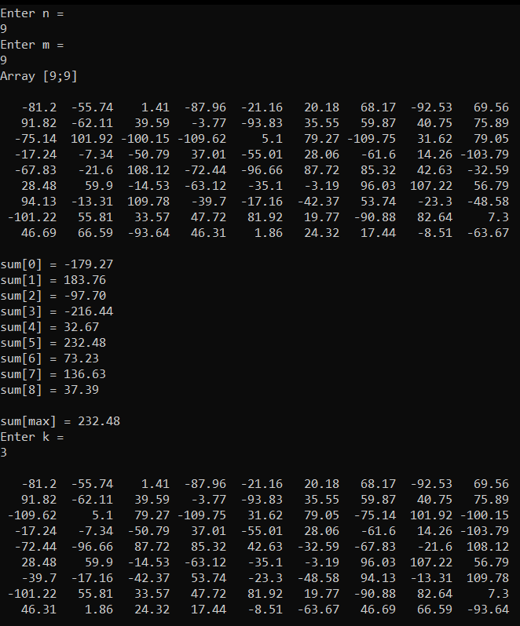
Результат роботи програми

Лістинг програми:
using System;
using System.Collections.Generic;
using System.ComponentModel;
using System.Data;
using System.Drawing;
using System.Linq;
using System.Text;
using System.Threading.Tasks;
using System.Windows.Forms;

namespace Arrays2DWinForms
{
public partial class Form1 : Form
{
public Form1()
{
InitializeComponent();
System.Globalization.CultureInfo customCulture = (System.Globalization.CultureInfo)
System.Threading.Thread.CurrentThread.CurrentCulture.Clone();
customCulture.NumberFormat.NumberDecimalSeparator = ".";
System.Threading.Thread.CurrentThread.CurrentCulture = customCulture;
}
double[,] arr;
private void Form1_Load(object sender, EventArgs e)
{

}

private void dataGridViewMatrix_CellContentClick(object sender, DataGridViewCellEventArgs e)
{

}
private void dataGridViewMatrix_CellPainting(object sender, DataGridViewCellPaintingEventArgs e)
{
if (e.ColumnIndex == -1 && e.RowIndex > -1)
{
e.PaintBackground(e.CellBounds, true);
using (SolidBrush br = new SolidBrush(Color.Black))
{
StringFormat sf = new StringFormat();
sf.Alignment = StringAlignment.Center;
sf.LineAlignment = StringAlignment.Center;
e.Graphics.DrawString(e.RowIndex.ToString(),
e.CellStyle.Font, br, e.CellBounds, sf);
}
e.Handled = true;
}
}

private void buttonGenerate_Click(object sender, EventArgs e)
{
int n,m;
n = (int)numericUpDownN.Value;
m = (int)numericUpDownM.Value;
dataGridViewMatrix.RowCount = n;
dataGridViewMatrix.ColumnCount = m;
dataGridViewMatrix.RowHeadersWidth = 80;

for (int i = 0; i < dataGridViewMatrix.RowCount; i++)
{
dataGridViewMatrix.Rows[i].HeaderCell.Value = i.ToString();
}
for (int i = 0; i < dataGridViewMatrix.ColumnCount; i++)
{
dataGridViewMatrix.Columns[i].HeaderCell.Value = i.ToString();
}

arr = new double[n, m];
Random rnd = new Random();

for (int i = 0; i < n; i++)
{
for (int j = 0; j < m; j++)
{
arr[i, j] = rnd.Next(-11034, 11035) / 100.0;
dataGridViewMatrix[j, i].Value = arr[i,j];
}

}

}

private void buttonSolve_Click(object sender, EventArgs e)
{
double[] arrdo = new double[arr.GetLength(0)];

double sum = 0, max = 0;

for (int i = 0; i < arr.GetLength(0); i++)
{
for (int j = 0; j < arr.GetLength(1); j++)
{
sum += arr[i, j];
if (j == arr.GetLength(1) - 1)
{
arrdo[i] = sum;
sum = 0;

}
}
}
for (int i = 0; i < arrdo.Length; i++)
if (arrdo[i] > max) max = arrdo[i];
textBoxsum.Text = $"{max}";
}

private void button1_Click(object sender, EventArgs e)
{

int k = int.Parse(textBoxStep.Text);
double temp;

for (int i = 0; i < k; i++)
{
for (int j = 0; j < arr.GetLength(0); j++)
{
if (j % 2 == 0 && j != 0)
{
temp = arr[j, 0];
for (int g = 0; g < arr.GetLength(1) - 1; g++)
arr[j, g] = arr[j, g + 1];
arr[j, arr.GetLength(1) - 1] = temp;
}
}
}

for (int i = 0; i < arr.GetLength(0); i++)
{
for (int j = 0; j < arr.GetLength(1); j++)
{

dataGridViewMatrix[j, i].Value = arr[i, j];
}

}

}
}
}

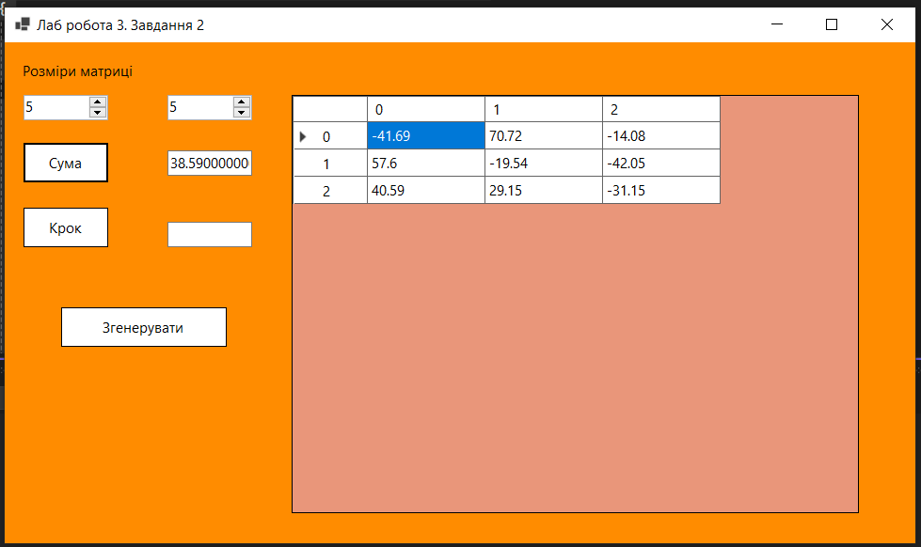
Результат роботи програми

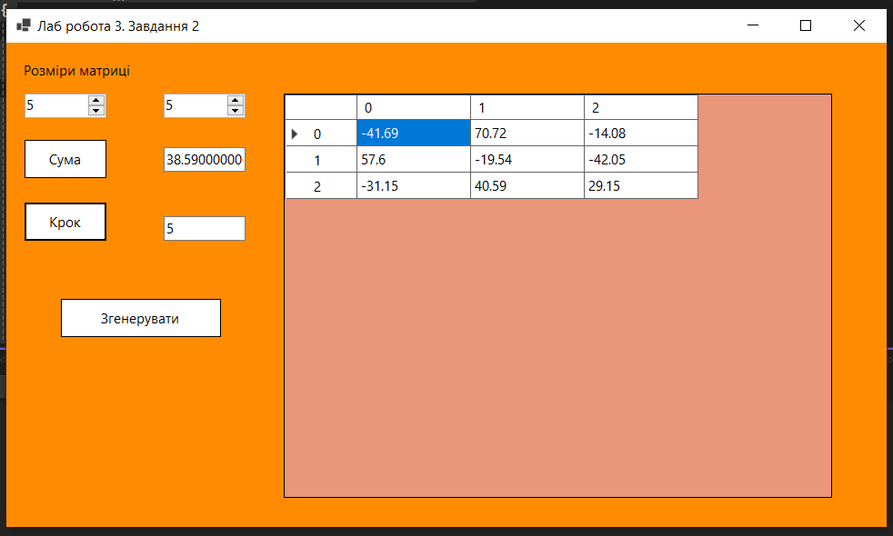
Результат роботи програми

Висновки: набуто практичного досвіду використання одновимірних та багатовимірних масивів у мові C#.

