Лабораторна робота №22
Робота з рядками
Мета: отримання практичних навиків роботи з рядками
Хід виконання

Лістинг програми:
#include <stdio.h>
#include <string.h>
#include <ctype.h>
#include <windows.h>
void removeSpaces(char* str) {
int count = 0;
int _count = 0;
for (int i = 0; str[i]; i++) {
if (str[i] != ' ') {
str[count++] = str[i];
}
else {
_count++;
}
}
str[count] = '\0';
printf("Перетворений текст: %s\n", str);
printf("Кількість вилучених пробілів: %d\n", _count);
}

int main() {
SetConsoleCP(1251);
SetConsoleOutputCP(1251);
char inputString[1000];

printf("Введіть рядок символів: ");
fgets(inputString, sizeof(inputString), stdin);
inputString[strcspn(inputString, "\n")] = '\0';
removeSpaces(inputString);
return 0;
}

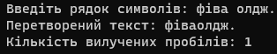
Результат роботи програми
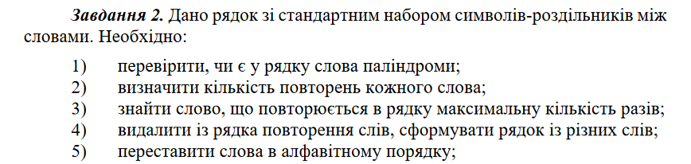

Лістинг програми:
#define _CRT_SECURE_NO_WARNINGS
#include <stdio.h>
#include <string.h>
#include <stdlib.h>

#define MAX_LENGTH 100

int isPalindrome(char* word) {
int len = strlen(word);
for (int i = 0; i < len / 2; i++) {
if (word[i] != word[len - i - 1]) {
return 0;
}
}
return 1;
}

int main() {
char inputString[MAX_LENGTH];
printf("Enter a string with words: ");
fgets(inputString, sizeof(inputString), stdin);

if (inputString[strlen(inputString) - 1] == '\n') {
inputString[strlen(inputString) - 1] = '\0';
}

char* token;
char* words[MAX_LENGTH];
int wordCount = 0;

token = strtok(inputString, " ");
while (token != NULL) {
words[wordCount++] = token;
token = strtok(NULL, " ");
}

printf("Words that are palindromes:\n");
for (int i = 0; i < wordCount; i++) {
if (isPalindrome(words[i])) {
printf("%s\n", words[i]);
}
}

printf("\nNumber of repetitions for each word:\n");
int count[MAX_LENGTH] = { 0 };
for (int i = 0; i < wordCount; i++) {
for (int j = 0; j < wordCount; j++) {
if (strcmp(words[i], words[j]) == 0) {
count[i]++;
}
}
printf("%s: %d\n", words[i], count[i]);
}
char* mostRepeatedWord = NULL;
int maxCount = 0;
for (int i = 0; i < wordCount; i++) {
if (count[i] > maxCount) {
maxCount = count[i];
mostRepeatedWord = words[i];
}
}
if (mostRepeatedWord != NULL) {
printf("\nWord repeated the maximum number of times: %s\n", mostRepeatedWord);
}
else {
printf("\nNo words are repeated\n");
}

printf("\nString of unique words (without repetitions):\n");
for (int i = 0; i < wordCount; i++) {
int isUnique = 1;
for (int j = i + 1; j < wordCount; j++) {
if (strcmp(words[i], words[j]) == 0) {
isUnique = 0;
break;
}
}
if (isUnique) {
printf("%s ", words[i]);
}
}

printf("\nWords in alphabetical order:\n");
char* temp;
for (int i = 0; i < wordCount - 1; i++) {
for (int j = i + 1; j < wordCount; j++) {
if (strcmp(words[i], words[j]) > 0) {
temp = words[i];
words[i] = words[j];
words[j] = temp;
}
}
}
for (int i = 0; i < wordCount; i++) {
printf("%s ", words[i]);
}
printf("\n");

return 0;
}
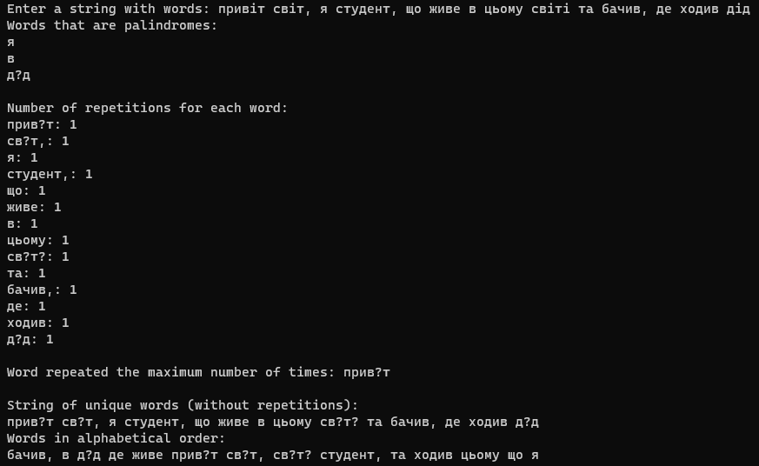
Результат виконання програми
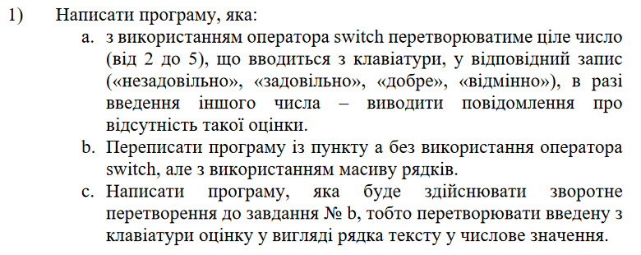
Лістинг програми:
#include <stdio.h>
#include <string.h>

int main() {
const char* grades[] = { "No such grade", "No such grade", "Unsatisfactory", "Satisfactory", "Good", "Excellent" };

int choice;
printf("Choose an option:\n");
printf("1. Convert number to grade using switch\n");
printf("2. Convert number to grade using string array\n");
printf("3. Convert grade to number\n");
scanf_s("%d", &choice);

switch (choice) {
case 1: {
int grade;
printf("Enter a number (2 to 5): ");
scanf_s("%d", &grade);

switch (grade) {
case 2:
printf("Unsatisfactory\n");
break;
case 3:
printf("Satisfactory\n");
break;
case 4:
printf("Good\n");
break;
case 5:
printf("Excellent\n");
break;
default:
printf("No such grade\n");
}
break;
}

case 2: {
const char* grades[] = { "No such grade", "No such grade", "Unsatisfactory", "Satisfactory", "Good", "Excellent" };

int grade;
printf("Enter a number (2 to 5): ");
scanf_s("%d", &grade);

if (grade >= 2 && grade <= 5) {
printf("%s\n", grades[grade]);
}
else {
printf("%s\n", grades[0]);
}
break;
}
case 3: {
getchar();

char input[20];
printf("Enter a grade (Unsatisfactory, Satisfactory, Good, Excellent): ");
fgets(input, sizeof(input), stdin);

int grade = -1;
input[strcspn(input, "\n")] = '\0';

for (int i = 2; i <= 5; i++) {
if (strcmp(input, grades[i]) == 0) {
grade = i;
break;
}
}

if (grade != -1) {
printf("Numeric grade: %d\n", grade);
}
else {
printf("No such grade\n");
}
break;
}
default:
printf("Invalid choice\n");
}

return 0;
}

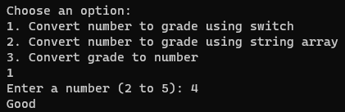
Результат виконання програми

Висновок: отримано практичні навики роботи з рядками

