Лабораторна робота №23
Програмування з використанням структур.
Мета: отримання практичних навиків роботи зі структурами
Хід виконання
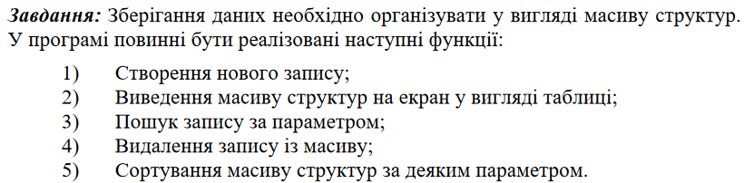

Лістинг програми:
#define _CRT_SECURE_NO_WARNINGS
#include <stdio.h>
#include <string.h>
#include <stdlib.h>

#define MAX_CARS 100

struct Car {
char brand[50];
char color[20];
int serialNumber;
char regNumber[15];
int yearOfManufacture;
int inspectionYear;
float price;
};

struct Car cars[MAX_CARS];
int numberOfCars = 0;

void addCar() {
if (numberOfCars < MAX_CARS) {
struct Car newCar;
printf("Enter car details:\n");
printf("Brand: ");
scanf("%s", newCar.brand);
printf("Color: ");
scanf("%s", newCar.color);
printf("Serial number: ");
scanf("%d", &newCar.serialNumber);
printf("Registration number: ");
scanf("%s", newCar.regNumber);
printf("Year of manufacture: ");
scanf("%d", &newCar.yearOfManufacture);
printf("Inspection year: ");
scanf("%d", &newCar.inspectionYear);
printf("Price: ");
scanf("%f", &newCar.price);

cars[numberOfCars++] = newCar;
printf("Car added successfully!\n");
}
else {
printf("Cannot add more cars. Maximum limit reached.\n");
}
}

void displayCars() {
if (numberOfCars == 0) {
printf("No cars to display.\n");
}
else {
printf("Cars information:\n");
printf("----------------------------------------------------------------------------------------------------------------\n");
printf("Brand\t\tColor\t\tSerial\t\tReg. Number\tYear\t\tInspect.\tPrice\n");
printf("----------------------------------------------------------------------------------------------------------------\n");
for (int i = 0; i < numberOfCars; ++i) {
printf("%s\t\t%s\t\t%d\t\t%s\t\t%d\t\t%d\t\t%.2f\n", cars[i].brand, cars[i].color, cars[i].serialNumber,
cars[i].regNumber, cars[i].yearOfManufacture, cars[i].inspectionYear, cars[i].price);
}
printf("----------------------------------------------------------------------------------------------------------------\n");
}
}

void searchCarByField() {
int choice;
printf("\nEnter the field for search (1 - Brand, 2 - Color, 3 - Serial Number, 4 - Reg. Number, 5 - Year of Manufacture, 6 - Inspection Year, 7 - Price): ");
scanf("%d", &choice);

int found = 0;
char searchString[50];
int searchNumber;
float searchingPrice;

switch (choice) {
case 1:
printf("Enter the brand: ");
scanf("%s", &searchString);
for (int i = 0; i < numberOfCars; ++i) {
if (strcmp(cars[i].brand, searchString) == 0) {
printf("%s\t\t%s\t\t%d\t\t%s\t\t%d\t\t%d\t\t%.2f\n", cars[i].brand, cars[i].color, cars[i].serialNumber,
cars[i].regNumber, cars[i].yearOfManufacture, cars[i].inspectionYear, cars[i].price);
printf("----------------------------------------------------------------------------------------------------------------\n");
found = 1;
}
}
break;
case 2:
printf("Enter the color: ");
scanf("%s", &searchString);
for (int i = 0; i < numberOfCars; ++i) {
if (strcmp(cars[i].color, searchString) == 0) {
printf("%s\t\t%s\t\t%d\t\t%s\t\t%d\t\t%d\t\t%.2f\n", cars[i].brand, cars[i].color, cars[i].serialNumber,
cars[i].regNumber, cars[i].yearOfManufacture, cars[i].inspectionYear, cars[i].price);
printf("----------------------------------------------------------------------------------------------------------------\n");
found = 1;
}
}
break;

case 3:
printf("Enter the serial number: ");
scanf("%d", &searchNumber);
for (int i = 0; i < numberOfCars; ++i) {
if (cars[i].serialNumber == searchNumber) {
printf("%s\t\t%s\t\t%d\t\t%s\t\t%d\t\t%d\t\t%.2f\n", cars[i].brand, cars[i].color, cars[i].serialNumber,
cars[i].regNumber, cars[i].yearOfManufacture, cars[i].inspectionYear, cars[i].price);
printf("----------------------------------------------------------------------------------------------------------------\n");
found = 1;
}
}
break;
case 4:
printf("Enter the registration number: ");
scanf("%s", &searchString);
for (int i = 0; i < numberOfCars; ++i) {
if (strcmp(cars[i].regNumber, searchString) == 0) {
printf("%s\t\t%s\t\t%d\t\t%s\t\t%d\t\t%d\t\t%.2f\n", cars[i].brand, cars[i].color, cars[i].serialNumber,
cars[i].regNumber, cars[i].yearOfManufacture, cars[i].inspectionYear, cars[i].price);
printf("----------------------------------------------------------------------------------------------------------------\n");
found = 1;
}
}
break;
case 5:
printf("Enter the year of manufacture: ");
scanf("%d", &searchNumber);
for (int i = 0; i < numberOfCars; ++i) {
if (cars[i].yearOfManufacture == searchNumber) {
printf("%s\t\t%s\t\t%d\t\t%s\t\t%d\t\t%d\t\t%.2f\n", cars[i].brand, cars[i].color, cars[i].serialNumber,
cars[i].regNumber, cars[i].yearOfManufacture, cars[i].inspectionYear, cars[i].price);
printf("----------------------------------------------------------------------------------------------------------------\n");
found = 1;
}
}
break;

case 6:
printf("Enter the inspection year: ");
scanf("%d", &searchNumber);
for (int i = 0; i < numberOfCars; ++i) {
if (cars[i].inspectionYear == searchNumber) {
printf("%s\t\t%s\t\t%d\t\t%s\t\t%d\t\t%d\t\t%.2f\n", cars[i].brand, cars[i].color, cars[i].serialNumber,
cars[i].regNumber, cars[i].yearOfManufacture, cars[i].inspectionYear, cars[i].price);
printf("----------------------------------------------------------------------------------------------------------------\n");
found = 1;
}
}
break;
case 7:
printf("Enter the price: ");
scanf("%f", &searchingPrice);
for (int i = 0; i < numberOfCars; ++i) {
if (cars[i].price == searchingPrice) {
printf("%s\t\t%s\t\t%d\t\t%s\t\t%d\t\t%d\t\t%.2f\n", cars[i].brand, cars[i].color, cars[i].serialNumber,
cars[i].regNumber, cars[i].yearOfManufacture, cars[i].inspectionYear, cars[i].price);
printf("----------------------------------------------------------------------------------------------------------------\n");
found = 1;
}
}
break;
default:
printf("Invalid choice.\n");
}

if (!found) {
printf("Car not found.\n");
}
}

void deleteCarByIndex() {
int index;
printf("Enter the index of the car to delete: ");
scanf("%d", &index);

if (index >= 0 && index < numberOfCars) {
for (int i = index; i < numberOfCars - 1; ++i) {
cars[i] = cars[i + 1];
}
numberOfCars--;
printf("Car deleted successfully!\n");
}
else {
printf("Invalid index for deletion.\n");
}
}

int compareBrand(const void* a, const void* b) {
return strcmp(((struct Car*)a)->brand, ((struct Car*)b)->brand);
}

int compareColor(const void* a, const void* b) {
return strcmp(((struct Car*)a)->color, ((struct Car*)b)->color);
}

int compareSerialNumber(const void* a, const void* b) {
return ((struct Car*)a)->serialNumber - ((struct Car*)b)->serialNumber;
}

int compareRegNumber(const void* a, const void* b) {
return strcmp(((struct Car*)a)->regNumber, ((struct Car*)b)->regNumber);
}

int compareYearOfManufacture(const void* a, const void* b) {
return ((struct Car*)a)->yearOfManufacture - ((struct Car*)b)->yearOfManufacture;
}

int compareInspectionYear(const void* a, const void* b) {
return ((struct Car*)a)->inspectionYear - ((struct Car*)b)->inspectionYear;
}

int comparePrice(const void* a, const void* b) {
if (((struct Car*)a)->price < ((struct Car*)b)->price) return -1;
if (((struct Car*)a)->price > ((struct Car*)b)->price) return 1;
return 0;
}

void sortCarsByField() {
int choice;
printf("\nEnter the field for sorting (1 - Brand, 2 - Color, 3 - Serial Number, 4 - Reg. Number, 5 - Year of Manufacture, 6 - Inspection Year, 7 - Price): ");
scanf("%d", &choice);

if (numberOfCars > 0) {
switch (choice) {
case 1:
qsort(cars, numberOfCars, sizeof(struct Car), compareBrand);
break;
case 2:
qsort(cars, numberOfCars, sizeof(struct Car), compareColor);
break;
case 3:
qsort(cars, numberOfCars, sizeof(struct Car), compareSerialNumber);
break;
case 4:
qsort(cars, numberOfCars, sizeof(struct Car), compareRegNumber);
break;
case 5:
qsort(cars, numberOfCars, sizeof(struct Car), compareYearOfManufacture);
break;
case 6:
qsort(cars, numberOfCars, sizeof(struct Car), compareInspectionYear);
break;
case 7:
qsort(cars, numberOfCars, sizeof(struct Car), comparePrice);
break;
default:
printf("Invalid choice.\n");
return;
}
printf("Cars sorted successfully.\n");
}
else {
printf("No cars to sort.\n");
}
}

int main() {
int choice;

while (1) {
printf("\nChoose an option:\n");
printf("1. Add a new car\n");
printf("2. Display cars\n");
printf("3. Search for a car by field\n");
printf("4. Delete a car\n");
printf("5. Sort cars by field\n");
printf("6. Exit\n");
printf("Enter your choice: ");
scanf("%d", &choice);

switch (choice) {
case 1:
addCar();
break;
case 2:
displayCars();
break;
case 3:
searchCarByField();
break;
case 4:
deleteCarByIndex();
break;
case 5:
sortCarsByField();
break;
case 6:
exit(0);
default:
printf("Invalid choice.\n");
}
}

return 0;
}

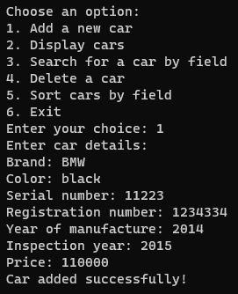
Результат виконання програми

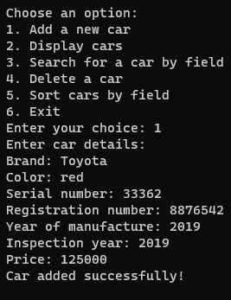
Результат виконання програми

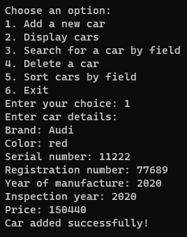
Результат виконання програми

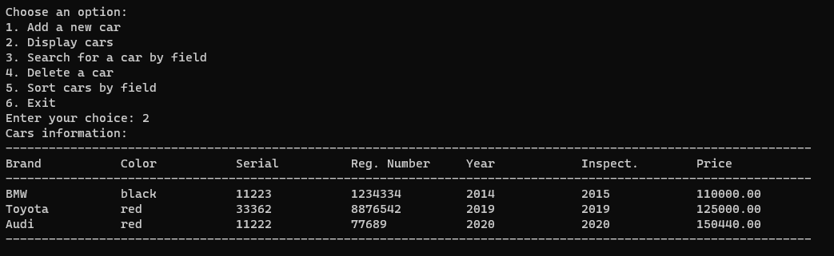
Результат виконання програми

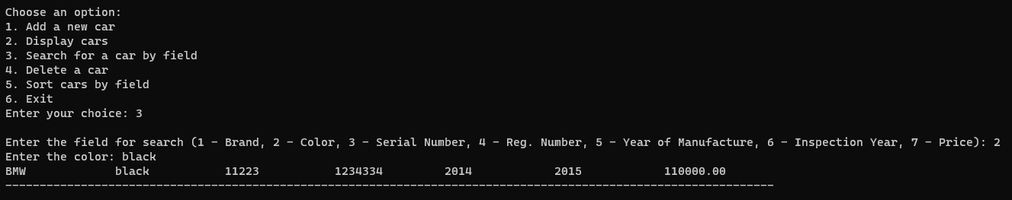
Результат виконання програми

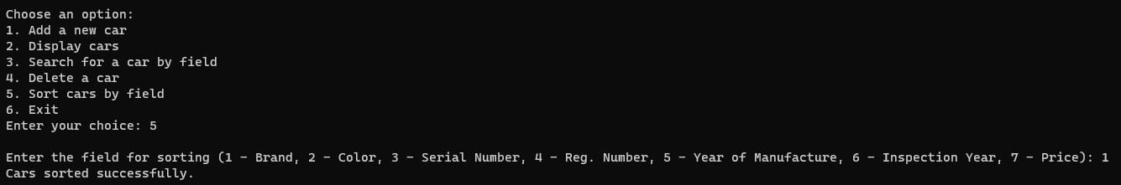
Результат виконання програми

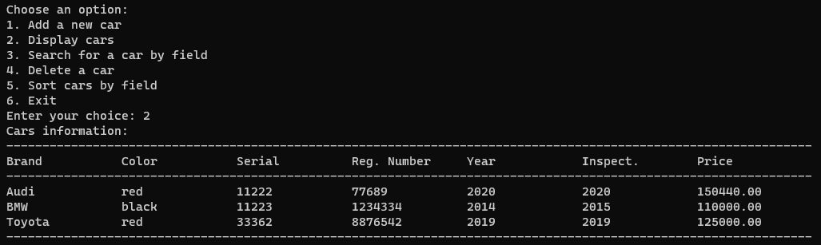
Результат виконання програми

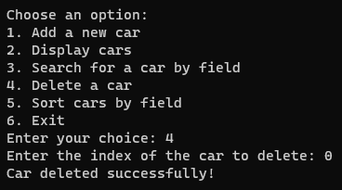
Результат виконання програми

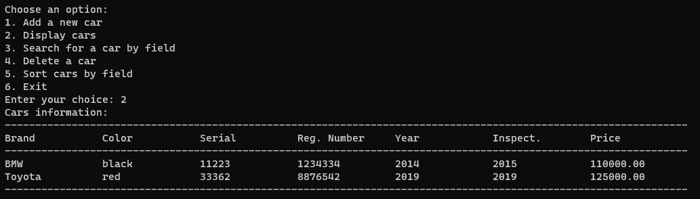
Результат виконання програми

Висновок: отримано практичні навички роботи зі структурами

