## 训练程序（详细参见后面的配置文件，共训练8000轮）：

# !/usr/bin/env python3

# -*- coding:utf-8 -*-

from mmengine import Config

from mmengine.runner import Runner

from mmseg.utils import register_all_modules

cfg = Config.fromfile('pspnet-watermelon.py')

register_all_modules(init_default_scope=False)

runner = Runner.from_cfg(cfg)

runner.train()

## 推理程序：

# !/usr/bin/env python3

# -*- coding:utf-8 -*-

import numpy as np

import matplotlib.pyplot as plt

from mmseg.apis import init_model, inference_model, show_result_pyplot

import mmcv

import cv2

from mmengine.runner import Runner

from mmseg.utils import register_all_modules

from mmengine import Config

# 载入 config 配置文件

cfg = Config.fromfile('pspnet-watermelon.py')

checkpoint_path = './work_dirs/watermelon/iter_8000.pth'

model = init_model(cfg, checkpoint_path, 'cuda:0')

register_all_modules(init_default_scope=False)

runner = Runner.from_cfg(cfg)

img = mmcv.imread('data/watermelon.jpeg')

result = inference_model(model, img)

print(result.keys()) # ['seg_logits', 'pred_sem_seg']

pred_mask = result.pred_sem_seg.data[0].cpu().numpy()

print(np.unique(pred_mask)) # [0, 1, 2, 3, 4]

visualization = show_result_pyplot(model, img, result, opacity=0.5, out_file='pred.jpg')

plt.imshow(mmcv.bgr2rgb(visualization))

# plt.show()

plt.savefig('watermelon.png')

## 配置文件：

norm_cfg = dict(type='BN', requires_grad=True)

data_preprocessor = dict(

type='SegDataPreProcessor',

mean=[123.675, 116.28, 103.53],

std=[58.395, 57.12, 57.375],

bgr_to_rgb=True,

pad_val=0,

seg_pad_val=255,

size=(256, 256))

model = dict(

type='EncoderDecoder',

data_preprocessor=dict(

type='SegDataPreProcessor',

mean=[123.675, 116.28, 103.53],

std=[58.395, 57.12, 57.375],

bgr_to_rgb=True,

pad_val=0,

seg_pad_val=255,

size=(256, 256)),

pretrained='open-mmlab://resnet50_v1c',

backbone=dict(

type='ResNetV1c',

depth=50,

num_stages=4,

out_indices=(0, 1, 2, 3),

dilations=(1, 1, 2, 4),

strides=(1, 2, 1, 1),

norm_cfg=dict(type='BN', requires_grad=True),

norm_eval=False,

style='pytorch',

contract_dilation=True),

decode_head=dict(

type='PSPHead',

in_channels=2048,

in_index=3,

channels=512,

pool_scales=(1, 2, 3, 6),

dropout_ratio=0.1,

num_classes=6,

norm_cfg=dict(type='BN', requires_grad=True),

align_corners=False,

loss_decode=dict(

type='CrossEntropyLoss', use_sigmoid=False, loss_weight=1.0)),

auxiliary_head=dict(

type='FCNHead',

in_channels=1024,

in_index=2,

channels=256,

num_convs=1,

concat_input=False,

dropout_ratio=0.1,

num_classes=6,

norm_cfg=dict(type='BN', requires_grad=True),

align_corners=False,

loss_decode=dict(

type='CrossEntropyLoss', use_sigmoid=False, loss_weight=0.4)),

train_cfg=dict(),

test_cfg=dict(mode='whole'))

dataset_type = 'WatermelonDataset'

data_root = 'Watermelon87_Semantic_Seg_Mask/'

crop_size = (256, 256)

train_pipeline = [

dict(type='LoadImageFromFile'),

dict(type='LoadAnnotations'),

dict(

type='RandomResize',

scale=(2048, 1024),

ratio_range=(0.5, 2.0),

keep_ratio=True),

dict(type='RandomCrop', crop_size=(64, 64), cat_max_ratio=0.75),

dict(type='RandomFlip', prob=0.5),

dict(type='PhotoMetricDistortion'),

dict(type='PackSegInputs')

]

test_pipeline = [

dict(type='LoadImageFromFile'),

dict(type='Resize', scale=(2048, 1024), keep_ratio=True),

dict(type='LoadAnnotations'),

dict(type='PackSegInputs')

]

img_ratios = [0.5, 0.75, 1.0, 1.25, 1.5, 1.75]

tta_pipeline = [

dict(type='LoadImageFromFile', file_client_args=dict(backend='disk')),

dict(

type='TestTimeAug',

transforms=[[{

'type': 'Resize',

'scale_factor': 0.5,

'keep_ratio': True

}, {

'type': 'Resize',

'scale_factor': 0.75,

'keep_ratio': True

}, {

'type': 'Resize',

'scale_factor': 1.0,

'keep_ratio': True

}, {

'type': 'Resize',

'scale_factor': 1.25,

'keep_ratio': True

}, {

'type': 'Resize',

'scale_factor': 1.5,

'keep_ratio': True

}, {

'type': 'Resize',

'scale_factor': 1.75,

'keep_ratio': True

}],

[{

'type': 'RandomFlip',

'prob': 0.0,

'direction': 'horizontal'

}, {

'type': 'RandomFlip',

'prob': 1.0,

'direction': 'horizontal'

}], [{

'type': 'LoadAnnotations'

}], [{

'type': 'PackSegInputs'

}]])

]

train_dataloader = dict(

batch_size=16,

num_workers=2,

persistent_workers=True,

sampler=dict(type='InfiniteSampler', shuffle=True),

dataset=dict(

type='WatermelonDataset',

data_root=' data/watermelon/',

data_prefix=dict(

img_path='img_dir/train', seg_map_path='ann_dir/train'),

pipeline=[

dict(type='LoadImageFromFile'),

dict(type='LoadAnnotations'),

dict(

type='RandomResize',

scale=(2048, 1024),

ratio_range=(0.5, 2.0),

keep_ratio=True),

dict(type='RandomCrop', crop_size=(64, 64), cat_max_ratio=0.75),

dict(type='RandomFlip', prob=0.5),

dict(type='PhotoMetricDistortion'),

dict(type='PackSegInputs')

]))

val_dataloader = dict(

batch_size=1,

num_workers=4,

persistent_workers=True,

sampler=dict(type='DefaultSampler', shuffle=False),

dataset=dict(

type='WatermelonDataset',

data_root='data/watermelon/',

data_prefix=dict(img_path='img_dir/val', seg_map_path='ann_dir/val'),

pipeline=[

dict(type='LoadImageFromFile'),

dict(type='Resize', scale=(2048, 1024), keep_ratio=True),

dict(type='LoadAnnotations'),

dict(type='PackSegInputs')

]))

test_dataloader = dict(

batch_size=4,

num_workers=4,

persistent_workers=True,

sampler=dict(type='DefaultSampler', shuffle=False),

dataset=dict(

type='WatermelonDataset',

data_root='Watermelon87_Semantic_Seg_Mask/',

data_prefix=dict(img_path='img_dir/val', seg_map_path='ann_dir/val'),

pipeline=[

dict(type='LoadImageFromFile'),

dict(type='Resize', scale=(2048, 1024), keep_ratio=True),

dict(type='LoadAnnotations'),

dict(type='PackSegInputs')

]))

val_evaluator = dict(type='IoUMetric', iou_metrics=['mIoU'])

test_evaluator = dict(type='IoUMetric', iou_metrics=['mIoU'])

default_scope = 'mmseg'

env_cfg = dict(

cudnn_benchmark=True,

mp_cfg=dict(mp_start_method='fork', opencv_num_threads=0),

dist_cfg=dict(backend='nccl'))

vis_backends = [dict(type='LocalVisBackend')]

visualizer = dict(

type='SegLocalVisualizer',

vis_backends=[dict(type='LocalVisBackend')],

name='visualizer')

log_processor = dict(by_epoch=False)

log_level = 'INFO'

load_from = None

resume = False

tta_model = dict(type='SegTTAModel')

optimizer = dict(type='SGD', lr=0.01, momentum=0.9, weight_decay=0.0005)

optim_wrapper = dict(

type='OptimWrapper',

optimizer=dict(type='SGD', lr=0.01, momentum=0.9, weight_decay=0.0005),

clip_grad=None)

param_scheduler = [

dict(

type='PolyLR',

eta_min=0.0001,

power=0.9,

begin=0,

end=40000,

by_epoch=False)

]

train_cfg = dict(type='IterBasedTrainLoop', max_iters=8000, val_interval=400)

val_cfg = dict(type='ValLoop')

test_cfg = dict(type='TestLoop')

default_hooks = dict(

timer=dict(type='IterTimerHook'),

logger=dict(type='LoggerHook', interval=100, log_metric_by_epoch=False),

param_scheduler=dict(type='ParamSchedulerHook'),

checkpoint=dict(type='CheckpointHook', by_epoch=False, interval=2000),

sampler_seed=dict(type='DistSamplerSeedHook'),

visualization=dict(type='SegVisualizationHook'))

work_dir = './work_dirs/Watermelon'

randomness = dict(seed=0)

最终结果第8000轮

#### 测试精度

+------------+-------+-------+

| Class | IoU | Acc |

+------------+-------+-------+

| background | 89.67 | 93.67 |

| red | 88.34 | 98.19 |

| green | 62.03 | 69.47 |

| white | 76.06 | 87.34 |

| seed-black | 57.23 | 63.66 |

| seed-white | 39.31 | 41.92 |

+------------+-------+-------+

06/15 10:45:29 - mmengine - INFO - Iter(test) [10/10] aAcc: 92.4400 mIoU: 68.7700 mAcc: 75.7100 data_time: 0.0169 time: 1.018

## 原图：

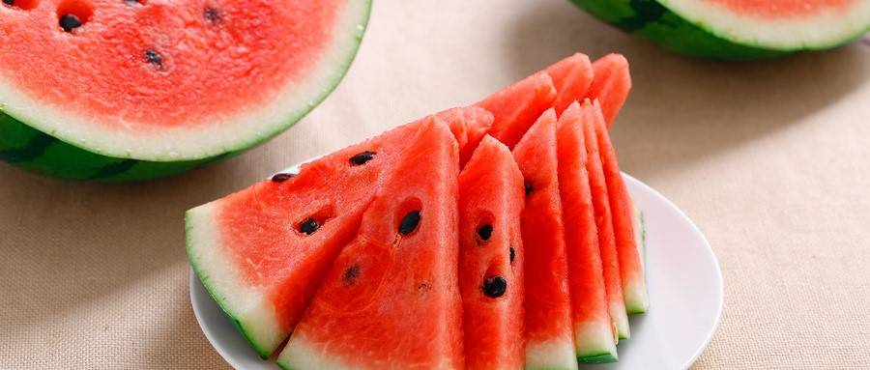

## 分割图：

