**Peak hour = between 7am and 8am**

**GENERATION**

$$prod_{agg}=0.046∙jobs+0.3017∙population$$

$$att_{agg}=0.2349∙jobs+0.0188∙population+0.3367∙visitors$$

R2 productions = 0.6770333854137537

R2 attractions = 0.8695219883983881

Counted trips (peak hour) = 96 153

Generated trips (peak hour) = 96 245

Delta trips = 91

* The difference between the counted and the modeled comes from the estimation error, which represents 0.09% of counted trips

**DISTRIBUTION**

Impedance function: $f\left(t_{ij}\right)=t_{ij}^{ -2.5}e^{-6 t_{ij} }$, $t_{ij}$ in hours

Intrazonal times were modeled as (walk speed = 4km/h)

$$Time_{intrazonal}=\frac{\sqrt{Area_{zone}}}{{walk}_{speed}}$$

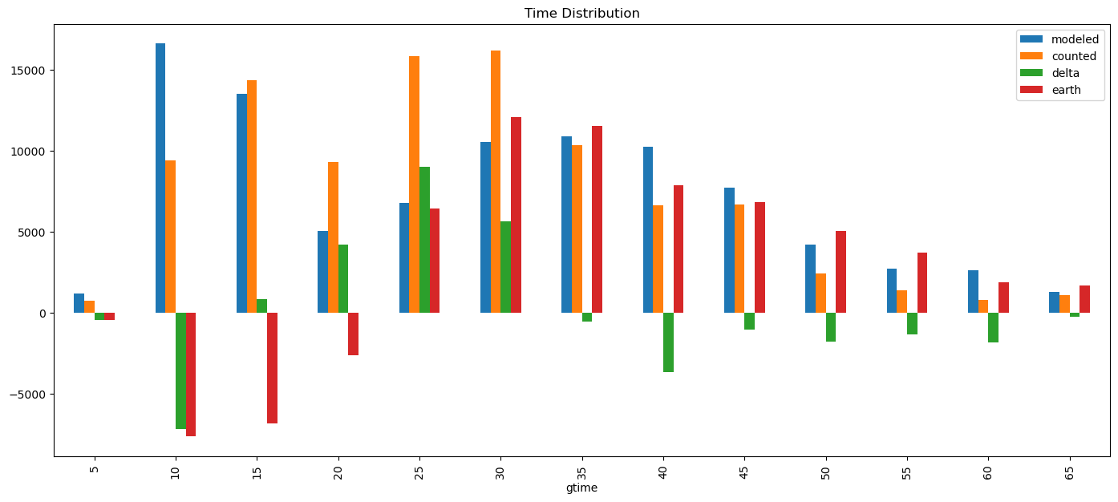

Counted average time (peak hour) = 28.04 minutes

Modeled average time (peak hour) = 30.22 minutes

Earth sum = 77 163

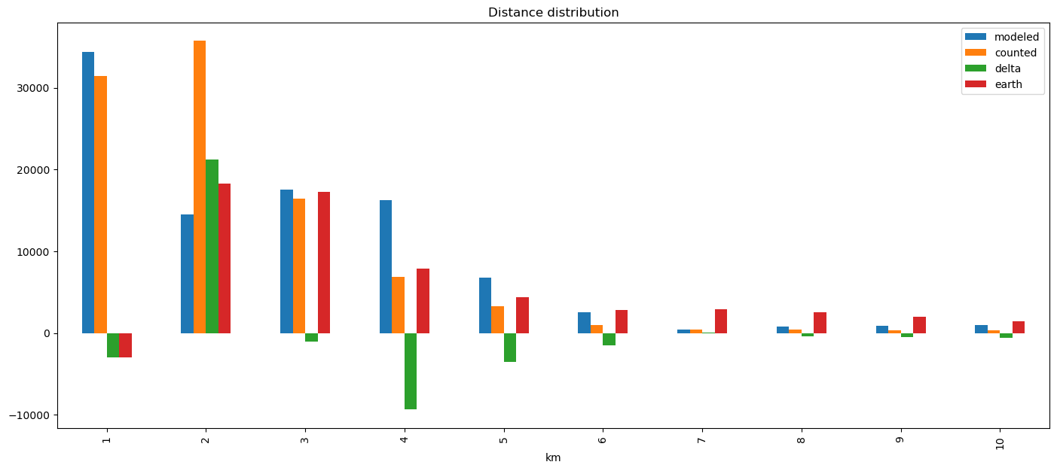

Counted average distance = 2.23 km

Modeled average distance = 2.83 km

Earth sum = 62 989 km

Trip distribution by kebele:

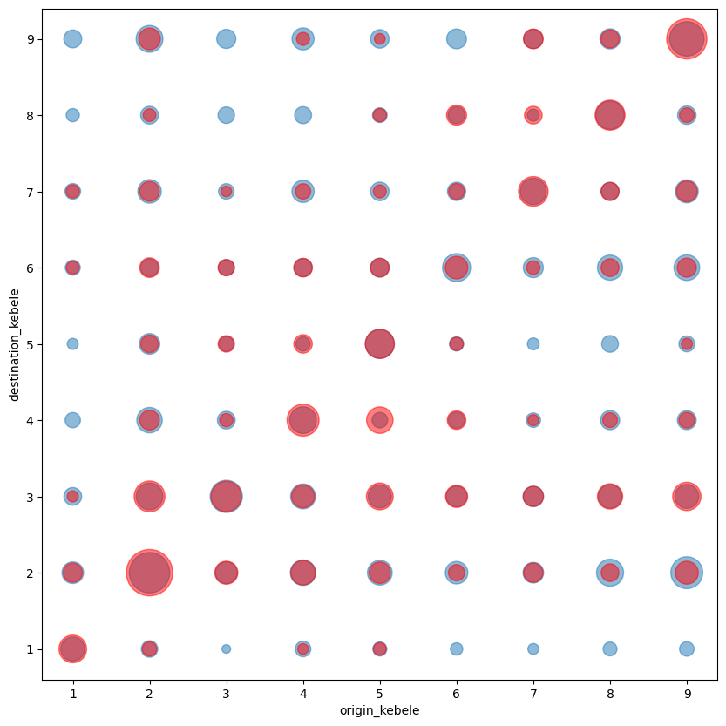

* Distribution underestimates short trips and overestimates long trips. This could be explained by the simplification of intrazonal time.

**MODAL SPLIT**

Average monthly salary Ethiopia: 8900 birr

Median monthly salary Ethiopia: 9080 birr

Value of Time used = 20 birr/h

Modal split by volumes:

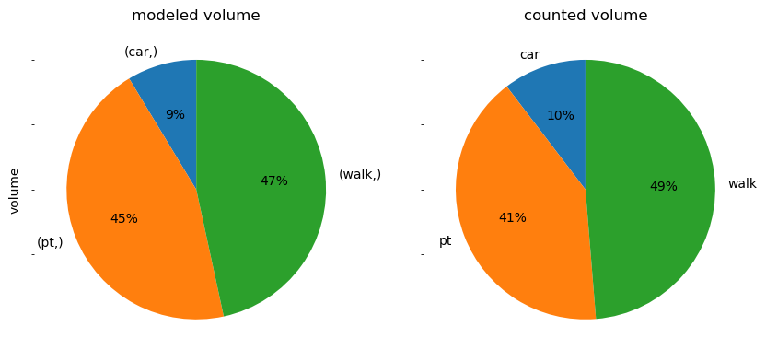

Modal split by passenger.km:

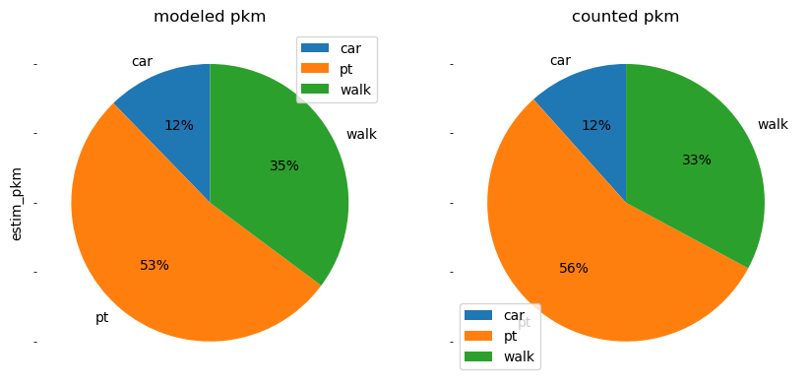

* The modal split by volume shows a good fit with respect to the survey data.
* Proportionally, the modal split by pkm is in accordance with the surveys. However, the model overall presents a higher pkm than counted. Since this indicator is calculated with Euclidean distances, this mismatch between modeled and counted may be due to the overestimation of long trips given at the distribution stage.

**ASSIGNMENT**

Calibration indicators by counts:

Average GEH = 24.84

Average deviation = 45%

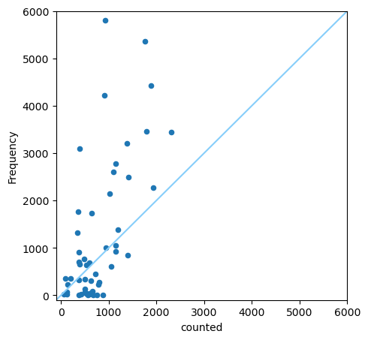

Calibration indicators by screenlines:

Average GEH = 34.52

Average deviation = 58%

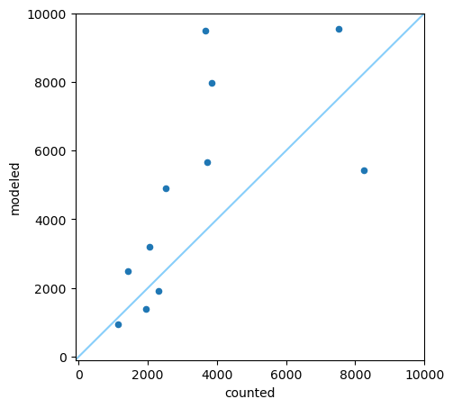

* Modeled flows are higher that counted ones, in both counting points and screenlines.
* Counterintuitively, counting points GEH is better than screenlines GEH. Normally, gaps found in counting points should be cancelled out by aggregating them into screenlines, improving their adjustment to the actual situation.