STUDENT EXPENSE TRACKER
Project Report
Project Type: Python Console Application
Technology: Python 3, JSON, Text File Storage
Student Name | Ayush Singh Thakur
Registration No. | 26BAI10120
Course / Section | SCOPE
Faculty | Trapti Sharma
Institution | VIT Bhopal University
Academic Year | 2026–27
A simple command-line application designed to help students record, search, summarize and manage their expenses while monitoring a monthly budget.

Introduction
Managing small daily expenses can become difficult when payments are made for food, travel, outings and other activities. The Student Expense Tracker was developed as a simple Python-based solution for maintaining these records in one place. The application works through a menu-driven command-line interface and stores data locally so that previously added expenses are available when the program is started again.
The project focuses on core Python programming concepts such as functions, lists, dictionaries, loops, conditional statements, exception handling, file handling and the datetime module. JSON is used to store expense records, while a text file stores the monthly budget.

Problem Statement
Students often make several small payments during a month, such as food, travel and other personal expenses. Without a simple tracking system, it can be difficult to know how much has been spent, where the money is going, and whether the monthly budget has been crossed.
Problem: Develop a simple and easy-to-use expense tracking system that allows a student to record expenses, view stored records, search by category, calculate spending summaries, set a monthly budget, check the remaining budget and delete incorrect records.

Functional Requirements
- Add Expense: Accept amount, category and description and automatically record the current date.
- View Expenses: Display all saved expenses with their amount, category, description and date.
- Search Expense: Search stored expenses by category.
- Expense Summary: Calculate total spending and category-wise spending.
- Set Monthly Budget: Save a monthly budget in a local file.
- Check Budget: Compare total spending with the saved budget and show the remaining amount.
- Delete Expense: Remove a selected expense from the list and save the updated data.
- Exit: Close the application from the menu.

Non-functional Requirements
- Usability: The menu and prompts are simple enough for a beginner to understand.
- Reliability: Data is saved after add/delete operations so changes are not lost when the program exits.
- Maintainability: Separate functions are used for different operations, making the code easier to modify.
- Portability: The project requires only Python 3 and standard-library modules.
- Performance: The operations are lightweight and suitable for a small personal expense dataset.
- Data persistence: JSON and text files provide basic local persistence without requiring a database server.

System Architecture
The application follows a simple local three-part flow: the user interacts with the menu, the Python application processes the selected operation, and local files provide persistent storage.
User
Enters menu choices and expense details
↓
Python Application
Menu → Functions → Validation → Calculations
■ ■
expenses.json  Expense records | budget.txt  Monthly budget
The application starts by loading existing expenses. Menu choices then call dedicated functions. Expense records are stored as dictionaries inside a list and written to JSON. The budget is read from or written to a separate text file.

Design Diagrams
The following diagrams describe the logical design of the application based directly on the implemented Python functions.
7.1 Use Case Diagram
Student / User | Add Expense View Expenses Search Expense Expense Summary  Set Budget Check Budget Delete Expense Exit
The student is the only external actor. All eight menu operations are initiated by the student.
7.2 Workflow Diagram
Start
↓
Load expenses.json
↓
Display main menu
↓
Read user choice
↓
Call selected function
↓
Save data if required
↓
Return to menu / Exit
7.3 Sequence Diagram
User | Application | Storage
Select Add Expense | → add_expense()
Enter amount/category/d | escription→ validate amount
 | → create expense dictionary
 | → save_data() | → write expenses.json
 | success message
Select Check Budget | → check_budget()
 | → get_budget() | read budget.txt
 | → calculate total and remainin | g
display budget status
The sequence shows two representative operations: adding an expense and checking the saved budget.
7.4 Class / Component Diagram
Student Expense Tracker
main() | load_data() | save_data()
add_expense() | show_expenses() | search_expense()
show_summary() | set_budget() | get_budget()
check_budget() | delete_expense()
↓
Data: expenses list → expenses.json
Budget: budget.txt
7.5 ER Diagram
Although the project does not use a relational database, its JSON structure can be represented conceptually as an Expense entity.
EXPENSE
amount : float
category : string
description : string date : string
1 Expense record → stored as one dictionary inside the expenses list → serialized to expenses.json

Design Decisions & Rationale
Decision | Rationale
Python standard library | Keeps the project simple and avoids external dependencies.
Functions for each operation | Makes the program easier to read, test and maintain.
List of dictionaries
JSON storage
Separate budget.txt
Automatic date
Exception handling
Provides a straightforward structure for storing multiple expense records. Human-readable format that is easy to save and load using Python's json modu Keeps the budget independent from the expense records and simple to update. Reduces manual input and records the date on which the expense is added.
Prevents invalid numeric input and missing files from immediately crashing the

Implementation Details
The program begins with an empty global list named expenses. The load_data() function attempts to read expenses.json and loads the JSON array into this list. If the file does not exist, an empty list is used.
The add_expense() function reads an amount, category and description. The current date is generated using datetime.now() and formatted as day-month-year. A dictionary is appended to the expenses list and then saved using save_data().
The show_summary() function calculates the overall total and maintains a category_total dictionary. The search_expense() function performs a case-insensitive category comparison. The budget functions use budget.txt to save and retrieve the monthly budget.
The check_budget() function computes remaining = budget - total spending and reports whether the user is within, exactly at, or above the budget. The delete_expense() function removes the selected item using its displayed number and then saves the modified list.
Main menu: The main() function runs a while loop and maps choices 1–8 to the corresponding functions.
Invalid choices display an error message and return to the menu.
Example of the expense data structure:
{"amount": 1000.0, "category": "food", "description": "bistro", "date": "29-09-2026"}

Screenshots / Results
The screenshots below show the implemented program running successfully. The sample run demonstrates adding expenses, viewing records, setting a budget, checking budget status, searching by category and generating a summary.
Main Menu
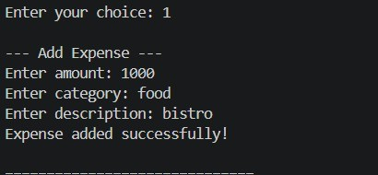
Add Expense
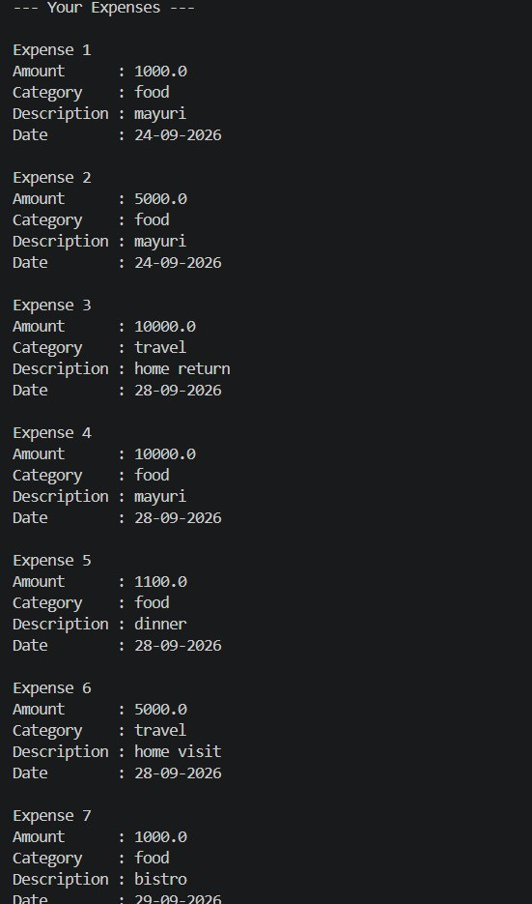
View Expenses
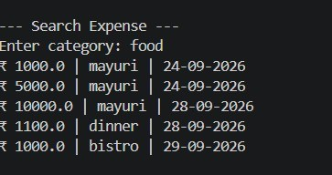
Set Monthly Budget
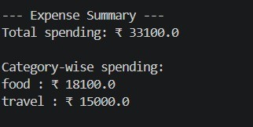
Budget Status
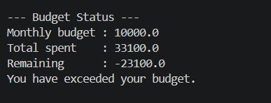
Expense Summary
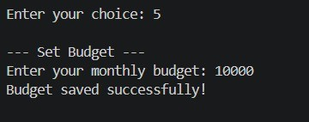
Search Expense by Category
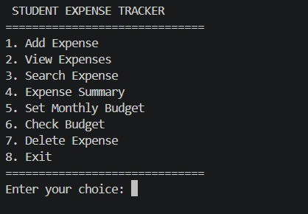
Observed Test Result
Metric | Observed value
Monthly budget | ■10,000
Total spending | ■33,100
Remaining budget | ■−23,100
Food spending | ■18,100
Travel spending | ■15,000

Testing Approach
Testing was performed by executing the menu options and checking whether the displayed output matched the entered data and calculations.
Test Case | Input / Condition | Expected / Observed Result
Add valid expense | Valid amount, category and descripti | on entExpense added and savedred
Invalid amount | Non-numeric amount | Error message displayed; operation stopped
View expenses | Existing records available | All records displayed
Search category | food | Matching food records displayed
Expense summary | Existing records | Total and category totals calculated
Set budget | 10000 | Budget saved successfully
Check budget | Budget + saved expenses | Remaining amount and status displayed
Delete expense | Valid expense number | Selected expense removed and data saved
Missing data files | expenses.json/budget.txt absent
Program starts with empty data / asks to set budget

Challenges Faced
- Persistent data: The program needed a way to retain expenses after closing, so JSON file handling was used.
- Input validation: Numeric inputs such as amount and budget can cause errors if text is entered. try/except was added for these cases.
- Budget calculation: The application must combine all expense amounts before comparing them with the budget.
- Category search: Case-insensitive comparison was used so that inputs such as Food and food can match.
- Deletion: The user sees numbered records, so the selected number must be converted to the correct list index using number - 1.

Learnings & Key Takeaways
- Learned how to divide a program into reusable functions.
- Understood how lists and dictionaries can represent structured records.
- Practiced reading from and writing to files.
- Learned basic JSON serialization and deserialization.
- Used datetime to generate the current date automatically.
- Applied loops and conditional statements to calculations and menu control.
- Used exception handling to make input processing safer.
- Understood how a small real-world problem can be converted into a working console application.

Future Enhancements
- Add edit/update functionality for existing expenses.
- Add date-range filtering and monthly history.
- Add income tracking and balance calculation.
- Add charts for category-wise spending.
- Use SQLite for more scalable structured storage.
- Add a graphical user interface or web interface.
- Add stronger input validation such as preventing negative expenses.
- Support multiple users with separate profiles.
- Export reports to CSV or PDF.

References
- Python Standard Library documentation – json module.
- Python Standard Library documentation – datetime module.
- Python documentation – file input/output and exception handling.
- VITyarthi project/report submission instructions provided for the course.
Project files: expense_tracker.py, expenses.json, budget.txt, README.md
Submission note: Replace the cover-page placeholders with your name, registration number, section and faculty details before submitting.

