中山大学软件学院2010级软件工程专业(2011学年春季学期)
《计算机组成原理与接口技术》期末考试试卷
答案(B)
(考试形式： 闭卷 考试时间: 2小时)
警 示
《中山大学授予学士学位工作细则》第六条
考试作弊不授予学士学位

方向：___________ 姓名： ______ 学号： 成绩：____________
出卷： 邓革、李国桢 审核：
注意：答案一定要写在答题纸上，写在本试卷中不给分。本试卷要和答卷一起交回。

Part I Choose the best answer from the choices.（2 points for each question, 20 points total）

1. Given x=-0.1010, the representation of 1.0110 is ( ).
A. Sign-Magnitude Representation B. One’s Complement Representation
C. Two’s Complement Representation D. Floating-Point Representation
C
2. Which one is independent of the hit ratio of cache?
A. Access time of memory B. The size of block
C. Cache organization D. The size of cache
A
3. Which of the following operations do not exist for ADD instruction in RISC?
A. memory to register B. register to register
C. immediate to register D. either B or C
A
4. In the instruction “OUT DX, AL”, the port address is:
A. 8 bits B. 16 bits C. either A or B D. none of the above
C
5. The main components in CPU are ( ).
A. Control Unit, ALU, Memory B. Control Unit, Register, Memory
C. Control Unit, ALU, Cache D. Instruction Pointer, I/O module
C
6. Microinstructions are placed in ( )
A. memory controller B. main memory
C. control memory D. Cache
C
7. A byte is being transferred on the D8-D15 data bus from an odd-address location, the status of AO and BHE are ( )
A. A0=0, BHE=0 B. A0=0, BHE=1 C. A0=1, BHE=0 D. A0=1, BHE=1
C
8. For a special RAM chip, the organization is 256 x 4, the total number of address pins and data pins is ( ).
A. 10 B.12 C. 16 D. 8
B
9. Computer organization is a computer architecture（ ）implementation。
A. physics B. ．logical C. circuit D. simulate
B
10. DATA1 DB 5 DUP （ 0， 2 DUP（ 1，0, 0））, the size of DATA1 is ( ）.
A.35 B. 30 C. 20 D. 16
A

Part II True or Fault （1 points for each question, 10 points total）
1. The last instruction in the ISR is IRET, whereas the last instruction in a FAR subroutine is RET. ( T )
2. While CISC instructions are variable sizes, RISC instructions are all the same size. ( T )
3. To ensure the integrity of the contents of RAM, the check sum is used . ( F )
4. The more address pins, the more memory locations are inside the chip. The more data pins, the more each location inside the chip will hold. ( T )
5. IP(instruction pointer) register is available in low-byte and high-byte formats. ( F )
6. Port and interfaces have the same concepts, both can be implemented in the same way. ( F )
7. In 8086, physical address is the 20-bit address, logical address can be consists of 16-bit segment value, and 16-bit offset address . ( T )
8. The NMI has a higher priority than INTR. ( T )
9. While memory contains both code and data, ports contain data only. ( T )
10. Memory-mapped I/O uses controls MEMR and MEMW. ( T )

Part III Answer the following questions.（22 points）
1. (5 points) How many bytes are used by the interrupt vector table, and why?
1024 bytes, since there are 256 interrupts and each interrupt takes 4 bytes.
2. (5 points) What is the purpose of pseudo-instructions ?
Pseudo-instructions direct the assembler as to how to assemble the program.
3. (5points) Which control signal is activated during the memory write cycle?
Which control signal is activated during the I/O read cycle?
MEMW is activated during the memory read cycle. IOR is activated during the I/O write cycle.
4．(7 points) Express the following number in IEEE 754 32-bit floating-point format.
-138.125
-138.125=-10001010.001=-1.0001010001 x 2⁷
The sign bit is 1
Exponent bits 7+127=134=1000 0110B
Mantissa bits 00010100 01000000 0000000
IEEE 754 32-bit Express is
1 10000110 00010100 01000000 0000000

Part IV Write a program to find the numbers of zero in a 16-bit word stored in DS:0300 and DS:0301. (10 points)

STSEG SEGMENT
DB 32 DUP(?)
STSEG ENDS
DTSEG SEGMENT
COUNT DW ?
DESEG ENDS
CODE SEGMENT
ASSUME CS:CODE, DS:DTSEG, SS :STSEG
START PROC FAR
MOV AX, DTSEG
MOV DS, AX
MOV CX, 16
CLC
SUB BX, BX
MOV DI, 0300H
MOV AX, WORD PTR [DI]
BACK: SHR AX, 1
JC END_LOOP
INC BX
END_LOOP: LOOP BACK
MOV COUNT, BX
MOV AH，4CH
INT 21H
START ENDP
CODE ENDS
END START
Part V The following program contains some errors. Fix the errors and make the program run correctly. (8 points)
.MODEL SMALL
.STACK 32
.DATA
DATA DW 234DH, DE6H, 3BC7H, 566AH
SUM DW ?
.CODE
START: PROC FAR
MOV AX, DATA
MOV DS, AX
MOV CX, 04
MOV BX, 0
MOV DI, offset DATA
LOOP1: ADD BX, [DI]
INC DI
JNZ LOOP1
MOV SI, offset RESULT
MOV [SI], BX
MOV AH, 4CH
INT 21H
START ENDP
END STRT

.MODEL SMALL
.STACK 32
.DATA
DATA1 DW 234DH, 0DE6H, 3BC7H, 566AH
RESULT DW ?
.CODE
START PROC FAR
MOV AX, @DATA
MOV DS, AX
MOV CX, 04
MOV BX, 0
MOV DI, offset DATA
LOOP1 ADD BX, [DI]
INC DI
DEC CX
JNZ LOOP1
MOV SI, offset RESULT
MOV [SI], BX
MOV AH, 4CH
INT 21H
START ENDP
END START

Part VI A computer has 32-bit instructions and 12-bit addresses. Suppose there are 250 2-address instructions. How many 1-address instructions can be formulated? Explain your answer. (10 points)
Solution:
6 x 2¹²
1111 1010 0000 0000 0000 xxxx xxxx xxxx
1111 1010 1111 1111 1111 xxxx xxxx xxxx
1111 1011 0000 0000 0000 xxxx xxxx xxxx
1111 1011 1111 1111 1111 xxxx xxxx xxxx
1111 1100 0000 0000 0000 xxxx xxxx xxxx
1111 1100 1111 1111 1111 xxxx xxxx xxxx
1111 1101 0000 0000 0000 xxxx xxxx xxxx
1111 1101 1111 1111 1111 xxxx xxxx xxxx
1111 1110 0000 0000 0000 xxxx xxxx xxxx
1111 1110 1111 1111 1111 xxxx xxxx xxxx
1111 1111 0000 0000 0000 xxxx xxxx xxxx
1111 1111 1111 1111 1111 xxxx xxxx xxxx

Part VII Suppose that CPU has 16-bit address pins and 8-bit data pins, access the memory when 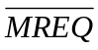 is active low, 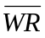is control signal (low for writing/ high for reading). Using this CPU and RAM (1K x 4, 2K x 8, 8K x 8, 16k x 1, 4k x 4 ), ROM (2K x 8, 8K x 8, 32K x 8), 74LS138, and several logic gates to build the system satisfy the following requests:
0~2047 is set aside for system program;
2048~8191 is set aside for user program.
Which chip and how many chips will be used to build the system? Show the diagram. （10 points）
Solution:
One chip of ROM (2K x 8)
Three chips of RAM (2K x 8)

ROM 0000H~0FFFH
0000 0000 0000 0000 ~0000 0111 1111 1111
RAM 1000H~3FFFH
0000 1000 0000 0000 ~ 0000 1111 1111 1111
0001 0000 0000 0000 ~ 0001 0111 1111 1111
0001 1000 0000 0000 ~ 0001 1111 1111 1111

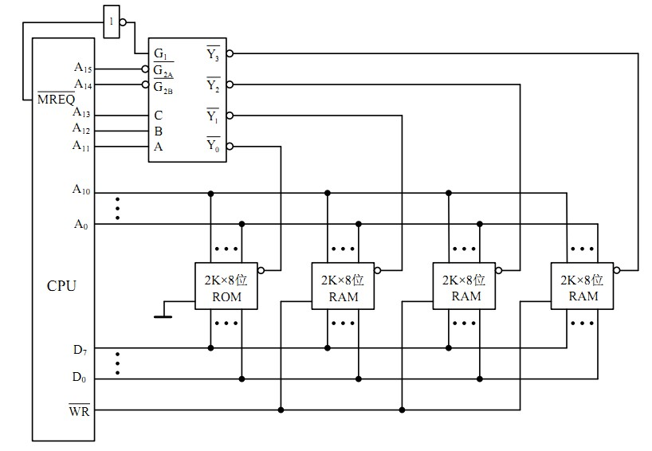

Part VIII Write a program in Assembly language to get a byte of data from PA of 8255. If DO of the received byte is 1, then send the data stored in DS:0001H to PB; if D0 of the received byte is 0, then send data stored in DS:0002H to PB.The port address of PA is 310H. (10 point)
Solution:
MOV AL, 90H ; PA=IN
MOV DX, 313H
OUT DX, AL
MOV DX, 310H
IN AL, DX
SHR AL,1
JC LOOP1
MOV AL, [0002H]
MOV DX, 311H
OUT DX, AL
JMP LOOP2
LOOP1: MOV AL, [0001H]
MOV DX, 311H
OUT DX, AL
LOOP2:

Appendix
8255Control word
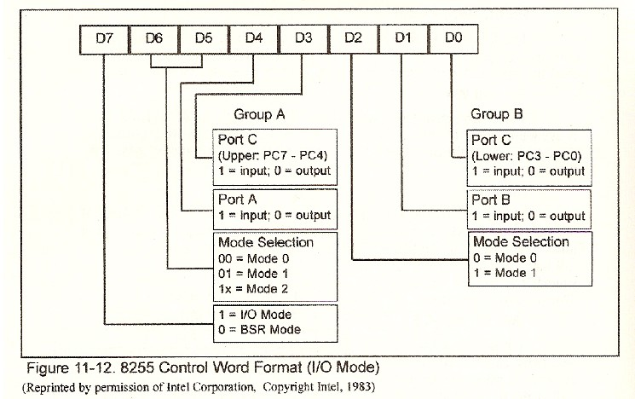
74LS138
