中山大学软件学院2012级软件工程专业(2014学年秋季学期)
《SE-301计算机网络》期末试题答案(B)

- Use cookies. Check textbook for answers.

a)
Each transmitter sends one window's worth of data each RTT. The window size increases linearly from W/2 to W. So average length of transmit window .
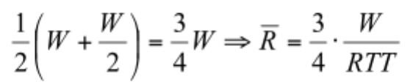
b)
In each period of the sawtooth, one packet is lost, and the transmitter sends 1+W/2 windows of packets; and the average window size is 3/4*W.Therefore, 1 packet is lost for every
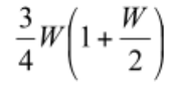 that are transmitted.
c)
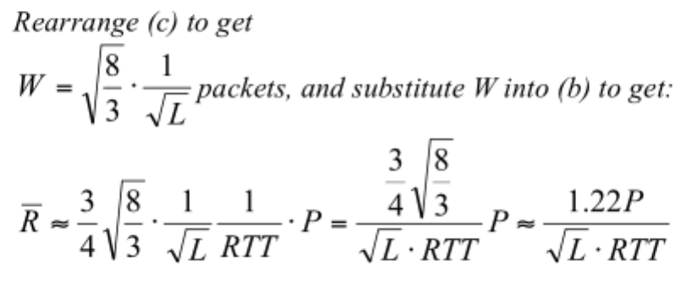

- Check ppt Network layer 4-93 for details.

- NAT:
(a)
1) The source IP address,
2) TCP source port number.
The change in the value of these two parameters implies that the following two fields also need to be changed:
3) IP checksum
4) TCP checksum
(b)
P2: S=138.76.29.7, 5001 D=128.110.40.186, 80
P3: S=128.110.40.186, 80 D=138.76.29.7, 5001
P4: S=128.110.40.186, 80 D=10.0.0.1, 3345
- Checksums have a greater probability of undetected errors than do CRCs. That is, CRCs are better at detecting errors and will result in less undetected errors than checksums. CRCs are easily be computed in hardware, but not very easily in software. Checksums can be computed in software much faster than can CRCs.

- Check textbook for answers.

- Any reasonable answer which contains the following terminologies: DNS, TCP/UDP, IP, MAC in network and link layers is acceptable.

