中山大学软件学院2012级软件工程专业(2014学年秋季学期)
《SE-301计算机网络》期末试题(A卷)
(考试形式：闭 卷 考试时间: 2小时)
警 示
《中山大学授予学士学位工作细则》第六条
考试作弊不授予学士学位

方向： 姓名： ____ __ 学号：

出卷： 郑贵锋、温武少 复核：

- (14 points)Briefly answer the following questions on the basics of computer networks and the Internet.
- What are the two primary causes of packet loss?(6 points)
- Name the four factors of delay for a packet. Then, identify which factor will most likely predominate (i.e., be the largest factor) for 1000 Byte packets in a flow on a
1) 10 Mb/s LAN segment between two PCs in the same building,
2) 1 Mb/s geosynchronous-orbit satellite link between the Guangzhou and Shenzhen,
3) on the Internet between the Guangzhou and Shenzhen. (8 points)
- (12 points)TCP mechanisms. You decide to modify the TCP stack on your desktop so you experience better performance (higher throughput when either sending, receiving, or both). Note that you only get to change your desktop’s TCP—you can’t change that of the other endpoint with which you’ll be communicating.
- Suppose your stack originally supports both timeout-driven retransmission and fast retransmission. Among the following, circle which one would gain you the greatest beneﬁt to your performance.(4 points)
(A). disable timeout retransmissions (instead only retransmit using fast retransmission)
(B). disable exponential backoff of timeouts.
(C). disable fast retransmission (instead only retransmit using timeouts)
(D). disable RTT estimation / RTO adaptation (use the initial values set for RTT and RTO)
and explain why it would offer an improvement.
- What would happen if everyone’s TCP stack in the Internet did this?(4 points)
- If you could pick something else to modify about your TCP stack so that you experience better performance, what would it be, and why?(4 points)

- (16 points)Consider the following network with nodes A through F
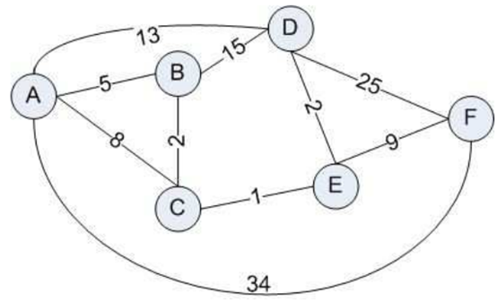

- Use a table to illustrate how the Dijkstra's algorithm works in determining the shortest distance from node A to other nodes.(12 points)
- Name two problems that would arise if all routing in the Internet was done using Link-State and Dijkstra’s algorithm. Does Distance-Vector routing suffer from these? (4 points)

- (20 points)Consider the scenario in the figure below in which a server is connected to a router by a 100 Mbps link, with a 100ms propagation delay. That router in turn is connected to two routers, each over a 25 Mbps link with a 200ms propagation delay. A 1 Gbps link connects a host and a cache (when present) to each of these routers; this link, being a local area network, has a propagation delay that is essentially zero. All packets in the network are 10,000 bits long.
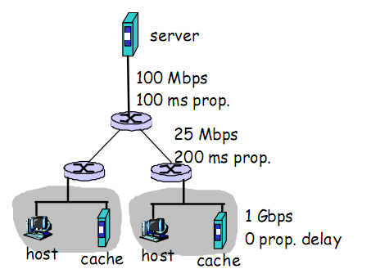
- What is the end-to-end delay from when a packet is transmitted by the server to when it is received at a host? Assume that there are no caches, that there is no queuing delay at a link, and that the node (router) packet-processing delays are also zero.(5 points)
- First assume that client hosts send requests for files directly to the server (i.e., the caches are off). What is the maximum rate at which the server can deliver data to a single client, assuming no other clients are making request. (5 points)
- Again assume that only one client is active, but now suppose the caches are HTTP caches and are turned on. A client HTTP GET is always first directed to its local cache. 50% of the requests can be satisfied by the local cache. What is the maximum rate at which this client can receive data in this scenario?(5 points)
- Now suppose that the clients in both LANs are active and the HTTP caches are on, as in c) above. 50% of the requests can be satisfied by the local cache. What is the maximum rate at which each client can receive data, in this scenario?(5 points)

- (9 points)Error detection problem
- Compute the CRC for a given message (M) and a generator polynomial (P). M is 0111101 and P is 1011. (6 points)
- Describe an error that cannot be detected with a checksum. (3 points)

- (14 points)Medium Access Control
- Why does Ethernet have a minimum packet size? How is it determined?(8 points)
- Give two reasons why a CSMA/CD-type protocol cannot be used in a wireless environment.(6 points)

- (15 points)Now suppose you type the URL www.goolge.com in your browser and press the ENTER key. Provided that you will get the homepage of Google search successfully, briefly describes what will happen after you press the ENTER key regarding the layers from network layer to link layer. (Note that you do not have to take into account the Great Fire Wall in China.)

