中山大学软件学院2012级软件工程专业(2014学年秋季学期)
《SE-301计算机网络》期末试题(B卷)
(考试形式：闭 卷 考试时间: 2小时)
警 示
《中山大学授予学士学位工作细则》第六条
考试作弊不授予学士学位

方向： 姓名： ____ __ 学号：

出卷： 郑贵锋、温武少 复核：

- (10 points) As an HTTP server is stateless. How does a Web site identify users? Describe the technology HTTP used to solve this problem in detailed.

- (18 points) In this question we’ll find approximate equations for the throughput of the TCP AIMD mechanism. The graph below shows the evolution of the TCP sender’s window size as a function of time. W is the maximum window size (measured in packets). In this question, assume that all packets are P bits long, and that exactly one packet is dropped every time the window size reaches W.
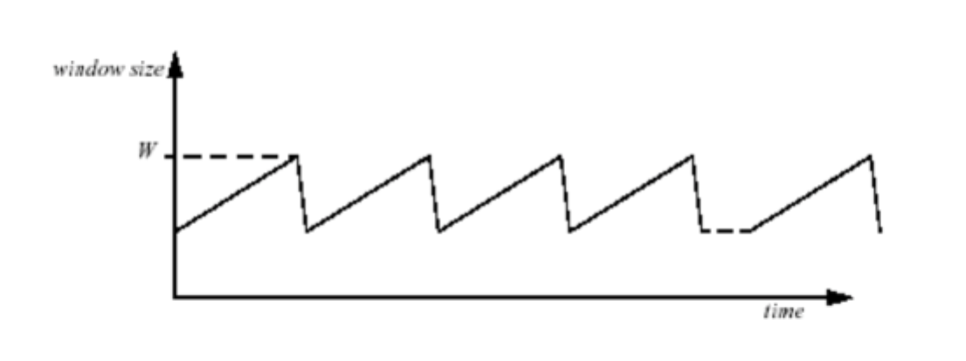
- If we ignore the "slow-start" phase at the beginning of the flow, show (证明) that the average rate at which the transmitter sends packets is given by:
Rate = (3/4)*(W/RTT) packets per second
RTT is the round-trip time, which is assumed constant. (6 points)
- Show that the fraction of packets dropped, L, is given by the following expression:
L = 1/((3/4)*W*(1+W/2))
Hint: Remember that we’re assuming that exactly one packet is dropped every time the window size reaches W. (6 points)

- Using your answers to (a) and (b), and assuming that W is very large, show that the average rate at which the transmitter sends is given by:
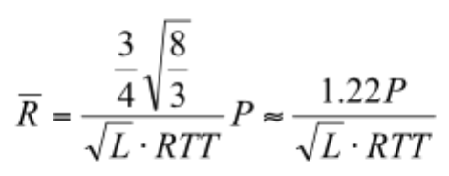bits per second. (6 points)
- (20 points) Consider the three-node topology shown below, the link costs are c(x,y)=6, c(y,z)=8, and c(z,x)=1.
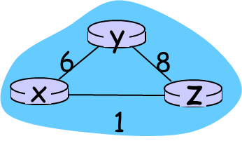
  - Compute the distance tables after the initialization step and (6 points)
  - The final iteration of the distance-vector algorithm. (8 points)
  - Compare link-state and distance-vector routing algorithm. (6 points)

- (15 points)NAT
- Assume an IP packet carrying an HTTP request is going from a local (i.e. home) area network onto the wider Internet through a NAT router. Name all header fields that the NAT router needs to change in the given packet? Explain your answer. (Hint: encapsulation as well as the syntax/semantics of all involved protocols must be taken into consideration.)(6 points)
- The diagram below shows a packet traveling through a NAT router. Packet 1 is sent from the internal host (S) to the NAT router, packet 2 is sent from the NAT router to the external web server (D), packet 3 is received from the web server by the NAT router, and packet 4 is sent by the NAT router to the original host. Fill in the missing source and destination IP addresses and port numbers in packets 2-4. (Note: You don’t have to draw the diagram below on your answer sheet.) (9 points)
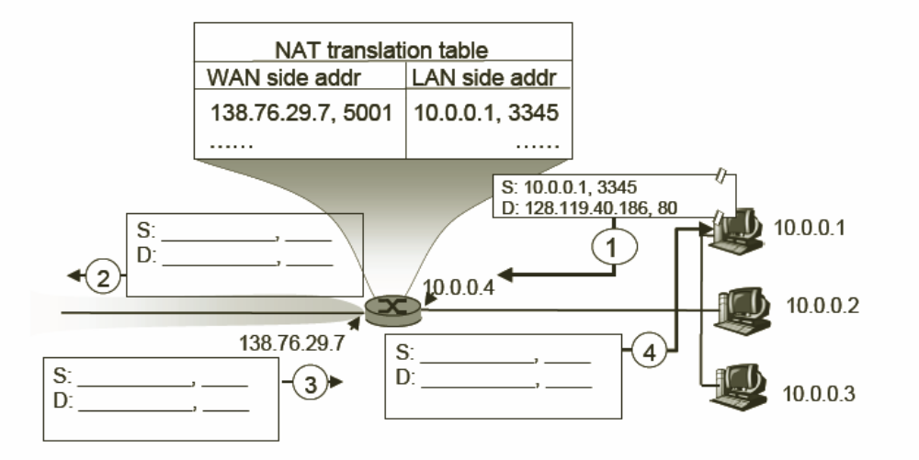

- (10 points) Compare checksums and CRCs as a means of detecting errors. Discuss the tradeoffs between checksums and CRCs.
- (12 points) What is CSMA/CA? Why WIFI(802.11) uses CSMA/CA? How CSMA/CA works?
- (15 points)Now suppose you type the URL www.google.com in your browser and press the ENTER key. Provided that you will get the homepage of Google search successfully, briefly describes what will happen after you press the ENTER key regarding the network layer and the link layer. (Note that you do not have to take into account the Great Fire Wall in China.)

