E-SUKAN
Project Proposal Report

CSC584 — Group Project
Campus Facility & Equipment Booking System

Information System Development

Group Members:
[Name 1] — [Matric No.]
[Name 2] — [Matric No.]
[Name 3] — [Matric No.]
[Name 4] — [Matric No.]

Submission Date: 04 June 2026
Institution: [University / Faculty Name]
Lecturer: [Lecturer Name]

Table of Contents
1.0 Project Overview
2.0 Problem Statement
3.0 Objective
4.0 Proposed User Interface
5.0 Database Design
6.0 Flow of Application
Appendix A — Scoresheet Mapping
Appendix B — Project Files
Tip: In Microsoft Word, select all and press F9 to refresh page numbers after adding screenshots.

1.0 PROJECT OVERVIEW
E-Sukan is a web-based information system for managing campus sports facilities and equipment at a university. Students and lecturers book sports courts (badminton and futsal), rent equipment, join waitlists when slots are full, pay for bookings and rentals, and participate in tournaments. Administrators manage users, facilities, equipment, bookings, and system settings.

Architecture
Layer | Description
Presentation | Responsive dashboard (login.html, index.html), custom CSS, sidebar navigation, REST API calls
Business logic | Jakarta Servlet 6 JSON APIs (/api/bookings, /api/equipment, /api/tournaments, etc.)
Data | MySQL/H2 database esukan_db, 14 tables, HikariCP pool, sql/schema.sql

User roles
Role | Capabilities
STUDENT | Book facilities, rent equipment, waitlist, payments, tournament registration, dashboard reports
LECTURER | Student features plus create and manage tournaments
ADMIN | User management, facility/equipment CRUD, booking approval, system settings

Authentication uses JWT login, BCrypt passwords, password reset tokens, and role-based menu visibility on every screen.

2.0 PROBLEM STATEMENT
- Double booking and scheduling conflicts — no real-time availability check.
- Poor equipment tracking — quantity, condition, and return status not centralized.
- No structured waitlist when facility slots are full.
- Weak payment and cost visibility — deposits and booking fees hard to reconcile.
- Tournament management disconnected from facility and user data.
- Limited reporting — no dashboard for peak hours, inventory health, or trends.
- Security gaps — informal sign-in without proper session control and validation.
These problems reduce efficiency, increase administrative workload, and create a poor experience for campus sports users.

3.0 OBJECTIVE
1. Provide a centralized online platform for facility booking with conflict prevention.
2. Implement equipment rental management with quantity, status, deposit, and returns.
3. Support a booking waitlist with promotion when bookings are cancelled.
4. Record payments linked to bookings and rentals (pending, paid, failed).
5. Enable tournament lifecycle management integrated with users and facilities.
6. Deliver analysis reports: booking stats, inventory health, peak usage hours.
7. Enforce secure access via JWT, roles, and server-side input validation.
8. Offer a consistent responsive UI with navigation on every screen.

4.0 PROPOSED USER INTERFACE
The UI uses a custom responsive template (CSS variables, sidebar layout, cards) in src/main/resources/static/. Capture screenshots from http://localhost:9090 after running mvn jetty:run.

UI 1 — Login & Registration (login.html)
[ INSERT SCREENSHOT: Login page — sign in, register, forgot password ]

UI 2 — Dashboard
[ INSERT SCREENSHOT: Dashboard — stats, inventory health report, peak hours, schedule ]

UI 3 — Facilities & Booking
[ INSERT SCREENSHOT: Facilities list and New Booking modal with payment ]

UI 4 — Equipment & Rentals
[ INSERT SCREENSHOT: Equipment catalog and active/returned rentals ]

UI 5 — Tournaments
[ INSERT SCREENSHOT: Tournament list, team registration, match bracket ]

UI 6 — User Management (Admin)
[ INSERT SCREENSHOT: Admin user table — create, edit role, enable/disable ]

UI 7 — Password Reset (reset.html)
[ INSERT SCREENSHOT: Reset password form with token ]

Navigation consistency
- Fixed sidebar with role-filtered menu on every authenticated page.
- Top bar with page title and primary action (+ New Booking, etc.).
- User chip and logout in sidebar footer.

5.0 DATABASE DESIGN
Database name: esukan_db (14 tables). Source: sql/schema.sql. ERD tool: dbdiagram.io using docs/esukan-erd.dbml.

5.1 Table structure
Table | Purpose | Key attributes
system_settings | Config | setting_key PK, setting_value
users | Accounts | id PK, username UK, email UK, role, password_hash
password_reset_tokens | Recovery | token UK, user_id FK
facilities | Courts | name, type, open_time, close_time, cost_per_hour
equipment | Inventory | name, category, status, quantity
facility_equipment | M:N link | facility_id, equipment_id composite PK
bookings | Reservations | facility_id FK, user_id FK, booking_date, status
booking_waitlist | FIFO queue | facility_id FK, promoted_booking_id
equipment_rentals | Checkout | equipment_id FK, deposit_amount, status
payments | Transactions | booking_id FK, rental_id FK, amount, status
tournaments | Events | organizer_id FK, venue_facility_id FK, format
tournament_registrations | Teams | tournament_id FK, team_name
tournament_team_members | Roster | registration_id FK
tournament_matches | Bracket | team_a/b/winner FK, next_match_id self-FK

5.2 Entity Relationship Diagram
Figure 1: E-Sukan database ERD (orthogonal notation: 1 = one, crow's foot = many).
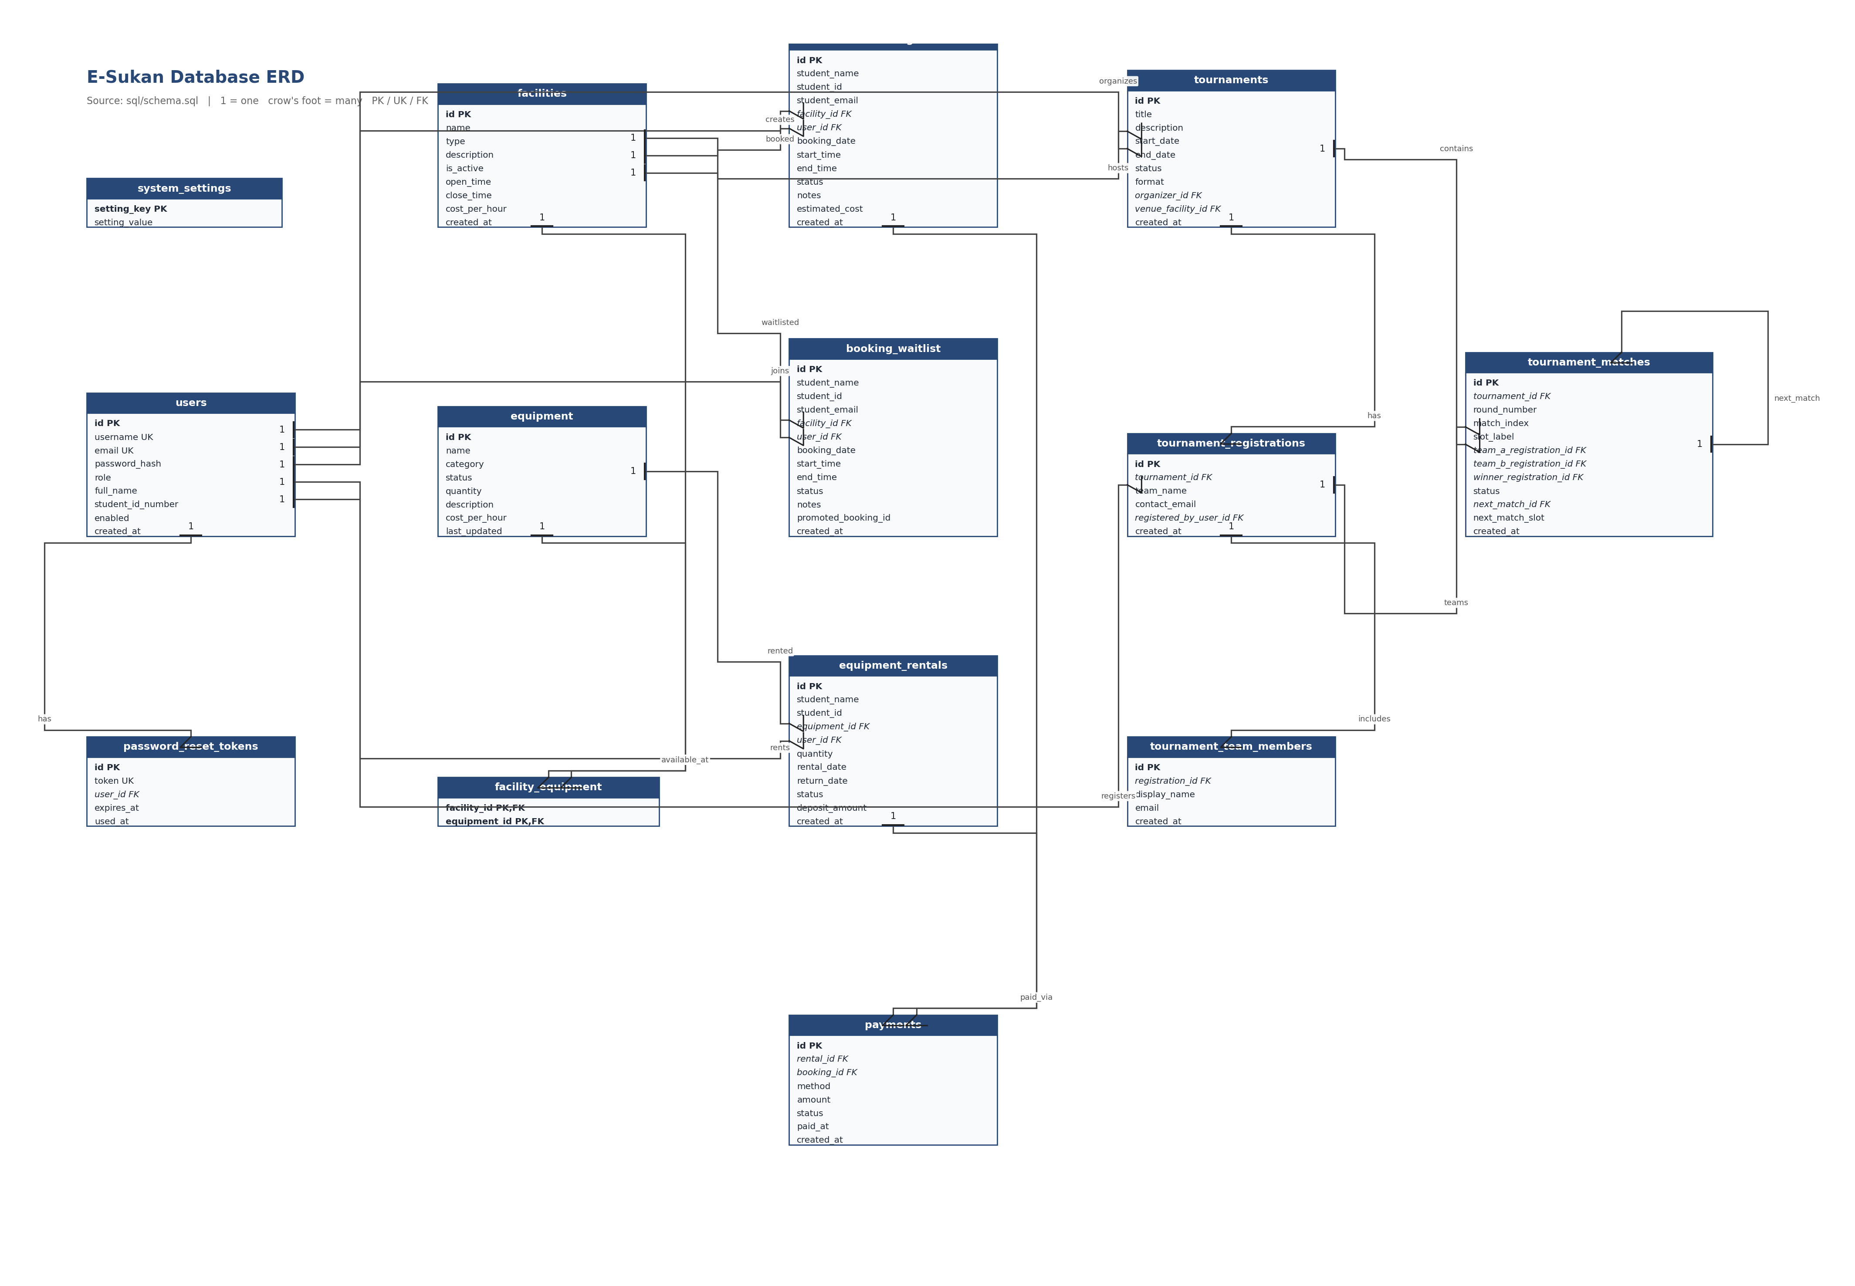

5.3 Relationships between tables
Parent (1) | Child (many) | Description
users | bookings, rentals, tokens, tournaments | One user, many records
facilities | bookings, waitlist, tournaments | One facility, many uses
equipment | rentals, facility_equipment | One item, many rentals
bookings / rentals | payments | Optional payment link
tournaments | registrations, matches | One event, many teams/matches
tournament_matches | tournament_matches | Bracket next_match_id self-reference

6.0 FLOW OF APPLICATION

6.1 High-level system flow
- User opens login.html → Sign in or Register → JWT stored in browser.
- Authenticated user opens index.html Dashboard.
- Navigate via sidebar: Facilities, Bookings, Equipment, Rentals, Tournaments, Users (admin).
- Dashboard loads analysis reports (stats, health, peak hours).

6.2 Create / Read (CR)
Module | Create | Read
Auth | POST /api/auth/register | POST login, GET /api/auth/me
Facilities | Admin POST facility | GET /api/facilities
Bookings | POST /api/bookings + payment | GET bookings, GET dashboard
Equipment | Admin POST equipment | GET catalog, health report
Rentals | POST /api/rentals | GET active/returned rentals
Tournaments | POST tournament, register team | GET tournaments, matches
Users | Admin POST user | GET user list

Success message shown in UI after each successful create operation.

6.3 Update
- Admin edits facility/equipment → PUT/PATCH API → success message.
- Admin approves booking → status CONFIRMED → confirmation dialog first.
- Lecturer changes tournament status (DRAFT → OPEN → CLOSED).
- User returns equipment → rental status RETURNED.

6.4 Delete
- User/admin selects delete → confirmation dialog → DELETE API → refresh list.
- Applies to: booking cancel, facility/equipment (admin), user (admin), tournament.

6.5 Report (Analysis)
- Open Dashboard → GET /api/bookings/dashboard (total, today, pending).
- GET /api/equipment/health-report (available, damaged, maintenance).
- Peak usage hours chart per selected facility.
- Today's booking schedule table.

APPENDIX A — Scoresheet Mapping
Scoresheet | Criterion | Max | Section
Proposal | Overview, problem, objective | 5 | 1.0 – 3.0
Proposal | Design / UI template | 5 | 4.0
Proposal | Table structure | 3 | 5.1
Proposal | Relationships | 3 | 5.2 – 5.3
Proposal | CRUD + Report flows | 4 | 6.2 – 6.5
Information System | Validation + session | 4 | JWT, servlets
Information System | CRUD messages + reports | 8 | app.js + dashboard
Information System | UI + navigation | 8 | style.css sidebar
Presentation | Video | 10 | Demo all modules

APPENDIX B — Project Files
Item | Path
ERD image | docs/esukan-erd.png
DBML (dbdiagram.io) | docs/esukan-erd.dbml
SQL schema | sql/schema.sql
This report (Word) | docs/PROJECT_PROPOSAL_REPORT.docx
README / run guide | README.md

