Springboot+Swagger

1 SpringBoot+Swagger 2
1.1 创建项目SpringBoot+Jersey: 2
1.2 POM文件中添加Swagger配置: 2
1.3 在resource-static中添加swagger需要文件: 3
1.4 添加配置类: 3
1.5 修改application.properties: 5
1.6 添加相关测试类: 5
1.7 运行结果: 6
1.8 进行接口测试： 6
2 SwaggerApi项目生成 7
2.1 Swagger-config.json 7
2.2 执行命令 7
2.3 SwaggerApi项目结构 8
2.4 测试 8
2.5 后续调用 9

SpringBoot+Swagger

创建项目SpringBoot+Jersey:
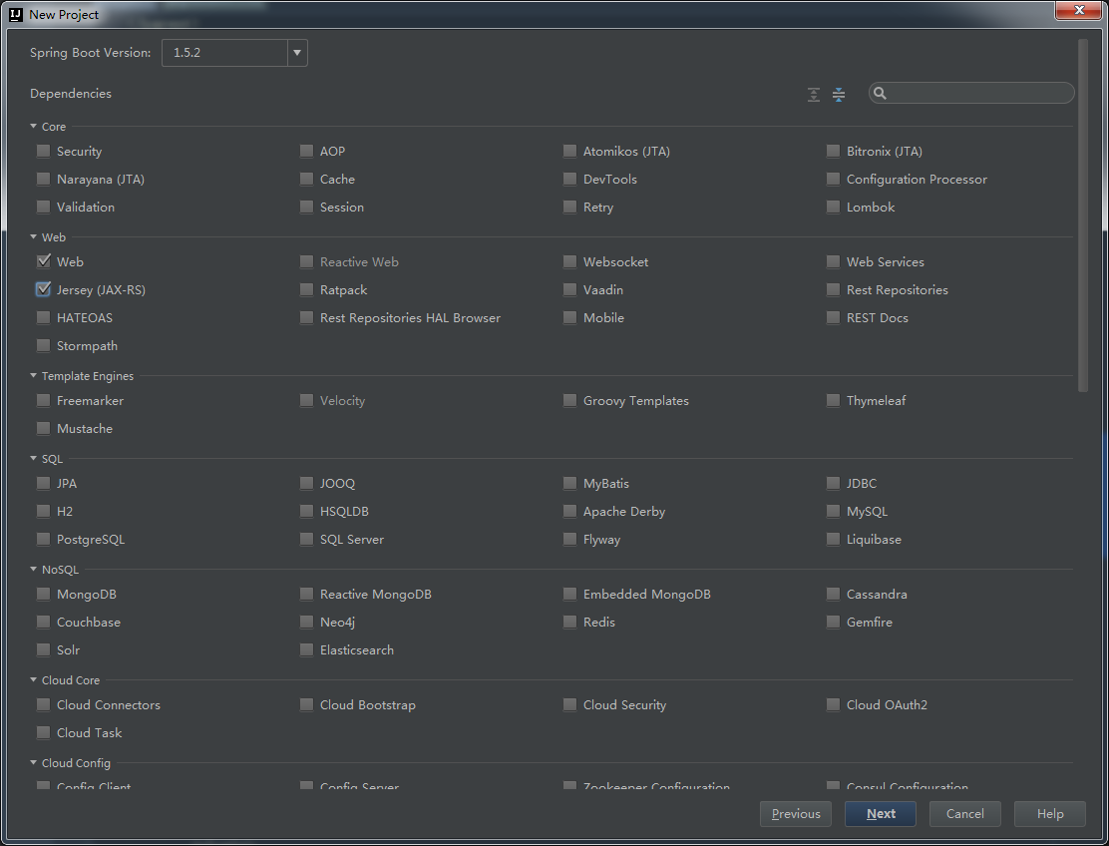

POM文件中添加Swagger配置:
- <!--swagger jar add-->
<dependency>
<groupId>io.swagger</groupId>
<artifactId>swagger-jersey2-jaxrs</artifactId>
<version>1.5.10</version>
</dependency>
- <dependency>
<groupId>io.swagger</groupId>
<artifactId>swagger-annotations</artifactId>
<version>1.5.9</version>
</dependency>
<dependency>
<groupId>io.swagger</groupId>
<artifactId>swagger-annotations</artifactId>
<version>1.5.9</version>
</dependency>

在resource-static中添加swagger需要文件:
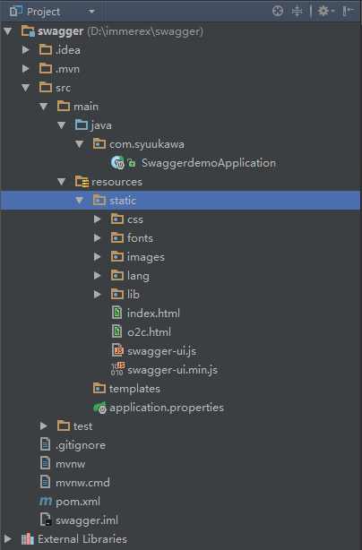

添加配置类:
ApiOriginFilter：
public class ApiOriginFilter implements Filter {
@Override
public void init(FilterConfig filterConfig) throws ServletException {
}
@Override
public void doFilter(ServletRequest req, ServletResponse res, FilterChain chain) throws IOException, ServletException {
HttpServletResponse response = (HttpServletResponse) res;
response.setHeader("Access-Control-Allow-Origin", "*");
response.setHeader("Access-Control-Allow-Methods", "GET, POST, DELETE, PUT, PATCH, OPTIONS");
response.setHeader("Access-Control-Max-Age", "3600");
response.setHeader("Access-Control-Allow-Headers", "Origin, X-Requested-With, Content-Type, Accept, api_key, Authorization");
// response.setHeader("Content-Type", "application/json");
chain.doFilter(req, res);
}
@Override
public void destroy() {
}
}

JerseyConfig:
@Component
public class JerseyConfig extends ResourceConfig {
@Value("${spring.jersey.application-path:/}")
private String apiPath;
public JerseyConfig() {
// Register endpoints, providers, ...
this.registerEndpoints();
}
@PostConstruct
public void init() {
// Register components where DI is needed
this.configureSwagger();
}
private void registerEndpoints() {
packages("com.syuukawa");
// Access through /<Jersey's servlet path>/application.wadl
this.register(WadlResource.class);
}
private void configureSwagger() {
// Available at localhost:port/swagger.json
this.register(ApiListingResource.class);
this.register(SwaggerSerializers.class);
BeanConfig config = new BeanConfig();
config.setConfigId("springboot-jersey-swagger-docker-example");
config.setTitle("Spring Boot + Jersey + Swagger + Docker Example");
config.setVersion("v1");
config.setContact("Orlando L Otero");
config.setSchemes(new String[]{"http", "https"});
config.setBasePath(this.apiPath);
//TODO need to modify
config.setResourcePackage("com.syuukawa");
config.setPrettyPrint(true);
config.setScan(true);
}
}

修改application.properties:
server.port= 8081
spring.jersey.application-path= /api

添加相关测试类:
@Path("/user")
@Api(value = "/userResource", description = "description")
@SuppressWarnings("all")
public class UserDetailResource {
private static final Logger log = LoggerFactory.getLogger(UserDetailResource.class);
/**
* <p>Description: 这里用一句话描述这个方法的作用</p>
* <p>param </p>
* <p>author zhouhe </p>
* <p>date 2017/3/17 14:28 </p>
* <p>return </p>
*/
@ApiOperation(value = "/detail", notes = "get userDetail by userId")
@GET
@Path("/detail")
@Produces({"application/json;charset=utf-8"})
@Consumes({"application/json;charset=utf-8"})
public Response<String> getUserDetail(@QueryParam("userId") Long userId) {
System.out.println("========="+ userId);
return new Response(Result.SUCCESS,userId);
}
}

运行结果:
Localhost:8081
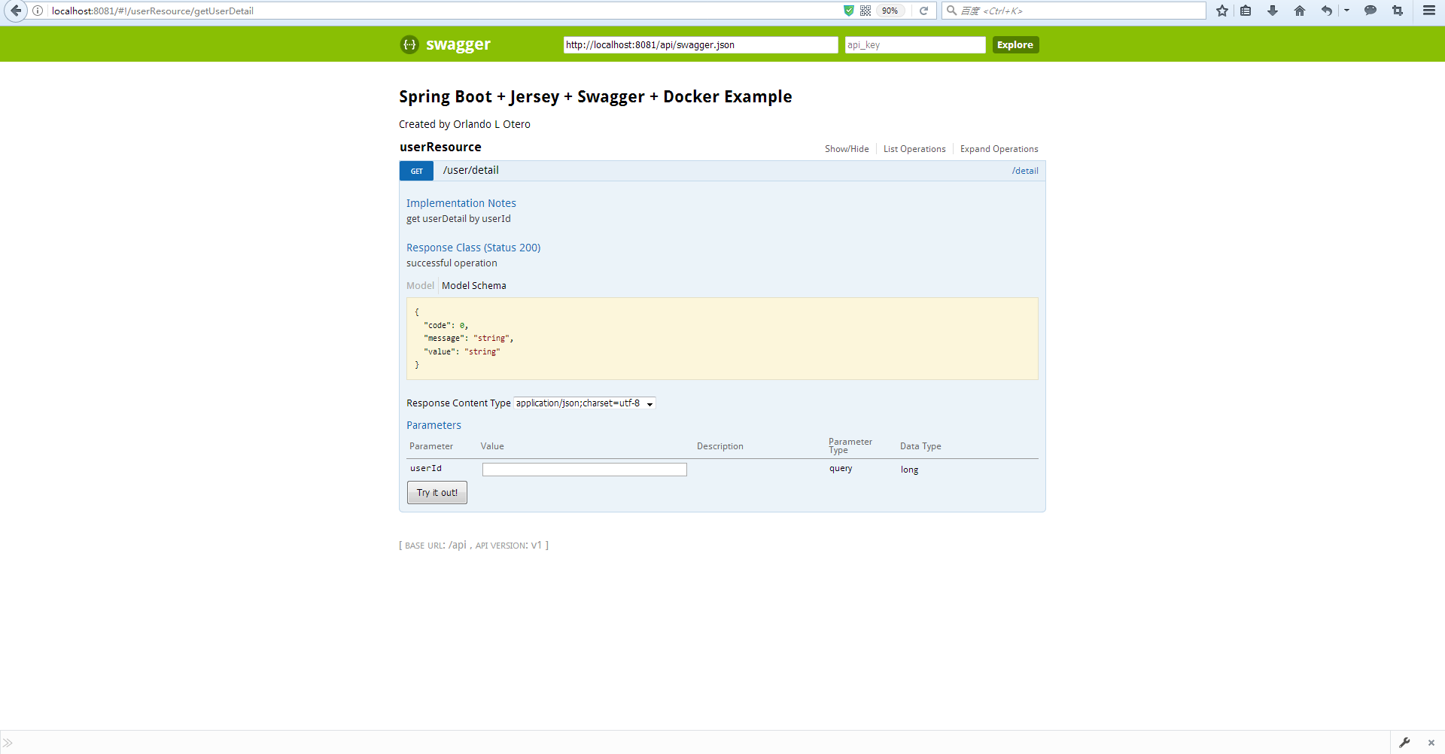

进行接口测试：
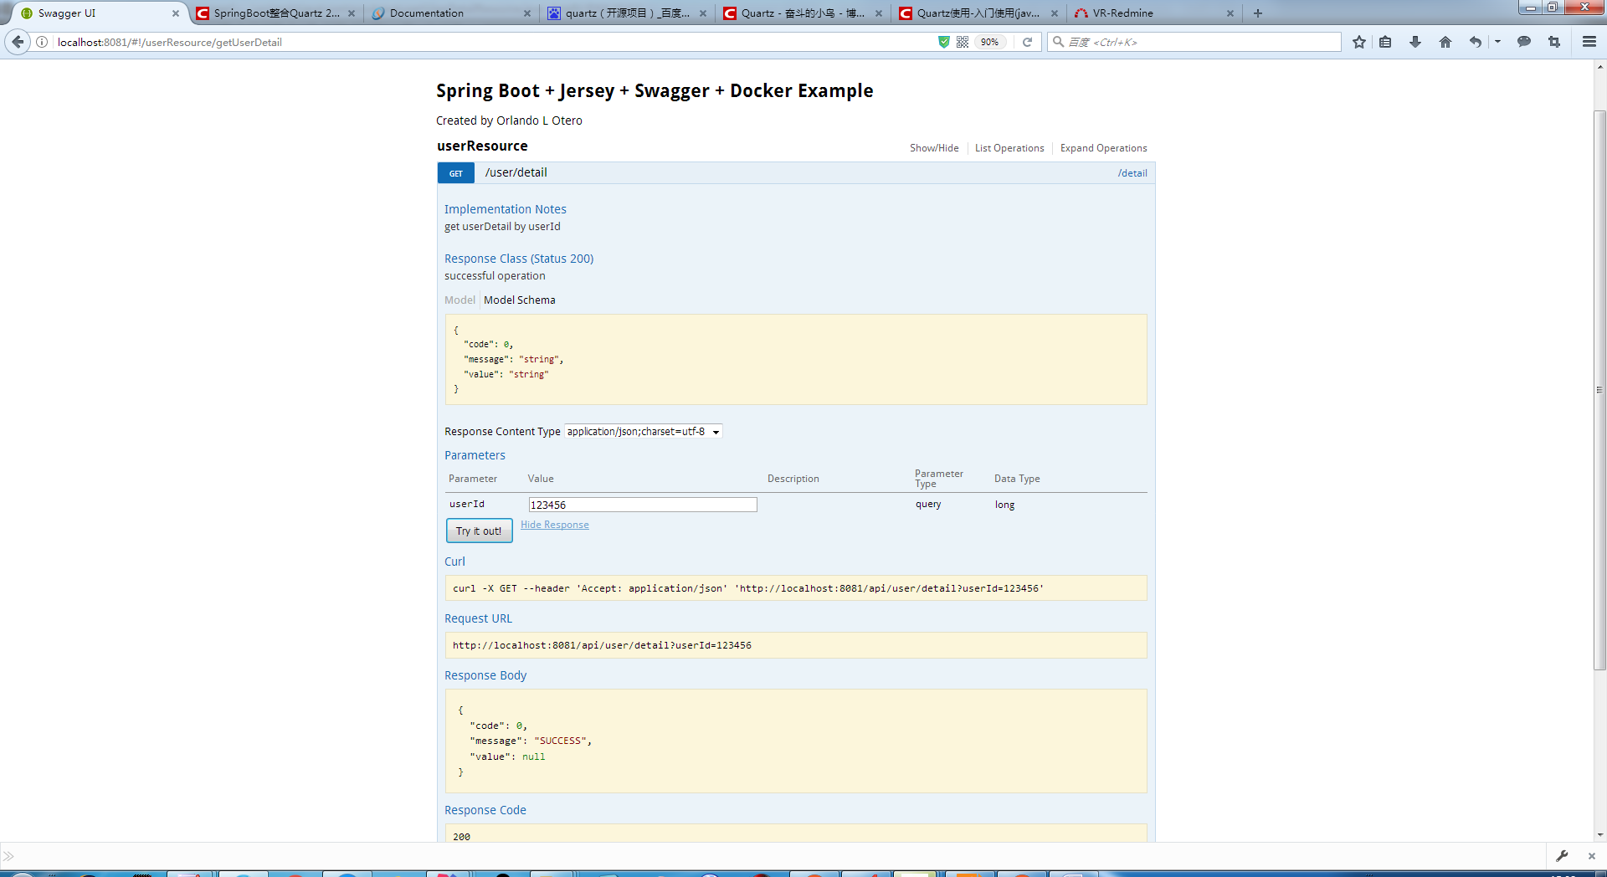

SwaggerApi项目生成

Swagger-config.json
{
"apiPackage":"com.syuukawa.user.api",
"invokerPackage":"com.syuukawa.user.invoker",
"modelPackage":"com.syuukawa.user.entity",
"dateLibrary":"legacy",
"serializableModel":true,
"fullJavaUtil":true
}

执行命令
java -jar swagger-codegen-cli-2.2.1.jar generate -i http://localhost:8081/api/swagger.json -l java -c D:\immerex\swagger_config.json -o D:\immerex\swaggerApi
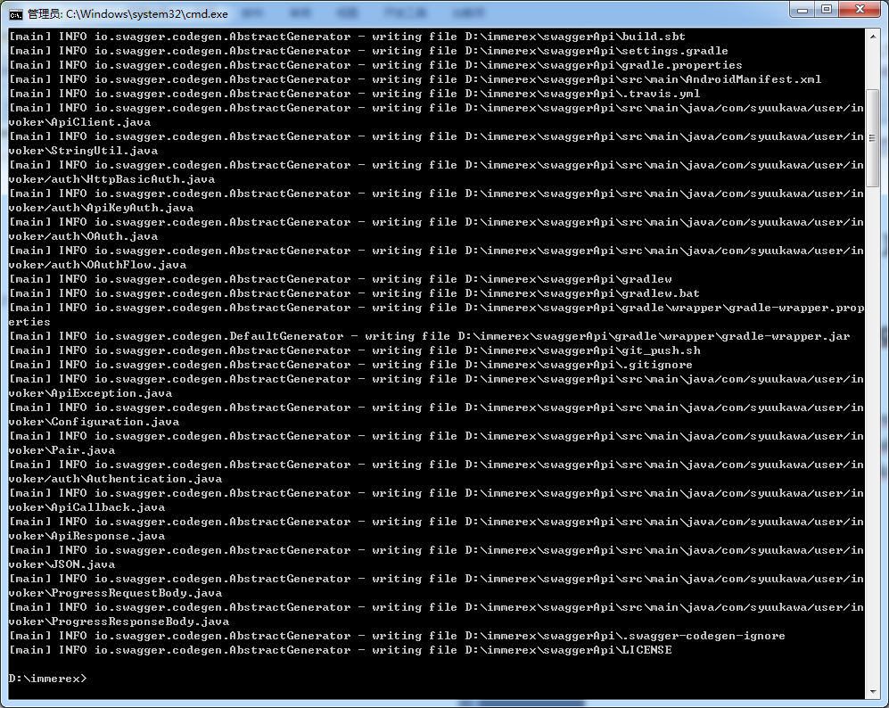

SwaggerApi项目结构
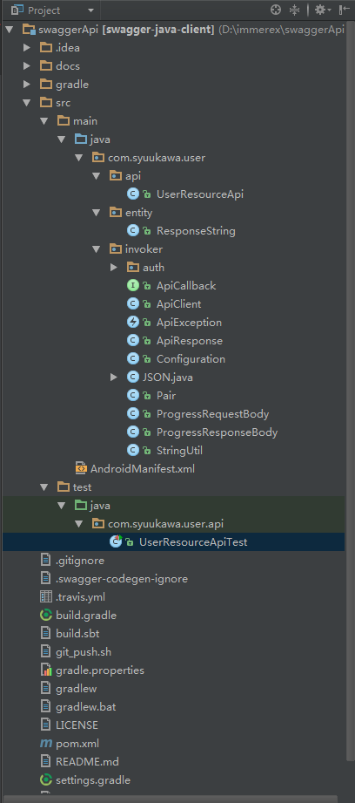

测试
1、修改ApiClient中的basePath
private String basePath = "http://localhost:8081/api";
2、修改测试类中的方法
@Test
public void getUserDetailTest() throws ApiException {
Long userId = 123L;
ResponseString response = api.getUserDetail(userId);
System.out.println("===========" + response);
// TODO: test validations
}
3、测试结果如下
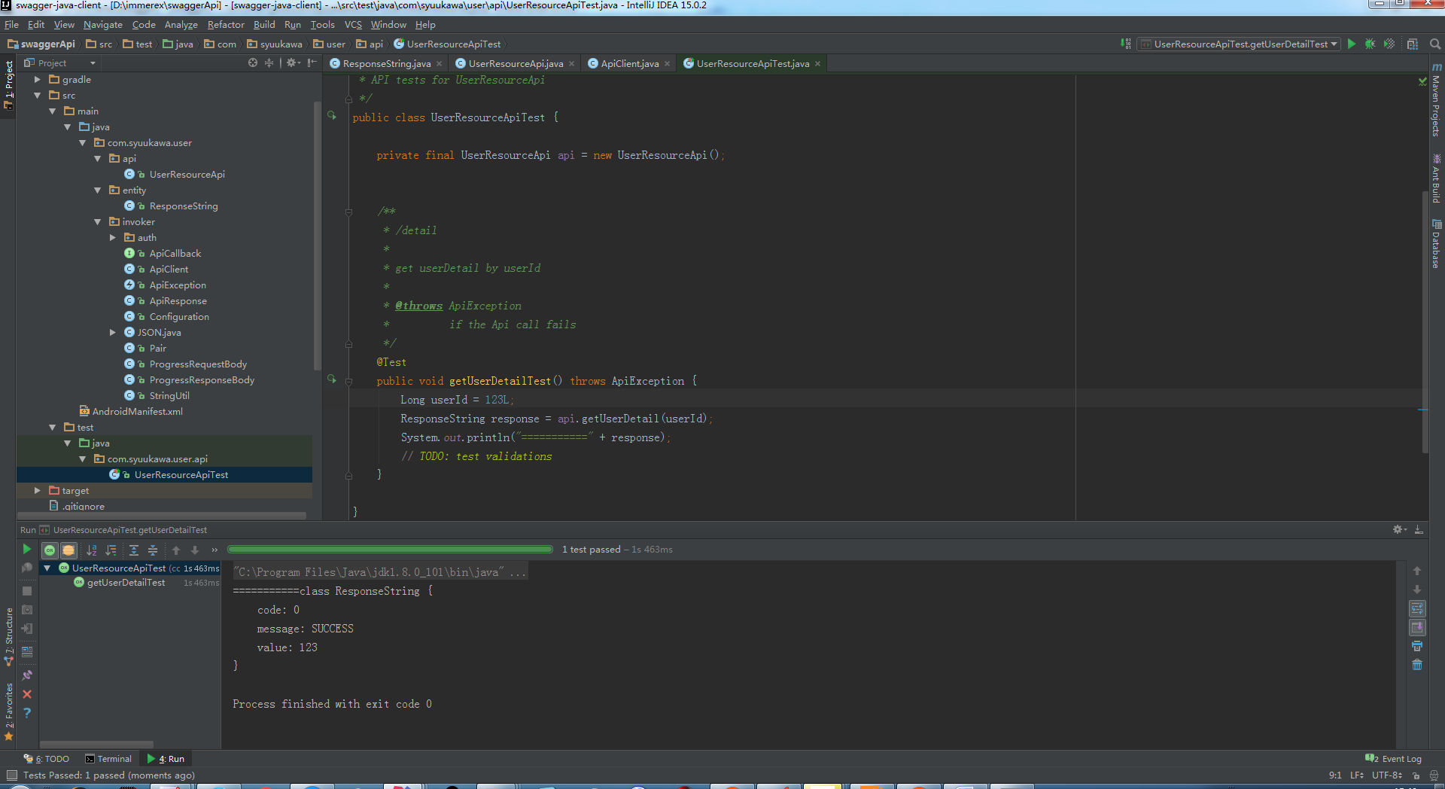

后续调用
- SwaggerApi项目可以打成jar，放到前端项目中，实现前端---SwaggerApi---后端的调用，此处省略。
<dependency>
<groupId>f5</groupId>
<artifactId>iControl</artifactId>
<version>11.4.1</version>
<scope>system</scope>
<systemPath>${project.basedir}/src/main/webapp/WEB-INF/lib/iControl.jar</systemPath>
</dependency>
- 前端项目可以引入SwaggerApi项目，实现前端---SwaggerApi---后端的调用，此处省略。
<dependency>
<groupId>SwaggerApi</groupId>
<artifactId>SwaggerApi</artifactId>
<version>1.0.0</version>
</dependency>

