Lab 1:   
Data Communications\Networking

This course is essentially divided into two parts: Data Communications (weeks 1-5) and Networking (weeks 7-11). It is common for users, to use these terms synonymously; however, in this course we will me more technical and treat them differently. Data Communications involves transmitting signals which represent “0s” and “1s” between two hosts over a point-to-point circuit.Data communication uses the data link and physical layers of the TCP/IP protocol stack to provide framing, error checking, encoding\decoding and the type of transmission, synchronous or asynchronous. Networking is built on top of data communications and involves the logical connection of point-to-point circuits for the exchange and sharing of information among networked applications. Networking uses the application, transport and Internet layers of the TCP/IP protocol stack. This lab will introduce you to the concepts of data communications and networking.

**A Data Communications:**

1. Open a PowerShell console
2. Type **ipconfig /all**

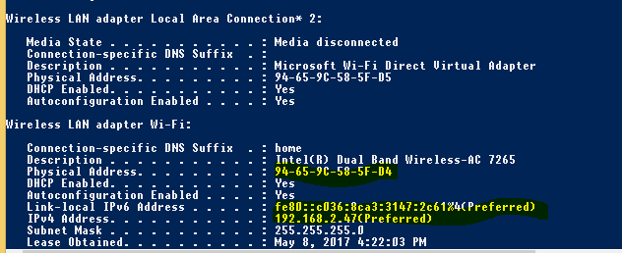

You should see a screen like the one above. Notice you have two addresses: Physical Address and an IPv4 address. There is also a Link-local IPv6 address.

1. Write down your MAC address without the hyphens ECB1D738D15B.
2. Copy the MAC address to Windows Calculator. Make sure the Calculator is set to Programmer View and the input format is set to HEX
3. Click the BIN radio button. How many bits is the MAC address?48

The MAC (Media Access Control) address is used by all LANs and most WANs to forward frames on a single switched network. A switched network consists of many point-to-point connections connecting hosts.

1. Click on the DEC radio button. What is the decimal conversion? 260248564191579
2. Write down your IPv4 address? 10.40.46.133
3. Navigate to <http://www.subnetonline.com/pages/subnet-calculators/ip-subnet-calculator.php>
4. Type in the IP address and subnet mask.
   1. What is the network portion of the address? 10.40.46.0
   2. What is the maximum number of hosts? 254
   3. How many bits is the IPv4 address? 32

The IPv4 address is used to connect different single switched networks together so that packets can be routed to the destination network. Thus, the IP address is clearly a “networking” device while the MAC address is a data communications device.

1. Conduct a Google search and identify 2 devices used in data communications.

Bluetooth devices

Infrared devices

1. Who is the Father of” Data Communications” or the “Information Age” of today?  
     
   Claude
2. Test you download speed.
3. Navigate to <http://www.speedtest.net>
4. Click the Go button. This web site will automatically download and upload a file and measure the speed of the connection.
   1. What is the PING value (latency or delay)? 5
   2. What is your download speed? 883.60 Mbps
   3. What is your upload speed? 828.70 Mbps

***B Networking:***

1. In the PowerShell console. Clear the screen. Type **CLS** and press enter

We will use the PING command to test if a networked host is “alive”.

1. Type **PING my.senecacollege.ca**. What is the IPv4 address returned? 69.196.236.36
2. Type **PING Google.ca.** What is the IPv4 address returned? 172.217.1.163  
   1. What is the average round trip time? 1ms
3. Type **TRACERT Google.ca.** This command records the pathway taken when packets are routed from your computer to Google.ca web site. The first hop is your IP address.  
   1. What is the IP address of the first router? (2nd hop) 10.19.2.250
4. How many hops (each hop is a server or a router) were taken? 11
5. Name 4 applications, based on a client\server architecture, you use everyday?

Google search

Email

Facebook

Instagram

1. Notice the IPv6 address is not written in dotted decimal format.
   1. What format is it? 2607:fea8:91df:ee4f::3(Preferred)
   2. How many bits long is it? 64

The local-link address is a specific address used by hosts which can not get an IP address from the network. On Windows machines this block will have the address 169.254.0.0/16 . We will discuss IP addressing in week 5.

1. Conduct a Google search and identify 2 devices used in networking?

Modem

Network Router

1. In one sentence explain the following acronyms PAN, LAN, MAN, and WAN

->A personal area network(PAN) is the interconnection of information technology devices within the range of an indivudual person, typically within a range of 10 meters.

->A local area network(LAN) is a computer network that interconnects computers within a limited area such as a residence, school, laboratory, university campus or office building.

->A metropolitan area network(MAN) is a computer network that interconnects users with computer resources in a geographic area or region larger than the area covered by even a large local area network.

->A wide area network(WAN) is a telecommunications network or computer network that extends over a large geographical distance. Wide area networks are often established with leased telecommunication circuits.

1. What is the most popular networking technology today? Ethernet
2. What address does Ethernet use to forward frames MAC or IP? Ethernet Switch
3. The protocol TCP/IP is used to network single switched networks together.
   1. What does this protocol acronym mean?

The transmission control protocol(TCP) is one of the main protocols of the internet protocol suite. It originated in the initial network implementation in which it complemented the internet protocol(IP).

1. Which Internet pioneers invented TCP/IP and are generally regarded as the “Fathers of the Internet”.

Bob Kahn

Louise Pouzin

1. On your desktop is a program called Wireshark. This is a network protocol capture and analyzer tool. There will be controls at the top with a blank capture area below them.
2. To start a capture, click on the Go menu item. Then when the Wireshark capture Interfaces Dialog box opens, select a network interface and click start.
3. Open your browser and enter a URL. This will create a plethora of packets between you and the host in the URL. The packets will appear in the capture area which will look similar to below.

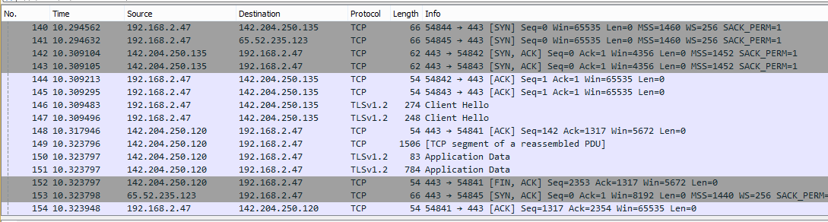

1. Scroll down the protocol column to find the beginning of the conversation with the IP address in he URL. In the screen shot above, My Seneca is identified. Browse all the protocols used and exchanges required to make a secure connection to the host. We will discuss many of the protocols throughout the course.