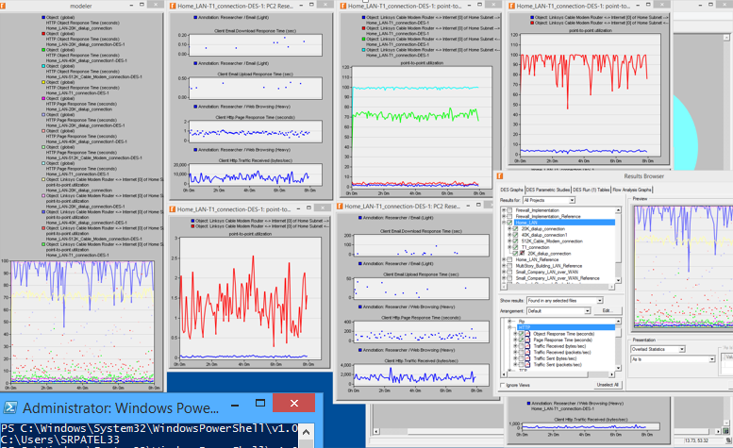

I think so the best speed is 512kbps is the better for tha family member because the utilization went down to 4% and the response time for the researcher went down to 0.15seconds. The cable modem improves our download times greatly and although response time is very good.